Table of Contents

UNITED STATES
SECURITIES AND EXCHANGE COMMISSION
Washington, D.C. 20549

SCHEDULE 14A
(Rule
14a-101)
INFORMATION REQUIRED IN PROXY STATEMENT
SCHEDULE 14A INFORMATION
Proxy Statement Pursuant to Section 14(a) of the
Securities Exchange Act of 1934

Filed by the Registrant ☒ Filed by a party other than the Registrant ☐
Check the appropriate box:

☐ | Preliminary Proxy Statement

☐ | Confidential, for Use of the Commission Only (as permitted by Rule  14a-6(e)(2))

☒ | Definitive Proxy Statement

☐ | Definitive Additional Materials

☐ | Soliciting Material Pursuant to  §240.14a-12
Bath & Body Works, Inc.
(Name of Registrant as Specified in its Charter)
Not applicable.
(Name of Person(s) Filing Proxy Statement, if other than the Registrant)
Payment of Filing Fee (Check all boxes that apply):
☒ |  | No fee required.
☐ |  | Fee paid previously with preliminary materials.
☐ |  | Fee computed on table in exhibit required by Item 25(b) per Exchange Act Rules  14a-6(i)(1)  and  0-11.

Table of Contents
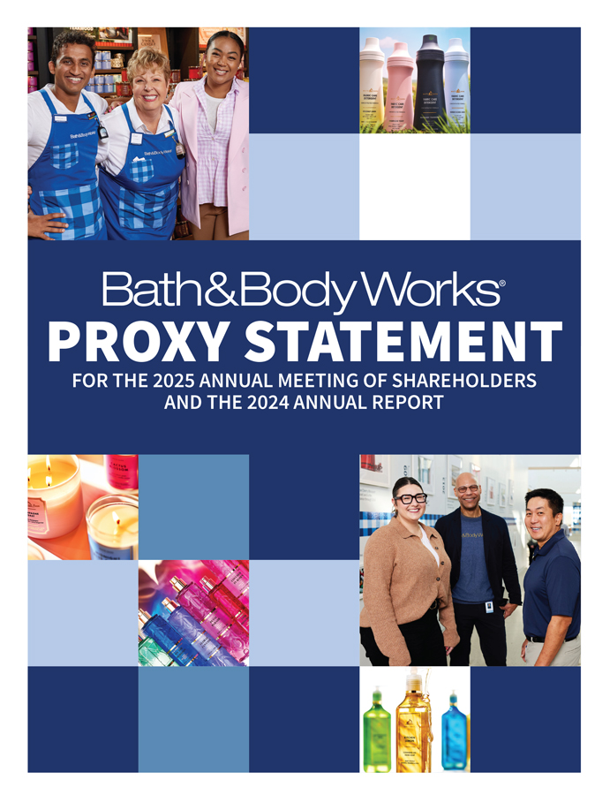
Bath & BodyWorks PROXY STATEMENT FOR THE 2025 ANNUAL MEETING OF SHAREHOLDERS AND THE 2024 ANNUAL REPORT

Table of Contents

We help the WORLD live more fully through the POWER OF FRAGRANCE. Home of America’s Favorite Fragrances®, Bath & Body Works is a global leader in personal care and home fragrance, including top-selling collections for fine fragrance mist, body lotion and body cream, 3-wick candles, home fragrance diffusers and liquid hand soap. Powered by agility and innovation, the company’s predominantly U.S.-based supply chain enables it to deliver quality, on-trend luxuries at affordable prices. Bath & Body Works serves and delights customers however and wherever they want to shop, from welcoming, in-store experiences at more than 1,890 company-operated Bath & Body Works locations in the U.S. and Canada, more than 525 international franchised locations and an online storefront at bathandbodyworks.com.

Table of Contents

Dear Fellow Shareholders,

enhance our corporate governance. If all nominees are elected to serve as directors at the 2025 annual meeting, 90% of the Company’s directors will have joined the Board in 2019 or later, and the average director tenure on our Board will be 4.2 years.
The Board is committed to ongoing dialogue with shareholders and taking a proactive approach to addressing matters and suggestions with thoughtful action. Through our ongoing shareholder engagement program, we continue to listen, learn and implement feedback that supports our Company’s long-term growth.
On behalf of the entire Board, I would like to thank our dedicated leadership team and associates that work every day to deliver on our purpose to help the world live more fully through the power of fragrance.
Thank you for your continued support and investment in our Company. We ask for your voting support on the terms contained in this proxy statement and appreciate you taking the time to cast your vote.

 |  | Sincerely,  Sarah E. Nash  Board Chair  Bath & Body Works, Inc.

Fiscal 2024 was a significant year for Bath & Body Works. The team executed with focus and discipline, building momentum throughout the year, making progress on our strategy and establishing a strong foundation for long-term growth.
Throughout the year, the Company made meaningful progress on our three strategic priorities, including accelerating topline growth, enhancing operational effectiveness and efficiency, and strengthening our financial position, which helped reinvigorate the business while also delivering value for our shareholders, associates and customers.
Despite a choppy macroeconomic backdrop, when adjusting for holiday timing and calendar impacts, revenue improved sequentially every quarter in 2024 and the Company returned to positive sales growth in the second half of the year. Bath & Body Works’ return to growth was driven by strategic investments in product innovation, marketing and technology. We introduced innovative products across our core categories – Body Care, Home Fragrance, and Soaps and Sanitizers – and drove strong performance in newer categories (which we call adjacencies), including Men’s, Lip, Hair and Laundry. At the same time, the team remained focused on enhancing operational efficiency. The Company’s Fuel for Growth cost optimization plan delivered approximately $155 million dollars in incremental cost savings – significantly exceeding initial targets.
Additionally, in 2024, the Company invested approximately $245 million in technology and other capital projects to strengthen our infrastructure and improve the customer experience, reinforcing our commitment to long-term growth. After making these investments, we are pleased to have generated $660 million in free cash flow in fiscal 2024, enabling us to achieve our targeted debt leverage ratio of 2.5x while returning cash to shareholders.
These achievements reflect the strength of our business model and the disciplined execution of our leadership team. The new share repurchase program, which authorizes the Company to buy back up to $500 million in outstanding common stock, underscores our confidence in the Company’s long-term growth strategy and our commitment to delivering shareholder value through disciplined capital allocation.
Looking ahead, we are excited about the opportunities we see and the momentum we have built. With a focused strategy, a robust innovation pipeline and a highly engaged team, we are confident in the Company’s ability to continue delivering for our shareholders and all stakeholders in 2025 and beyond.
In terms of governance, we have significantly refreshed our Board of Directors over the last few years to ensure an optimal structure and composition with the right mix of expertise, backgrounds and tenures. In 2024, we reduced the size of our Board to 10 directors and rotated our committee chairs to

Table of Contents

Dear Fellow Shareholders,

program. Our technology roadmap remains on track as we enhance our systems and implement foundational tools to enable more personalization and seamless customer engagement.
• |  | Delivering approximately $155 million in cost savings under our Fuel for Growth cost optimization plan, bringing our two-year total to over $300 million in cost savings, and maintaining a continuous improvement mindset to manage cost and enhance operational efficiencies as we move forward.
As a result, we closed out 2024 in a strong financial position. We generated $660 million in free cash flow and were disciplined in paying down debt, achieving our target debt leverage ratio of 2.5x, while returning approximately $577 million to investors through share repurchases and dividends.
These achievements, combined with our strong financial position, demonstrate that our strategy is working. We are building momentum as we enter 2025, and we believe the Company is well positioned for continued growth.
Above all else, our culture and our associates are integral to our success. They are the heart of our Company, fostering a sense of belonging in our stores, distribution and fulfillment centers, and offices. The dedication of our associates ensures we execute on our business strategy effectively. I am confident that our teams will continue to deliver excellence as we move forward.
Looking ahead to 2025 and beyond, our fragrance leadership, innovation pipeline, investments in marketing and technology, dedicated teams, and thoughtful capital allocation strategy position us well to drive long-term sustainable growth and deliver shareholder value.
Thank you for your investment and your continued support.

 |  | Sincerely,  Gina R. Boswell  Chief Executive Officer  Bath & Body Works, Inc.

At Bath & Body Works, we help the world live more fully through the power of fragrance. After more than two years at Bath & Body Works, I am proud of how we have brought that purpose to life for our customers and I am excited about the possibilities for the future. Everywhere I look across the Company, I see a steadfast commitment to delivering for our customers through innovation, strong execution and a culture that truly sets us apart.
For Bath & Body Works, 2024 was about building momentum toward long-term sustainable growth. Amid macroeconomic uncertainty and an evolving competitive landscape, we delivered strong results. Revenue growth accelerated sequentially every quarter in 2024, when adjusting for calendar impacts and holiday timing. We finished the year strong, exceeding our revenue and earnings guidance in our all-important fourth quarter.
We attribute our progress this year to our associates’ exceptional execution of our strategy, which includes three priorities:

• |  | Accelerating top-line growth across our core categories through product innovation, marketing and technology, and extending our reach through adjacencies and international expansion.
• |  | Enhancing operational excellence and efficiency through disciplined cost management and a continuous-improvement mindset.
• |  | Strengthening our financial position through strong cash flow generation and disciplined capital allocation, ensuring we invest for growth while delivering returns to shareholders through dividends and share repurchases.
Our performance highlights in 2024 include the following:

• |  | Maintaining category leadership and unit market share across our core categories which include Body Care, Home Fragrance, and Soaps and Sanitizers.
• |  | Launching exciting collaborations with companies like Netflix, including Bridgerton, Stranger Things and Emily in Paris, and introducing new product innovations such as our prestige-inspired line of fine fragrance mists called Everyday Luxuries to deepen our connection with new and existing customers.
• |  | Expanding our reach in international markets and adjacencies such as Men’s, Laundry, Lip and Haircare. Adjacencies now represent approximately 10% of our business with the potential to become a larger percentage of our mix over time.
• |  | Investing in marketing, loyalty, and technology to improve the in-store and online customer experience. We grew our active loyalty membership by 6% year-over-year with approximately 80% of U.S. sales flowing through the

Table of Contents


Notice of Annual Meeting of Shareholders
June 5, 2025

 |  | ITEMS OF BUSINESS
 |  | 1 |  | Elect the ten nominees proposed by the Board of Directors as directors.
 |  | 2 |  | Ratify the appointment of our independent registered public accounting firm.
 |  | 3 |  | Hold an advisory vote to approve named executive officer compensation.
 |  | 4 |  | Transact such other business as may properly come before the meeting.
This proxy statement contains important information, including a description of the business that will be acted upon at the meeting. Shareholders will not be able to attend the meeting in person. Please see “Information About the Annual Meeting and Voting” on page 66 of this proxy statement for additional information regarding attendance at the meeting. Your vote is important. Shareholders of record can give proxies by calling a toll-free telephone number, by using the Internet or by mailing their signed proxy cards. Whether or not you plan to virtually attend the meeting, please vote by telephone or via the Internet or sign, date and return the enclosed proxy card in the envelope provided. Instructions are included on your proxy card. You may change your vote by submitting a later dated proxy (including a proxy via telephone or the Internet) or by attending the meeting and voting virtually.

By Order of the Board of Directors,

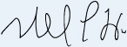

Michael C. Wu
Chief Legal Officer
and Corporate Secretary
April 25, 2025

Who May Vote
Shareholders of record at the close of business on April 8, 2025, may vote at the meeting.

  DATE:  Thursday,  June 5, 2025 |  |   TIME:  8:30 a.m.  Eastern Time |  |   PLACE:  Meeting will be held virtually with a link to be provided by registering at https://proxydocs.com/BBWI
Date of Mailing
A Notice of Internet Availability of Proxy Materials or this proxy statement and the enclosed proxy card is first being sent to shareholders on or about April 25, 2025.
Internet Availability
In accordance with Securities and Exchange Commission rules, we are using the Internet as our primary means of furnishing our proxy materials to most of our shareholders. Rather than sending those shareholders a paper copy of our proxy materials, we are sending them a Notice of Internet Availability of Proxy Materials with instructions for accessing the materials and voting via the Internet. We believe this method of distribution makes the proxy distribution process more efficient and less costly and limits our impact on the environment. This proxy statement and our Annual Report on Form 10-K for the fiscal year ended February 1, 2025, are available at www.bbwinc.com (see the “Investors” link followed by the “Annual Reports/Proxy” link).

Bath & Body Works, Inc. | 2025 Proxy Statement

Table of Contents

Table of Contents

 |  | PAGE
2025 Proxy Statement Summary |  |  | 1
Safe Harbor Statement Under the Private Securities Litigation Reform Act of 1995 |  |  | 4
Election of Directors |  |  | 4
The Board’s 2025 Director Nominees |  |  | 5
Qualifications and Skills |  |  | 6
A Broadly Representative Board |  |  | 6
Board Nominees |  |  | 7
Director Independence |  |  | 17
Board Refreshment and Selection of Director Nominees |  |  | 17
Corporate Governance |  |  | 18
Corporate Governance Highlights |  |  | 19
Board Leadership Structure |  |  | 20
Meeting Attendance |  |  | 20
Committees of the Board |  |  | 20
Board and Committee Evaluations |  |  | 22
Meetings of Independent Directors |  |  | 22
Board Role in Strategic Planning and Capital Structure |  |  | 22
Board Role in Risk Oversight |  |  | 23
Code of Conduct, Insider Trading, Governance Documents and Related Person Transactions |  |  | 23
Human Capital & Compensation Committee Participation and Interlocks |  |  | 24
Director Stock Ownership Guidelines |  |  | 24
Contacting the Board |  |  | 24
Fiscal 2024 Director Compensation |  |  | 25
Ratification of the Appointment of Independent Registered Public Accounting Firm |  |  | 26

 |  | PAGE
Report of the Audit Committee |  |  | 27
Independent Registered Public Accounting Firm’s Fees |  |  | 28
Audit and Other Fees |  |  | 28
Pre-approval Policies and Procedures |  |  | 28
Information About Our Executive Officers |  |  | 29
Advisory Vote to Approve Named Executive Officer Compensation |  |  | 31
Compensation-related Matters |  |  | 32
Compensation Discussion and Analysis |  |  | 32
2024 Summary Compensation Table |  |  | 49
Grants of Plan-based Awards for Fiscal 2024 |  |  | 51
Outstanding Equity Awards at Fiscal Year-end 2024 |  |  | 52
Option Exercises and Stock Vested Information for Fiscal 2024 |  |  | 53
Potential Payments Upon Termination or Change in Control |  |  | 54
2024 Pay Ratio Disclosure |  |  | 58
2024 Pay Versus Performance Disclosure |  |  | 59
Beneficial Ownership of Common Stock |  |  | 64
Information About the Annual Meeting and Voting |  |  | 66
General Matters |  |  | 69
Shareholder Proposals or Director Nominations for the 2026 Annual Meeting |  |  | 69
Other Proposed Actions |  |  | 69
Solicitation of Proxies |  |  | 69
Appendix A – Non-GAAP Financial Measures |  |  | A-1

Table of Contents
2025 Proxy Statement Summary

This summary highlights information about Bath & Body Works, Inc. (referred to in this proxy statement as “we,” “us,” “our” and the “Company”) and our upcoming 2025 annual meeting of shareholders contained elsewhere in this proxy statement. This summary does not contain all of the information you should consider. Please carefully read the entire proxy statement before voting.

Your Vote Is Important
How to Vote Your Shares (See Page 66)
You may vote if you were a Company shareholder of record as of the close of business on April 8, 2025.

 |  | Online before the meeting  Go to the website designated on the enclosed proxy card or to the website indicated on the materials provided by your broker |  |  |  | By phone  Call the phone number designated on the enclosed proxy card or the materials provided by your broker
 |  | By mail  Complete, sign and date the enclosed proxy card and return it promptly in the envelope provided |  |  |  | Virtually during the annual meeting  Submit your vote online at the annual meeting on June 5, 2025

Roadmap for Voting Items

ITEMS TO BE VOTED ON |  | VOTE STANDARD |  | BOARD VOTE RECOMMENDATION |  | SEE PAGE
Item 1. Election of directors |  | Majority of votes cast |  | ☑ FOR EACH NOMINEE |  |  | 4
Item 2. Ratification of the appointment of independent registered public accounting firm |  | Majority of votes present in person or by proxy and voting thereon |  | ☑ FOR |  |  | 26
Item 3. Advisory vote to approve named executive officer compensation |  | Majority of votes present in person or by proxy and voting thereon |  | ☑ FOR |  |  | 31

2025 Proxy Statement | Bath & Body Works, Inc. 1

Table of Contents

Our Director Nominees (See Page 5)
The following table provides summary information about the ten director nominees the Board of Directors (the “Board”) has nominated for election at our 2025 annual meeting of shareholders. Additional information about each nominee’s background and experience can be found beginning on page 7 of this proxy statement.

NAME AND PRINCIPAL OCCUPATION |  | AGE |  | TENURE |  | INDEPEN-  DENT |  | AC |  | HCCC |  | NGC
Alessandro Bogliolo  Former CEO, Tiffany & Co. |  | 60 |  | 3.1 |  | ● |  | ● |  | ● |  | ●
Gina Boswell  CEO, Bath & Body Works, Inc. |  | 62 |  | 2.3 |  | ● |  | ● |  | ● |  | ●
Lucy Brady  Former President, Snacks & Grocery, Conagra Brands, Inc. |  | 55 |  | 2.2 |  | ● |  | ● |  | ● |  | ●
Francis Hondal  Former President of Loyalty & Engagement, Mastercard, Inc. |  | 60 |  | 4.1 |  | ● |  | ● |  | ● |  | ●
Danielle Lee  Former President, Warner Music Artist & Fan Experiences, Warner Music Group Corp. |  | 49 |  | 4.1 |  | ● |  | ● |  | ● |  | ●
Sarah Nash  Chair of the Company’s Board of Directors; CEO & Owner of Novagard Solutions |  | 71 |  | 5.9 |  | ● |  | ● |  | ● |  | ●
Juan Rajlin  Vice President & Treasurer, Alphabet Inc. |  | 50 |  | 3.1 |  | ● |  | ● |  | ● |  | ●
Stephen Steinour  Chairman, President & CEO, Huntington Bancshares Incorporated |  | 66 |  | 11.2 |  | ● |  | ● |  | ● |  | ●
J.K. Symancyk  CEO, Signet Jewelers Limited |  | 53 |  | 3.9 |  | ● |  | ● |  | ● |  | ●
Steven Voskuil  Senior Vice President & CFO, The Hershey Company |  | 56 |  | 2.2 |  | ● |  | ● |  | ● |  | ●
AC Audit HCCC Human Capital & Compensation NGC Nominating & Governance ● Committee Member

Director Nominee Highlights

90% of the  Nominees  Joined the Board  in 2019 or Later |  | 4.2 Years  Average  Tenure |  | 58  Average  Age

2 Bath & Body Works, Inc. | 2025 Proxy Statement

Table of Contents

Relevant Qualifications, Skills and Experience
We believe that our director nominees, as a whole, possess the optimal mix of qualifications, skills and experience that, taken together, provide us with the variety and depth of knowledge, judgment and vision necessary to provide effective oversight of the Company, including:

EXECUTIVE BUSINESS EXPERIENCE
10 of 10
GOVERNANCE
10 of 10
OPERATIONS / SUPPLY CHAIN
4 of 10
OMNICHANNEL RETAIL
7 of 10
SUSTAINABILITY
8 of 10

TECHNOLOGY
9 of 10
FINANCIAL EXPERTISE
9 of 10
MARKETING, DIGITAL & CONSUMER INSIGHTS
8 of 10
PUBLIC COMPANY CEO / SENIOR LEADERSHIP EXPERIENCE
6 of 10
GLOBAL / INTERNATIONAL
9 of 10

Governance Highlights (See Page 19)
The “Corporate Governance” section beginning on page 18 of this proxy statement describes our strong governance framework, which includes:

☑ Independent Board Chair |  | ☑ Separate CEO and Board Chair roles
☑ Nine of ten director nominees are independent |  | ☑ Independent directors meet without management present
☑ Board actively involved in overseeing the Company’s long-term business strategy, strategic priorities and material risks |  | ☑ Each of our standing Board committees is composed of 100% independent directors
☑ Shareholders have the right to call special meetings (25%) |  | ☑ All directors are elected annually by majority vote
☑ Regular management succession planning |  | ☑ No supermajority voting requirements
☑ Proxy access rights |  | ☑ Robust executive officer and director stock ownership guidelines
☑ No shareholders rights plan in effect |  | ☑ Annual Board and committee self-evaluations

Our Executive Compensation Program Aligns Pay-for-Performance (See Page 32)
Our executive compensation program is designed to emphasize pay-for-performance and to provide a meaningful and direct link between the interests of our named executive officers (“NEOs”) and those of our shareholders. We employ a pay mix philosophy that focuses on performance-based compensation, and we utilize rigorous performance metrics that align with our strategic direction, provide balance between growth and profitability and are designed to drive total shareholder return.

2025 Proxy Statement | Bath & Body Works, Inc. 3

Table of Contents

Safe Harbor Statement Under the Private Securities Litigation Reform Act of 1995

We caution that any forward-looking statements (as such term is defined in the Private Securities Litigation Reform Act of 1995) contained in this proxy statement or made by our Company or our management involve risks and uncertainties and are subject to change based on various factors, many of which are beyond our control. Accordingly, our future performance and financial results may differ materially from those expressed or implied in any such forward-looking statements. Words such as “estimate,” “project,” “plan,” “believe,” “expect,” “anticipate,” “intend,” “planned,” “potential,” “target,” “goal” and any similar expressions may identify forward-looking statements. The forward-looking statements contained in this proxy statement are subject to certain risks, uncertainties and other factors that could affect our financial performance and actual results and could cause actual results to differ materially from those expressed or implied in any forward-looking statements included in this proxy statement or otherwise made by our Company or our management. We are not under any obligation and do not intend to make publicly available any update or other revisions to any of the forward-looking statements contained in this proxy statement to reflect circumstances existing after the filing date of this proxy statement or to reflect the occurrence of future events even if experience or future events make it clear that any expected results expressed or implied by those forward-looking statements will not be realized. Additional information regarding these and other factors can be found in “Item 1A. Risk Factors” in the Company’s 2024 Annual Report on Form 10-K for the fiscal year ended February 1, 2025 (the “2024 10-K”), as filed with the Securities and Exchange Commission (the “Commission”), and our subsequent filings.
Election of Directors
(Item 1 on the Proxy Card)

Our Board is elected annually by our shareholders and currently has ten members. Each director is, and throughout his or her service during fiscal 2024 was, independent in accordance with applicable New York Stock Exchange (“NYSE”) standards other than Gina Boswell, our Chief Executive Officer.

4 Bath & Body Works, Inc. | 2025 Proxy Statement

Table of Contents

The Board’s 2025 Director Nominees
The Nominating & Governance Committee is responsible for considering candidates for the Board and recommending director nominees for the Board. After evaluating the performance, qualifications, skills and experience of each of the current Board members and the composition of our full Board, based upon the recommendations of the Nominating & Governance Committee, the Board has recommended the election of ten directors.
THE BOARD UNANIMOUSLY RECOMMENDS THAT SHAREHOLDERS VOTE “FOR” THE ELECTION OF EACH OF THE NOMINEES LISTED BELOW.

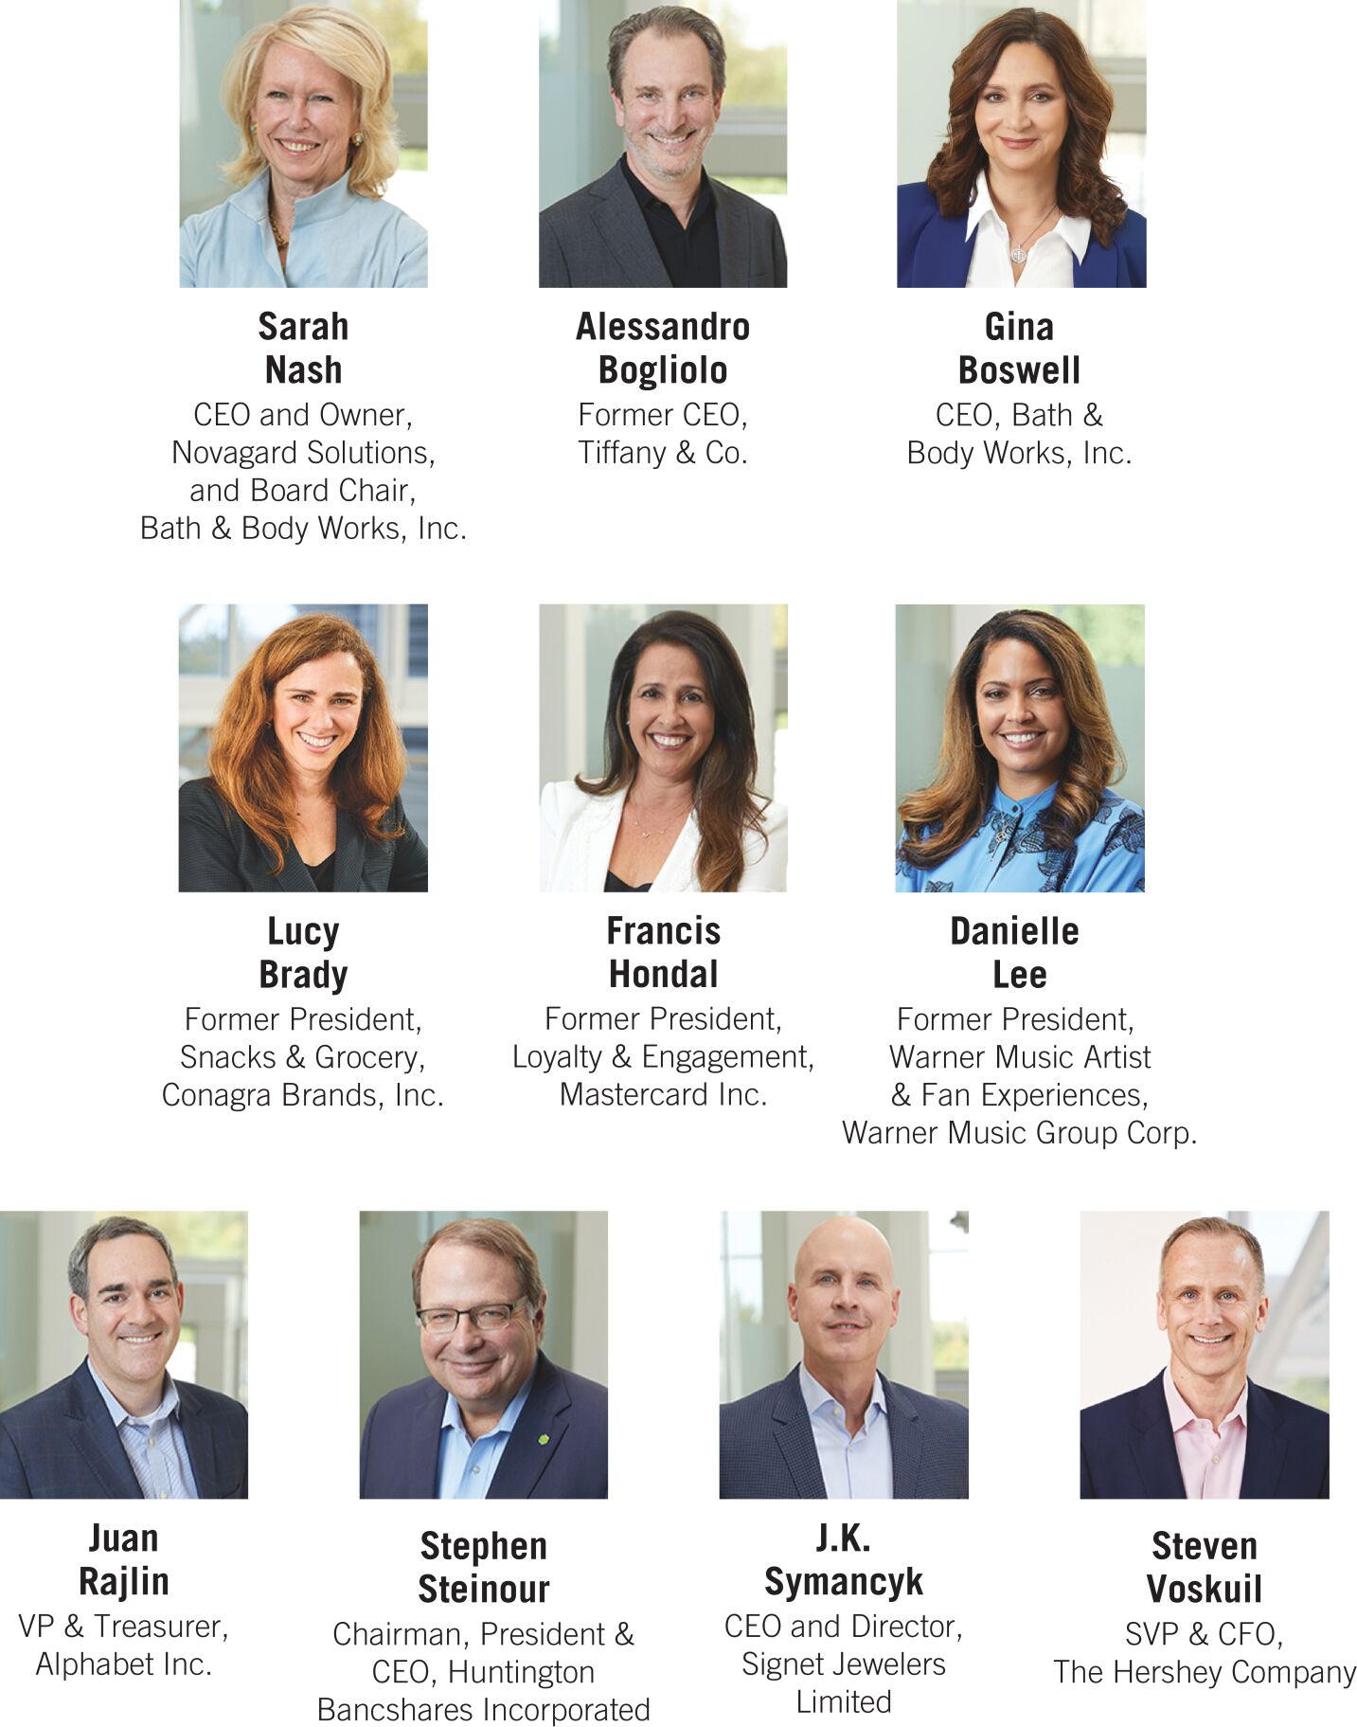

2025 Proxy Statement | Bath & Body Works, Inc. 5

Table of Contents

We believe that our director nominees, as a whole, possess the right mix of qualifications, skills and experience that, taken together, provide us with the variety and depth of knowledge, judgment and vision necessary to provide effective oversight of the Company. The tables below summarize the skills, qualifications and attributes of our director nominees.

Qualifications and Skills

Qualifications / Skills |  |  |  |  |  |  |  |  |  |  |  |  |  |  |  |  |  |  |  |  |  |  |  |  |  |  |  |  |  |  |  |  |  |  |  |  |  |  |  |  |  | 
Technology - Knowledge of or experience with technology, including digital solutions, information technology systems and architecture, and/or cybersecurity or data security |  |  |  |  |  |  |  |  | ∎ |  |  |  |  | ∎ |  |  |  |  | ∎ |  |  |  |  | ∎ |  |  |  |  | ∎ |  |  |  |  | ∎ |  |  |  |  | ∎ |  |  |  |  | ∎ |  |  |  |  | ∎
Executive Business Experience - Experience serving in an executive capacity in a public company |  |  |  | ∎ |  |  |  |  | ∎ |  |  |  |  | ∎ |  |  |  |  | ∎ |  |  |  |  | ∎ |  |  |  |  | ∎ |  |  |  |  | ∎ |  |  |  |  | ∎ |  |  |  |  | ∎ |  |  |  |  | ∎
Financial Expertise - Knowledge of or experience in capital markets, capital allocation, corporate finance and/or accounting |  |  |  | ∎ |  |  |  |  | ∎ |  |  |  |  | ∎ |  |  |  |  | ∎ |  |  |  |  |  |  |  |  |  | ∎ |  |  |  |  | ∎ |  |  |  |  | ∎ |  |  |  |  | ∎ |  |  |  |  | ∎
Governance - Experience serving on a public company board or developing corporate governance policies or investor relations programs for public companies |  |  |  | ∎ |  |  |  |  | ∎ |  |  |  |  | ∎ |  |  |  |  | ∎ |  |  |  |  | ∎ |  |  |  |  | ∎ |  |  |  |  | ∎ |  |  |  |  | ∎ |  |  |  |  | ∎ |  |  |  |  | ∎
Marketing, Digital & Consumer Insights - Experience in marketing, branding, digital and e-commerce, data analytics, customer loyalty and/or consumer insights |  |  |  | ∎ |  |  |  |  | ∎ |  |  |  |  | ∎ |  |  |  |  | ∎ |  |  |  |  | ∎ |  |  |  |  |  |  |  |  |  | ∎ |  |  |  |  | ∎ |  |  |  |  | ∎
Operations / Supply Chain - Experience with multi-site operational management, including logistics, distribution and/or fulfillment |  |  |  | ∎ |  |  |  |  | ∎ |  |  |  |  |  |  |  |  |  |  |  |  |  |  |  |  |  |  |  | ∎ |  |  |  |  |  |  |  |  |  |  |  |  |  |  | ∎
Public Company CEO / Senior Leadership Experience - Experience serving as a chief executive officer or in a similar leadership position of a public company |  |  |  | ∎ |  |  |  |  | ∎ |  |  |  |  |  |  |  |  |  |  |  |  |  |  |  |  |  |  |  | ∎ |  |  |  |  |  |  |  |  |  | ∎ |  |  |  |  | ∎ |  |  |  |  | ∎
Omnichannel Retail - Retail or consumer products experience or experience connecting digital and physical commerce, including services and capabilities, organizational structure and related solutions |  |  |  | ∎ |  |  |  |  | ∎ |  |  |  |  | ∎ |  |  |  |  | ∎ |  |  |  |  | ∎ |  |  |  |  |  |  |  |  |  | ∎ |  |  |  |  |  |  |  |  |  | ∎
Global / International - International experience or experience managing international operations or organizations |  |  |  | ∎ |  |  |  |  | ∎ |  |  |  |  | ∎ |  |  |  |  | ∎ |  |  |  |  | ∎ |  |  |  |  | ∎ |  |  |  |  | ∎ |  |  |  |  |  |  |  |  |  | ∎ |  |  |  |  | ∎
Sustainability - Expertise in sustainability |  |  |  | ∎ |  |  |  |  | ∎ |  |  |  |  | ∎ |  |  |  |  |  |  |  |  |  | ∎ |  |  |  |  | ∎ |  |  |  |  | ∎ |  |  |  |  | ∎ |  |  |  |  | ∎

A Broadly Representative Board

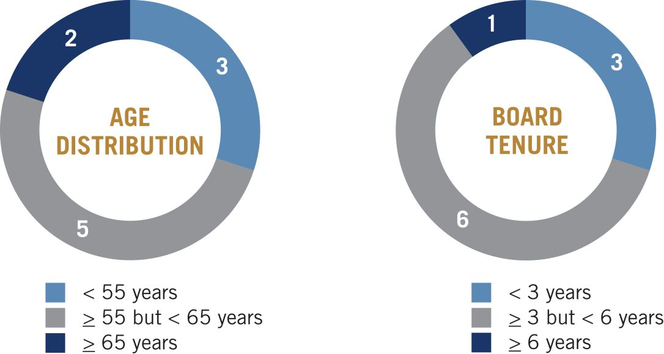
Each of the ten individuals nominated for election to the Board would hold office until our 2026 annual meeting of shareholders or until his or her successor is elected and qualified. If any nominee is unable to serve, your proxy may vote for another nominee proposed by the Board; alternatively, the Board may elect to reduce the size of the Board. We are unaware of any nominee of the Board who would be unable to serve as a director if elected.

6 Bath & Body Works, Inc. | 2025 Proxy Statement

Table of Contents

Set forth below is additional information about the experience and qualifications of each of the nominees for director that led the Board to conclude that the director nominee would provide valuable insight and guidance as a member of the Board.

Board Nominees

 |  |   Age: 60  Director since: 2022  Committees:  • Human Capital & Compensation  • Nominating & Governance |  |  |  | Alessandro Bogliolo |  | INDEPENDENT DIRECTOR
Career Highlights
• Chief Executive Officer and director of Tiffany & Co. (“Tiffany”), a luxury jewelry and specialty retailer (October 2017 through the acquisition of Tiffany, then a publicly traded company, by LVMH Moët Hennessy Louis Vuitton SE in January 2021)
• Chief Executive Officer and director of Diesel SpA, an international fashion brand that is part of the OTB Group (2013 to 2017)
• Senior roles in Asia, Europe and the US, including as Chief Operating Officer, North America, for Sephora USA and Executive Vice President and Chief Operating Officer of Bulgari (2011 to 2013)
• Born in Italy, Mr. Bogliolo also serves as the chairman of the board of Audemars Piguet, a Swiss manufacturer of luxury mechanical watches

Other Current Public Company Boards
Hyatt Hotels Corporation, an international hotel chain, since December 2023

Education
Mr. Bogliolo graduated from Bocconi University with a degree in Business Administration. He also attended Ecole des Hautes Etudes Commerciales’s International Management Program.

Key Qualifications
Mr. Bogliolo’s nomination is supported by his extensive executive, strategic and operational leadership experience, including as chief executive officer of a publicly traded retail brand, his deep knowledge of the retail industry and consumers, his international experience and perspective and his service on other public company boards of directors.

2025 Proxy Statement | Bath & Body Works, Inc. 7

Table of Contents

 |  |   Age: 62  Director since: 2022 |  |  |  | Gina R. Boswell |  | CHIEF EXECUTIVE OFFICER
Career Highlights
• Chief Executive Officer of the Company since December 2022
• Senior executive roles with Unilever PLC (“Unilever”), a global food, personal care and household products company, including President, US Customer Development (2017 to 2019); General Manager, U.K. and Ireland (2015 to 2017); and Executive Vice President, Personal Care (2011 to 2015)
• President, Global Brands (2008 to 2011) with Alberto-Culver Company, overseeing marketing, research and development, consumer insights and packaging for numerous hair and skin care brands, until its acquisition by Unilever
• Prior to joining Alberto-Culver, Ms. Boswell held the role of Chief Operating Officer of Avon North America and senior positions at Ford Motor Company and The Estée Lauder Companies Inc.
• Member of the board of trustees of Yale University

Prior Public Company Boards
• ManpowerGroup Inc. (2007 to 2022)
• Wolverine World Wide, Inc. (2013 to 2022)
• ACCO Brands Corporation (2022)

Education
Ms. Boswell is a summa cum laude graduate of Boston University and has an M.B.A. from Yale University.

Key Qualifications
Ms. Boswell’s nomination is supported by her extensive beauty and personal care leadership roles at global companies, her expertise in sales, marketing, brand-building and business development and strategy, and her experience serving on several other public company boards of directors.

8 Bath & Body Works, Inc. | 2025 Proxy Statement

Table of Contents

 |  |   Age: 55  Director since: 2023  Committees:  • Human Capital & Compensation  • Nominating & Governance |  |  |  | Lucy O. Brady |  | INDEPENDENT DIRECTOR
Career Highlights
• President, Snacks and Grocery at Conagra Brands, Inc. (“Conagra”), a publicly traded leading branded food company (June 2022 to February 2025)
• Senior Vice President and Chief Digital Customer Engagement Officer (January 2020 to April 2022) and Senior Vice President of Corporate Strategy, Business Development and Innovation (September 2016 to January 2020) at McDonald’s Corporation (“McDonald’s”), the owner and operator of McDonald’s restaurants located in more than 100 countries
• Prior to joining McDonald’s, Ms. Brady served as Managing Director and Senior Partner at The Boston Consulting Group

Education
Ms. Brady received a B.A. in Economics from the Wharton School at the University of Pennsylvania and has an M.B.A. from the Stanford University Graduate School of Business.

Key Qualifications
Ms. Brady’s nomination is supported by her omnichannel retail and consumer products experience, her executive leadership and corporate strategy experience and her expertise in global digital strategy and customer loyalty and engagement. As President, Snacks and Grocery, Ms. Brady led the ongoing modernization and growth of Conagra’s $5 billion grocery and snacks portfolio. In addition, Ms. Brady oversaw some of McDonald’s most significant growth drivers, including delivery, loyalty, digital ordering and pickup and personalized communications.

2025 Proxy Statement | Bath & Body Works, Inc. 9

Table of Contents

 |  |   Age: 60  Director since: 2021  Committees:  • Audit  • Human Capital & Compensation |  |  |  | Francis A. Hondal |  | INDEPENDENT DIRECTOR
Career Highlights
• President, Loyalty & Engagement (September 2018 to March 2022); Executive Vice President, Global Credit/Loyalty Products and Services (September 2015 to September 2018); and Executive Vice President of products, marketing and advisors at Mastercard within the Latin American region (August 2011 to September 2015) at Mastercard Inc. (“Mastercard”), a global technology company in the payments industry
• Prior to joining Mastercard, Ms. Hondal spent 17 years at American Express Company in global and regional general management, marketing and finance roles within its consumer services division
• Member of the board of directors of the Florida International University Foundation

Other Current Public Company Boards
Equitable Holdings, Inc., a financial services holding company composed of two principal franchises, Equitable and AllianceBernstein since 2020

Education
Ms. Hondal has a B.A. in Finance and International Business and an M.B.A. from Florida International University.

Key Qualifications
Ms. Hondal’s nomination is supported by her extensive consumer marketing, finance, loyalty and international general management experience. She was a member of Mastercard’s management committee and, in that role, led the expansion of consumer benefits, performance-based and personalized marketing services, loyalty and rewards programs and data and technology services for enterprises worldwide ranging from financial institutions, retail and commerce, hospitality and fintech. At Mastercard, Ms. Hondal was also responsible for innovative new product development, strategic partnerships and data services via direct and partners’ marketing channels.

10 Bath & Body Works, Inc. | 2025 Proxy Statement

Table of Contents

 |  |   Age: 49  Director since: 2021  Committees:  • Human Capital & Compensation  • Nominating & Governance |  |  |  | Danielle M. Lee |  | INDEPENDENT DIRECTOR
Career Highlights
• President, Warner Music Artist and Fan Experiences (June 2021 to June 2023) at Warner Music Group Corp. (“Warner Music”), a publicly traded music entertainment company
• Chief Fan Officer (March 2020 through May 2021) with the National Basketball Association (the “NBA”), a professional basketball league
• Global Vice President, Partner Solutions (March 2016 to March 2020) at Spotify Technology S.A. (“Spotify”)
• Prior to Spotify, Ms. Lee served as Global Vice President, Commercial Marketing at Vevo LLC and spent seven years at AT&T Inc. and served as Vice President of Product Marketing and Innovation for AT&T AdWorks after beginning her career at Showtime Networks Inc.
• Member of the board of directors of Applause App Quality, Inc., a digital testing company owned by Vista Equity Partners

Education
Ms. Lee holds a B.A. from Columbia University and an M.B.A. from Columbia Business School.

Key Qualifications
Ms. Lee’s nomination is supported by her extensive experience and involvement in brand-building, product innovation and strategic marketing across technology, media and entertainment. At Warner Music, Ms. Lee led an in-house creative agency for the Warner Recorded Music roster as well as for third-party musical artists. At the NBA, she oversaw brand, creative and multiplatform fan marketing globally and was charged with elevating brand perceptions, cultural connection and fan engagement. At Spotify, she was responsible for developing go-to-market strategy and growing global revenue across music, podcasts and high-impact digital experiences.

2025 Proxy Statement | Bath & Body Works, Inc. 11

Table of Contents

 |  |   Age: 71  Director since: 2019  Board Chair |  |  |  | Sarah E. Nash |  | INDEPENDENT CHAIR OF THE BOARD
Career Highlights
• Independent Chair of the Company’s Board of Directors (January 2023 to present and May 2020 to February 2022)
• Interim Chief Executive Officer of the Company (May 2022 through November 2022) and Executive Chair of the Board (February 2022 to January 2023), following the resignation of the Company’s Chief Executive Officer in May 2022
• Chief Executive Officer and owner (2018 to present) of Novagard Solutions, an innovator and manufacturer of silicone sealants and coatings and hybrid and foam solutions for the building systems, electronics, EV and battery, and industrial and transportation markets
• Ms. Nash spent nearly 30 years in investment banking at JPMorgan Chase & Co. (and predecessor companies), a financial services firm, retiring as vice chairman of global investment banking in July 2005
• Ms. Nash has also served on the board of directors of Irving Oil Company and as a member of the National Board of the Smithsonian Institution
• She currently serves on the board of directors of HBD Industries, Inc. and as a trustee of the New York-Presbyterian Hospital, a member of the Smithsonian Tropical Research Institute, Panama, the chair of the International Advisory Board of the Montreal Museum of Fine Arts and a trustee for the Cleveland Museum of Art

Other Current and Former Public Company Boards
• Blackbaud, Inc., since 2010
• Knoll, Inc. (2006 through its acquisition by Herman Miller, Inc. in 2021)

Education
Ms. Nash holds a B.A. in political science from Vassar College.

Key Qualifications
Ms. Nash’s nomination is supported by her extensive experience in capital markets, strategic transactions, operations and corporate governance as well as her management expertise.

12 Bath & Body Works, Inc. | 2025 Proxy Statement

Table of Contents

 |  |   Age: 50  Director since: 2022  Committees:  • Audit  • Nominating & Governance |  |  |  | Juan Rajlin |  | INDEPENDENT DIRECTOR
Career Highlights
• Vice President and Treasurer (October 2018 to present) of Alphabet Inc. (“Alphabet”), a publicly traded multinational technology company, and its subsidiary Google LLC
• Chief Financial Officer, Products and Services (October 2017 to September 2018) and Corporate Treasurer and Chief Risk Officer (February 2013 to October 2017) of Mastercard
• Before joining Mastercard, Mr. Rajlin held various roles with increasing levels of responsibility at General Motors Company

Education
Born in Argentina, Mr. Rajlin holds a B.S. in economics from Universidad Torcuato Di Tella in Argentina and an M.B.A. from Columbia University.

Key Qualifications
Mr. Rajlin’s nomination is supported by his extensive finance and risk management experience, his experience with financial and capital allocation matters, consumer-driven technologies and sustainability matters and his deep international experience and perspective. In Mr. Rajlin’s role with Alphabet, he oversees over $100 billion of investments, corporate finance policy and financial risk management. He is also a key executive overseeing Google’s sustainability strategy.

2025 Proxy Statement | Bath & Body Works, Inc. 13

Table of Contents

 |  |   Age: 66  Director since: 2014  Committees:  • Audit  • Human Capital & Compensation |  |  |  | Stephen D. Steinour |  | INDEPENDENT DIRECTOR
Career Highlights
• Chairman, President and Chief Executive Officer since 2009 of Huntington Bancshares Incorporated (“Huntington”), a publicly traded bank holding company
• Interim Lead Independent Director on the Company’s Board of Directors (March 2022 to January 2023)
• Managing Partner (2008 to 2009) with CrossHarbor Capital Partners, LLC, a recognized leading manager of alternative investments
• Mr. Steinour was with Citizens Financial Group from 1992 to 2008, where he served in various executive roles, including President from 2005 to 2007 and Chief Executive Officer from 2007 to 2008
• Mr. Steinour also serves as a supervisory board member of The Clearing House, a real-time payments platform and he previously served as a trustee of Liberty Property Trust, a real estate investment trust, from 2010 to 2014 and as a director of the Federal Reserve Bank of Cleveland, from 2017 to 2019

Other Current and Former Public Company Boards
• Huntington, since 2009
• Exelon Corporation, a utility services holding company, from 2007 to 2020

Education
Mr. Steinour holds a bachelors in economics from Gettysburg College and completed the Stanford University Graduate School of Business Executive Program in Leadership.

Key Qualifications
Mr. Steinour’s nomination is supported by his extensive executive experience, financial expertise and service on several public company boards of directors.

14 Bath & Body Works, Inc. | 2025 Proxy Statement

Table of Contents

 |  |   Age: 53  Director since: 2021  Committees:  • Audit  • Nominating & Governance |  |  |  | J.K. Symancyk |  | INDEPENDENT DIRECTOR
Career Highlights
• Chief Executive Officer and director of Signet Jewelers Limited, a specialty jewelry retailer, since November 2024
• President and Chief Executive Officer and a director (June 2018 to September 2024) of PetSmart LLC, a large specialty pet retailer
• Chief Executive Officer (September 2015 to June 2018) of Academy Sports and Outdoors, Inc., a sporting goods and outdoor recreation retailer (“Academy Sports”)
• Mr. Symancyk has nearly 30 years of industry experience managing complex retail organizations, including in roles of increasing responsibility with each of Academy Sports, Meijer and Walmart Stores

Former Public Company Boards
• Chewy, Inc., an online retailer for pet products, supplies and prescriptions, from June 2018 through July 2021
• GameStop Corp., a gaming and entertainment products retailer, from March 2020 to June 2021

Education
Mr. Symancyk holds a B.A. from the University of Arkansas.

Key Qualifications
Mr. Symancyk’s nomination is supported by his executive experience, including as a leading retail chief executive officer, his financial and operational experience, and his deep understanding of the retail industry.

2025 Proxy Statement | Bath & Body Works, Inc. 15

Table of Contents

 |  |   Age: 56  Director since: 2023  Committees:  • Audit  • Human Capital & Compensation |  |  |  | Steven E. Voskuil |  | INDEPENDENT DIRECTOR
Career Highlights
• Senior Vice President and Chief Financial Officer (2019 to present) of The Hershey Company (“Hershey”), a global confectionary leader
• Senior Vice President and Chief Financial Officer (2014 to 2019) of Avanos Medical, Inc. (previously Halyard Health, Inc.) (“Avanos”), a publicly traded global medical device company serving healthcare needs in more than 90 countries, after he led Avanos’ successful spin-off from Kimberly-Clark Corporation (“Kimberly-Clark”) in 2014
• Prior to Avanos, he worked for 23 years at Kimberly-Clark, including serving as Chief Financial Officer of Kimberly-Clark International and Vice President and Treasurer of Kimberly-Clark
• Since 2023, Mr. Voskuil has served on the Economic and Community Advisory Council for the Federal Reserve Bank of Philadelphia, and currently as Vice Chairman

Education
Mr. Voskuil received a B.B.A. in Finance from the University of Wisconsin, and has a Master’s degree in Management from the Stanford Graduate School of Business.

Key Qualifications
Mr. Voskuil’s nomination is supported by his extensive financial (including capital allocation) and executive experience, including as chief financial officer of a Fortune 500 company, his international business experience and his consumer products experience. At Hershey, Mr. Voskuil is responsible for leading Hershey’s global finance organization, including financial planning and analysis, accounting and reporting, tax, treasury, internal audit and investor relations.

WE RECOMMEND THAT YOU VOTE “FOR” THE ELECTION OF EACH NOMINEE TO OUR BOARD OF DIRECTORS.

16 Bath & Body Works, Inc. | 2025 Proxy Statement

Table of Contents

Director Independence
The Board has determined that each of the individuals nominated to serve on the Board (except for Ms. Boswell, our Chief Executive Officer) has no material relationship with the Company other than in his or her capacity as a director of the Company and that each is “independent” in accordance with applicable NYSE standards. The Board also determined that each of Patricia Bellinger and Michael Morris, who retired from the Board effective on June 27, 2024, and Thomas Kuhn, who resigned from the Board effective on April 20, 2024, was “independent” in accordance with applicable NYSE standards during the time each such person served on the Board during fiscal 2024. If all director nominees are elected to serve as our directors at our 2025 annual meeting, independent directors will continue to constitute 90% of our Board.
In making these determinations, the Board took into account all factors and circumstances that it considered relevant, including, where applicable, the existence of any employment relationship between the director or a member of the director’s immediate family and the Company; whether within the past three years the director or a member of the director’s immediate family has served as an executive officer of the Company; whether the director or a member of the director’s immediate family has received, during any 12-month period within the last three years, direct compensation from the Company in excess of $120,000 (other than compensation in respect of such person’s service on the Board); whether the director or a member of the director’s immediate family has been, within the last three years, a partner or an employee of the Company’s internal or external auditors; and whether the director or a member of the director’s immediate family is employed by an entity that is engaged in business dealings with the Company that exceed the greater of $1 million or 2% of such entity’s consolidated gross revenues. The Board has not adopted categorical standards with respect to director independence. The Board believes that it is more appropriate to make independence determinations on a case-by-case basis in light of all relevant factors.
The Board considered Ms. Nash’s service as the Executive Chair and/or Interim Chief Executive Officer of the Company during the period from February 22, 2022, through January 28, 2023, and the one-time award of restricted stock units (“RSUs”) to Ms. Nash on March 10, 2022, that vested over three years (as described under the heading “Compensation-Related Matters—Compensation Discussion and Analysis—Compensation for NEOs—2022 Nash Equity Award” in the Company’s 2023 proxy statement as filed with the Commission on April 18, 2023) and determined, in accordance with the applicable NYSE standards, that such service as an interim executive officer and compensation, as well as the one-time nature of the award, did not disqualify Ms. Nash from being an independent director following the end of such service.

Board Refreshment and Selection of Director Nominees
The Company believes that an effective Board consists of individuals who possess a variety of complementary skills, a range of tenures, a diversity of perspectives and expertise in key areas supporting our business and evolving strategy. Accordingly, the Nominating & Governance Committee and the Board consider the performance, contributions, skills and experience of our Board members in the broader context of the Board’s overall composition, with a view toward constituting a Board that has the integrity, judgment, skill set, experience and other characteristics to oversee the broad set of challenges that the Company faces and evaluate management on executing the Company’s strategy. Refreshment of the Board promotes the long-term interests of our shareholders and strengthens Board and management accountability.

The Board has in place a robust refreshment process. If all nominees are elected to serve as directors at the 2025 annual meeting, 90% of the Company’s directors will have joined the Board in 2019 or later, and the average director tenure on our Board will be 4.2 years.

In assessing new individuals to serve as directors and committee members, the Nominating & Governance Committee takes into account the qualifications of existing directors for continuing service or re-nomination, which may be affected by, among other things, the quality of their contributions, their attendance records, changes in their primary employment or other business affiliations, the number of boards of publicly traded companies on which they serve or other competing demands on their time and attention. While the Board has not established any specific minimum qualifications for director nominees, as indicated in the Company’s corporate governance principles, the directors and any potential nominees should possess the integrity, judgment, skills, experience and other characteristics that are deemed necessary or desirable for the effective performance of the Board’s oversight function. Certain of the skills, qualifications and particular areas of expertise considered with respect to the members of

2025 Proxy Statement | Bath & Body Works, Inc. 17

Table of Contents

the Board are summarized under the heading “Election of Directors—The Board’s 2025 Director Nominees” and in the director biographies found on pages 5 through 16 of this proxy statement. The Company’s corporate governance principles provide that the Board will be composed of members of diverse backgrounds. The Nominating & Governance Committee considers the diversity of experience, background and expertise of the current directors and areas where new directors might add additional perspectives as factors in the selection of Board nominees.
The Nominating & Governance Committee does not have a formal policy regarding the consideration of director candidates recommended by shareholders. The Board believes that it is more appropriate to provide the Nominating & Governance Committee flexibility in evaluating shareholder recommendations. In the event that a director nominee is recommended by a shareholder, the Nominating & Governance Committee will give due consideration to the director nominee and will use the same criteria used for evaluating individuals nominated by the Board, in addition to considering the information relating to the director nominee provided by the shareholder.
Corporate Governance

The Company has a long-standing commitment to strong corporate governance, which promotes the long-term interests of our shareholders, strengthens Board and management accountability and helps build stakeholder trust in the Company. The Board regularly reviews the Company’s major governance documents, policies and processes in the context of current governance trends, recognized best practices and legal and regulatory changes.
The following sections provide an overview of our corporate governance structure, policies and processes, including key aspects of our Board’s and its committees’ operations.

18 Bath & Body Works, Inc. | 2025 Proxy Statement

Table of Contents

Corporate Governance Highlights

INDEPENDENT BOARD OVERSIGHT
Majority Independent Board |  | Our Board includes ten members, nine of whom are independent, including our independent Board Chair.
Separate Board Chair  and CEO Roles |  | The Chief Executive Officer and Board Chair have been two separate people since March 2020 (other than from May 2022 to November 2022 when Ms. Nash served as our Interim Chief Executive Officer). The Chief Executive Officer and Board Chair roles are required to be separated pursuant to our Nominating & Governance Committee charter.
Independent Board Committees |  | Each of our standing Board committees is composed solely of independent directors.
Oversight of Critical Matters |  | Our Board oversees the Company’s strategy, capital structure (including capital allocation), risk management, financial and other controls, legal and regulatory, ethics and compliance, technology, cybersecurity, data security, culture and sustainability matters.
Management Succession |  | Our Board regularly reviews succession plans for our Chief Executive Officer and other senior management positions.
Independent Executive Sessions |  | At every regular Board meeting, time is set aside for the independent directors to meet in executive session.
SHAREHOLDER RIGHTS AND ACCOUNTABILITY
Annual Board Elections |  | All directors are elected annually. We do not have a classified Board.
Majority Voting Requirements |  | Neither our Certificate of Incorporation nor our Amended and Restated Bylaws (the “Bylaws”) has a supermajority voting requirement.
Proxy Access |  | Our Bylaws include proxy access rights, permitting up to 20 shareholders owning 3% or more of the outstanding shares of the Company’s common stock continuously for at least three years to nominate the greater of two directors or up to 20% of our Board and include those nominees in our proxy materials.
Shareholder Ability to Call Special Meetings |  | Shareholders who own at least 25% of the outstanding shares of the Company’s common stock may call a special meeting of shareholders.
Majority Voting Standard for Uncontested Director Elections |  | In uncontested director elections, directors are elected by a majority of votes cast.
No Shareholder Rights Plan |  | We do not have a shareholder rights plan / “poison pill” in effect.
BOARD STRUCTURE
Director Nominee Qualifications and Skills |  | We believe that our director nominees, as a whole, possess the optimal mix of qualifications, skills and experience.
Director Overboarding Policy |  | Under the Company’s corporate governance principles, directors may serve on no more than four public company boards (including the Company’s Board), and any director who is also a named executive officer of another public company may serve on no more than two public company boards (including the Company’s Board).
Annual Self-assessments |  | The Board and its committees perform annual self-assessments to enhance performance.

2025 Proxy Statement | Bath & Body Works, Inc. 19

Table of Contents

Board Leadership Structure
Ms. Boswell serves as Chief Executive Officer and Ms. Nash serves as Chair of the Board. Ms. Nash, who has chaired our Board since May 2020, served as independent Board Chair throughout fiscal 2024. The charter of the Nominating & Governance Committee provides that the positions of Chair of the Board and Chief Executive Officer will be held by different persons. If the Chair of the Board is not an independent director, our corporate governance principles further provide that an independent director will be appointed by the independent directors of the Board as the lead independent director (the “Lead Independent Director”). If a Lead Independent Director is appointed, the Lead Independent Director will have the following responsibilities:

 | • |  | preside at all meetings of the Board at which the Chair of the Board is not present, including executive sessions of the independent and non-management directors;
 | • |  | serve as liaison between the Chair of the Board and the independent and non-management directors;
 | • |  | approve information sent to the Board;
 | • |  | collaborate with the Chair of the Board to set meeting agendas for the Board;
 | • |  | approve meeting schedules to assure that there is sufficient time for discussion of all agenda items;
 | • |  | have the authority to call meetings of the independent and non-management directors;
 | • |  | if requested by major shareholders, ensure that he or she is available for consultation and direct communication;
 | • |  | assist the Chair of the Board and the Board in assuring compliance with and implementation of the Company’s corporate governance principles; and
 | • |  | perform any other duties that may be deemed appropriate or necessary by the Board.
Given that we currently have an independent Chair of the Board, we do not have a Lead Independent Director.
The Board believes that the separated roles of Chair of the Board and Chief Executive Officer, and the significant responsibilities of a Lead Independent Director in the event that the Chair of the Board is not independent, provide an appropriate balance between leadership and independent oversight.

Meeting Attendance
Our Board held six meetings during fiscal 2024. During fiscal 2024, all of the then-current directors attended 75% or more of the total number of meetings of the Board and of the committees of the Board on which they served. Each director is expected to dedicate sufficient time, energy and attention to ensure the diligent performance of the director’s duties, including by attending meetings of the Board and the committees of which the director is a member.
The Company does not have a formal policy regarding attendance by members of the Board at the Company’s annual meeting of shareholders. However, it encourages directors to attend and historically nearly all have done so. All of the then-current Board members, other than Ms. Bellinger and Mr. Morris, attended the 2024 annual meeting of shareholders.

Committees of the Board
During fiscal 2024, the Board had a standing Audit Committee, Human Capital & Compensation (“HCC”) Committee and Nominating & Governance Committee. The charters for the Audit, HCC and Nominating & Governance Committees are available on the Company’s website at www.bbwinc.com (see the “Investors” link followed by the “Committee Charters and Governance Materials” link). The current members of our committees, the principal roles and responsibilities of each committee and the number of meetings each committee held during fiscal 2024 are reflected below. Each member of each committee during fiscal 2024 was, and each current member continues to be, independent in accordance with the Company’s corporate governance principles and applicable NYSE standards and Commission rules.

20 Bath & Body Works, Inc. | 2025 Proxy Statement

Table of Contents

Audit Committee
 |  | Chair  Steven Voskuil  Other Members  Francis Hondal  Juan Rajlin  Stephen Steinour  J.K. Symancyk |  | Number of Meetings in Fiscal 2024  8  Principal Roles and Responsibilities  • Oversees the integrity of the Company’s financial statements and internal controls  • Reviews significant legal and regulatory matters affecting the Company as well as significant matters arising under the Company’s code of conduct  • Oversees the Company’s ethics and compliance function, including at least quarterly reports to the committee  • Oversees the qualifications, independence and performance of the Company’s independent auditors  • Oversees the performance of the Company’s internal audit function  • Oversees the Company’s enterprise risk management program and has primary responsibility for oversight of the Company’s policies and practices with respect to risk assessment and risk management, including the Company’s policies and practices with respect to cybersecurity risk and the Company’s data security policies  The Board has determined that each of the Audit Committee members qualifies as an “audit committee financial expert” within the meaning of the regulations promulgated by the Commission.

Human Capital & Compensation Committee
 |  | Chair  Francis Hondal  Other Members  Alessandro Bogliolo  Lucy Brady  Danielle Lee  Stephen Steinour  Steven Voskuil |  | Number of Meetings in Fiscal 2024  7  Principal Roles and Responsibilities  • Reviews the key workforce management and human capital policies and practices of the Company  • Reviews the Company’s programs for executive and management level development  • Oversees the Company’s compensation and benefits philosophy, policies and programs  • Evaluates the Chief Executive Officer’s performance and approves the Chief Executive Officer’s compensation  • Oversees the compensation structure for other executive officers of the Company and, based on the recommendations of the Company’s Chief Executive Officer, approves such officers’ compensation  • Reviews, approves and oversees the stock ownership guidelines for the Company’s executive officers and directors and any other associates of the Company as the HCC Committee deems appropriate  • Evaluates and recommends for approval by the Board compensation for the Company’s directors  • Administers any Company policies related to the clawback, forfeiture, recoupment or recovery of compensation  • Conducts an annual review and risk assessment of the Company’s compensation policies and practices  • Monitors the independence of the committee’s compensation consultant  The HCC Committee may delegate its authority to subcommittees or the Chair of the HCC Committee as it deems appropriate and in the best interests of the Company, provided that periodic reports by the parties receiving any such delegation are made to the full HCC Committee in accordance with the terms of the delegation. In accordance with its charter, the HCC Committee may also delegate to one or more Company officers its authority to make stock awards to any individual who is not an executive officer of the Company. The HCC Committee has delegated to our Chief Human Resources Officer the authority to make stock awards under the provisions of the Company’s 2020 Stock Option and Performance Incentive Plan (the “2020 Plan”) with a value up to $500,000 in any year to any associate who is not a Section 16 officer of the Company.

2025 Proxy Statement | Bath & Body Works, Inc. 21

Table of Contents

Nominating & Governance Committee
 |  | Chair  Alessandro Bogliolo  Other Members  Lucy Brady  Danielle Lee  Juan Rajlin  J.K. Symancyk |  | Number of Meetings in Fiscal 2024  4  Principal Roles and Responsibilities  • Actively engages in the ongoing review of the composition of the Board and opportunities for Board refreshment  • Recommends criteria for the selection of the candidates to the Board and its committees, and identifies and recommends to the Board candidates who are qualified to serve on the Board and its committees  • Considers and reviews the qualifications of any individual nominated for election to the Board by shareholders and is responsible for proposing a slate of candidates for election as directors at each annual meeting of shareholders  • Oversees the evaluation of the performance of the Board and its committees and recommends ways to improve Board and committee performance  • Reviews the Company’s actions in furtherance of its corporate social responsibility, including sustainability and philanthropic initiatives  • Develops and reviews, at least annually, the Company’s corporate governance policies, practices and procedures to ensure they reflect evolving best practices  • Reviews the composition, size, structure, practices, policies and activities of the Board and its committees  • Reviews the independence of directors  • Oversees orientation programs and continuing education opportunities for directors

Board and Committee Evaluations
To ensure that the Board and its committees remain effective, the Nominating & Governance Committee oversees a robust annual evaluation of the Board, the Audit Committee, the HCC Committee and the Nominating & Governance Committee and recommends ways to improve performance. At least annually, each of the Audit Committee, the HCC Committee and the Nominating & Governance Committee evaluates its own performance and reports to the Board on such evaluation. The full Board also engages in self-evaluation at least annually.

Meetings of Independent Directors
The independent directors on the Board meet in regular executive sessions. Ms. Nash serves as the chair of those meetings. Ms. Boswell does not attend any meetings of the independent directors.

Board Role in Strategic Planning and Capital Structure
Our Board plays an important role in the Company’s strategic planning process through dedicated strategy sessions that occur at least annually as well as active engagement with Company management regarding the Company’s strategy at each regular Board meeting. The Board regularly reviews the Company’s capital structure with a view toward long-term value creation for the Company’s shareholders. As discussed under the heading “Election of Directors—The Board’s 2025 Director Nominees,” beginning on page 5 of this proxy statement, our director nominees possess specific qualifications, skills and experience that support the Company’s strategy.

22 Bath & Body Works, Inc. | 2025 Proxy Statement

Table of Contents

Board Role in Risk Oversight
The Board as a whole has responsibility for risk oversight, with a focus on the most significant risks facing the Company, including strategic, competitive, economic, operational, legal, regulatory, sustainability and compliance risks. In addition, certain committees of the Board have been assigned oversight of risk areas that are particularly relevant to their respective areas of responsibility and oversight. For example, the Audit Committee oversees our enterprise risk management program and reviews policies and practices with respect to risk assessment and risk management, including discussing with management the Company’s major financial risk exposures and the steps that have been taken to monitor and control such exposures. The Audit Committee also reviews policies and practices with respect to cybersecurity risk and the Company’s data security policies. The HCC Committee considers the risks to our business associated with our compensation policies and practices from the perspective of enterprise risk. The HCC Committee is also responsible for overseeing any allegation of any claim of discrimination, harassment or retaliation that presents a material risk to the Company. The Nominating & Governance Committee reviews the Company’s corporate governance structure, director succession matters and sustainability matters. All committees report to the full Board on risk matters as appropriate. The nature and effect of the risks faced by our Company vary in many ways. The potential impact of some risks may be minor, and accordingly, as a matter of business judgment, allocating significant resources to avoid or mitigate a minor potential adverse impact may not be prudent. In some cases, a higher degree of risk may be acceptable. As such, the amount of oversight of the Board for different types of risk depends on the nature of the risk.
The risk oversight responsibility of the Board and its committees is supported by our management reporting processes, which are designed to provide visibility to the Board to those Company personnel responsible for risk assessment, including our Chief Legal Officer, who also serves as our Chief Compliance Officer and reports to the Chief Executive Officer, and to provide information about management’s identification, assessment and mitigation strategies for critical risks. Our management team is responsible for
day-to-day
risk management. This includes identifying, evaluating and addressing potential risks that may exist at the enterprise, strategic, reputational, financial, operational, legal, compliance and reporting levels. The Board maintains an open dialogue with, has regular access to, and receives ongoing updates from, management and, when appropriate, outside advisors and experts, with respect to any potential risks identified by management. The Board believes that this division of responsibilities among the Board, its committees and management allow us to appropriately monitor risks over the short, intermediate and long-term.

Code of Conduct, Insider
Trading, Governance Documents and Related Person Transactions
The Company has a code of conduct that is applicable to all of our associates, officers and directors. Any amendments to the code or any waivers from any provisions of the code granted to executive officers or directors will be promptly disclosed to shareholders through posting on the Company’s website at
www.bbwinc.com
.
The Company maintains an Insider Trading Policy governing all transactions in the Company’s securities by our directors and associates (including officers), as well as any other person designated by the Chief Legal Officer or Chief Financial Officer. The Insider Trading Policy is reasonably designed to promote compliance with insider trading laws, rules and regulations, and applicable listing standards. For further discussion on our Insider Trading Policy and practices related to compensation and equity, see “Compensation-related Matters—Compensation Discussion and Analysis—Executive Compensation Philosophy—Executive Compensation Best Practices” on page 36 of this proxy statement. A copy of our insider trading policy was filed as Exhibit 19 to the
2024 10-K.
Under the Company’s related person transaction
policy
, subject to certain exceptions, directors and executive officers of the Company are required to notify the Company’s Corporate Secretary of any potential financial or commercial transaction, agreement or relationship involving the Company in which a director or executive officer, his or her immediate family members or a 5% beneficial owner of the Company’s common stock has a direct or indirect material interest. Each such transaction must be approved by the Board or a committee consisting solely of independent directors after consideration of all material facts and
circumstances
.
Based on the information provided by the Company’s officers and directors and assessments by the Company’s management, there were no such related person transactions during fiscal 2024.

2025 Proxy Statement
| Bath & Body Works, Inc.
23

Table of Contents

The Company’s code of conduct, corporate governance principles and related person transaction policy, as well as the charters of the Audit Committee, HCC Committee and Nominating & Governance Committee, are available on the Company’s website at

www.bbwinc.com

(see the “Investors” link followed by the “Committee Charters and Governance Materials” link). Shareholders may also request a copy of any such document from: Bath & Body Works, Inc., Attention: Corporate Secretary, Three Limited Parkway, Columbus, Ohio 43230.

Human Capital & Compensation Committee Participation and Interlocks
No person who has served as a member of the Human Capital & Compensation Committee during the last fiscal year is a former or current officer of the Company or any of its subsidiaries. None of our executive officers serve as a member of a board of directors or compensation committee of any other company that has one or more executive officers who serve on our Board or the Human Capital & Compensation Committee.

Director Stock Ownership Guidelines

All independent directors are required to own Company common stock with a value equal to six times the amount of their annual cash retainer by October 2028. All members of our Board are either in compliance with the guidelines or are on track to comply with the guidelines within the required time frame. For a discussion of the stock ownership guidelines that apply to our executive officers, see “Compensation-related Matters—Compensation Discussion and Analysis—Compensation Governance—Executive Stock Ownership Guidelines” on page 47 of this proxy statement. |  | We require our  directors to own  Company common  stock with a value  equal to 6X their  annual cash  retainer

Contacting the Board
The Board provides a process for interested parties to send communications to the full Board, the Chair of the Board, the independent directors and any committee of the Board. The Board, any Board committee or any individual director may be contacted by writing to the Board, committee or director, as applicable, c/o Bath & Body Works, Inc., Three Limited Parkway, Columbus, Ohio 43230, Attention: Corporate Secretary, or by sending an email to
boardofdirectors@bbw.com
. Communications that are not related to a director’s duties and responsibilities as a Board or committee member may be excluded by the Office of the Chief Legal Officer, including, without limitation, solicitations and advertisements; junk mail; product-related communications; job referral materials such as resumes; surveys; and any other material that is determined to be illegal or otherwise inappropriate. The directors to whom such information is addressed are informed that the information has been removed and that it will be made available to such directors upon request.

24
Bath & Body Works, Inc. |
2025 Proxy Statement

Table of Contents

Fiscal 2024 Director Compensation
The following table sets forth compensation earned by the individuals who served as directors of the Company during fiscal 2024 (other than Ms. Boswell, who, as a Company associate, receives no additional compensation for her service on the Board).

 |  | FEES EARNED  OR PAID  IN CASH(1) |  |  |  |  | STOCK  AWARDS  ($)(2) |  |  |  |  | TOTAL  ($)
Bellinger, Patricia(3) |  |  | $ | 73,695 |  |  |  | $ | 0 |  |  |  | $ | 73,695
Bogliolo, Alessandro |  |  | $ | 157,033 |  |  |  | $ | 147,033 |  |  |  | $ | 304,066
Brady, Lucy |  |  | $ | 145,000 |  |  |  | $ | 147,033 |  |  |  | $ | 292,033
Hondal, Francis |  |  | $ | 165,041 |  |  |  | $ | 147,033 |  |  |  | $ | 312,074
Kuhn, Thomas J.(3) |  |  | $ | 30,675 |  |  |  | $ | 0 |  |  |  | $ | 30,675
Lee, Danielle |  |  | $ | 145,000 |  |  |  | $ | 147,033 |  |  |  | $ | 292,033
Morris, Michael(3) |  |  | $ | 77,679 |  |  |  | $ | 0 |  |  |  | $ | 77,679
Nash, Sarah |  |  | $ | 250,000 |  |  |  | $ | 245,030 |  |  |  | $ | 495,030
Rajlin, Juan |  |  | $ | 145,000 |  |  |  | $ | 147,033 |  |  |  | $ | 292,033
Steinour, Stephen |  |  | $ | 157,967 |  |  |  | $ | 147,033 |  |  |  | $ | 305,000
Symancyk, J.K. |  |  | $ | 145,000 |  |  |  | $ | 147,033 |  |  |  | $ | 292,033
Voskuil, Steve |  |  | $ | 165,041 |  |  |  | $ | 147,033 |  |  |  | $ | 312,074

(1) | Directors (other than the Board Chair) received an annual cash retainer of $100,000. Ms. Nash, as Board Chair, received an annual cash retainer of $250,000. Directors received an additional annual cash retainer of $25,000 for membership on the Audit Committee and HCC Committee and $20,000 for membership on the Nominating & Governance Committee. The Audit Committee and HCC Committee Chairs received an additional $25,000. The Nominating & Governance Committee Chair received an additional $20,000.

(2) | Directors (other than the Board Chair) received an annual stock retainer of $150,000. Ms. Nash, as Board Chair, received an annual stock retainer of $250,000. Stock retainers were granted under the 2020 Plan and vest one year following the grant date, generally subject to the director’s continued service on the Board through the vesting date. The number of RSUs granted was calculated based on the fair market value of the Company’s common stock on the date the RSUs were granted. The value of stock awards reflects the aggregate grant date fair value, excluding estimated forfeitures, computed in accordance with Accounting Standards Codification (“ASC”) Topic 718 Compensation—Stock Compensation, for each award. See Note 14 to the Company’s consolidated financial statements filed in the Company’s 2024 10-K for a discussion of the Company’s assumptions in determining the aggregate grant date fair value of these awards.

(3) | Each of Ms. Bellinger and Mr. Morris retired from the Board effective June 27, 2024 and Mr. Kuhn resigned from the Board effective April 20, 2024. Cash payments were pro-rated based on the number of days of Board service, as applicable.

2025 Proxy Statement | Bath & Body Works, Inc. 25

Table of Contents

Ratification of the Appointment of Independent Registered Public Accounting Firm
(Item 2 on the Proxy Card)

The Audit Committee has appointed Ernst & Young LLP to serve as the Company’s independent registered public accounting firm for the fiscal year ending January 31, 2026. Ernst & Young LLP has been retained as the Company’s independent registered public accounting firm continuously since 2003.
The Audit Committee is responsible for the appointment, compensation, retention and oversight of the Company’s independent registered public accounting firm. The Audit Committee is also responsible for approving the fees associated with the Company’s retention of Ernst & Young LLP. In accordance with the Commission’s rules, Ernst & Young LLP’s lead engagement partner rotates every five years. The Audit Committee is directly involved in the selection of Ernst & Young LLP’s lead engagement partner. In addition, the Audit Committee evaluates Ernst & Young LLP’s qualifications, performance and independence and presents its conclusions on these matters to the Board on at least an annual basis, and annually considers whether to continue its engagement of Ernst & Young LLP.
The members of the Audit Committee and the Board believe that the continued retention of Ernst & Young LLP to serve as the Company’s independent registered public accounting firm is in the best interests of the Company and its shareholders. We are asking you to ratify Ernst & Young LLP’s appointment, although your ratification is not required. The Audit Committee intends to carefully consider the results of the vote. If the shareholders do not ratify the appointment of Ernst & Young LLP, the Audit Committee will reconsider Ernst & Young LLP’s selection. Even if the selection is ratified, the Audit Committee, in its discretion, may select a different independent registered public accounting firm at any time during the year if the Audit Committee determines that such a change would be in the best interests of the Company and its shareholders. A representative of Ernst & Young LLP will be present at the annual meeting, will have the opportunity to make a statement and will be available to respond to appropriate questions.
Additional information concerning the Company’s engagement of Ernst & Young LLP is included under the heading “Independent Registered Public Accounting Firm’s Fees” on page 28 of this proxy statement.
WE RECOMMEND THAT YOU VOTE “FOR” THE RATIFICATION OF THE APPOINTMENT OF ERNST & YOUNG LLP AS THE COMPANY’S INDEPENDENT REGISTERED PUBLIC ACCOUNTING FIRM.

26 Bath & Body Works, Inc. | 2025 Proxy Statement

Table of Contents

Report of the Audit Committee

As provided in our written charter, the Audit Committee is instrumental in the Board’s fulfillment of its oversight responsibilities relating to (i) the integrity of the Company’s financial statements and internal controls, (ii) the Company’s compliance with legal and regulatory requirements, (iii) the qualifications, independence and performance of the Company’s independent auditors and (iv) the performance of the Company’s internal audit function.
It is not the duty of the Audit Committee to plan or conduct audits or to determine that the Company’s financial statements are complete and accurate and are in accordance with generally accepted accounting principles (“GAAP”). This is the responsibility of management and the independent auditors. Furthermore, while we are responsible for reviewing the Company’s policies and practices with respect to risk assessment and risk management, it is the responsibility of the Chief Executive Officer and senior management to determine the appropriate level of the Company’s exposure to risk.
We have reviewed and discussed the Company’s audited financial statements as of and for the year ended February 1, 2025, and met with both management and the Company’s independent auditors to discuss the financial statements. Management has represented to us that the financial statements were prepared in accordance with GAAP. We have reviewed with the internal auditors and independent auditors the overall scope and plans for their respective audits. We also met with the internal auditors and independent auditors, with and without management present, to discuss the results of their examinations and their evaluations of the Company’s internal controls.
We have also discussed with the independent auditors the matters required to be discussed by the applicable requirements of the Public Company Accounting Oversight Board (the “PCAOB”) and the Commission. The Company’s independent auditors also provided to us the written disclosures and the letter required by applicable requirements of the PCAOB regarding the independent auditor’s communications with the audit committee concerning independence, and we discussed with the independent auditors their independence from the Company. We considered whether the provision of non-audit services by the independent auditors to the Company is compatible with maintaining their independence.
Based on the reviews and discussions summarized in this Report, and subject to the limitations on our role and responsibilities, certain of which are referred to above and in the Audit Committee charter, we recommended to the Board that the Company’s audited financial statements be included in the Company’s 2024 10-K for filing with the Commission.
We have appointed Ernst & Young LLP as the Company’s independent registered public accounting firm.
Audit Committee
Steven Voskuil, Chair
Francis Hondal
Juan Rajlin
Stephen Steinour
J.K. Symancyk

2025 Proxy Statement | Bath & Body Works, Inc. 27

Table of Contents

Independent Registered Public Accounting Firm’s Fees

During fiscal 2024, Ernst & Young LLP served as the Company’s independent registered public accounting firm and, in that capacity, rendered an opinion on our consolidated financial statements as of and for the fiscal year ended February 1, 2025. The Audit Committee has selected Ernst & Young LLP as the Company’s independent registered public accounting firm for fiscal 2025.

Audit and Other Fees
The following table presents fees billed or expected to be billed for services rendered by Ernst & Young LLP for fiscal 2024 and 2023 (amounts in thousands):

 |  |  |  | FISCAL 2024  ($) |  | FISCAL 2023  ($)
Audit Fees(1) |  |  |  | 3,869 |  | 4,557
Audit-related Fees(2) |  |  |  | 133 |  | 356
Tax Fees(3) |  |  |  | 0 |  | 0
All Other Fees |  |  |  | 0 |  | 0
Total Fees |  |  |  | 4,002 |  | 4,913

(1) | “Audit Fees” consist of fees for professional services rendered by Ernst & Young LLP in connection with the audit of our consolidated financial statements and reviews of our unaudited consolidated interim financial statements, as well as fees for services that generally only the independent auditor can reasonably be expected to provide, including comfort letters and consultations regarding financial accounting and/or reporting standards. These amounts also include fees for services rendered in connection with the audit of our internal control over financial reporting and fees for services rendered in connection with statutory audits of our international subsidiaries’ financial statements.

(2) | “Audit-related Fees” consist of assurance and related services that are traditionally performed by the independent auditor and include audits of employee benefit plans, agreed upon procedures and other attest engagements not required by statute or regulation.

(3) | “Tax Fees” consist of tax compliance and advisory services.

Pre-approval Policies and Procedures
Our Audit Committee is required to pre-approve the audit and non-audit services performed by Ernst & Young LLP in order to ensure that these services do not impair Ernst & Young LLP’s independence from us. We maintain an auditor independence policy that, among other things, mandates that our Audit Committee annually pre-approves all audit and permitted non-audit services expected to be performed each year by Ernst & Young LLP and the related fees. This policy also mandates that we may not enter into engagements with Ernst & Young LLP for other permissible non-audit services without the express pre-approval of the Audit Committee. In accordance with this policy, the Audit Committee pre-approved all services performed by Ernst & Young LLP in fiscal 2024 and 2023.

28 Bath & Body Works, Inc. | 2025 Proxy Statement

Table of Contents

Information About Our Executive Officers

Set forth below is the name, age (as of April 25, 2025) and certain information regarding each of our executive officers, other than Ms. Boswell whose biographical information is presented on page 8 of this proxy statement under the heading “Election of Directors—The Board’s 2025 Director Nominees.”

 |  |   Age: 58 |  |  |  | Eva Boratto |  | CHIEF FINANCIAL OFFICER
Career Highlights
• Chief Financial Officer (August 2023 to present). Ms. Boratto, a seasoned executive with over three decades of financial and operational experience at both public and private companies, oversees the Company’s global finance organization and real estate group.
• Chief Financial Officer (February 2022 to July 2023) of Opentrons Labworks, Inc., a privately held life sciences company.
• Executive Vice President and Chief Financial Officer (November 2018 to May 2021); Executive Vice President, Controller and Chief Accounting Officer (2017 to 2018); Senior Vice President and Chief Accounting Officer (2013 to 2017); and Senior Vice President for Pharmacy Benefit Management Finance (2010 to 2013) with CVS Health Corporation (“CVS Health”), a leading health solutions company with more than 300,000 employees and over 9,000 retail locations. During her tenure at CVS Health, Ms. Boratto held roles with increasing responsibility and was critical to the development of the company’s growth plan, including investment in digitization efforts and new businesses, and supporting the integration of CVS Health’s transformative acquisition of Aetna.
• Earlier in her career, she spent 20 years at Merck & Co., Inc. in a number of leadership roles, including vice president and U.S. market finance leader.

Public Company Boards
United Parcel Service Inc. (“UPS”), including as chair of UPS’s audit committee, since 2020

Education
Ms. Boratto earned a B.S. in Accounting and Economics from Rutgers University and an M.B.A. from Drexel University.

2025 Proxy Statement | Bath & Body Works, Inc. 29

Table of Contents

 |  |   Age: 58 |  |  |  | Tom Mazurek |  | CHIEF SUPPLY CHAIN OFFICER
Career Highlights
• Chief Supply Chain Officer (May 2022 to present). Mr. Mazurek has more than two decades of experience in product development, production and manufacturing and leads teams responsible for collaborating with merchants and the design function to bring products to life. He also manages all commercial product development including R&D and engineering, in addition to all manufacturing and sourcing across a diverse global base of supply and leads the Company’s enterprise sustainability strategies and initiatives.
• Mr. Mazurek joined the Company in 2000 and throughout his tenure, he has taken on progressively larger roles and initiatives, including being a key contributor to Beauty Park, a business park that includes several of the Company’s key manufacturing partners within close proximity to the Company’s central Ohio distribution centers and headquarters.
• Earlier in his career, Mr. Mazurek worked in operational roles with Hasbro and Mattel.

Education
Mr. Mazurek earned a B.S. degree from Fordham University in New York City and an M.B.A. from The University at Buffalo.

 |  |   Age: 58 |  |  |  | Michael Wu |  | CHIEF LEGAL OFFICER AND CORPORATE SECRETARY
Career Highlights
• Chief Legal Officer and Corporate Secretary (May 2021 to present). Mr. Wu oversees the Company’s legal, ethics and compliance, regulatory compliance, trade compliance and environmental, health and safety teams. Mr. Wu is a four-time public company general counsel and corporate secretary with nearly 30 years of experience in growth companies and retail. He has deep expertise in corporate governance, corporate social responsibility, compliance and risk management, as well as in securities, mergers and acquisitions and international expansion.
• Prior to joining the Company, Mr. Wu served as Chief Legal Officer and Corporate Secretary (2019 to 2020) for Madewell, a clothing brand and a division of J. Crew, where he drove the company’s preparation for an initial public offering and spin-off.
• He served as General Counsel at Carter’s, a leading children’s apparel company, from 2014 to 2019; Rosetta Stone, an education technology software company, from 2006 to 2014, where he led the company’s initial public offering and listing on the NYSE; and Teleglobe, an international telecommunications company, from 2003 to 2006, where he led the company’s acquisition of ITXC and the listing of the combined company on NASDAQ and the sale of the company to Tata Communications.

Education
Mr. Wu earned an undergraduate degree from Emory University and a juris doctorate degree from the University of Virginia School of Law.

30 Bath & Body Works, Inc. | 2025 Proxy Statement

Table of Contents

Advisory Vote to Approve Named
Executive Officer Compensation
(Item 3 on the Proxy Card)

We are providing our shareholders with the opportunity to vote to approve, on an advisory, non-binding basis, the compensation of our NEOs as disclosed in this proxy statement in accordance with the Commission’s rules. This proposal, which is commonly referred to as the “say-on-pay” proposal, is required by the Dodd-Frank Wall Street Reform and Consumer Protection Act of 2010 (the “Dodd-Frank Act”), which added Section 14A to the Securities Exchange Act of 1934, as amended (the “Exchange Act”).
We conduct our “say-on-pay” advisory vote on an annual basis to provide our shareholders with the ability to regularly express a view on our executive compensation program and practices. Accordingly, we are providing our shareholders with the opportunity to cast an advisory vote on the fiscal 2024 compensation of our NEOs as disclosed in this proxy statement, including the Compensation Discussion and Analysis and the compensation tables and other related disclosures. The next advisory vote to approve the compensation of our named executive officers will be at our 2026 annual meeting of shareholders.
The Board is asking our shareholders to approve a non-binding advisory vote on the following resolution. While this vote is advisory and therefore not binding on the Company, the Board and the HCC Committee value the opinions of our shareholders.
THERE IS ALIGNMENT BETWEEN OUR PERFORMANCE, OUR SHAREHOLDERS’ INTERESTS AND OUR NEOS’ PAY; THEREFORE, WE RECOMMEND THAT YOU VOTE “FOR” THIS PROPOSAL.

2025 Proxy Statement | Bath & Body Works, Inc. 31

Table of Contents

Compensation-related Matters

Compensation Discussion and Analysis
This Compensation Discussion and Analysis section (referred to as the “CD&A”) summarizes our general philosophy regarding the compensation of our NEOs for fiscal 2024 and describes in detail the compensation paid to our NEOs for fiscal 2024. The CD&A provides context for the executive compensation disclosures presented below in both tabular and narrative forms.
Named Executive Officers
Our success is built on the leadership of our executive team with significant industry experience. Our fiscal 2024 NEOs are as follows:

NAMED EXECUTIVE OFFICER |  | TITLE
Gina Boswell |  | Chief Executive Officer
Eva Boratto |  | Chief Financial Officer
Michael Wu |  | Chief Legal Officer and Corporate Secretary
Tom Mazurek |  | Chief Supply Chain Officer
Julie Rosen(1) |  | Former President, Retail
Deon Riley(2) |  | Former Chief Human Resources Officer

(1) | Ms. Rosen ceased serving as President, Retail effective as of September 25, 2024.

(2) | Ms. Riley ceased serving as Chief Human Resources Officer effective as of January 31, 2025.
Executing on Our Strategy to Deliver Top- and Bottom-Line Growth and Long-Term Shareholder Value Through our Strategic Priorities

 |  | Elevating the brand through innovation and upgrades to our forms, packaging and merchandising
 |  | Extending our reach through new category adjacencies (e.g., Men’s, Laundry, Hair Care and Lip) and international growth
 |  | Deepening engagement with our customers by fully leveraging the strengths of our loyalty program, enhanced technology and more personalization
 |  | Enabling a seamless omnichannel experience by advancing our digital platforms and integrating them with our stores
 |  | Enhancing operational excellence to drive efficiency
Fiscal 2024 Financial and Business Overview
We are a leading global omnichannel consumer products company focused on personal care and home fragrance. As one of the premier fragrance companies in the world, we deliver customers their favorite fragrances in multiple forms and categories with industry-leading speed and innovation that power our deep customer connections. Our highly differentiated business model, including our predominantly domestic supply chain, and strong relationships with our vendor partners and fragrance houses, enable us to continually deliver newness and meet the demands of our omnichannel customers and changing macro trends with speed and agility.
Bath & Body Works is a world-class brand with a passionate and loyal customer base. As of fiscal year-end 2024, our loyalty program included approximately 39 million active members (which we define as loyalty program members who have purchased at least once directly from the Company during the preceding 12-month period).

32 Bath & Body Works, Inc. | 2025 Proxy Statement

Table of Contents

We achieved the following financial results during fiscal 2024:

 | • |  | Net income from continuing operations per diluted share of $3.61

 | • |  | Adjusted net income from continuing operations per diluted share of $3.29

 | • |  | Net sales of $7,307 million

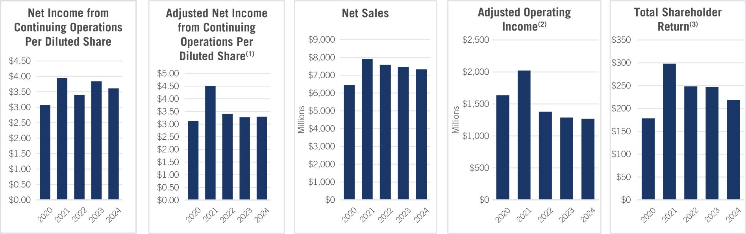

(1) | Adjusted net income from continuing operations per diluted share is a non-GAAP financial measure that reflects the Company’s net income from continuing operations per diluted share excluding certain items. Attached as Appendix A are reconciliations of the Company’s fiscal 2024, 2023, 2021 and 2020 adjusted net income from continuing operations per diluted share to the Company’s fiscal 2024, 2023, 2021 and 2020 GAAP net income from continuing operations per diluted share, as well as other important disclosures regarding non-GAAP financial measures. For fiscal 2022, we did not make any adjustments to net income from continuing operations per diluted share; therefore, for fiscal 2022, adjusted net income from continuing operations per diluted share is equal to our fiscal 2022 GAAP net income from continuing operations per diluted share.

(2) | Adjusted operating income is a non-GAAP financial measure. Attached as Appendix A are reconciliations of the company’s fiscal 2021 and 2020 adjusted operating income to the Company’s fiscal 2021 and 2020 GAAP operating income, as well as other important disclosures regarding non-GAAP financial measures. For fiscal 2024, 2023 and 2022, adjusted operating income is equal to our GAAP operating income.

(3) | The Total Shareholder Return chart represents $100 invested in Company stock at the closing price on January 31, 2020, including reinvestment of dividends. Stock prices prior to August 3, 2021, have been adjusted to give effect to the Victoria’s Secret & Co. spin-off.
During 2024 we were focused on our three key strategic priorities of (1) accelerating top-line growth, (2) enhancing operational excellence and efficiency, and (3) strengthening our financial positioning and disciplined deployment of capital. During the year, we built momentum and established a strong foundation for long-term growth by successfully executing a number of key strategic initiatives, highlighted below:

• Launched collaborations with leading brands in pop culture, which allow us to deliver highly differentiated storytelling that generates brand awareness with existing and new customers and enhances our cultural relevancy;

• Introduced new product innovations such as Everyday Luxuries, our prestige-inspired line of fine fragrance mists, to attract new customers;

• Grew our active loyalty membership to approximately 39 million members as of February 1, 2025, deepening brand connectivity with our customers;

• Expanded our customer reach by growing category adjacencies such as Men’s, Hair, Lip and Laundry; and

• Delivered approximately $155 million of cost reductions as part of our cost optimization work, bringing our two-year total over $300 million, exceeding our initial targets of $200 million.

Fiscal 2024 Compensation Highlights
Our executive compensation program continues to place a significant emphasis on pay-for-performance and provides a meaningful and direct link between the interests of our NEOs and those of our shareholders. We align pay with performance by providing our NEOs with predominantly performance-based compensation, delivered in the form of short-term cash incentives based on key seasonal performance metrics and long-term equity incentives subject to rigorous performance metrics that align with our strategic direction, provide balance between growth and profitability, and are designed to drive shareholder value creation.

2025 Proxy Statement | Bath & Body Works, Inc. 33

Table of Contents

The compensation paid to our NEOs for fiscal 2024 as described in detail in this CD&A is directly reflective of the Company’s business and operational performance achievements in fiscal 2024. This relationship between pay and performance exemplifies the HCC Committee’s commitment to providing compensation for performance that drives our strategic business goals and shareholder value creation.
The following summarizes certain key highlights from our fiscal 2024 executive compensation program:

 | • |  | Our short-term cash incentive program payout continued to align with our financial and strategic performance. To more appropriately balance top and bottom line focus, the HCC Committee revised our short-term cash incentive program for fiscal 2024 to include a new absolute net sales metric (weighted 25%), with absolute adjusted operating income (weighted 75%) continuing to serve as the primary performance metric. The short-term cash incentive program for the Spring season paid out above target for our NEOs, with absolute net sales performing below target and operating income performing above target. The short-term cash incentive program for the Fall season paid out below target for our NEOs, with both absolute net sales and operating income performing below target. Overall, short-term cash incentive payout for the year was slightly below target for the NEOs. Sales were impacted significantly by a choppier macro environment than anticipated affecting our business and customership, and by international markets being affected by war in the Middle East. These payouts for 2024 reflect the direct linkage between our NEOs’ incentive pay and company performance. See “—Compensation for NEOs—Compensation Components—Short-term Performance-based Incentive Compensation” beginning on page 39 of this proxy statement for more details.

 | • |  | A significant portion of the long-term equity incentives granted to our NEOs in fiscal 2024 were granted subject to challenging performance metrics. We redesigned our performance stock unit (“PSU”) program in 2023 following discussions with our shareholders to more closely align award payouts with shareholder returns. PSUs are subject to two performance metrics: (i) relative total shareholder return (“TSR”) (50%) and (ii) operating income margin (50%), each of which is measured over a cumulative three-year performance period. In addition, all PSUs are subject to a “negative absolute TSR cap,” whereby the payout is limited to the target performance level when our absolute TSR is negative over the performance period. The HCC Committee also increased the proportion of our Chief Executive Officer’s long-term equity incentive compensation that is subject to performance-based conditions to 60%, thereby enhancing the weighting of performance-based compensation for our Chief Executive Officer. We believe these rigorous performance metrics provide a balance of growth and profitability, support the strategic direction of the Company and ensure alignment with the interests of our shareholders.
Shareholder Engagement
The Board values the input of shareholders on all matters, including our executive compensation programs. We annually provide shareholders with the opportunity to cast an advisory vote on the compensation of the Company’s NEOs. The HCC Committee considers the feedback we receive during shareholder engagements, as well as the results of the say-on-pay votes, when reviewing and implementing our executive compensation program. At the 2024 annual meeting of shareholders, 96.05% of the votes cast supported the say-on-pay proposal.
Since the beginning of the calendar year, we have held meetings addressing compensation, in addition to strategy, Board structure and experience, corporate governance and environmental and social concerns with the Company’s top shareholders, representing approximately 37% of our outstanding shares as of 2024 year end. We started this outreach in the Fall of 2024, extending invitations to shareholders representing approximately 66% of our outstanding shares as of 2024 year end. We continued to maintain an active dialogue and incorporate their feedback into our ongoing reviews of pay programs for our executives. During fiscal 2024, shareholders were pleased with the actions we took in fiscal year 2023 in response to shareholder feedback.

34 Bath & Body Works, Inc. | 2025 Proxy Statement

Table of Contents

Executive Compensation Philosophy
Guiding Principles
The HCC Committee oversees an executive compensation program based on the following clear and purposeful guiding principles:

COMPENSATION  COMPONENT |  | OUR PRINCIPLES
Pay Level |  | • Attract and retain superior leaders in a highly competitive market for talent.  • Pay competitively and equitably.  • Recognize depth and scope of accountability and complexity of responsibility.
Pay Mix |  | • Emphasize performance-contingent, long-term equity-based incentive compensation over fixed compensation.
Pay-for-Performance |  | • Recognize and reward enterprise and individual performance.  • Utilize performance metrics that closely align executives’ interests with shareholders’ interests.  • Require NEOs to own a significant amount of the Company’s common stock.  • For fiscal 2024, set Spring and Fall season goals that reflect the seasonal nature of our business and incent goal achievement in each season.  • Create long-term shareholder value through regular achievement of short- and long-term financial strategic goals.  • Retain and incent high-performers with a pay mix delivered predominantly through long-term equity incentive awards.

2025 Proxy Statement | Bath & Body Works, Inc. 35

Table of Contents

Executive Compensation Best Practices
Our executive compensation practices incorporate the following corporate governance best practices that promote the interests of our shareholders and are consistent with high standards of risk management.

What We Do:

✓ We align our NEOs’ pay with company and individual performance and grant incentive awards based on actual results and achievements.

✓ We maintain robust clawback policies as described under the heading “—Compensation Governance—Recovery of Compensation” on page 47 of this proxy statement.

✓ The HCC Committee engages a compensation consultant that is independent of the Company and management to advise on compensation-related matters.

✓ We maintain robust stock ownership guidelines for our NEOs and directors.

✓ Our equity incentive plan requires a minimum vesting period of at least one year for all awards, subject to certain exceptions.

✓ We use appropriate peer group comparisons when determining compensation.

✓ We mitigate undue business risk in compensation programs and, in consultation with the HCC Committee’s independent compensation consultant, perform an annual compensation risk assessment.

What We Don’t Do:

× No tax gross-ups for NEOs to cover excise taxes under Section 4999 of the Internal Revenue Code (the “Code”).

× Hedging and short-selling of Company securities is prohibited under our insider trading policy.

× No pledging of Company stock without advance approval by our Chief Legal Officer. None of the Company’s stock held by our NEOs or Board members is pledged.

× No re-pricing of stock options without shareholder approval.

× No single-trigger vesting of NEO equity awards upon a change in control.

× No payments of dividends on unearned awards.

× No excessive perquisites provided to our directors and executive officers.

36 Bath & Body Works, Inc. | 2025 Proxy Statement

Table of Contents

Connecting Pay and Performance
There are two key elements of our executive compensation program design that connect pay to performance. First, our incentive goals are designed to challenge our NEOs to achieve a high level of performance to earn incentives at target levels. When the Company’s performance meets and exceeds, or falls short of, these goals, our NEOs’ compensation is calibrated accordingly. Second, to further connect executive pay to performance and shareholder interests, we employ a pay mix philosophy that places greater emphasis on performance-based incentive compensation over non-performance-based base salary and RSUs.
The following charts illustrate the pay mix philosophy of our executive compensation program, showing a higher percentage of performance-based incentive compensation.

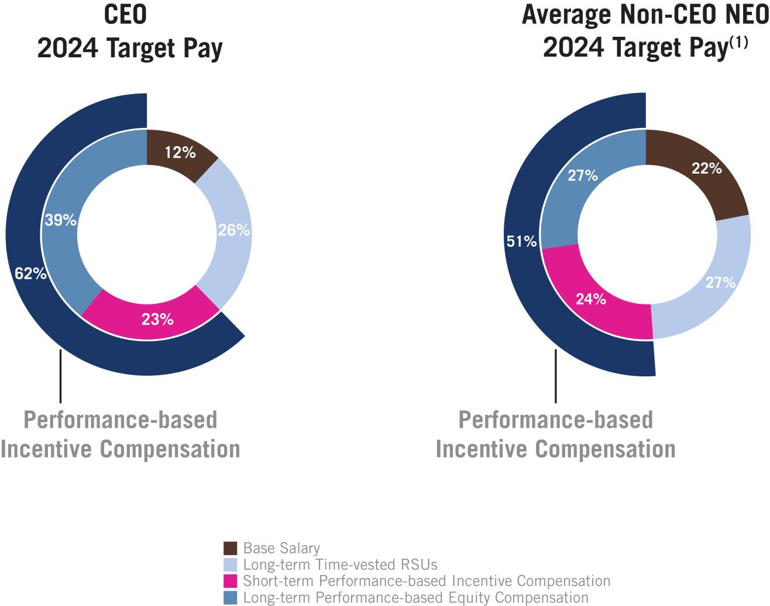 |  | 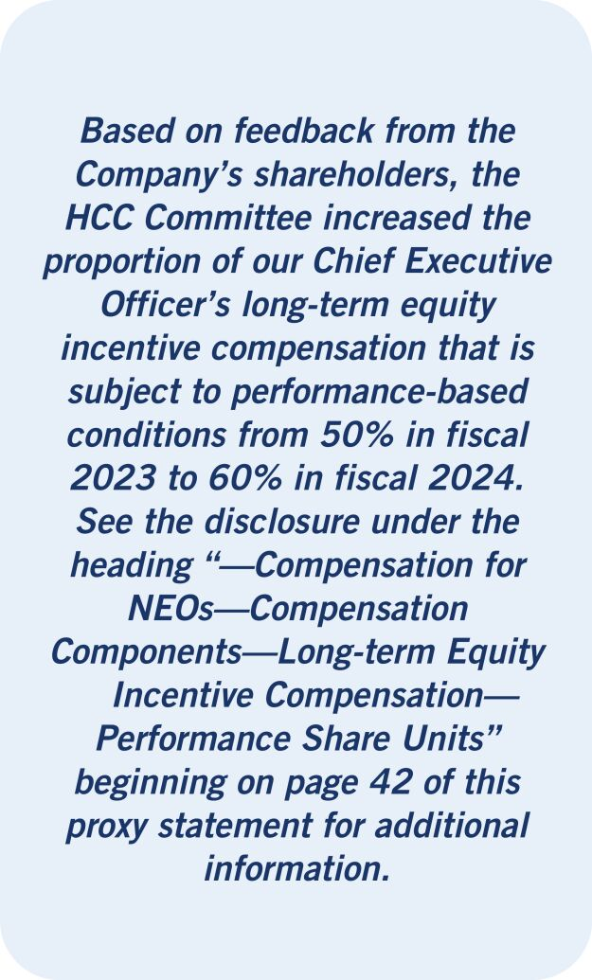

(1) | The Average Non-CEO NEO Target Pay excludes compensation for Ms. Rosen whose employment with the Company ceased effective on October 22, 2024, due to her partial year of employment.
Compensation Comparison
We review our NEO compensation against publicly available data on executive compensation, including compensation paid by a group of peer companies. We use this data to evaluate the competitiveness of our compensation levels, establish an appropriate mix of our NEO compensation elements and ensure our compensation programs properly attract, retain and incentivize highly talented executives who are critical to executing our strategy and business plan.
The HCC Committee annually reviews and approves our peer group used for compensation comparisons (the “Compensation Peer Group”) in consultation with the HCC Committee’s independent compensation consultant, and with consideration for companies considered to be peers by certain proxy advisory firms, to generally include a balanced mix of the following criteria:

 | • |  | Businesses that are similar in size and scope (using criteria such as total revenue, market capitalization, global footprint, business and/or merchandise focus);
 | • |  | Companies that compete with us for executive talent; and
 | • |  | Companies with similar talent and business model characteristics.
We do not specifically set our NEOs’ compensation against our Compensation Peer Group. Instead, we consider peer group comparisons provided by the HCC Committee’s independent compensation consultant as one of several factors the HCC Committee uses, along with its business judgment and experience, in setting the pay of our NEOs.

2025 Proxy Statement | Bath & Body Works, Inc. 37

Table of Contents

The HCC Committee reviewed the Company’s 2024 Compensation Peer Group and determined that no change would be made to that group for 2025. The HCC Committee believes the 2025 Compensation Peer Group closely aligns with our business model and merchandise focus and reflects companies that are similar in size and scope, and that compete with us for executive talent.

2024 COMPENSATION PEER GROUP
Abercrombie & Fitch Co. [AND] |  | Sally Beauty Holdings, Inc. [SBH]
American Eagle Outfitters, Inc. [AEO] |  | Signet Jewelers Limited [SIG]
Coty Inc. [COTY] |  | Tapestry, Inc. [TPR]
DICK’s Sporting Goods, Inc. [DKS] |  | The Estée Lauder Companies Inc. [EL]
Gap Inc. [GPS] |  | Tractor Supply Company [TSCO]
lululemon athletica inc. [LULU] |  | Ulta Beauty, Inc. [ULTA]
Newell Brands Inc. [NWL] |  | Victoria’s Secret & Co. [VSCO]
PVH Corp. [PVH] |  | Williams-Sonoma, Inc. [WSM]
Ralph Lauren Corporation [RL]
Compensation for NEOs
Compensation Setting Process
The HCC Committee makes all decisions regarding Chief Executive Officer compensation with advisory input from its independent compensation consultant. Our Chief Executive Officer recommends, and the HCC Committee approves, compensation for the other NEOs, including all grants of stock awards. In making compensation decisions for our NEOs, the HCC Committee takes into consideration input, recommendations and market-based analyses provided by management and the HCC Committee’s independent compensation consultant. Target compensation for the NEOs is reviewed annually after the fiscal year closes and is designed to reward historical performance, incent future performance and be competitive with the external market for talent.
Compensation Components
The three principal elements of our executive compensation program are base salary, short-term performance-based cash incentive compensation and long-term equity incentive compensation. Each NEO’s base salary is set considering multiple factors described below. For fiscal 2024, all of our NEOs participated in the same short-term performance-based incentive compensation program and long-term equity incentive compensation program. The Company also provides our NEOs with health and welfare benefits, retirement benefits and a limited set of perquisites, in line with market practice and generally focused on managing risk to the enterprise. Additional information about each of these compensation components is provided below.
Base Salary
The following factors are considered in determining any base salary adjustments for our NEOs:

 | • |  | Scope and responsibility of the NEO’s position;
 | • |  | Achievement of seasonal and annual business goals;
 | • |  | Level of overall compensation paid by competitors for comparable positions;
 | • |  | Recruitment, retention and development of leadership talent; and
 | • |  | Appropriate balancing of the NEO’s base salary against their incentive compensation to ensure there is a higher mix of performance-based compensation as a percentage of their total pay mix.

38 Bath & Body Works, Inc. | 2025 Proxy Statement

Table of Contents

Our NEOs’ base salaries for fiscal 2024 are set forth in the following table. Our NEOs’ base salaries have not been increased since 2022 and, for fiscal 2024, the HCC Committee determined to again hold base salaries flat. This decision, when coupled with increases in NEO target long-term equity incentive compensation as described under the heading “—Long-term Equity Incentive Compensation” on page 42 of this proxy statement, further enhances the weighting of our NEOs’ long-term equity incentive compensation as a percentage of their total pay mix.

NAMED EXECUTIVE OFFICER(1) |  | FISCAL  2024 BASE  SALARY  ($) |  |  |  |  | YEAR  OVER  YEAR %  CHANGE
Ms. Boswell |  |  |  | 1,500,000 |  |  |  |  | 0 | %
Ms. Boratto |  |  |  | 850,000 |  |  |  |  | 0 | %
Mr. Wu |  |  |  | 725,000 |  |  |  |  | 0 | %
Mr. Mazurek |  |  |  | 700,000 |  |  |  |  | 0 | %
Ms. Riley |  |  |  | 800,000 |  |  |  |  | 0 | %

(1) | In fiscal 2024, Ms. Rosen’s annual base salary was $1,000,000, which was also unchanged from fiscal 2023.
Short-term Performance-based Incentive Compensation
Short-term performance-based incentive compensation, if earned, is paid in cash pursuant to the Company’s Cash Incentive Compensation Performance Plan (the “Cash Incentive Plan”). In fiscal 2024, the Cash Incentive Plan focused on achievement of six-month goals, reflecting our two selling seasons, with the Fall season weighted more heavily because of the importance of the holiday season to our profitability. The use of two six-month performance periods in our plan design reflects our belief that achievement of our short-term goals season after season creates long-term value for our shareholders.

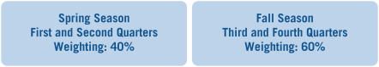
The HCC Committee revised our short-term cash incentive program for fiscal 2024 to include a new absolute net sales metric (weighted 25%), with absolute adjusted operating income (weighted 75%) continuing to serve as the primary performance metric. The HCC Committee incorporated the new absolute net sales metric for the fiscal 2024 short-term cash incentive program based on the importance of returning to net sales growth as part of the Company’s strategic initiatives, the desire to balance top- and bottom-line performance in the program, the prevalence of the metric in peer companies’ short-term cash incentive programs and the ability of our associates to directly impact performance against the metric.
The HCC Committee carefully considered the Spring and Fall season goals to ensure that our executives were properly incentivized in fiscal 2024, while at the same time incorporating a level of rigor that maintained a strong link between pay and performance. The HCC Committee believes incentive goals for both seasons were set at challenging and meaningful levels.

2025 Proxy Statement | Bath & Body Works, Inc. 39

Table of Contents

The charts below show the Spring and Fall season adjusted operating income and net sales goals required to earn short-term performance-based incentive compensation at target, along with the range of performance goals as a percentage of target for threshold and maximum payouts, and actual performance results achieved in fiscal 2024:

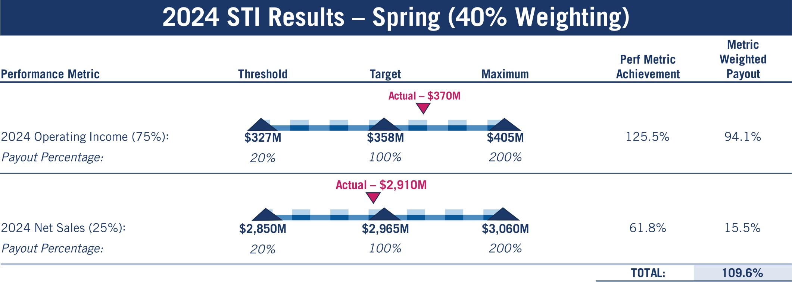

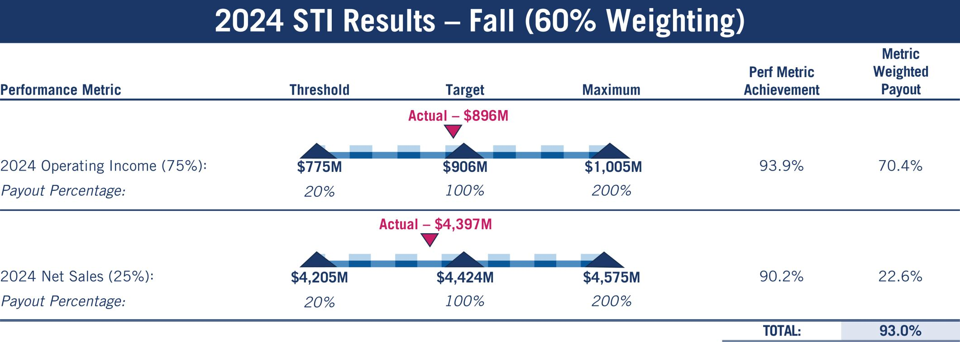
Performance between threshold and target and target and maximum is interpolated to determine the payout percentage beginning at 20% for threshold performance (if achieved) up to 200% at maximum performance. Short-term performance-based incentive compensation targets are set as a percentage of base salary with the amount earned ranging from 0% to 200% of the weighted target incentive, based on the extent to which financial goals are achieved.
The table below shows the short-term performance-based incentive compensation targets as a percentage of base salary for each NEO during fiscal 2024. None of our NEOs received an increase in their target annual incentive compensation opportunities for fiscal 2024 from fiscal 2023. The HCC Committee determined not to increase the short-term performance-based incentive compensation targets for NEOs to enhance the weighting of our NEO’s long-term equity incentive compensation as a percentage of their total pay mix. See the disclosure under the heading “—Long-term Equity Incentive Compensation” on page 42 of this proxy statement for additional information.

40 Bath & Body Works, Inc. | 2025 Proxy Statement

Table of Contents

NAMED EXECUTIVE OFFICER(1) |  | FISCAL  2024 TARGET  ANNUAL  INCENTIVE  OPPORTUNITY
Ms. Boswell |  |  |  | 190 | %
Ms. Boratto |  |  |  | 120 | %
Mr. Wu |  |  |  | 100 | %
Mr. Mazurek |  |  |  | 100 | %
Ms. Riley |  |  |  | 100 | %

(1) | In fiscal 2024, Ms. Rosen’s target annual incentive compensation opportunity was 160%, which was also unchanged from fiscal 2023.
The NEOs’ payouts for fiscal 2024 performance are set forth below and in the “Non-Equity Incentive Plan Compensation” column of the 2024 Summary Compensation Table on page 49 of this proxy statement.

NAMED EXECUTIVE OFFICER(1) |  | FISCAL 2024  TARGET  INCENTIVE  ($) |  |  |  |  | FISCAL 2024  SPRING  INCENTIVE  PAYOUT  ($) |  |  |  |  | FISCAL 2024  FALL INCENTIVE  PAYOUT  ($) |  |  |  |  | FISCAL 2024  TOTAL  PAYOUT  ($) |  |  |  |  | PERCENT OF  FISCAL 2024  TARGET  (%)
Ms. Boswell |  |  |  | 2,850,000 |  |  |  |  | 1,249,440 |  |  |  |  | 1,590,300 |  |  |  |  | 2,839,740 |  |  |  |  | 99.6 | %
Ms. Boratto |  |  |  | 1,020,000 |  |  |  |  | 447,168 |  |  |  |  | 569,160 |  |  |  |  | 1,016,328 |  |  |  |  | 99.6 | %
Mr. Wu |  |  |  | 725,000 |  |  |  |  | 317,840 |  |  |  |  | 404,550 |  |  |  |  | 722,390 |  |  |  |  | 99.6 | %
Mr. Mazurek |  |  |  | 700,000 |  |  |  |  | 306,880 |  |  |  |  | 390,600 |  |  |  |  | 697,480 |  |  |  |  | 99.6 | %
Ms. Riley |  |  |  | 800,000 |  |  |  |  | 350,720 |  |  |  |  | 446,400 |  |  |  |  | 797,120 |  |  |  |  | 99.6 | %

(1) | Ms. Rosen’s employment with the Company ceased on October 22, 2024. She received $701,440 for the fiscal 2024 Spring season incentive payout and received $392,440 for the fiscal 2024 Fall season incentive payout reflecting a pro-rated amount for the season she was terminated pursuant to the terms of her existing agreement with the Company.
Additional Incentive Compensation
To induce Ms. Boratto to join the Company, and consistent with market practice for senior executives and recognizing the competitive market for talent at the time of her hire, she received a one-time cash sign-on bonus in the aggregate amount of $1 million, 50% of which was paid to her during the third quarter of 2023, and the remaining amount was paid to her during the third quarter of 2024 which is subject to repayment to the Company upon certain terminations of employment prior to the second anniversary of her start date. These amounts were paid to Ms. Boratto as replacements for guaranteed compensation she was otherwise forfeiting at her prior employer.

2025 Proxy Statement | Bath & Body Works, Inc. 41

Table of Contents

Long-term Equity Incentive Compensation
During fiscal 2024, we granted stock awards to our NEOs under the 2020 Plan, which was approved by our shareholders at our 2020 annual meeting.

Our Fiscal 2024 Long-term Equity Incentive Compensation Design

2024 Long-term Equity  Incentive Mix for the Chief Executive Officer  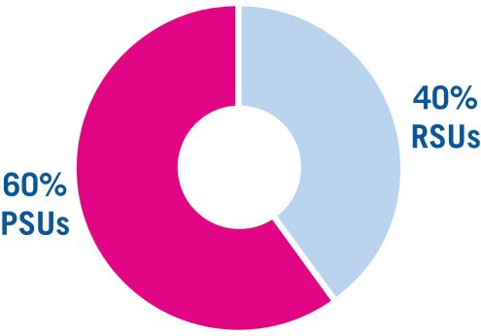  Performance Share Units  • 3-year performance period  • Weighted 50% operating income margin; 50% relative TSR  • Includes “negative absolute TSR cap” |  | 2024 Long-term Equity  Incentive Mix for NEOs other than the Chief Executive Officer  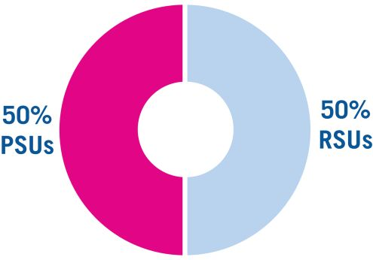  Restricted Share Units  • 3-year vesting period  • Vest 30% one year from the grant date; 30% two years from the grant date; and 40% three years from the grant date

Beginning in fiscal year 2024, the proportion of our Chief Executive Officer’s long-term equity incentive compensation that is subject to performance-based conditions was increased to 60%, thereby enhancing the alignment of our Chief Executive Officer’s long-term incentives with the company’s performance.

Performance Share Units
PSUs incent executive performance through the achievement of challenging growth and profitability metrics that closely align the long-term interests of our executives with those of our shareholders. As a result, we place a significant emphasis on the PSU component of our long-term equity incentive program for our NEOs. For fiscal 2024, 50% of our NEOs’ long-term equity incentives (60% for our Chief Executive Officer) were granted in the form of “at-risk” PSUs.
Our NEOs’ annual 2024 PSU awards are subject to two equally weighted performance metrics:

 | • |  | Cumulative operating income as a percentage of cumulative net sales (operating income margin); and
 | • |  | Relative TSR assessed against the companies listed in the S&P 500 Consumer Discretionary Distribution & Retail Index as of the date of grant.
The HCC Committee selected this peer group for purposes of the relative TSR metric because the index is relevant from an industry perspective (i.e., reasonable business, talent and/or investment dollar competitors) and is more easily tracked and communicated to Company associates and investors. In addition, the HCC Committee also added a “negative absolute TSR cap”—i.e., if our absolute total shareholder return is negative during the performance period, the payout under the PSU awards is capped at 100% of target performance.
The HCC Committee is committed to establishing robust performance metrics that challenge our executives to deliver superior performance aligned to creating value for our shareholders, while at the same time balancing the rigor of the performance metrics with ensuring that the metrics are reasonably attainable to meaningfully incent executive performance and retention.
Finally, consistent with market practice to ensure our annual PSU program is competitive with our peer companies’ programs and to balance the leverage of the program with the weighting it is expected to command within the NEOs’ pay mix, the maximum payout for the 2024 annual PSU program awards was 200%.
The HCC Committee believes the PSU program aligns our NEOs’ interests with those of our shareholders. Specifically, the HCC Committee believes that operating income margin continues to provide a direct link between our NEOs’ compensation and the importance of growing and maintaining our operating income margin as part of the Company’s strategic initiatives. The relative TSR metric for fiscal 2024 is intended to promote alignment between long-term shareholder value creation and our NEOs’ pay outcomes. Its inclusion is also consistent with input we received from our shareholders as well as market practice.

42 Bath & Body Works, Inc. | 2025 Proxy Statement

Table of Contents

Performance for awards granted in fiscal 2024 will be evaluated based on performance over a three-year performance period, starting with fiscal 2024 through the end of fiscal 2026.
The specific targets are as set forth in the chart below:

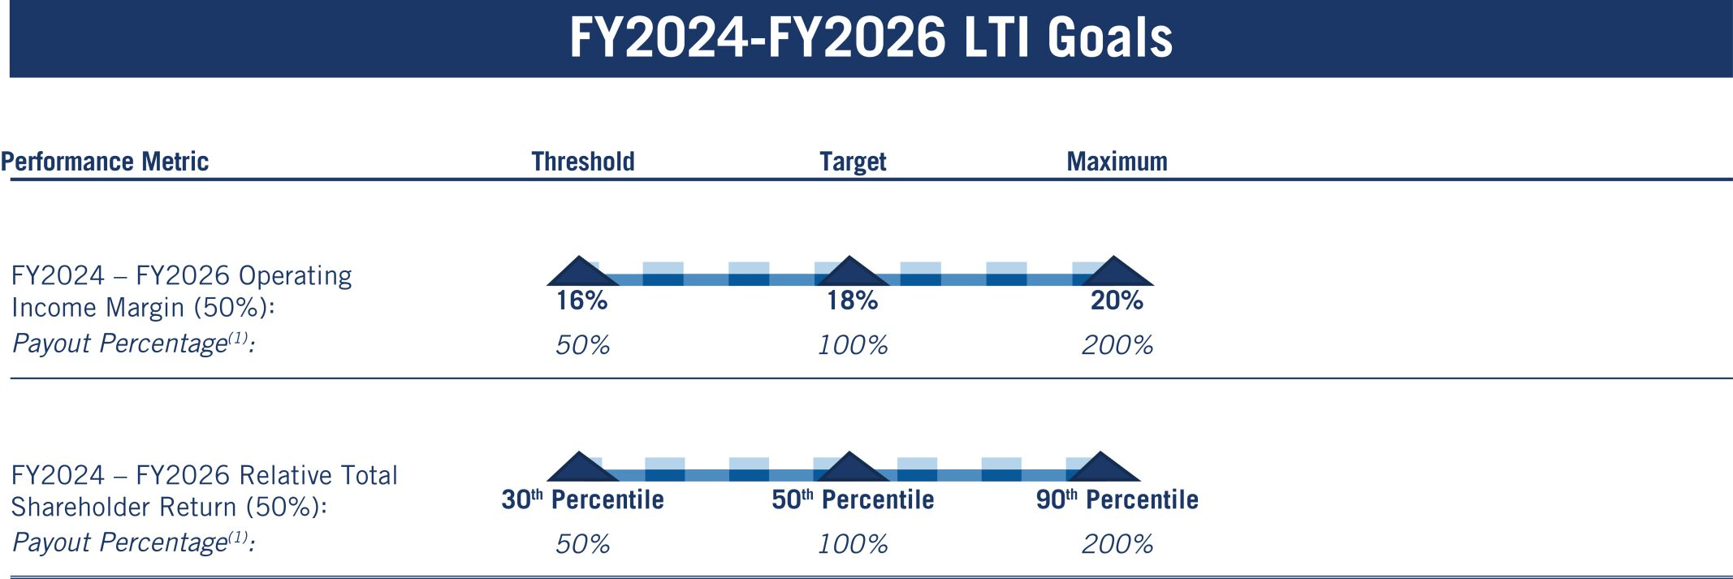

(1) | The Payout Percentage is subject to the “negative absolute TSR cap”—i.e., if our absolute total shareholder return is negative during the performance period, the payout under the PSU awards is capped at 100% of target performance.
Performance will be evaluated based on a scale, and payout, if any, will be interpolated between threshold, target and maximum levels. The earned annual PSU awards (if any) granted in fiscal 2024 will vest in March 2027, subject generally to the executive’s continued employment through such date.
Restricted Share Units
RSUs are granted to ensure market competitiveness of the executive compensation package, align executives’ long-term interests with our shareholders and retain executives over the long-term. The RSU awards vest over three years in three tranches (30% one year from the grant date, 30% two years from the grant date and 40% three years from the grant date), in each case subject generally to continued employment through each such date.
Below is a summary of the grant date fair value of the long-term equity incentive compensation, including PSUs and RSUs, awarded to our NEOs during fiscal 2024 as reported in the summary compensation table found on page 49 of this proxy statement.

NAMED EXECUTIVE OFFICER(1) |  | VALUE OF  TIME-VESTED  RSU AWARD  ($) |  |  |  |  | TARGET VALUE  OF ANNUAL  PSU AWARD  ($) |  |  |  |  | TOTAL EQUITY  VALUE OF  AWARD(S)  ($)
Ms. Boswell |  |  |  | 3,069,987 |  |  |  |  | 5,056,177 |  |  |  |  | 8,126,164
Ms. Boratto |  |  |  | 1,327,506 |  |  |  |  | 1,457,431 |  |  |  |  | 2,784,937
Mr. Wu |  |  |  | 741,946 |  |  |  |  | 814,547 |  |  |  |  | 1,556,493
Mr. Mazurek |  |  |  | 716,374 |  |  |  |  | 786,469 |  |  |  |  | 1,502,843
Ms. Riley |  |  |  | 818,663 |  |  |  |  | 898,877 |  |  |  |  | 1,717,540

(1) | In fiscal 2024, Ms. Rosen’s Value of Time-Vested RSU’s was $1,023,329 and Target Value of Annual PSU was $1,123,596; with a total annual grant of $2,146,925.

2025 Proxy Statement | Bath & Body Works, Inc. 43

Table of Contents

Payout of 2021 Annual Award PSUs
The annual PSUs that were granted in March 2021 to our named executive officers at that time (which included Mses. Rosen and Riley) vested in 2024. Performance was evaluated based on a scale, and payout was interpolated between threshold, target and maximum levels as set forth below.

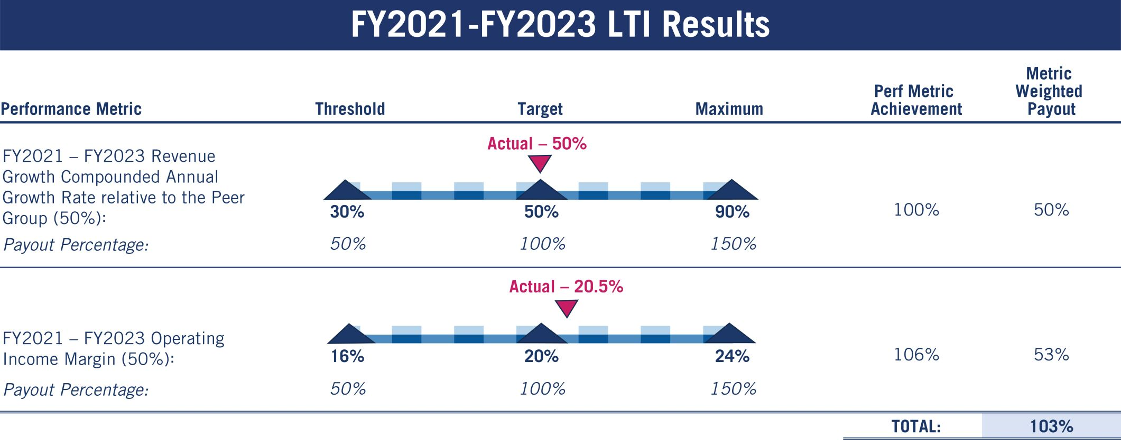

 |  | TARGET FY21  PSU AWARDED  (#) |  |  |  |  | ACTUAL FY21  PSU EARNED  (#)
Ms. Rosen |  |  |  | 10,279 |  |  |  |  | 10,587
Ms. Riley |  |  |  | 8,738 |  |  |  |  | 9,000
Payout of 2022 Retention PSUs
The retention PSUs that were granted to Messrs. Wu and Mazurek and Mses. Rosen and Riley in May of 2022 to ensure our leadership remained focused on performance and facilitated a seamless CEO transition period vested in 2024. Performance was evaluated based on a scale, and payout was interpolated between threshold, target and maximum levels as set forth below. There are currently no other outstanding retention awards or programs, and the Company does not anticipate making any such awards at this time.

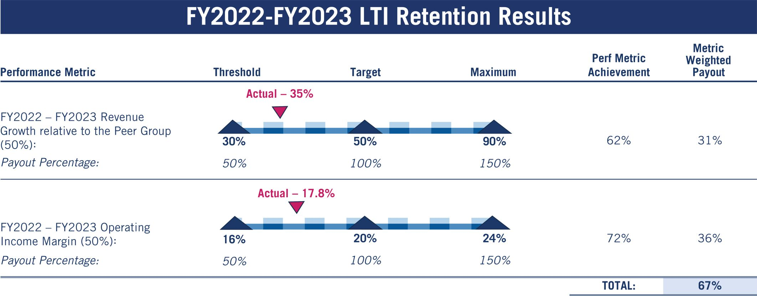

44 Bath & Body Works, Inc. | 2025 Proxy Statement

Table of Contents

 |  | TARGET  RETENTION  PSU AWARDED  (#) |  |  |  |  | ACTUAL  RETENTION  PSU EARNED  (#)
Mr. Wu |  |  |  | 22,765 |  |  |  |  | 15,253
Mr. Mazurek |  |  |  | 18,055 |  |  |  |  | 12,097
Ms. Rosen |  |  |  | 41,867 |  |  |  |  | 28,051
Ms. Riley |  |  |  | 25,120 |  |  |  |  | 16,830
Other Benefits and Perquisites
Qualified Defined Contribution Retirement Plan
Our qualified defined contribution retirement plan (our “401K plan”) is available to all Company associates who meet certain age and service requirements. Associates can contribute up to the amounts allowable under Section 401 of the Code. The Company matches associates’ contributions according to a predetermined formula and, through fiscal 2023, contributed additional amounts based on a percentage of the associates’ eligible annual compensation and years of service (the “Retirement Contributions”). Associates’ contributions and Company matching contributions to the qualified plan vest immediately. Effective in fiscal 2024, the Company’s associates, including our NEOs, no longer receive Retirement Contributions under our 401K plan.
Perquisites
We provide our NEOs with certain perquisites that the HCC Committee has determined are reasonable and in the best interests of the Company and its shareholders. These perquisites include life insurance coverage, an annual executive physical, cybersecurity coverage, and a financial planning reimbursement.
We also provide relocation benefits, as applicable, pursuant to the Company’s policy applicable to senior executives or as may otherwise be set forth in an applicable employment agreement. As a condition of Ms. Boratto’s employment, she is required to perform a significant portion of her duties from the Company’s Columbus, Ohio headquarters and to relocate to the Columbus, Ohio region no later than June 30, 2025. To induce Ms. Boratto to join the Company and based on temporary family obligations she continues to have in her current home region, the HCC Committee approved a temporary travel and lodging stipend to Ms. Boratto in the amount of $130,000 per year (pro-rated for any partial periods and taxable to Ms. Boratto) to offset a portion of her expenses, with eligibility that commenced on July 31, 2023 and ends on the date of her permanent relocation to Columbus, Ohio, but no later than June 30, 2025. The cost to the Company of the travel and lodging stipend for fiscal 2024 is included in the “All Other Compensation” column of the 2024 Summary Compensation Table on page 49 of this proxy statement.
Until fiscal 2024, we maintained corporate aircraft that was used primarily by our senior management for business travel. The Company began the sales process in February 2024, and the last corporate aircraft was sold on January 28, 2025. As of fiscal 2024, the Company contracts with a private jet service for senior management business travel. During fiscal 2024, the HCC Committee approved the use of corporate aircraft and the contracted private jet service for personal purposes by Ms. Boswell to ensure her safety and security and promote the efficient and effective use of her time while traveling. The use of corporate aircraft and the contracted private jet service also provides Ms. Boswell with an environment that permits her to perform confidential work while traveling for personal purposes, which would otherwise be impossible on commercial aircraft. In addition, Ms. Boswell’s spouse accompanied her on four flights, including use of the contracted private jet service, for which the Company incurred no incremental cost. None of our NEOs other than Ms. Boswell were permitted to use corporate aircraft and the contracted private jet service for personal purposes during fiscal 2024. We do not cover, reimburse or otherwise gross-up the income taxes owed for personal use of corporate aircraft or the contracted private jet service. The aggregate incremental cost to the Company of personal use of corporate aircraft and the contracted private jet service is disclosed in the “All Other Compensation” column of the 2024 Summary Compensation Table on page 49 of this proxy statement.
Severance and Change in Control Agreements
Under the severance agreements with our NEOs, upon a termination of the applicable executive’s employment by the Company without “cause” or by the executive for “good reason” (as defined in such executive’s severance agreement and described in more detail under the heading “—Potential Payments Upon Termination or Change in Control” below), in each case other than during the three-month period prior to, and the 24-month period following, a “change in control” of the Company, the applicable executive will be entitled to receive (i) continued payment of annual base salary for two years following the termination date, (ii) an

2025 Proxy Statement | Bath & Body Works, Inc. 45

Table of Contents

amount equal to two years of COBRA premiums (for Ms. Boswell, including her eligible dependents), (iii) the executive’s incentive compensation award for the season in which the termination date occurs, prorated based on the number of days employed during such season and determined based on actual performance, (iv) the incentive compensation the executive would have received if the executive had remained employed by the Company for two years following the termination date, determined based on actual performance, (v) accelerated vesting of a pro rata portion of the unvested equity awards held by the executive that vest solely upon the time-based vesting conditions and (vi) continued vesting of a pro rata portion of the unvested equity awards held by the executive that vest based on performance-based vesting conditions, which will remain subject to achievement of the existing performance metrics.
In the event such termination of employment occurs during the three-month period prior to, or during the 24-month period following, a “change in control” of the Company, then the executive will be entitled to receive (a) the amounts described in clauses (i) and (ii) above (for Ms. Boswell, the amounts pursuant to clause (i) are paid in a lump sum if the termination of her employment occurs on or following a change in control), (b) a payment equal to the sum of the incentive compensation payouts that the executive received for the four completed seasons prior to the termination date, (c) the executive’s incentive compensation award for the season in which the termination date occurs, prorated based on the number of days employed during such season and determined by reference to the average of the incentive compensation payouts the executive received for the four completed seasons prior to the termination date, and (d) accelerated vesting of any outstanding unvested equity awards held by the executive (with performance goals deemed to be achieved at target levels if less than one-third of the applicable performance period has lapsed, otherwise performance goals will be deemed to be achieved at maximum levels). For Ms. Boswell’s payouts pursuant to (b) and (c), the payout for any partial seasonal performance period will be annualized and the target seasonal incentive opportunity will be used for purposes of calculating such bonus amounts for any season during which she is not eligible for a payout because she has not been employed long enough to be eligible for four seasonal incentive payouts.
None of our NEOs is entitled to a tax gross-up for any excise taxes on compensation paid in connection with a change in control under their agreements with the Company.
For additional details regarding the severance and change in control arrangements with our NEOs (including a description of estimated benefits in connection with a change in control and/or a termination of employment), see “—Potential Payments Upon Termination or Change in Control” beginning on page 54 of this proxy statement.
Compensation Governance
Independent Compensation Consultant
As permitted by its charter, the HCC Committee retained Willis Towers Watson as its independent compensation consultant in fiscal 2024. For fiscal 2025, the HCC Committee has retained Meridian Compensation Partners, LLC (“Meridian”) as its independent compensation consultant.
The HCC Committee considers recommendations from our management team and determines the work to be performed by the consultant. The consultant works with management to gather data required in preparing analyses for HCC Committee review. Specifically, the services the consultant provides include:

 | • |  | Assisting in the evaluation of, and providing recommendations for, Chief Executive Officer and other NEO compensation;
 | • |  | Informing the HCC Committee of changing market practices;
 | • |  | Consulting on our executive compensation strategy and program design, including assessing compensation risk from design and practice perspectives;
 | • |  | Analyzing the competitiveness of our executive pay, including benchmarking base salaries, short-term incentive design, long-term incentive design and executive perquisites;
 | • |  | Reviewing and benchmarking the structure of our Board compensation;
 | • |  | Assisting in the selection of our peer groups; and
 | • |  | Assisting in the preparation and review of this disclosure.
In addition to the services provided at the request of the HCC Committee, management, with the knowledge of the HCC Committee, has engaged Willis Towers Watson to provide a call center tracking system for which the Company pays quarterly software usage fees (provided by a separate division of Willis Towers Watson). The HCC Committee did not participate in management’s decision to engage Willis Towers Watson for this service. For fiscal 2024, the fees for services provided by Willis Towers Watson to management were less than $120,000. The HCC Committee has determined that the provision of these limited services by Willis Towers Watson to management is not material and does not impair the independence and objectivity of advice provided to or otherwise raise any conflict of interest for the HCC Committee on executive compensation matters.

46 Bath & Body Works, Inc. | 2025 Proxy Statement

Table of Contents

The HCC Committee reviews and approves the provision of additional services by Willis Towers Watson to the Company and evaluates the performance and independence of Willis Towers Watson, specifically considering independence factors identified by NYSE rules. This evaluation includes a review of written representations from Willis Towers Watson confirming its independence. Based on the HCC Committee’s evaluation, it believes that there are no conflicts of interest that could impair Willis Towers Watson’s ability to provide independent, objective advice to the HCC Committee regarding executive compensation matters.
Compensation Risk Assessment
On an annual basis, the HCC Committee, in consultation with its independent compensation consultant, considers the risks to our business associated with our compensation policies and practices for the purpose of determining whether any risks arising from those policies and practices are reasonably likely to have a material adverse effect on the Company. The HCC Committee determined that the Company’s compensation structure includes mitigating factors such as a mix of pay that is balanced between long- and short-term, fixed and variable payouts under the 2020 Plan and the Cash Incentive Plan (and their respective predecessor plans), robust clawback policies and robust executive stock ownership guidelines. Based on these features, we believe our executive compensation program effectively (i) ensures that our compensation program does not encourage excessive risk taking, (ii) keeps our NEOs focused on the creation of long-term, sustainable value for our shareholders and (iii) provides competitive and appropriate levels of compensation over time.
Executive Stock Ownership Guidelines
The HCC Committee encourages and mandates Company common stock ownership by our NEOs through stock ownership guidelines that promote a long-term focus on stock performance, discourage inappropriate risk-taking and further align the interests of our NEOs with those of our shareholders. Stock ownership guidelines can be met through direct ownership of common stock and indirect ownership through both grants of stock-based awards under our stock incentive plans and common stock held through Company benefit plans. PSUs that remain subject to performance-based vesting requirements and unexercised stock options do not count toward ownership under our stock ownership guidelines.

ROBUST EXECUTIVE STOCK OWNERSHIP GUIDELINES
Chief Executive Officer |  | 6 Times Base Salary
Other NEOs |  | 3 Times Base Salary
Our NEOs are required to achieve and maintain these ownership levels within five years of becoming subject to the ownership guidelines. All of our NEOs are either in compliance with the guidelines or are on track to comply with the guidelines within the required time frame.
Tax Deductibility
Section 162(m) of the Code generally does not allow a tax deduction to public companies for compensation paid to certain executive officers that is more than $1 million during the tax year. The HCC Committee takes into consideration the tax implications of our executive compensation program, including with respect to the tax deductibility of compensation paid under Section 162(m) of the Code. In the exercise of its business judgment, and in accordance with its compensation philosophy, the HCC Committee continues to have flexibility to award compensation that is not tax deductible if it determines that such award is in our shareholders’ best interests and is necessary to comply with contractual commitments, or to maintain flexibility needed to attract talent, promote retention or recognize and reward desired performance.
Recovery of Compensation
Under the 2020 Plan (and its predecessor plan), the HCC Committee has the power and authority to recover previously awarded bonuses or equity-based compensation or profits if (i) required by applicable law with respect to a participant, (ii) a participant engaged in fraudulent conduct or activities (or had knowledge of such conduct or activities) relating to the Company or (iii) a participant should have had knowledge of such conduct or activities based on the participant’s position, duties or responsibilities.
The HCC Committee adopted a compensation recoupment policy in connection with the NYSE’s adoption of final listing standards implementing the Commission’s clawback rule mandated by Section 954 of the Dodd-Frank Act (which we refer to as the Financial Statement Compensation Recoupment Policy). The Financial Statement Compensation Recoupment Policy requires the HCC

2025 Proxy Statement | Bath & Body Works, Inc. 47

Table of Contents

Committee to seek a recovery (subject to specified exceptions) of certain “excess” performance-based incentive compensation paid to any current or former executive officer of the Company if the payment of that incentive compensation was calculated based on financial statements that were required to be restated due to material noncompliance with financial reporting requirements.
In addition, we also maintain a supplemental compensation recoupment policy pursuant to which the HCC Committee has the ability to cancel and/or recoup certain cash and equity incentive compensation (including any equity or equity-based awards that are subject to time- and/or performance-based conditions) and severance compensation paid to associates who are at the level of Vice President or above (including our NEOs) in the event of a termination of employment for cause, or the HCC Committee’s discovery that grounds for cause existed at the time of such associate’s termination of employment.
Tally Sheets
To assess the reasonableness of the compensation of our NEOs, the HCC Committee annually reviews all of the components of the NEOs’ compensation, including base salary, short-term cash incentive compensation, realized and unrealized gains on stock options, PSUs and RSUs, the cost to the Company of all perquisites and potential payouts under several severance and change of control scenarios. Based on this review, the HCC Committee concluded that our NEOs’ compensation components individually and in the aggregate are reasonable, encourage retention, incent performance and are in the best interests of the Company and its shareholders.
Equity Grant Practices
We have the following practices regarding equity compensation grants:

 | • |  | Annual equity incentive awards are granted by the HCC Committee and/or our Board generally in the first half of the fiscal year, at a meeting typically scheduled over a year in advance.
 | • |  | Occasionally, the HCC Committee and/or our Board may also grant equity awards outside of our annual grant cycle, including for new hires or other special circumstances. The timing of any equity grants to executive officers in connection with any such new hires or other  non-routine  grants is tied to the event giving rise to the award (such as an executive officer’s date of commencement of employment).
 | • |  | We do not strategically time long-term incentive awards in coordination with the release of material  non-public  information (“MNPI”) and have never had a practice of doing so. We do not time the release of MNPI for the purpose of affecting the value of executive compensation.
 | • |  | We do not currently grant stock options, stock appreciation rights or any similar awards with “option-like” features and therefore we have not adopted a policy regarding the timing of any such awards in connection with the disclosure of MNPI of the Company.

48
Bath & Body Works, Inc. |
2025 Proxy Statement

Table of Contents

2024 Summary Compensation Table
The following table sets forth information concerning total compensation earned by or paid to our NEOs during fiscal 2024, 2023 and 2022, as applicable.

NAME AND PRINCIPAL POSITION |  | YEAR |  |  |  |  | SALARY  ($) |  |  |  |  | BONUS  ($)(1) |  |  |  |  | STOCK  AWARDS  ($)(2) |  |  |  |  | OPTION  AWARDS  ($) |  |  |  |  | NON-EQUITY  INCENTIVE  PLAN  COMPENSATION  ($)(3) |  |  |  |  | CHANGE IN  PENSION  VALUE AND  NON-QUALIFIED  DEFERRED  COMPENSATION  EARNINGS  ($) |  |  |  |  | ALL OTHER  COMPENSATION  ($)(4) |  |  |  |  | TOTAL  ($)
Gina Boswell  Chief Executive Officer |  |  |  | 2024 |  |  |  |  | 1,500,000 |  |  |  |  | 0 |  |  |  |  | 8,126,164 |  |  |  |  | 0 |  |  |  |  | 2,839,740 |  |  |  |  | 0 |  |  |  |  | 104,389 |  |  |  |  | 12,570,293
Gina Boswell  Chief Executive Officer |  |  |  | 2023 |  |  |  |  | 1,500,000 |  |  |  |  | 0 |  |  |  |  | 7,333,900 |  |  |  |  | 0 |  |  |  |  | 2,547,900 |  |  |  |  | 0 |  |  |  |  | 312,713 |  |  |  |  | 11,694,513
 |  |  |  | 2022 |  |  |  |  | 213,462 |  |  |  |  | 1,500,000 |  |  |  |  | 3,853,024 |  |  |  |  | 0 |  |  |  |  | 1,080,964 |  |  |  |  | 0 |  |  |  |  | 261,541 |  |  |  |  | 6,908,991
Eva Boratto  Chief Financial Officer |  |  |  | 2024 |  |  |  |  | 850,000 |  |  |  |  | 500,000 |  |  |  |  | 2,784,937 |  |  |  |  | 0 |  |  |  |  | 1,016,328 |  |  |  |  | 0 |  |  |  |  | 150,971 |  |  |  |  | 5,302,236
Eva Boratto  Chief Financial Officer |  |  |  | 2023 |  |  |  |  | 408,654 |  |  |  |  | 500,000 |  |  |  |  | 1,913,900 |  |  |  |  | 0 |  |  |  |  | 911,880 |  |  |  |  | 0 |  |  |  |  | 81,238 |  |  |  |  | 3,815,672
Michael Wu  Chief Legal Officer and Corporate Secretary |  |  |  | 2024 |  |  |  |  | 725,000 |  |  |  |  | 0 |  |  |  |  | 1,556,493 |  |  |  |  | 0 |  |  |  |  | 722,390 |  |  |  |  | 0 |  |  |  |  | 33,113 |  |  |  |  | 3,036,996
Michael Wu  Chief Legal Officer and Corporate Secretary |  |  |  | 2023 |  |  |  |  | 725,000 |  |  |  |  | 326,250 |  |  |  |  | 1,417,874 |  |  |  |  | 0 |  |  |  |  | 648,150 |  |  |  |  | 0 |  |  |  |  | 34,559 |  |  |  |  | 3,151,833
Michael Wu  Chief Legal Officer and Corporate Secretary |  |  |  | 2022 |  |  |  |  | 715,385 |  |  |  |  | 761,250 |  |  |  |  | 2,180,189 |  |  |  |  | 0 |  |  |  |  | 848,250 |  |  |  |  | 0 |  |  |  |  | 645,765 |  |  |  |  | 5,150,839
Thomas Mazurek  Chief Supply Chain Officer |  |  |  | 2024 |  |  |  |  | 700,000 |  |  |  |  | 0 |  |  |  |  | 1,502,843 |  |  |  |  | 0 |  |  |  |  | 697,480 |  |  |  |  | 0 |  |  |  |  | 25,931 |  |  |  |  | 2,926,254
Julie Rosen  Former President, Retail |  |  |  | 2024 |  |  |  |  | 757,692 | (5) |  |  |  | 0 |  |  |  |  | 2,146,925 |  |  |  |  | 0 |  |  |  |  | 1,093,880 |  |  |  |  | 0 |  |  |  |  | 2,073,009 |  |  |  |  | 6,071,506
Julie Rosen  Former President, Retail |  |  |  | 2023 |  |  |  |  | 1,000,000 |  |  |  |  | 600,000 |  |  |  |  | 1,955,701 |  |  |  |  | 0 |  |  |  |  | 1,430,400 |  |  |  |  | 0 |  |  |  |  | 30,603 |  |  |  |  | 5,016,704
 |  |  |  | 2022 |  |  |  |  | 969,231 |  |  |  |  | 1,400,000 |  |  |  |  | 3,508,347 |  |  |  |  | 0 |  |  |  |  | 1,872,000 |  |  |  |  | 0 |  |  |  |  | 40,930 |  |  |  |  | 7,790,508
Deon Riley(6)  Former Chief Human Resources Officer |  |  |  | 2024 |  |  |  |  | 800,000 |  |  |  |  | 0 |  |  |  |  | 1,717,540 |  |  |  |  | 0 |  |  |  |  | 797,120 |  |  |  |  | 0 |  |  |  |  | 39,236 |  |  |  |  | 3,353,896
Deon Riley(6)  Former Chief Human Resources Officer |  |  |  | 2023 |  |  |  |  | 800,000 |  |  |  |  | 360,000 |  |  |  |  | 1,564,562 |  |  |  |  | 0 |  |  |  |  | 715,200 |  |  |  |  | 0 |  |  |  |  | 47,406 |  |  |  |  | 3,487,168
Deon Riley(6)  Former Chief Human Resources Officer |  |  |  | 2022 |  |  |  |  | 792,308 |  |  |  |  | 1,090,000 |  |  |  |  | 2,488,354 |  |  |  |  | 0 |  |  |  |  | 936,000 |  |  |  |  | 0 |  |  |  |  | 553,477 |  |  |  |  | 5,860,139

(1) | The bonus amount paid to Ms. Boratto represents the second installment of a one-time cash sign-on bonus in connection with her hire in 2023 as replacement for compensation awards she forfeited with her prior employer. The amount of Ms. Boratto’s cash sign-on bonus is subject to repayment to the Company upon certain terminations of employment prior to the first and second anniversaries of her start date. See discussion under the heading “—Compensation Discussion and Analysis—Compensation for NEOs—Compensation Components—Additional Incentive Compensation” for additional details.

(2) | Stock awards were granted to each NEO under the 2020 Plan. Awards are long-term compensation and generally vest over two to three years and are not realizable on an annual basis. See discussion under the heading “—Compensation Discussion and Analysis—Compensation for NEOs—Compensation Components—Long-term Equity Incentive Compensation” for additional details.

The value of stock awards reflects the aggregate grant date fair value computed in accordance with ASC Topic 718 Compensation—Stock Compensation for each award. The grant date fair values of the PSUs granted to the NEOs during fiscal 2023 were calculated based on the probable outcome of the performance conditions as of the grant date, consistent with the estimate of aggregate compensation cost to be recognized over the service period determined as of the grant date under ASC Subtopic718-10, excluding the effect of estimated forfeitures. The grant date value of the PSUs granted to the NEOs in fiscal 2024 assuming the maximum level of performance conditions will be achieved is $10,112,355 for Ms. Boswell, $2,914,863 for Ms. Boratto, $1,629,093 for Mr. Wu, $1,572,938 for Mr. Mazurek, $2,247,192 for Ms. Rosen, and $1,797,754 for Ms. Riley.

See Note 14 to the Company’s financial statements filed in the 2024 10-K for the related assumptions for stock awards granted during fiscal 2024 and for a discussion of our assumptions in determining the aggregate grant date fair value of these awards.

(3) | Represents the aggregate of the non-equity performance-based incentive compensation for the applicable Spring and Fall seasons. Incentive compensation targets are set based on a percentage of base salary and are paid seasonally based on the achievement of adjusted operating income results. See the discussion under the heading “—Compensation Discussion and Analysis—Compensation for NEOs—Short-term Performance-based Incentive Compensation” beginning on page 39 of this proxy statement for additional details. Ms. Rosen received the Fall 2024 incentive compensation payment pursuant to her existing separation agreement in connection with their termination of employment. For additional details regarding Ms. Rosen separation agreement, see “—Compensation Discussion and Analysis—Compensation for NEOs—Severance and Change in Control Agreements” beginning on page 45 of this proxy statement and “—Potential Payments Upon Termination or Change in Control— Ms. Rosen’s Separation Agreement” beginning on page 55 of this proxy statement.

2025 Proxy Statement | Bath & Body Works, Inc. 49

Table of Contents

(4) | The following table and related footnotes detail all other compensation paid to each NEO during fiscal 2024:

 |  | INCREMENTAL  COMPANY COST  TO PROVIDE  SUPPLEMENTAL  LIFE  INSURANCE  COVERAGE  ($) |  |  |  |  | COMPANY  CONTRIBUTIONS  TO THE  EXECUTIVES’  QUALIFIED  RETIREMENT  PLAN ACCOUNT  ($) |  |  |  |  | FINANCIAL  PLANNING  BENEFIT  ($) |  |  |  |  | IDENTITY  PROTECTION/  MONITORING  ($) |  |  |  |  | EXECUTIVE  PHYSICAL  ($) |  |  |  |  | PERSONAL USE  OF COMPANY  AIRCRAFT  ($)(a) |  |  |  |  | COMMUTING  EXPENSE  STIPEND  ($)(b) |  |  |  |  | SEVERANCE  PAY  ($)(c) |  |  |  |  | TOTAL  ($)
Ms. Boswell |  |  |  | 413 |  |  |  |  | 18,404 |  |  |  |  | 8,500 |  |  |  |  | 2,999 |  |  |  |  | 3,834 |  |  |  |  | 70,239 |  |  |  |  | 0 |  |  |  |  | 0 |  |  |  |  | 104,389
Ms. Boratto |  |  |  | 702 |  |  |  |  | 3,270 |  |  |  |  | 14,000 |  |  |  |  | 2,999 |  |  |  |  | 0 |  |  |  |  | 0 |  |  |  |  | 130,000 |  |  |  |  | 0 |  |  |  |  | 150,971
Mr. Wu |  |  |  | 599 |  |  |  |  | 17,808 |  |  |  |  | 7,730 |  |  |  |  | 2,999 |  |  |  |  | 3,977 |  |  |  |  | 0 |  |  |  |  | 0 |  |  |  |  | 0 |  |  |  |  | 33,113
Mr. Mazurek |  |  |  | 578 |  |  |  |  | 17,789 |  |  |  |  | 0 |  |  |  |  | 2,999 |  |  |  |  | 4,565 |  |  |  |  | 0 |  |  |  |  | 0 |  |  |  |  | 0 |  |  |  |  | 25,931
Ms. Rosen |  |  |  | 630 |  |  |  |  | 14,173 |  |  |  |  | 0 |  |  |  |  | 2,999 |  |  |  |  | 4,986 |  |  |  |  | 0 |  |  |  |  | 0 |  |  |  |  | 2,050,221 |  |  |  |  | 2,073,009
Ms. Riley |  |  |  | 661 |  |  |  |  | 17,865 |  |  |  |  | 14,000 |  |  |  |  | 2,999 |  |  |  |  | 3,711 |  |  |  |  | 0 |  |  |  |  | 0 |  |  |  |  | 0 |  |  |  |  | 39,236

 | (a) | Until fiscal 2024, we maintained corporate aircraft that was used primarily by our senior management for business travel. The Company began the sales process in February 2024, and the last corporate aircraft was sold on January 28, 2025. As of fiscal 2024 the Company contracts with a private jet service for senior management business travel. During fiscal 2024, the HCC Committee approved the use of corporate aircraft and the contracted private jet service for personal purposes by Ms. Boswell to ensure her safety and security and promote the efficient and effective use of her time while traveling. The use of corporate aircraft and the contracted private jet service also provides Ms. Boswell with an environment that permits her to perform confidential work while traveling for personal purposes, which would otherwise be impossible on commercial aircraft. In addition, Ms. Boswell’s spouse accompanied her on four flights, including use the contracted private jet service, for which the Company incurred no incremental cost. We do not cover, reimburse or otherwise gross-up the income taxes owed for personal use of corporate aircraft or the contracted private jet service. The Company calculates the aggregate incremental cost to the Company based on the invoiced fees from NetJets for each personal flight, which includes variable charges such as fuel and flight hours and excludes certain fixed leasing and management fees charged by NetJets on a monthly basis.

 | (b) | In connection with trips to and from the Company’s headquarters in Columbus, Ohio during her service as Chief Financial Officer of the Company prior to Ms. Boratto’s relocation to Columbus, Ohio on or prior to June 30, 2025, pursuant to the terms of her offer letter, Ms. Boratto is provided an annual stipend in the amount of $130,000 to offset travel and lodging expenses. See “—Compensation Discussion and Analysis—Compensation for NEOs—Compensation Components—Other Benefits and Perquisites—Perquisites” for additional information.

 | (c) | Represents payments to Ms. Rosen pursuant to her separation agreement in connection with her termination of employment, which were made in accordance with her existing agreements with the Company. For additional details regarding Ms. Rosen’s separation agreement, see “—Compensation Discussion and Analysis—Compensation for NEOs—Severance and Change in Control Agreements” beginning on page 45 of this proxy statement and “—Potential Payments Upon Termination or Change in Control—Ms. Rosen’s Separation Agreement” beginning on page 55 of this proxy statement.

(5) | Ms. Rosen ceased serving as President, Retail effective as of September 25, 2024. The amount of salary paid to Ms. Rosen reflects the amount actually paid to her from the beginning of the fiscal year through her termination of employment on October 22, 2024.

(6) | Ms. Riley ceased serving as Chief Human Resources Officer effective as of January 31, 2025 and her employment terminated on March 2, 2025.

50 Bath & Body Works, Inc. | 2025 Proxy Statement

Table of Contents

Grants of Plan-based Awards for Fiscal 2024
The following table provides information relating to plan-based awards and opportunities granted to the NEOs during fiscal 2024.

NAME |  | GRANT  DATE |  |  |  |  | ESTIMATED FUTURE PAYOUTS UNDER  NON-EQUITY INCENTIVE PLAN  AWARDS(1) |  |  |  |  |  |  |  |  |  |  |  |  |  |  | ESTIMATED FUTURE PAYOUTS  UNDER EQUITY INCENTIVE PLAN  AWARDS(2) |  |  |  |  |  |  |  |  |  |  |  |  |  |  | ALL OTHER  STOCK  AWARDS:  NUMBER  OF SHARES  OF STOCK  OR UNITS(3)  (#) |  |  |  |  | ALL OTHER  OPTION  AWARDS:  NUMBER OF  SECURITIES  UNDERLYING  OPTIONS  (#) |  |  |  |  | EXERCISE  OR BASE  PRICE OF  OPTION  AWARDS  ($/SH) |  |  |  |  | GRANT DATE  FAIR VALUE  OF STOCK  AND OPTION  AWARDS(4)  ($)
NAME |  |  |  |  |  |  | THRESHOLD  ($) |  |  |  |  | TARGET  ($) |  |  |  |  | MAXIMUM  ($) |  |  |  |  | THRESHOLD  (#) |  |  |  |  | TARGET  (#) |  |  |  |  | MAXIMUM  (#)
Ms. Boswell |  |  |  | 3/13/2024 |  |  |  |  |  |  |  |  |  |  |  |  |  |  |  |  |  |  |  | 52,223 |  |  |  |  | 104,445 |  |  |  |  | 208,890 |  |  |  |  |  |  |  |  |  |  |  |  |  |  |  |  |  |  |  | 5,056,177
 |  |  |  | 3/13/2024 |  |  |  |  |  |  |  |  |  |  |  |  |  |  |  |  |  |  |  |  |  |  |  |  |  |  |  |  |  |  |  |  |  |  | 69,630 |  |  |  |  |  |  |  |  |  |  |  |  |  |  | 3,069,987
 |  |  |  |  |  |  |  |  | 570,000 |  |  |  |  | 2,850,000 |  |  |  |  | 5,700,000
Ms. Boratto |  |  |  | 3/13/2024 |  |  |  |  |  |  |  |  |  |  |  |  |  |  |  |  |  |  |  | 15,053 |  |  |  |  | 30,106 |  |  |  |  | 60,212 |  |  |  |  |  |  |  |  |  |  |  |  |  |  |  |  |  |  |  | 1,457,431
 |  |  |  | 3/13/2024 |  |  |  |  |  |  |  |  |  |  |  |  |  |  |  |  |  |  |  |  |  |  |  |  |  |  |  |  |  |  |  |  |  |  | 30,109 |  |  |  |  |  |  |  |  |  |  |  |  |  |  | 1,327,506
 |  |  |  |  |  |  |  |  | 204,000 |  |  |  |  | 1,020,000 |  |  |  |  | 2,040,000
Mr. Wu |  |  |  | 3/13/2024 |  |  |  |  |  |  |  |  |  |  |  |  |  |  |  |  |  |  |  | 8,413 |  |  |  |  | 16,826 |  |  |  |  | 33,652 |  |  |  |  |  |  |  |  |  |  |  |  |  |  |  |  |  |  |  | 814,547
 |  |  |  | 3/13/2024 |  |  |  |  |  |  |  |  |  |  |  |  |  |  |  |  |  |  |  |  |  |  |  |  |  |  |  |  |  |  |  |  |  |  | 16,828 |  |  |  |  |  |  |  |  |  |  |  |  |  |  | 741,946
 |  |  |  |  |  |  |  |  | 145,000 |  |  |  |  | 725,000 |  |  |  |  | 1,450,000
Mr. Mazurek |  |  |  | 3/13/2024 |  |  |  |  |  |  |  |  |  |  |  |  |  |  |  |  |  |  |  | 8,123 |  |  |  |  | 16,246 |  |  |  |  | 32,492 |  |  |  |  |  |  |  |  |  |  |  |  |  |  |  |  |  |  |  | 786,469
 |  |  |  | 3/13/2024 |  |  |  |  |  |  |  |  |  |  |  |  |  |  |  |  |  |  |  |  |  |  |  |  |  |  |  |  |  |  |  |  |  |  | 16,248 |  |  |  |  |  |  |  |  |  |  |  |  |  |  | 716,374
 |  |  |  |  |  |  |  |  | 140,000 |  |  |  |  | 700,000 |  |  |  |  | 1,400,000
Ms. Rosen |  |  |  | 3/13/2024 |  |  |  |  |  |  |  |  |  |  |  |  |  |  |  |  |  |  |  | 11,605 |  |  |  |  | 23,210 |  |  |  |  | 46,420 |  |  |  |  |  |  |  |  |  |  |  |  |  |  |  |  |  |  |  | 1,123,596
 |  |  |  | 3/13/2024 |  |  |  |  |  |  |  |  |  |  |  |  |  |  |  |  |  |  |  |  |  |  |  |  |  |  |  |  |  |  |  |  |  |  | 23,210 |  |  |  |  |  |  |  |  |  |  |  |  |  |  | 1,023,329
 |  |  |  |  |  |  |  |  | 320,000 |  |  |  |  | 1,600,000 |  |  |  |  | 3,200,000
Ms. Riley |  |  |  | 3/13/2024 |  |  |  |  |  |  |  |  |  |  |  |  |  |  |  |  |  |  |  | 9,284 |  |  |  |  | 18,568 |  |  |  |  | 37,136 |  |  |  |  |  |  |  |  |  |  |  |  |  |  |  |  |  |  |  | 898,877
 |  |  |  | 3/13/2024 |  |  |  |  |  |  |  |  |  |  |  |  |  |  |  |  |  |  |  |  |  |  |  |  |  |  |  |  |  |  |  |  |  |  | 18,568 |  |  |  |  |  |  |  |  |  |  |  |  |  |  | 818,663
 |  |  |  |  |  |  |  |  | 160,000 |  |  |  |  | 800,000 |  |  |  |  | 1,600,000

(1) | Non-Equity Incentive Plan Awards represent the aggregate threshold, target and maximum opportunities under the predecessor to the Cash Incentive Plan for the fiscal 2024 Spring and Fall seasons. The actual amounts earned for fiscal 2024 under this plan are disclosed in the 2024 Summary Compensation Table in the “Non-Equity Incentive Plan Compensation” column.

(2) | Equity Incentive Plan Awards are PSUs granted pursuant to the 2020 Plan. Grant dates are the dates the awards were approved (or otherwise deemed effective) by the HCC Committee. The awards vest on the third anniversary of the grant date, subject to continued employment through the vesting date, with the number of shares to be awarded determined based on the Company’s achievement of (i) Operating Income Margin over the three-year performance period and (ii) relative TSR over the three-year performance period as compared to the companies listed in the S&P 500 Consumer Discretionary Distribution & Retail Index as of the date of grant, in each case as further described under the heading “—Compensation Discussion and Analysis—Compensation for NEOs—Compensation Components—Long-term Equity Incentive Compensation” beginning on page 42 of this proxy statement.

(3) | All Other Stock Awards are RSUs granted pursuant to the 2020 Plan. Grant dates are the dates the awards were approved (or otherwise deemed effective) by the HCC Committee. The awards vest 30% on each of the first and second anniversaries of the grant date, and 40% on the third anniversary of the grant date, subject to continued employment through each such date.

(4) | The value of stock awards reflects the grant date fair value under ASC Topic 718 Compensation—Stock Compensation for each award. The grant date fair values of the PSUs granted to the NEOs during fiscal 2024 were calculated based on the probable outcome of the performance conditions as of the grant date, consistent with the estimate of aggregate compensation cost to be recognized over the service period determined as of the grant date under ASC Subtopic 718-10, excluding the effect of estimated forfeitures. See Note 14 to the Company’s financial statements included in the 2024 10-K for the related assumptions for stock awards granted during fiscal 2024 and for a discussion of the Company’s assumptions in determining the aggregate grant date fair value of these awards.

2025 Proxy Statement | Bath & Body Works, Inc. 51

Table of Contents

Outstanding Equity Awards at Fiscal Year-end 2024
The following table provides information relating to outstanding equity awards granted to the NEOs as of the fiscal year ended February 1, 2025. The market value of the stock awards assumes a stock price of $37.61, the closing price of the Company’s common stock on January 31, 2025 (the last trading day during fiscal 2024).

 |  |  |  |  |  |  | OPTION AWARDS |  |  |  |  |  |  |  |  |  |  |  |  |  |  | STOCK AWARDS
NAME |  | GRANT DATE |  |  |  |  | NUMBER OF  SECURITIES  UNDERLYING  UNEXERCISED  OPTIONS  # EXERCISABLE |  |  |  |  | OPTION  EXERCISE  PRICE  ($) |  |  |  |  | OPTION  EXPIRATION  DATE |  |  |  |  | GRANT DATE |  |  |  |  | NUMBER OF  SHARES OR  UNITS OF  STOCK THAT  HAVE NOT  VESTED  (#) |  |  |  |  | MARKET  VALUE OF  SHARES OR  UNITS OF  STOCK THAT  HAVE NOT  VESTED  ($) |  |  |  |  | EQUITY  INCENTIVE  PLAN  AWARDS:  NUMBER  OF  UNEARNED  SHARES,  UNITS OR  OTHER  RIGHTS  THAT  HAVE NOT  VESTED  (#) |  |  |  |  | EQUITY  INCENTIVE  PLAN AWARDS:  MARKET OR  PAYOUT VALUE  OF UNEARNED  SHARES, UNITS  OR OTHER  RIGHTS THAT  HAVE NOT  VESTED  ($)
Ms. Boswell |  |  |  |  |  |  |  |  |  |  |  |  |  |  |  |  |  |  |  |  |  |  |  | 12/1/2022 |  |  |  |  | 36,977 | (1) |  |  |  | 1,390,705
 |  |  |  |  |  |  |  |  |  |  |  |  |  |  |  |  |  |  |  |  |  |  |  | 5/19/2023 |  |  |  |  | 70,889 | (2) |  |  |  | 2,666,135 |  |  |  |  | 101,268 | (3) |  |  |  | 3,808,689
 |  |  |  |  |  |  |  |  |  |  |  |  |  |  |  |  |  |  |  |  |  |  |  | 3/13/2024 |  |  |  |  | 69,630 | (4) |  |  |  | 2,618,784 |  |  |  |  | 104,445 | (5) |  |  |  | 3,928,176
Ms. Boratto |  |  |  |  |  |  |  |  |  |  |  |  |  |  |  |  |  |  |  |  |  |  |  | 8/1/2023 |  |  |  |  | 38,147 | (6) |  |  |  | 1,434,709
 |  |  |  |  |  |  |  |  |  |  |  |  |  |  |  |  |  |  |  |  |  |  |  | 3/13/2024 |  |  |  |  | 30,109 | (4) |  |  |  | 1,132,399 |  |  |  |  | 30,106 | (5) |  |  |  | 1,132,287
Mr. Wu |  |  |  |  |  |  |  |  |  |  |  |  |  |  |  |  |  |  |  |  |  |  |  | 3/9/2022 |  |  |  |  | 4,613 | (7) |  |  |  | 173,495 |  |  |  |  | 11,533 | (8) |  |  |  | 433,756
 |  |  |  |  |  |  |  |  |  |  |  |  |  |  |  |  |  |  |  |  |  |  |  | 5/19/2023 |  |  |  |  | 13,705 | (2) |  |  |  | 515,445 |  |  |  |  | 19,578 | (3) |  |  |  | 736,329
 |  |  |  |  |  |  |  |  |  |  |  |  |  |  |  |  |  |  |  |  |  |  |  | 3/13/2024 |  |  |  |  | 16,828 | (4) |  |  |  | 632,901 |  |  |  |  | 16,826 | (5) |  |  |  | 632,826
Mr. Mazurek |  |  |  | 4/2/2015 |  |  |  |  | 2,547 | (9) |  |  |  | 73.58 |  |  |  |  | 4/2/2025 |  |  |  |  | 3/9/2022 |  |  |  |  | 2,516 | (7) |  |  |  | 94,627 |  |  |  |  | 6,291 | (8) |  |  |  | 236,605
 |  |  |  | 3/31/2016 |  |  |  |  | 4,232 | (9) |  |  |  | 70.87 |  |  |  |  | 3/31/2026 |  |  |  |  | 5/19/2023 |  |  |  |  | 13,233 | (2) |  |  |  | 497,693 |  |  |  |  | 18,902 | (3) |  |  |  | 710,904
 |  |  |  | 3/16/2021 |  |  |  |  | 4,933 | (9) (10) |  |  |  | 48.64 |  |  |  |  | 3/16/2031 |  |  |  |  | 3/13/2024 |  |  |  |  | 16,248 | (4) |  |  |  | 611,087 |  |  |  |  | 16,246 | (5) |  |  |  | 611,012
Ms. Rosen |  |  |  | 3/16/2021 |  |  |  |  | 12,334 | (9) (10) |  |  |  | 48.64 |  |  |  |  | 3/16/2031 |  |  |  |  | 3/9/2022 |  |  |  |  | 3,670 | (7) |  |  |  | 138,029 |  |  |  |  | 13,106 | (8) |  |  |  | 492,917
 |  |  |  |  |  |  |  |  |  |  |  |  |  |  |  |  |  |  |  |  |  |  |  | 5/19/2023 |  |  |  |  | 3,901 | (2) |  |  |  | 146,717 |  |  |  |  | 12,002 | (3) |  |  |  | 451,395
 |  |  |  |  |  |  |  |  |  |  |  |  |  |  |  |  |  |  |  |  |  |  |  | 3/13/2024 |  |  |  |  | 3,868 | (4) |  |  |  | 145,475 |  |  |  |  | 3,868 | (5) |  |  |  | 145,475
Ms. Riley |  |  |  | 3/16/2021 |  |  |  |  | 10,484 | (9) (10) |  |  |  | 48.64 |  |  |  |  | 3/16/2031 |  |  |  |  | 3/9/2022 |  |  |  |  | 5,452 | (7) |  |  |  | 205,050 |  |  |  |  | 13,630 | (8) |  |  |  | 512,624
 |  |  |  |  |  |  |  |  |  |  |  |  |  |  |  |  |  |  |  |  |  |  |  | 5/19/2023 |  |  |  |  | 15,123 | (2) |  |  |  | 568,776 |  |  |  |  | 21,604 | (3) |  |  |  | 812,526
 |  |  |  |  |  |  |  |  |  |  |  |  |  |  |  |  |  |  |  |  |  |  |  | 3/13/2024 |  |  |  |  | 18,568 | (4) |  |  |  | 698,342 |  |  |  |  | 18,568 | (5) |  |  |  | 698,342

(1) | Remaining shares to vest on December 1, 2025.

(2) | Remaining shares to vest 43% on May 19, 2025 and 57% on May 19, 2026.

(3) | Subject to achievement of performance conditions (assumed at target), 100% of these shares vest on May 19, 2026.

(4) | Shares vested 30% on March 13, 2025, and will vest 30% on March 13, 2026 and 40% on March 13, 2027.

(5) | Subject to achievement of performance conditions (assumed at target), 100% of these shares vest on March 13, 2027.

(6) | Remaining shares to vest 43% on August 1, 2025 and 57%% on August 1, 2026.

(7) | Shares vested on March 9, 2025.

(8) | Subject to achievement of performance conditions (assumed at target), 100% of these shares vested on March 9, 2025.

(9) | Pursuant to the terms of the Employee Matters Agreement, dated as of August 2, 2021, by and between the Company and Victoria’s Secret & Co., each applicable stock option, RSU and PSU held by our associates (including the applicable NEOs) as of such date was equitably adjusted upon the occurrence of the separation of the Company and Victoria’s Secret & Co. These amounts reflect these equitable adjustments.

(10) | Options vested 100% on March 16, 2024.

52 Bath & Body Works, Inc. | 2025 Proxy Statement

Table of Contents

Option Exercises and Stock Vested Information for Fiscal 2024
The following table provides information relating to option awards exercised and RSU and PSU awards vested during fiscal 2024.

 |  | OPTION AWARDS |  |  |  |  |  |  |  |  |  | STOCK AWARDS
NAME |  | NUMBER OF  SHARES  ACQUIRED ON  EXERCISE  (#) |  |  |  |  | VALUE  REALIZED ON  EXERCISE  ($)(1) |  |  |  |  | NUMBER OF  SHARES  ACQUIRED ON  VESTING  (#) |  |  |  |  | VALUE  REALIZED ON  VESTING  ($)(2)
Ms. Boswell |  |  |  | 0 |  |  |  |  | 0 |  |  |  |  | 58,114 |  |  |  |  | 2,528,955
Ms. Boratto |  |  |  | 0 |  |  |  |  | 0 |  |  |  |  | 16,349 |  |  |  |  | 574,340
Ms. Wu |  |  |  | 0 |  |  |  |  | 0 |  |  |  |  | 31,120 |  |  |  |  | 1,489,989
Mr. Mazurek |  |  |  | 2,285 |  |  |  |  | 11,751 |  |  |  |  | 27,029 |  |  |  |  | 1,220,252
Ms. Rosen |  |  |  | 0 |  |  |  |  | 0 |  |  |  |  | 57,234 |  |  |  |  | 2,673,528
Ms. Riley |  |  |  | 0 |  |  |  |  | 0 |  |  |  |  | 41,713 |  |  |  |  | 1,933,935

(1) | Option Award Value Realized is calculated based on the difference between the sale price and the option exercise price.

(2) | Stock Award Value Realized is calculated based on the closing stock price on the date the RSUs and PSUs vested.

2025 Proxy Statement | Bath & Body Works, Inc. 53

Table of Contents

Potential Payments Upon Termination or Change in Control
We have entered into certain agreements with our current NEOs that will require us to provide compensation in the event of certain terminations of employment, including a termination following a change in control of our Company.
The following tables set forth the expected benefits to be received by each of our current NEOs in the event of termination resulting from various scenarios, assuming a termination date of February 1, 2025, and a stock price of $37.61, the closing price of the Company’s common stock on January 31, 2025 (the last trading day during fiscal 2024). Each scenario relates to the single termination event described, and amounts are not cumulative in situations where multiple scenarios may apply. Assumptions and explanations of the numbers set forth in the tables below are set forth in additional text following the tables.

 |  | INVOLUNTARY  WITHOUT CAUSE  / VOLUNTARY  WITH GOOD  REASON  ($) |  |  |  |  | INVOLUNTARY  WITHOUT CAUSE  FOLLOWING  CHANGE IN  CONTROL  ($) |  |  |  |  | DEATH  ($)(5) |  |  |  |  | DISABILITY  ($) |  |  |  |  | VOLUNTARY OR  RETIREMENT  ($)
Ms. Boswell
Base Salary(1) |  |  |  | 3,000,000 |  |  |  |  | 3,000,000 |  |  |  |  | — |  |  |  |  | — |  |  |  |  | —
Short-term Incentive Compensation(2) |  |  |  | 5,700,000 |  |  |  |  | 5,387,640 |  |  |  |  | — |  |  |  |  | — |  |  |  |  | —
Value of Vested Stock(3) |  |  |  | 3,322,904 |  |  |  |  | 11,333,136 |  |  |  |  | 9,809,660 |  |  |  |  | 9,809,660 |  |  |  |  | —
Benefits and Perquisites(4) |  |  |  | 43,672 |  |  |  |  | 43,672 |  |  |  |  | 2,000,000 |  |  |  |  | 300,000 |  |  |  |  | —
Total |  |  |  | 12,066,576 |  |  |  |  | 19,764,448 |  |  |  |  | 11,809,660 |  |  |  |  | 10,109,660 |  |  |  |  | —
Ms. Boratto
Base Salary(1) |  |  |  | 1,700,000 |  |  |  |  | 1,700,000 |  |  |  |  | — |  |  |  |  | — |  |  |  |  | —
Short-term Incentive Compensation(2) |  |  |  | 2,040,000 |  |  |  |  | 1,928,208 |  |  |  |  | — |  |  |  |  | — |  |  |  |  | —
Value of Vested Stock(3) |  |  |  | 796,496 |  |  |  |  | 3,031,353 |  |  |  |  | 3,031,353 |  |  |  |  | 3,031,353 |  |  |  |  | —
Benefits and Perquisites(4) |  |  |  | 52,601 |  |  |  |  | 52,601 |  |  |  |  | 1,700,000 |  |  |  |  | 300,000 |  |  |  |  | —
Total |  |  |  | 4,589,097 |  |  |  |  | 6,712,162 |  |  |  |  | 4,731,353 |  |  |  |  | 3,331,353 |  |  |  |  | —
Mr. Wu
Base Salary(1) |  |  |  | 1,450,000 |  |  |  |  | 1,450,000 |  |  |  |  | — |  |  |  |  | — |  |  |  |  | —
Short-term Incentive Compensation(2) |  |  |  | 1,450,000 |  |  |  |  | 1,370,540 |  |  |  |  | — |  |  |  |  | — |  |  |  |  | —
Value of Vested Stock(3) |  |  |  | 998,985 |  |  |  |  | 2,699,564 |  |  |  |  | 2,140,441 |  |  |  |  | 2,140,441 |  |  |  |  | —
Benefits and Perquisites(4) |  |  |  | — |  |  |  |  | — |  |  |  |  | 1,450,000 |  |  |  |  | 300,000 |  |  |  |  | —
Total |  |  |  | 3,898,985 |  |  |  |  | 5,520,104 |  |  |  |  | 3,590,441 |  |  |  |  | 2,440,441 |  |  |  |  | —
Mr. Mazurek
Base Salary(1) |  |  |  | 1,400,000 |  |  |  |  | 1,400,000 |  |  |  |  | — |  |  |  |  | — |  |  |  |  | —
Short-term Incentive Compensation(2) |  |  |  | 1,400,000 |  |  |  |  | 1,323,280 |  |  |  |  | — |  |  |  |  | — |  |  |  |  | —
Value of Vested Stock(3) |  |  |  | 796,825 |  |  |  |  | 2,311,337 |  |  |  |  | 1,882,646 |  |  |  |  | 1,882,646 |  |  |  |  | —
Benefits and Perquisites(4) |  |  |  | 52,795 |  |  |  |  | 52,795 |  |  |  |  | 1,400,000 |  |  |  |  | 300,000 |  |  |  |  | —
Total |  |  |  | 3,649,620 |  |  |  |  | 5,087,412 |  |  |  |  | 3,282,646 |  |  |  |  | 2,182,646 |  |  |  |  | —
Ms. Riley
Base Salary(1) |  |  |  | 1,600,000 |  |  |  |  | 1,600,000 |  |  |  |  | — |  |  |  |  | — |  |  |  |  | —
Short-term Incentive Compensation(2) |  |  |  | 1,600,000 |  |  |  |  | 1,512,320 |  |  |  |  | — |  |  |  |  | — |  |  |  |  | —
Value of Vested Stock(3) |  |  |  | 1,133,624 |  |  |  |  | 3,033,904 |  |  |  |  | 2,396,193 |  |  |  |  | 2,396,193 |  |  |  |  | —
Benefits and Perquisites(4) |  |  |  | 53,325 |  |  |  |  | 53,325 |  |  |  |  | 1,600,000 |  |  |  |  | 300,000 |  |  |  |  | —
Total |  |  |  | 4,386,949 |  |  |  |  | 6,199,549 |  |  |  |  | 3,996,193 |  |  |  |  | 2,696,193 |  |  |  |  | —

(1) | In the event of a termination of the NEO’s employment by the Company other than for “Cause” or by the NEO for “Good Reason,” other than during the three-month period prior to or the 24-month period following a “Change in Control,” the NEO will receive continued payment of base salary for 24 months following the termination date in accordance with the Company’s normal payroll practices. If such termination

54 Bath & Body Works, Inc. | 2025 Proxy Statement

Table of Contents

occurs within the three-month period prior to or the 24-month period following a Change in Control, the NEO will receive a lump sum payment equal to two times his or her annual base salary. The foregoing payments are subject to such NEO’s execution and non-revocation of a release of claims.

(2) | In the event of a termination of the NEO’s employment by the Company other than for “Cause” or by the NEO for “Good Reason,” other than during the three-month period prior to or the 24-month period following a “Change in Control,” the NEO will receive bonus payments based on the bonus amounts the NEO would have received under the Cash Incentive Plan (and its predecessor plan) had the NEO remained employed by the Company for four seasons following the NEO’s termination date plus a pro rata amount for the season in which the termination occurs. For purposes of these tables, future bonus amounts are assumed at target levels.

If such termination occurs within the three-month period prior to or the 24-month period following a Change in Control, the NEOs will receive a lump sum amount equal to the sum of the last four seasonal bonus payments received under the Cash Incentive Plan (and its predecessor plan), plus a pro rata amount for the season in which the termination occurs (based on an average of the prior four payments received). Ms. Boswell, pursuant to the terms of her severance arrangement with the Company, will receive a lump sum amount equal to the sum of the last four seasonal bonus payments received under the Cash Incentive Plan (and its predecessor plan) (with the payout of any partial seasonal performance period to be annualized and the target seasonal incentive opportunity to be used for purposes of calculating such bonus amounts for any season during which she is not eligible for a payout because she has not been employed long enough to be eligible for four seasonal incentive payouts), plus a pro rata amount for the season in which the termination occurs (based on an average of the prior four payments received, with the payout for any partial seasonal performance period to be annualized and the target seasonal incentive opportunity to be included in such average if she has not been employed long enough to be eligible for four seasonal bonus payments).

(3) | Reflects the value of the “double-trigger” acceleration of unvested stock options, RSUs and PSUs in the event of a termination of the NEO’s employment by the Company without “Cause” or by the NEO for “Good Reason” within three months prior to or 24 months following a “Change in Control” or due to the NEO’s death or “Disability.” In the event of a termination of the NEO’s employment by the Company without “Cause” or by the NEO for “Good Reason” absent a “Change in Control,” unvested stock options, RSUs and PSUs will accelerate on a pro-rated basis. For purposes of these tables, PSUs are assumed achieved at target levels.

(4) | Reflects estimates for benefits and perquisites payable to the NEOs upon a termination of employment, which includes an amount equal to two years of COBRA premiums (based on the premium rate in effect as of February 3, 2024) under the involuntary termination without “Cause,” voluntary resignation for “Good Reason” and involuntary termination following a “Change in Control” scenarios. Under the death and disability scenarios, the applicable amounts include proceeds from life insurance policies, as applicable, and the value of unvested retirement plan balances that would become vested, as applicable. Under the disability scenario, the applicable amounts include the maximum long-term disability payments for one year.

(5) | Generally, in the event of a NEO’s death, subject to achievement of any underlying performance conditions, any time-vesting conditions are deemed satisfied. PSUs awarded to our NEOs are subject to continued vesting based on performance.
The HCC Committee retains discretion to provide, and in the past has provided, additional benefits to NEOs upon termination or resignation if it determines the circumstances so warrant.
Ms. Riley’s Separation Agreement
In connection with Ms. Riley’s termination of employment without cause in January 2025, we entered into a separation agreement with Ms. Riley which provided for certain payments and benefits in accordance with the terms of Ms. Riley’s existing entitlements under her executive severance agreement (the terms of which are described in more detail under the heading “—Compensation Discussion and Analysis—Compensation for NEOs—Severance and Change in Control Agreements” beginning on page 45 of this proxy statement). The payments and benefits are as follows: (i) continued payment of her annual base salary for two years following her termination date ($1,600,000), (ii) an amount equal to two years of COBRA premiums ($53,325), (iii) the incentive compensation she would have received if she had remained employed by the Company for two years following her termination date (i.e., through the Spring 2027 season), determined based on actual performance, (iv) a prorated cash bonus for the performance period in which the separation date occurs, determined based on actual performance (for Spring 2025 season), (v) accelerated vesting of a pro rata portion of her unvested equity awards that vest solely upon the time-based vesting conditions and (vi) continued vesting of a pro rata portion of her unvested equity awards that vest based on performance-based vesting conditions, which will remain subject to achievement of the existing performance metrics.
Payments of such benefits were conditioned on Ms. Riley remaining employed in good standing through her ultimate separation date to ensure a seamless transition and her execution and non-revocation of a release of claims.
Ms. Rosen’s Separation Agreement
In connection with Ms. Rosen’s termination of employment without cause in September 2024, we entered into a separation agreement with Ms. Rosen which provided for certain payments and benefits in accordance with the terms of Ms. Rosen’s existing entitlements under her executive severance agreement (the terms of which are described in more detail under the heading

2025 Proxy Statement | Bath & Body Works, Inc. 55

Table of Contents

“—Compensation Discussion and Analysis—Compensation for NEOs—Severance and Change in Control Agreements” beginning on page 45 of this proxy statement). The payments and benefits are as follows: (i) continued payment of her annual base salary for two years following her termination date ($2,000,000), (ii) an amount equal to two years of COBRA premiums ($50,221), (iii) the incentive compensation she would have received if she had remained employed by the Company for two years following her termination date (i.e., through the Fall 2026 season) determined based on actual performance, (iv) a prorated cash bonus for the performance period in which the separation date occurs, determined based on actual performance (for Fall 2024 season, $392,440), (v) accelerated vesting of a pro rata portion of her unvested equity awards that vest solely upon the time-based vesting conditions and (vi) continued vesting of a pro rata portion of her unvested equity awards that vest based on performance-based vesting conditions, which will remain subject to achievement of the existing performance metrics.
Payments of such benefits were conditioned on Ms. Rosen remaining employed in good standing through her ultimate separation date to ensure a seamless transition and her execution and non-revocation of a release of claims.
Confidentiality, Non-competition and Non-solicitation Agreements
As a condition to each NEO’s entitlement to receive certain severance payments and equity vesting acceleration upon certain termination scenarios, the NEO is required to execute a release of claims against the Company and shall be bound by the terms of certain restrictive covenants, including non-competition and non-solicitation agreements that prohibit the NEO from soliciting or diverting any current or potential associate, customer or supplier or competing with any of the Company’s businesses in which he or she has been employed for a period of one year from the date of termination.
Termination Provisions—Definitions of Cause and Good Reason
The agreements for the NEOs contain customary definitions of cause and good reason. “Cause” generally means that (i) the applicable NEO was grossly negligent in the performance of his or her duties with the Company (in each case, other than a failure resulting from his or her incapacity due to physical or mental illness); (ii) the NEO has pled “guilty” or “no contest” to or has been convicted of an act which is defined as a felony under federal or state law; (iii) the NEO engaged in misconduct in bad faith which could reasonably be expected to materially harm the Company’s business or its reputation; or (iv) the NEO committed or engaged in sexual harassment (including creation of a hostile work environment), gender discrimination and retaliation related to the foregoing or a violation of any policy of the Company relating to sexual harassment (including creation of a hostile work environment), gender discrimination and retaliation related to the foregoing.
Each NEO has the right to resign for “Good Reason” in case of certain events. “Good Reason” generally means (i) for Ms. Boswell, the failure to continue as Chief Executive Officer of the Company (or, in the event of a change in control, the resulting ultimate parent company) and, for our NEOs other than Ms. Boswell, a material diminution in such NEO’s position as of the date set forth in the severance agreement; (ii) the assignment to the NEO of any duties materially inconsistent with, and that constitute a material adverse change to, his or her duties, authority, responsibilities or reporting requirements or structure, including, for our NEOs other than Ms. Boswell, ceasing being a direct report of the Company’s Chief Executive Officer; (iii) the NEO’s mandatory relocation to an office location more than 50 miles from the NEO’s principal office location in the Columbus, Ohio area; (iv) the failure by the Company to obtain the assumption in writing of its obligation to perform the agreement by a successor; (v) for Ms. Boswell only, a reduction in her annual base salary, target annual bonus opportunity or target annual equity award opportunity (other than any across the board reduction in annual base salary not to exceed 15% of the annual base salary (and corresponding decrease in target annual bonus opportunity) that applies uniformly to Ms. Boswell and similarly situated executives of the Company); (vi) for Ms. Boswell only, the Company’s failure to renominate Ms. Boswell to the Board upon the expiration of her term of service as a member of the Board occurring during her employment; or (vii) for Ms. Boswell only, any other material breach by the Company of any material agreement between her and the Company.
Payments Upon a Termination in Connection with a Change in Control
A “Change in Control” of the Company will generally be deemed to have occurred upon the first to occur of any of the following events:

 | (a) | any person, together with all affiliates, becomes a beneficial owner of securities representing 33% or more of the combined voting power of the voting stock then outstanding;
 | (b) | during any period of 24 consecutive months, individuals who at the beginning of such period constitute the Board (and any new director, whose election by the Board or nomination for election by the shareholders of the Company was

56 Bath & Body Works, Inc. | 2025 Proxy Statement

Table of Contents

approved by a vote of at least two-thirds of the directors then in office who either were directors at the beginning of the period or whose election or nomination for election was so approved) cease for any reason to constitute a majority of directors then constituting the Board;
 | (c) | a reorganization, merger or consolidation of the Company is consummated, unless more than 50% of the outstanding shares of the Company’s common stock resulting from such reorganization, merger or consolidation are beneficially owned by individuals and entities who beneficially owned the Company’s voting stock outstanding just prior to such reorganization, merger or consolidation; or
 | (d) | the consummation of a complete liquidation or dissolution of the Company or the sale or other disposition of all or substantially all of the assets of the Company.
Participants in the 2020 Plan receive accelerated vesting of equity awards upon a Change in Control in the event of the participant’s termination of employment (other than for Cause) within 24 months of the Change in Control (“double trigger” vesting).
No Tax Gross-up
In the event of a Change in Control, none of our NEOs are entitled to reimbursement or gross-up for any excise taxes that may be imposed under Section 280G of the Code.

2025 Proxy Statement | Bath & Body Works, Inc. 57

Table of Contents

2024 Pay Ratio Disclosure
Pay Ratio
In accordance with the requirements of Section 953(b) of the Dodd-Frank Act and Item 402(u) of Regulation S-K (which we collectively refer to as the “Pay Ratio Rule”), we are providing the following estimated information for fiscal 2024:

 | • |  | the median of the annual total compensation of all our associates (except our Chief Executive Officer) was $9,733.36.
 | • |  | the annual total compensation of our Chief Executive Officer was $12,570,293; and
 | • |  | the ratio of these two amounts is 1,291 to 1.
We believe that this ratio is calculated in a manner consistent with the requirements of the Pay Ratio Rule.
Methodology for Identifying Our “Median Associate”
Identifying and Adjusting Our Associate Population
To identify the median of the annual total compensation of all of our associates (other than our Chief Executive Officer), we identified our total associate population as of February 1, 2025, the last day of our fiscal year. Our associate population consisted of full-time, part-time, seasonal and temporary associates globally.
Determining Our Median Associate
To identify our median associate, we calculated the cash compensation paid during the fiscal year for the associate population, annualizing the cash compensation of any permanent associate who joined the Company during the fiscal year. We identified the median compensation amount using this compensation measure which was consistently applied to all our associates in the calculation. We then selected a reasonably representative associate with total compensation equal to the median compensation amount as our “median associate.”
Using the methodologies described above, we determined that our median associate was a part-time, hourly associate.
Determination of Annual Total Compensation of Our Median Associate and Our Chief Executive Officer
Once we identified our median associate, we then calculated such associate’s annual total compensation for fiscal 2024 using the same methodology we used for purposes of determining the annual compensation of our NEOs for fiscal 2024. The total compensation of the median associate was $9,733.36.
Our Chief Executive Officer’s annual total compensation for 2024 for purposes of the Pay Ratio Rule is equal to the amount reported in the “Total” column in the 2024 Summary Compensation Table.
The Commission’s rules for identifying the median associate and calculating the pay ratio allow companies to apply various methodologies and assumptions and, as a result, the pay ratio reported by us may not be comparable to the pay ratio reported by other companies. Our median associate worked approximately 13.1 hours per week during fiscal 2024. If the total compensation per hour earned by the median associate was extrapolated to full-time employment, the median associate’s annual total compensation would be approximately $29,700 and the ratio would be 423 to 1.

58 Bath & Body Works, Inc. | 2025 Proxy Statement

Table of Contents

2024 Pay Versus Performance Disclosure
The following table sets forth the compensation for our Principal Executive Officers (“PEO”) and the average compensation for our other
non-PEO
NEOs, both as reported in the 2024 Summary Compensation Table and with certain adjustments to reflect the “compensation actually paid” (as defined under Commission rules) to such individuals for each of fiscal 2024, 2023, 2022, 2021 and 2020. The table also provides information on our cumulative TSR, the cumulative TSR of our peer group, our net income and our adjusted operating income over such years in accordance with Commission rules.

 |  | BOSWELL  (1) |  |  |  |  |  |  |  | NASH  (1) |  |  |  |  |  |  |  | MESLOW  (1) |  |  |  |  |  |  |  | WEXNER  (1)
YEAR |  | SUMMARY  COMPENSATION  TABLE “SCT”  TOTAL FOR PEO  ($) |  |  |  | COMPENSATION  ACTUALLY PAID  TO PEO  ($)  (2) |  |  |  | SUMMARY  COMPENSATION  TABLE TOTAL  FOR PEO  ($) |  |  |  | COMPENSATION  ACTUALLY PAID  TO PEO  ($)  (2) |  |  |  | SUMMARY  COMPENSATION  TABLE TOTAL  FOR PEO  ($) |  |  |  | COMPENSATION  ACTUALLY PAID  TO PEO  ($)  (2) |  |  |  | SUMMARY  COMPENSATION  TABLE TOTAL  FOR PEO  ($) |  |  |  | COMPENSATION  ACTUALLY PAID  TO PEO  ($)  (2)
2024 |  |  | 12,570,293 |  |  |  | 8,575,701 |  |  |  | N/A |  |  |  | N/A |  |  |  | N/A |  |  |  | N/A |  |  |  | N/A |  |  |  | N/A
2023 |  |  | 11,694,513 |  |  |  | 12,796,859 |  |  |  | N/A |  |  |  | N/A |  |  |  | N/A |  |  |  | N/A |  |  |  | N/A |  |  |  | N/A
2022 |  |  | 6,908,991 |  |  |  | 7,029,815 |  |  |  | 22,795,013 |  |  |  | 21,646,899 |  |  |  | 9,467,439 |  |  |  | (115,380,126 | ) |  |  | N/A |  |  |  | N/A
2021 |  |  | N/A |  |  |  | N/A |  |  |  | N/A |  |  |  | N/A |  |  |  | 17,668,627 |  |  |  | 90,562,269 |  |  |  | N/A |  |  |  | N/A
2020 |  |  | N/A |  |  |  | N/A |  |  |  | N/A |  |  |  | N/A |  |  |  | 18,494,939 |  |  |  | 56,713,648 |  |  |  | 1,554,209 |  |  |  | (1,902,884 | )

 |  | AVERAGE  SUMMARY  COMPENSATION  TABLE TOTAL  FOR  NON-PEO  NEOS  ($)  (2)(3) |  |  |  | AVERAGE  COMPENSATION  ACTUALLY PAID  TO  NON-PEO  NEOS  ($)  (2)(3) |  |  |  | VALUE OF INITIAL FIXED $100  INVESTMENT BASED ON:
YEAR |  |  |  |  |  |  |  |  |  | TOTAL SHAREHOLDER  RETURN  ($)  (4) |  |  |  | PEER GROUP TOTAL  SHAREHOLDER RETURN  ($)  (4) |  |  |  | NET INCOME  ($M) |  |  |  | ADJUSTED OPERATING  INCOME  ($M)  (5)
2024 |  |  | 4,138,178 |  |  |  | 2,506,748 |  |  |  | 218.10 |  |  |  | 227.91 |  |  |  | 798 |  |  |  | 1,266
2023 |  |  | 3,749,110 |  |  |  | 2,984,218 |  |  |  | 246.71 |  |  |  | 174.14 |  |  |  | 878 |  |  |  | 1,285
2022 |  |  | 6,048,032 |  |  |  | 5,371,173 |  |  |  | 248.05 |  |  |  | 123.99 |  |  |  | 800 |  |  |  | 1,376
2021 |  |  | 5,340,605 |  |  |  | 6,947,481 |  |  |  | 297.58 |  |  |  | 149.72 |  |  |  | 1,333 |  |  |  | 2,019
2020 |  |  | 3,550,502 |  |  |  | 3,936,298 |  |  |  | 178.17 |  |  |  | 141.39 |  |  |  | 844 |  |  |  | 1,634

(1) | The Company’s PEOs include the following: (i) for fiscal 2023 and 2024, Gina Boswell; (ii) for fiscal 2022, Gina Boswell, Sarah Nash and Andrew Meslow; (iii) for fiscal 2021, Andrew Meslow; and (iv) for fiscal 2020, Andrew Meslow and Leslie Wexner.

2025 Proxy Statement
| Bath & Body Works, Inc.
59

Table of Contents

(2) | The “compensation actually paid” (“CAP”) for the PEOs and average CAP for the Company’s  non-PEO  NEOs in each of fiscal 2024, 2023, 2022, 2021 and 2020 reflect such individuals’ “Total Compensation” for the applicable year (as reported in the Summary Compensation Table for such year), as reflected in the table on the previous page of this proxy statement, adjusted as set forth in the table below in accordance with Commission rules. The dollar amounts of CAP reflected in the table on the previous page of this proxy statement do not reflect the actual amount of compensation earned by or paid to the PEOs or our other NEOs during the applicable fiscal year, but rather reflect each NEO’s CAP for such year determined pursuant to Commission rules. For information regarding the compensation decisions made by the HCC Committee in regard to the Company’s PEO and other NEOs for fiscal 2024, see “—Compensation Discussion and Analysis” beginning on page 32 of this proxy statement.

 |  | TOTAL FROM  SUMMARY  COMPENSATION  TABLE (“SCT”)  ($) |  |  |  | SUBTRACT FAIR  VALUE (“FV”) OF  AWARDS GRANTED  IN YEAR FROM  SCT  (a)  ($) |  |  |  | ADD FV OF EQUITY  AWARDS GRANTED  DURING  THE COVERED  FISCAL YEAR  REMAINING  OUTSTANDING  AND UNVESTED AT  THE END OF THE  COVERED  FISCAL YEAR  (a)  ($) |  |  |  | ADD FV OF  EQUITY AWARDS  GRANTED  DURING THE  COVERED  FISCAL YEAR  AND VESTED  DURING THE  COVERED  FISCAL YEAR  (a)  ($) |  |  |  | CHANGE IN  FV OF ALL THE  EQUITY AWARDS  GRANTED DURING ANY  PRIOR FISCAL  YEAR AND VESTED  DURING THE FISCAL  YEAR  (a)  ($) |  |  |  | CHANGE IN FV OF  EQUITY AWARDS  GRANTED  DURING ANY  PRIOR FISCAL  YEAR THAT FAIL  TO MEET THE  APPLICABLE  VESTING  CONDITIONS  DURING THE  COVERED FISCAL  YEAR  (a)  ($) |  |  |  | CHANGE IN FV OF  EQUITY AWARDS  GRANTED DURING  ANY PRIOR FISCAL  YEAR REMAINING  OUTSTANDING AND  UNVESTED AS OF  THE END OF THE  COVERED FISCAL  YEAR  (a)  ($) |  |  |  | COMPENSATION  ACTUALLY PAID  ($)
Fiscal 2024:
Ms. Boswell |  |  | 12,570,293 |  |  |  | 8,126,164 |  |  |  | 6,141,959 |  |  |  | 0 |  |  |  | 37,659 |  |  |  | 0 |  |  |  | (2,048,047 | ) |  |  | 8,575,701
Non-PEO  NEO Average |  |  | 4,138,178 |  |  |  | 1,941,748 |  |  |  | 1,216,202 |  |  |  | 0 |  |  |  | 73,956 |  |  |  | (609,467 | ) |  |  | (370,373 | ) |  |  | 2,506,748
Fiscal 2023:
Ms. Boswell |  |  | 11,694,513 |  |  |  | 7,333,900 |  |  |  | 8,738,905 |  |  |  | 0 |  |  |  | (276,498 | ) |  |  | 0 |  |  |  | (26,161 | ) |  |  | 12,796,859
Non-PEO  NEO Average |  |  | 3,749,110 |  |  |  | 1,370,407 |  |  |  | 1,636,606 |  |  |  | 0 |  |  |  | (152,427 | ) |  |  | (253,153 | ) |  |  | (625,511 | ) |  |  | 2,984,218
Fiscal 2022:
Ms. Boswell |  |  | 6,908,991 |  |  |  | 3,853,024 |  |  |  | 3,973,847 |  |  |  | 0 |  |  |  | 0 |  |  |  | 0 |  |  |  | 0 |  |  |  | 7,029,815
Ms. Nash |  |  | 22,795,013 |  |  |  | 17,412,228 |  |  |  | 16,342,298 |  |  |  | 0 |  |  |  | (43,538 | ) |  |  | 0 |  |  |  | (34,646 | ) |  |  | 21,646,899
Mr. Meslow |  |  | 9,467,439 |  |  |  | 0 |  |  |  | 0 |  |  |  | 0 |  |  |  | (451,632 | ) |  |  | (124,395,933 | ) |  |  | 0 |  |  |  | (115,380,126 | )
Non-PEO  NEO Average |  |  | 6,048,032 |  |  |  | 2,642,339 |  |  |  | 2,409,483 |  |  |  | 0 |  |  |  | (141,718 | ) |  |  | 0 |  |  |  | (302,285 | ) |  |  | 5,371,173
Fiscal 2021:
Mr. Meslow |  |  | 17,668,627 |  |  |  | 7,348,518 |  |  |  | 6,102,879 |  |  |  | 0 |  |  |  | 1,405,205 |  |  |  | 0 |  |  |  | 72,734,076 |  |  |  | 90,562,269
Non-PEO  NEO Average |  |  | 5,340,605 |  |  |  | 1,126,764 |  |  |  | 1,023,384 |  |  |  | 0 |  |  |  | 735,793 |  |  |  | (480,289 | ) |  |  | 1,454,751 |  |  |  | 6,947,481
Fiscal 2020:
Mr. Meslow |  |  | 18,494,939 |  |  |  | 12,330,555 |  |  |  | 47,762,216 |  |  |  | 0 |  |  |  | (287,960 | ) |  |  | 0 |  |  |  | 3,075,007 |  |  |  | 56,713,648
Mr. Wexner |  |  | 1,554,209 |  |  |  | 0 |  |  |  | 0 |  |  |  | 0 |  |  |  | (1,416,835 | ) |  |  | (3,181,827 | ) |  |  | 1,141,568 |  |  |  | (1,902,884 | )
Non-PEO  NEO Average |  |  | 3,550,502 |  |  |  | 266,664 |  |  |  | 318,622 |  |  |  | 0 |  |  |  | (218,354 | ) |  |  | (760,169 | ) |  |  | 1,312,361 |  |  |  | 3,936,298

 | (a) | Represents the fair value of  equity  awards calculated in accordance with ASC Topic 718 Compensation—Stock Compensation.

Stock options are valued on the applicable measurement date using the Black-Scholes option pricing model. Valuation assumptions are based on an expected term calculated as the product of (i) the original expected term, multiplied by (ii) the ratio of remaining and original terms. Dividend yield is calculated based on the projected dividend at the time of measurement over the expected term. Volatility is calculated based on historical volatility at the time of measurement for the same time period as the expected term. The risk-free interest rate is based on U.S. Treasury rates on the measurement date for a time period that most closely aligns with the expected term.

RSUs and PSUs are valued based on the fair market value of a share of the
Company’s
common stock on the measurement date, adjusted for anticipated dividend yields. PSU value is determined based on the probable outcome of the performance conditions as of the applicable measurement date.

(3) | The average compensation for the  non-PEO  NEOs reflects the compensation for the following individuals: (i) for fiscal 2024, Eva Boratto, Michael Wu, Tom Mazurek, Julie Rosen and Deon Riley; (ii) for fiscal 2023, Wendy Arlin, Eva Boratto, Julie Rosen, Deon Riley and Michael Wu; (iii) for fiscal 2022, Wendy Arlin, Julie Rosen, Deon Riley and Michael Wu; (iv) for fiscal 2021, Wendy Arlin, James Bersani, Julie Rosen, Deon Riley and Stuart Burgdoerfer; and (v) for fiscal 2020, Stuart Burgdoerfer, James Bersani, Julie Rosen, Deon Riley, Charles McGuigan and Shelley Milano.

(4) | TSR is cumulative for the measurement periods beginning on February 2, 2020 and ending on the last day of each of fiscal 2024, 2023, 2022, 2021 and 2020, calculated in accordance with Item 201(e) of Regulation  S-K,  including reinvestment of dividends. The Company’s stock prices prior to August 3, 2021 have been adjusted to give effect to the  spin-off  of Victoria’s Secret & Co. Peer group TSR for purposes of this table is calculated based on the S&P 500 Consumer Discretionary Distribution & Retail Index.

(5) | Adjusted operating income is a  non-GAAP  financial measure that reflects the Company’s operating income excluding certain special items. Attached as Appendix A are reconciliations of the Company’s fiscal 2024, 2023, 2022, 2021 and 2020 adjusted operating income to the Company’s fiscal 2024, 2023, 2022, 2021 and 2020 GAAP operating income, as well as other important disclosures regarding  non-GAAP  financial measures. For fiscal 2024, 2023 and 2022, we did not make any adjustments to operating income; therefore, for fiscal 2024, 2023 and 2022, adjusted operating income is equal to our GAAP operating income for fiscal 2024, 2023 and 2022, respectively.

60
Bath & Body Works, Inc. |
2025 Proxy Statement

Table of Contents

Most Important Performance Measures for Fiscal 2024
The following table sets forth a list of the performance measures that we view as the “most important” measures for linking our PEO and other NEO pay to performance for fiscal 2024. While these financial measures are considered the most important measures, additional financial and other measures were also considered to align pay and performance as further described under the
heading
“—Compensation Discussion and Analysis” beginning on page 32 of this proxy statement.

PERFORMANCE MEASURE
Adjusted operating income
Net Sales
Relative total shareholder return
Cumulative operating income as a percentage of cumulative sales (“operating income margin”)
From the above list of performance measures, we view adjusted operating income as our most important financial performance measure used to link compensation actually paid to our PEOs and other NEOs to Company performance for fiscal 2024. Adjusted operating income is a key component of the Company’s short-term performance-based incentive compensation program and is a performance measure over which our NEOs can have significant impact. In addition, adjusted operating income is directly linked to the Company’s long-term strategic growth plan and performance that drive shareholder value and is highly correlated with fluctuations in our stock price. In fiscal 2024, we included a new absolute net sales metric to the Company’s short-term performance-based incentive compensation program, weighted at 25%, with absolute adjusted operating income weighted at 75% and continuing to serve as the primary performance metric.
As for the other performance measures listed in the table above, operating income margin and relative TSR are equally weighted metrics in our long-term performance-based incentive compensation program for fiscal 2024, which was a key component of our NEOs’ pay in 2024.
For additional information regarding how the above listed performance measures were utilized as part of our executive compensation program in fiscal 2024, see “—Compensation Discussion and Analysis” beginning on page 32 of this proxy statement.
Relationship Between CAP and Performance
The following charts illustrate the relationship of CAP of our PEOs and our other
non-PEO
NEOs to (i) the Company’s total shareholder return, (ii) the Company’s net income, and (iii) the Company’s adjusted operating income.

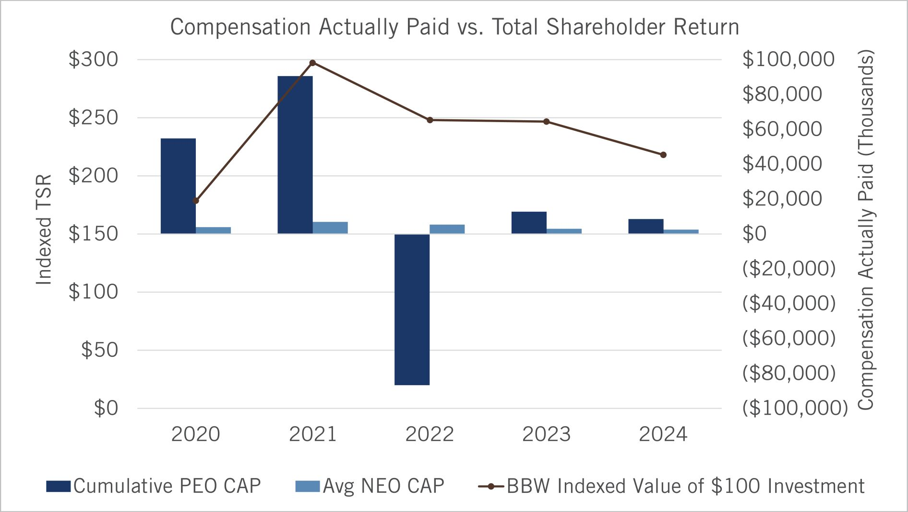

2025 Proxy Statement
| Bath & Body Works, Inc.
61

Table of Contents

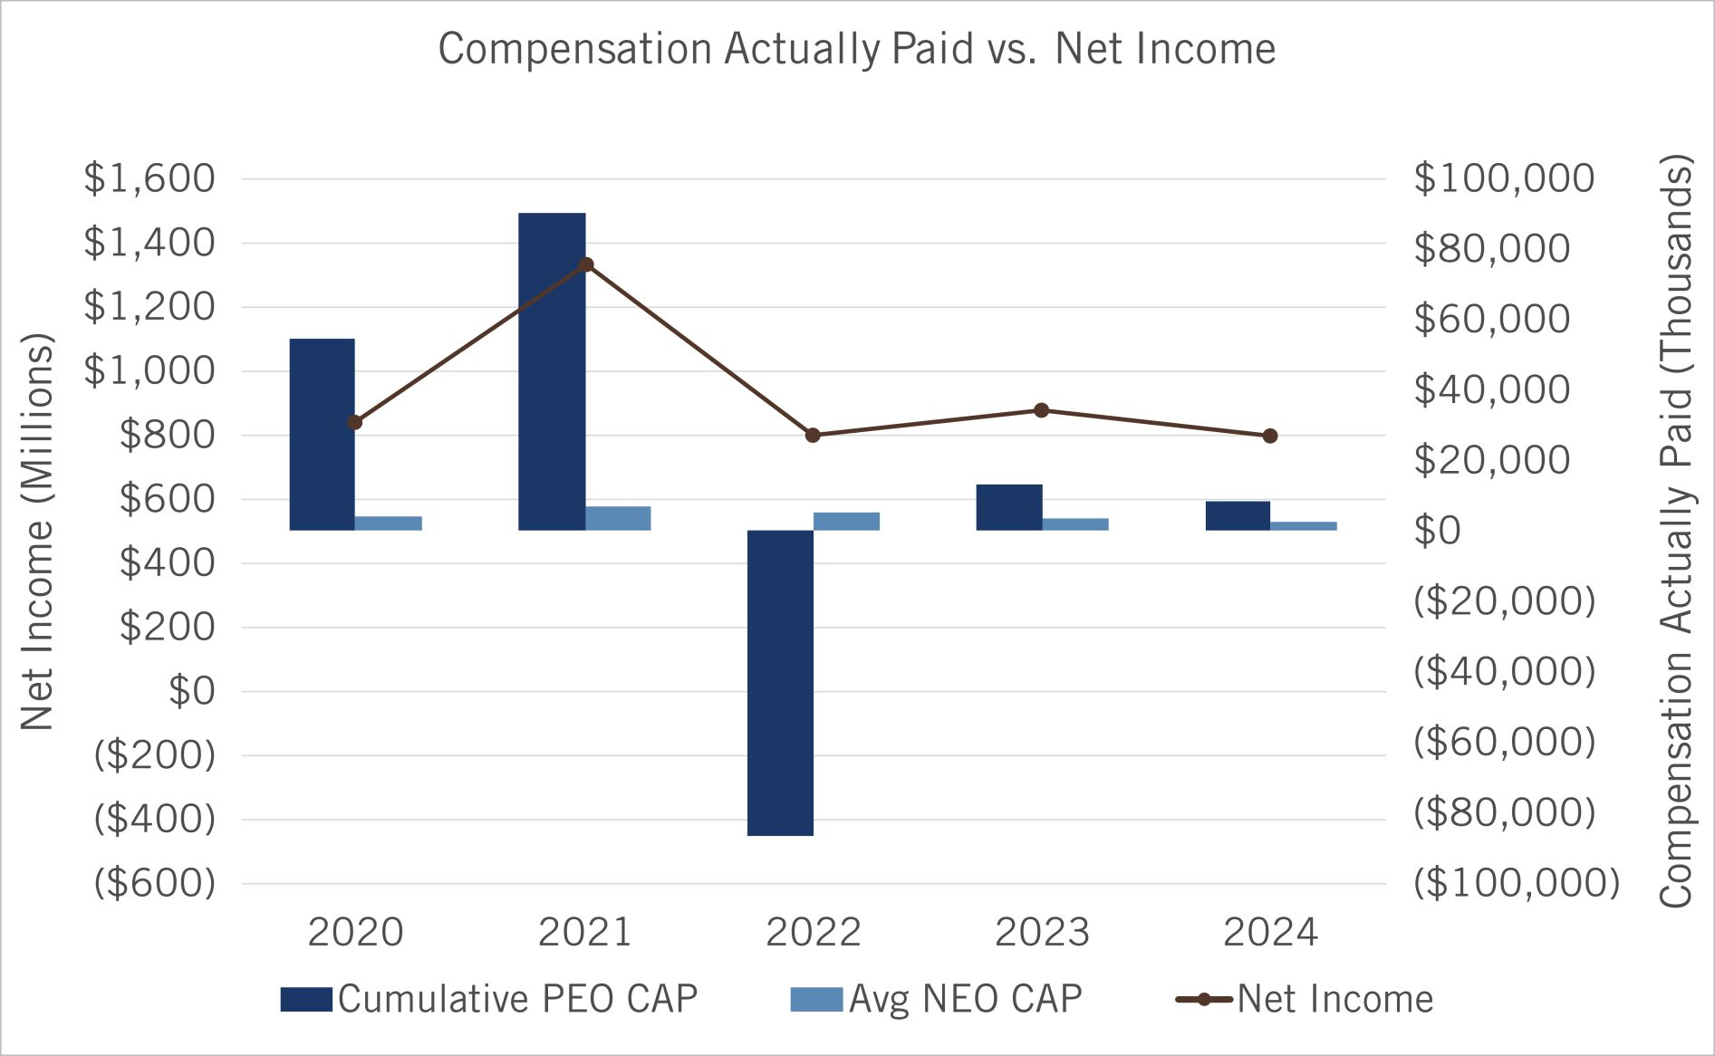

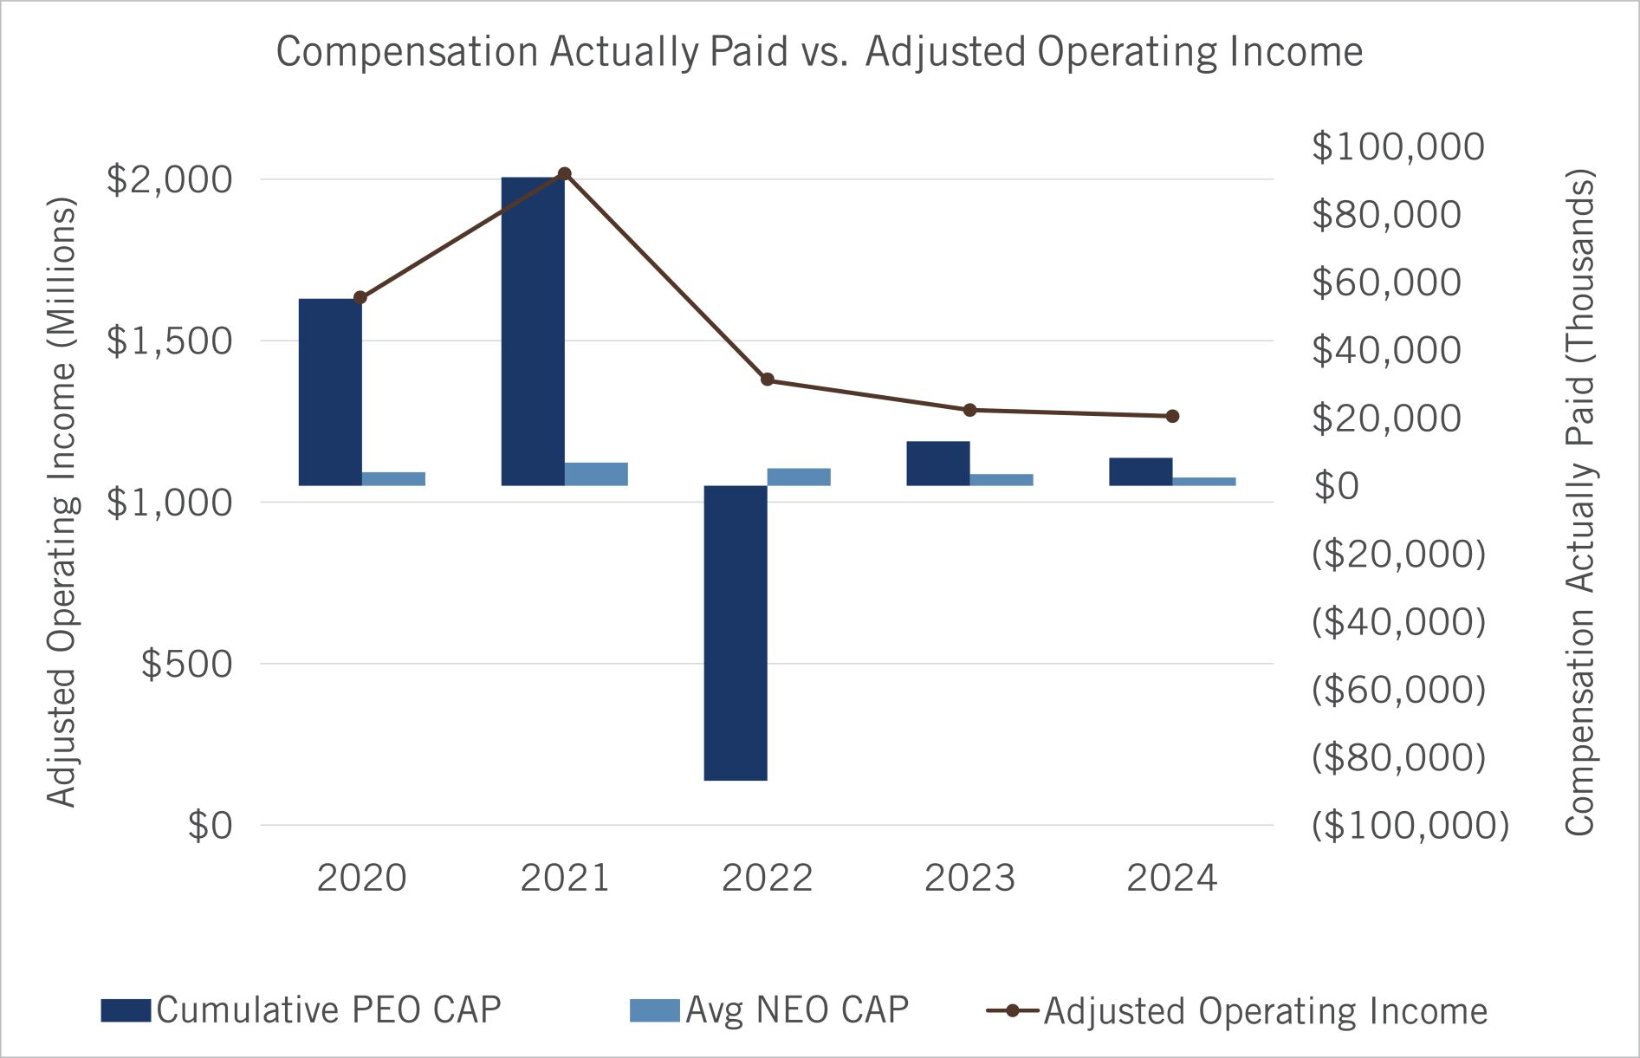

62
Bath & Body Works, Inc. |
2025 Proxy Statement

Table of Contents

The following chart reflects the Company’s cumulative TSR over the cumulative five-year fiscal 2020 through fiscal 2024 period compared to our industry index (i.e., the S&P 500 Consumer Discretionary Distribution & Retail Index).

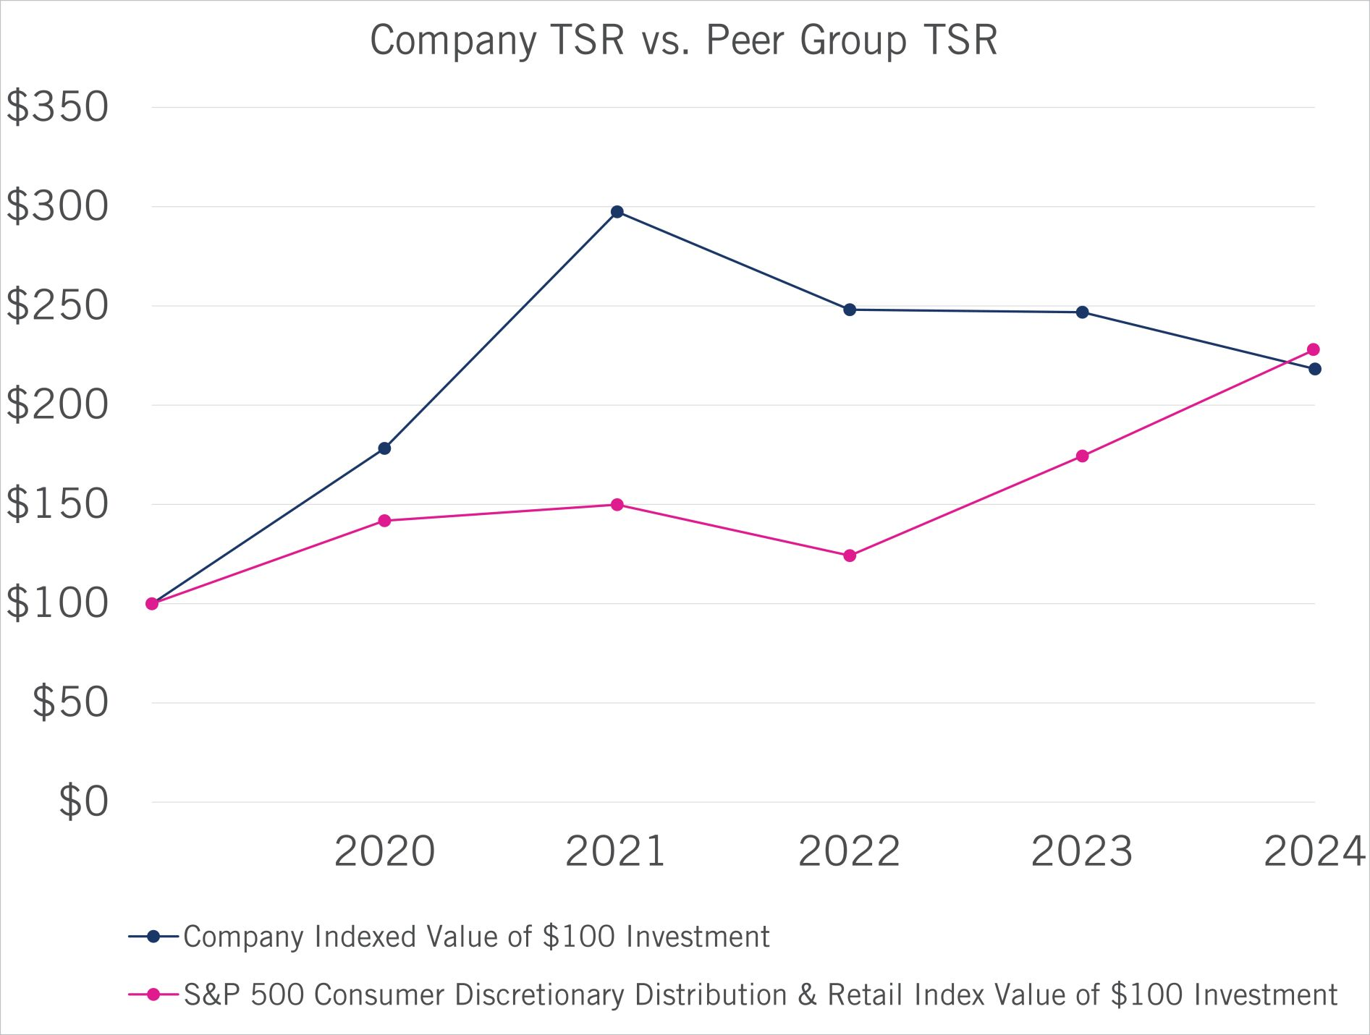

2025 Proxy Statement
| Bath & Body Works, Inc.
63

Table of Contents

Beneficial Ownership of Common Stock

The following table includes certain information about the securities ownership of all directors of the Company, the current and former executive officers of the Company named in the 2024 Summary Compensation Table on page 49 of this proxy statement and all directors and current executive officers of the Company as a group.

NAME OF BENEFICIAL OWNER |  | NUMBER OF SHARES OF  COMMON STOCK BENEFICIALLY  OWNED(1)(2) |  |  |  |  | PERCENT OF CLASS(2)
Alessandro Bogliolo |  |  |  | 7,035 |  |  |  |  | *
Eva Boratto |  |  |  | 15,648 |  |  |  |  | *
Gina Boswell |  |  |  | 94,711 | (3) |  |  |  | *
Lucy Brady |  |  |  | 4,527 |  |  |  |  | *
Francis Hondal |  |  |  | 8,726 |  |  |  |  | *
Danielle Lee |  |  |  | 8,726 |  |  |  |  | *
Tom Mazurek |  |  |  | 27,311.577 | (3) |  |  |  | *
Sarah Nash |  |  |  | 259,714 |  |  |  |  | *
Juan Rajlin |  |  |  | 7,035 |  |  |  |  | *
Deon Riley |  |  |  | 58,712 | (4) |  |  |  | *
Julie Rosen |  |  |  | 11,439 | (4) |  |  |  | *
Stephen Steinour |  |  |  | 64,715 | (5) |  |  |  | *
J.K. Symancyk |  |  |  | 8,394 |  |  |  |  | *
Steven Voskuil |  |  |  | 4,440 |  |  |  |  | *
Michael Wu |  |  |  | 39,368.178 | (3) |  |  |  | *
All directors and current executive officers as a group (13 people) |  |  |  | 550,350.755 | (3)(5) |  |  |  | *

* | Less than 1%

(1) | Unless otherwise indicated, each named person has voting and investment power over the listed shares and such voting and investment power is exercised solely by the named person or shared with a spouse. None of the listed shares have been pledged as security or otherwise deposited as collateral.

(2) | Reflects beneficial ownership of shares of the Company’s common stock, and shares outstanding, as of April 8, 2025.

(3) | Includes the following number of shares issuable within 60 days of April 8, 2025, upon the exercise or vesting of outstanding stock awards: Ms. Boswell, 30,381; Mr. Mazurek, 5,671; Mr. Wu, 5,873; and all directors and current executive officers as a group, 41,925.

(4) | Includes the following number of shares issuable within 60 days of April 8, 2025, upon the exercise or vesting of outstanding stock awards: Ms. Riley, 6,121; Ms. Rosen, 11,439;

(5) | Includes 9,900 shares held in the Patricia M. Steinour Legacy Trust, for which Mr. Steinour has shared voting and investment power, and 9,900 shares held in the Stephen D. Steinour Dynasty Trust, for which Mr. Steinour has shared voting and investment power. Includes 12,925 shares owned by Mr. Steinour’s spouse, as to which Mr. Steinour may be deemed to share voting and investment power.

64 Bath & Body Works, Inc. | 2025 Proxy Statement

Table of Contents

The following table sets forth the names of all persons who, as of the dates indicated below, were known by the Company to be the beneficial owners (as defined in the rules of the Commission) of more than 5% of the outstanding shares of the Company’s common stock.

NAME AND ADDRESS OF BENEFICIAL OWNER |  | AMOUNT  BENEFICIALLY  OWNED |  |  |  |  | PERCENT  OF CLASS
BlackRock, Inc.(1)  50 Hudson Yards  New York, NY 10001 |  |  |  | 18,850,697 |  |  |  |  | 8.8 | %
The Vanguard Group(2)  100 Vanguard Blvd.  Malvern, PA 19355 |  |  |  | 27,991,476 |  |  |  |  | 12.77 | %

(1) | As of March 31, 2025, based solely on information set forth in the Schedule 13G/A filed on April 17, 2025, BlackRock, Inc. reported having sole voting power over 18,339,958 shares and sole dispositive power over 18,850,697 shares.

(2) | As of September 30, 2024, based solely on information set forth in the Schedule 13G/A filed on November 12, 2024, the Vanguard Group reported having shared voting power over 139,920 shares, sole dispositive power over 27,665,691 shares and shared dispositive power over 325,785 shares.

2025 Proxy Statement | Bath & Body Works, Inc. 65

Table of Contents

Information About the Annual Meeting and Voting

The Board is soliciting your proxy to vote at our 2025 annual meeting of shareholders (or at any adjournment of the meeting). This proxy statement summarizes the information you need to know to vote at the meeting.
We began mailing this proxy statement and the enclosed proxy card, or the Notice of Internet Availability of Proxy Materials (the “Notice”), on or about April 25, 2025 to all shareholders entitled to vote. The 2024 10-K, which includes our financial statements, is being sent with this proxy statement and is available in paper copy by request or in electronic form. You may request copies of such documents from: Bath & Body Works, Inc., Three Limited Parkway, Columbus, Ohio 43230, Attention: Corporate Secretary.
Date, Time and Place of Meeting

Date: |  | June 5, 2025
Time: |  | 8:30 a.m. Eastern Time
Place: |  | Meeting will be held virtually with a link to be provided by registering at https://proxydocs.com/BBWI
Attending the Meeting
This year’s annual meeting will be held in a virtual format only. There will be no physical location for the meeting. We adopted a virtual format to make participation more convenient, safe and accessible for our shareholders regardless of their location. If you plan to virtually attend the meeting, please note that you will need to register at https://www.proxydocs.com/BBWI by entering your control number included on your proxy card, voting instruction form, or Notice of Internet Availability. Upon completing your registration, you will receive further instructions via email, including a unique link that will allow you access to the annual meeting and to vote and submit questions during the annual meeting.
By your attendance, you acknowledge that you have agreed to abide by the rules of conduct for our annual meeting that will be made available at the virtual meeting site. Only questions that comply with the rules of conduct of our annual meeting will be answered.
Shares Entitled to Vote
Shareholders entitled to vote are those who owned Company common stock (“Common Stock”) at the close of business on the record date, April 8, 2025. As of the record date, there were 213,007,116 shares of Common Stock outstanding. Each share of Common Stock that you own entitles you to one vote.
Voting Your Shares
Whether or not you plan to virtually attend the annual meeting, we urge you to vote. Shareholders of record can give proxies by calling a toll-free telephone number, by using the Internet or by mailing their signed proxy cards.
The telephone and Internet voting procedures are designed to authenticate shareholders’ identities, to allow shareholders to give their voting instructions and to confirm that shareholders’ instructions have been recorded properly. If you are voting by mail, please complete, sign and date the enclosed proxy card and return it promptly in the envelope provided. If you are voting by telephone or via the Internet, please use the telephone or Internet voting procedures set forth on the enclosed proxy card. Returning the proxy card or voting via telephone or the Internet will not affect your right to virtually attend the meeting and vote.
The enclosed proxy card indicates the number of shares that you own. Voting instructions are included on your proxy card. If you properly fill in your proxy card and send it to us or vote via telephone or the Internet in time to vote, one of the individuals named on your proxy card (your “proxy”) will vote your shares as you have directed. If you sign the proxy card or vote via telephone or the Internet but do not make specific choices, your proxy will follow the Board’s recommendations and vote your shares in the following manner:

 | • |  | “FOR” the election of the Board’s ten nominees for director (as described on page 4);

66 Bath & Body Works, Inc. | 2025 Proxy Statement

Table of Contents

 | • |  | “FOR” the ratification of the appointment of our independent registered public accounting firm (as described on page 26); and
 | • |  | “FOR” the advisory vote to approve named executive officer compensation (as described on page 31).
If any other matter is properly presented at the meeting, your proxy will vote in accordance with his or her best judgment. At the time this proxy statement was filed, we knew of no other matters to be acted on at the meeting. See “—Vote Necessary to Approve Proposals” below for a discussion of the votes required to approve these items.
Certain shareholders received a Notice containing instructions on how to access this proxy statement and our 2024 10-K via the Internet. Those shareholders should refer to the Notice for instructions regarding how to vote.
Revoking Your Proxy
You may revoke your proxy by:

 | • |  | submitting a later dated proxy (including a proxy via telephone or the Internet);
 | • |  | notifying our Corporate Secretary at our principal executive offices at Three Limited Parkway, Columbus, Ohio 43230, Attention: Corporate Secretary, in writing before the meeting that you have revoked your proxy; or
 | • |  | voting virtually at the meeting.
Voting at the Annual Meeting
If you own common stock of record, you may virtually attend the annual meeting and vote, regardless of whether you previously voted by proxy card, via the Internet, or by telephone. If your shares are held in the name of your broker, bank or other nominee, you may virtually attend the annual meeting, but in order to vote your shares at the annual meeting you must obtain a legal proxy from the brokerage firm, bank or other nominee that holds your shares indicating that you are the beneficial owner of the shares at the close of business on April 8, 2025, the record date of the meeting. You should contact your bank or brokerage account representative to learn how to obtain a legal proxy. We encourage you to vote your shares in advance of the annual meeting.
Our virtual meeting platform vendor will have technicians ready to assist you with any technical difficulties you may have accessing the virtual meeting or submitting questions. If you encounter any difficulties accessing the virtual meeting, please call the technical support number that will be posted on the meeting login page.
Appointing Your Own Proxy
If you want to give your proxy to someone other than the individuals named as proxies on the proxy card, you may cross out the names of those individuals and insert the name of the individual you are authorizing to vote. If you appoint your own proxy, either you or the individual you appoint must present the proxy card at the meeting.
Quorum Requirement
A quorum of shareholders is necessary to hold a valid meeting. The presence in person or by proxy at the meeting of holders of shares representing at least one-third of the votes of the Common Stock entitled to vote constitutes a quorum. Abstentions and “broker non-votes” are counted as present for establishing a quorum. A broker non-vote occurs on an item when a broker is not permitted to vote on that item absent instruction from the beneficial owner of the shares and no instruction is given.
Vote Necessary to Approve Proposals

 | • |  | Pursuant to the Company’s Bylaws, each director will be elected by a majority of the votes cast with respect to such director. A majority of the votes cast means that the number of votes “for” a director’s election must exceed 50% of the votes cast with respect to that director’s election. Any “against” votes will count as a vote cast, but “abstentions” and broker non-votes will not count as a vote cast with respect to that director’s election. Under Delaware law, if the director is not elected at the annual meeting, the director will continue to serve on the Board as a “holdover director.” As required by the Bylaws, each director has submitted an irrevocable letter of resignation as director that becomes effective if the director does not receive a majority of votes cast in an election and the Board accepts the resignation. If a director is not elected, the Nominating & Governance Committee will consider the director’s resignation and recommend to the Board whether to accept or reject the resignation.
 | • |  | The ratification of Ernst & Young LLP as our independent registered public accounting firm requires the affirmative vote of a majority of the votes present in person or by proxy and voting thereon.

2025 Proxy Statement | Bath & Body Works, Inc. 67

Table of Contents

 | • |  | The advisory vote to approve named executive officer compensation requires the affirmative vote of a majority of the votes present in person or by proxy and voting thereon. While this vote is required by law, it will neither be binding on the Company nor the Board, nor will it create or imply any change in the fiduciary or other duties of, or impose any additional fiduciary or other duties on, the Company or the Board. However, the HCC Committee will carefully consider the shareholder vote, along with all other expressions of shareholders’ views on this matter, when considering future executive compensation decisions.
Impact of Abstentions and Broker Non-votes
You may “abstain” from voting for any nominee in the election of directors and on the other proposals. Abstentions with respect to the election of directors, the ratification of Ernst & Young LLP as our independent registered public accounting firm, and the advisory vote to approve named executive officer compensation will be excluded entirely from the vote and will have no effect.
In addition, under NYSE rules, if your broker holds your shares in its name, your broker is permitted to vote your shares on the proposal to ratify Ernst & Young LLP as our independent registered public accounting firm, even if it did not receive voting instructions from you. Your broker may not vote your shares on any of the other matters without specific instruction. A “broker non-vote” occurs when a broker submits a proxy but refrains from voting. Shares represented by broker non-votes are counted as present or represented for purposes of determining the presence of a quorum but are not counted as otherwise present or represented.
Obtaining Additional Copies of the Proxy Materials
We have adopted a procedure called “householding.” Under this procedure, shareholders who share the same last name and reside at the same mailing address will receive one Notice or one set of proxy materials (if they have elected to receive hard copies of the proxy materials), unless one of the shareholders at that address has notified us that they wish to receive individual copies. Shareholders who participate in householding continue to receive separate control numbers for voting. Householding does not in any way affect dividend check mailings.
If you hold Common Stock and currently are subject to householding, but prefer to receive separate copies of proxy materials and other shareholder communications from the Company, or if you are sharing an address with another shareholder and would like to consent to householding, you may revoke or grant your consent to householding as appropriate at any time by calling (614) 415-3203 or notifying our Corporate Secretary at our principal executive offices at Three Limited Parkway, Columbus, Ohio 43230, Attention: Corporate Secretary.
A number of brokerages and other institutional holders of record have implemented householding. If you hold your shares beneficially in street name, please contact your broker or other intermediary holder of record to request information about householding.

68 Bath & Body Works, Inc. | 2025 Proxy Statement

Table of Contents

General Matters

Shareholder Proposals or Director Nominations for the 2026 Annual Meeting
Shareholder Proposals Pursuant to Rule 14a-8
Proposals submitted for inclusion in the proxy statement for our 2025 annual meeting of shareholders must be received by the Company’s Corporate Secretary at our principal executive offices on or before December 26, 2025.
Shareholder Director Nominations for Inclusion in Our 2026 Proxy Statement
Written notice of shareholder nominations of persons for election as a director at our 2025 annual meeting of shareholders that are to be included in our proxy statement for the 2025 annual meeting pursuant to the proxy access provisions in Section 2.05 of our Bylaws must be received by the Company’s Corporate Secretary at our principal executive offices no earlier than November 26, 2025, and no later than December 26, 2025. The notice must contain the information required by our Bylaws.
Other Shareholder Proposals
If a shareholder intends to present a proposal or nominate a person for election as a director at the 2026 annual meeting other than as described above, the shareholder must comply with the requirements set forth in Section 2.04 of our Bylaws. The Bylaws require, among other things, that the Company’s Corporate Secretary receive written notice of the intent to present a proposal or nomination no earlier than February 5, 2026, and no later than March 7, 2026. The notice must contain the information required by our Bylaws.

Other Proposed Actions
The Board knows of no other matters to be brought before the annual meeting. However, if other matters should come before the meeting, each of the persons named as a proxy intends to vote in accordance with such person’s judgment on such matters.

Solicitation of Proxies
We are soliciting proxies primarily by the use of the mail. However, we may also solicit proxies by telephone, email and personal solicitation, in addition to the use of the mail. To the extent our directors or associates participate in this solicitation, they will not receive compensation for their participation, other than their normal compensation. Innisfree M&A Incorporated assists us with the solicitation for a fee of $25,000 plus reasonable out-of-pocket expenses. We will, upon request, reimburse banks, brokerage houses and other institutions, nominees and fiduciaries for their expenses in forwarding proxy materials to beneficial owners. We bear all costs associated with this proxy solicitation.

2025 Proxy Statement | Bath & Body Works, Inc. 69

Table of Contents
Appendix A

Non-GAAP Financial Measures
The Company uses certain adjusted financial information in this proxy statement, including adjusted net income from continuing operations per diluted share, adjusted operating income, free cash flow and debt leverage ratio. The adjusted financial information should not be construed as an alternative to the results determined in accordance with GAAP. Further, the Company’s definitions of adjusted financial information may differ from similarly titled measures used by other companies. Management believes that the presentation of the adjusted financial information provides additional information to investors to facilitate the comparison of past and present operations. Further, the HCC Committee uses adjusted operating income because it is a performance measure over which the Company’s executives can have significant impact and is also directly linked to the Company’s long-term growth plan and performance that drive shareholder value. While it is not possible to predict future results, management believes the adjusted financial information is useful for the assessment of the operations of the Company because the adjusted items are not indicative of the Company’s ongoing operations due to their size and nature. Additionally, management uses adjusted financial information as key performance measures for the purpose of evaluating performance internally. The adjusted financial information should be read in conjunction with the Company’s historical financial statements and notes thereto contained in the Company’s Quarterly Reports on Form 10-Q and Annual Reports on Form 10-K.
The table below reconciles the Company’s adjusted net income from continuing operations per diluted share for fiscal 2024, 2023, 2022, 2021, and 2020 to the Company’s net income from continuing operations per diluted share, the most comparable GAAP financial measure. For fiscal 2022, the Company did not make any adjustments to net income from continuing operations per diluted share; therefore, for fiscal 2022, adjusted net income from continuing operations per diluted share is equal to the Company’s fiscal 2022 GAAP net income from continuing operations per diluted shares.
Reconciliations of Net Income from Continuing Operations Per Diluted Share to Adjusted Net Income from Continuing Operations Per Diluted Share

 |  | 2024  (52 WEEKS) |  |  |  |  | 2023  (53 WEEKS) |  |  |  |  | 2022  (52 WEEKS) |  |  |  |  | 2021  (52 WEEKS) |  |  |  |  | 2020  (52 WEEKS)
Reported Net Income from Continuing Operations Per Diluted Share |  |  | $ | 3.61 |  |  |  | $ | 3.84 |  |  |  | $ | 3.40 |  |  |  | $ | 3.94 |  |  |  | $ | 3.07
Restructuring Charges(1) |  |  |  | — |  |  |  |  | — |  |  |  |  | — |  |  |  |  | — |  |  |  |  | 0.08
Write-off of Inventory due to Tornado(2) |  |  |  | — |  |  |  |  | — |  |  |  |  | — |  |  |  |  | 0.03 |  |  |  |  | —
(Gain) / Loss on Extinguishment of Debt(3) |  |  |  | — |  |  |  |  | (0.11 | ) |  |  |  | — |  |  |  |  | 0.54 |  |  |  |  | 0.14
Impairment of Equity Method Investment(4) |  |  |  | — |  |  |  |  | 0.03 |  |  |  |  | — |  |  |  |  | — |  |  |  |  | —
Gain on Sales of Easton Investments(5) |  |  |  | (0.11 | ) |  |  |  | — |  |  |  |  | — |  |  |  |  | — |  |  |  |  | —
Tax Benefit from the Resolution of Certain Tax Matters(6) |  |  |  | — |  |  |  |  | — |  |  |  |  | — |  |  |  |  | — |  |  |  |  | (0.18 | )
Tax Benefit from Valuation Allowance Release(7) |  |  |  | (0.20 | ) |  |  |  | (0.49 | ) |  |  |  | — |  |  |  |  | — |  |  |  |  | —
Adjusted Net Income from Continuing Operations Per Diluted Share |  |  | $ | 3.29 |  |  |  | $ | 3.27 |  |  |  | $ | 3.40 |  |  |  | $ | 4.51 |  |  |  | $ | 3.12

(1) | In 2020, we recognized pre-tax severance charges of $30 million ($24 million after tax) related to restructuring activities.

(2) | In 2021, we recognized a pre-tax loss of $9 million ($7 million after tax) related to the write-off of inventory that was destroyed by a tornado at a vendor’s facility.

(3) | In 2023, we recognized pre-tax gains of $34 million related to the repurchase and extinguishment of outstanding notes. We recognized pre-tax losses of $195 million and $53 million in 2021 and 2020, respectively, due to the early extinguishment of outstanding notes. We recognized an after tax gain of $26 million in 2023, and after tax losses of $148 million and $40 million in 2021 and 2020, respectively.

(4) | In 2023, we recognized a pre-tax impairment charge of $8 million ($6 million after tax) related to an impairment charge on an equity method investment.

(5) | In 2024, we recognized a $39 million aggregate pre-tax gain ($25 million after tax) related to the sales of certain Easton investments.

(6) | In 2020, we recognized a $50 million tax benefit related to the resolution of certain tax matters.

(7) | In 2024, we recognized a $44 million tax benefit related to the release of a valuation allowance on a deferred tax asset. In 2023, we recognized a $112 million tax benefit related to the partial release of a valuation allowance on a deferred tax asset.

2025 Proxy Statement | Bath & Body Works, Inc. A-1

Table of Contents
The table below reconciles the adjusted operating income of the Company for fiscal 2024, 2023, 2022, 2021 and 2020 to the Company’s operating income, the most comparable GAAP financial measure. For fiscal 2024, 2023 and 2022, the Company did not make any adjustments to operating income; therefore, for fiscal 2024, 2023 and 2022, adjusted operating income is equal to the Company’s fiscal 2024, 2023 and 2022 GAAP operating income, respectively.
Reconciliations of Reported Operating Income to Adjusted Operating Income (in millions)

 |  | 2024  (52 WEEKS) |  |  |  |  | 2023  (53 WEEKS) |  |  |  |  | 2022  (52 WEEKS) |  |  |  |  | 2021  (52 WEEKS) |  |  |  |  | 2020  (52 WEEKS)
Reported Operating Income |  |  | $ | 1,266 |  |  |  | $ | 1,285 |  |  |  | $ | 1,376 |  |  |  | $ | 2,009 |  |  |  | $ | 1,604
Write-off of Inventory due to Tornado(1) |  |  |  | — |  |  |  |  | — |  |  |  |  | — |  |  |  |  | 9 |  |  |  |  | —
Restructuring Charges(2) |  |  |  | — |  |  |  |  | — |  |  |  |  | — |  |  |  |  | — |  |  |  |  | 30
Adjusted Operating Income |  |  | $ | 1,266 |  |  |  | $ | 1,285 |  |  |  | $ | 1,376 |  |  |  | $ | 2,019 |  |  |  | $ | 1,634

(1) | In 2021, the Company recognized a pre-tax loss of $9 million related to the write-off of inventory that was destroyed by a tornado at a vendor’s facility.

(2) | In 2020, the Company recognized pre-tax severance charges of $30 million related to restructuring activities.
The table below reconciles the Company’s fiscal 2024 free cash flow to the Company’s fiscal 2024 net cash provided by operating activities, the most comparable GAAP financial measure.
Reconciliations of Reported Net Cash Provided by Operating Activities to Free Cash Flow (in millions)

 |  | 2024
Reported Net Cash Provided by Operating Activities(1) |  |  | $ | 886
Capital Expenditures |  |  |  | (226 | )
Free Cash Flow |  |  | $ | 660

(1) | Fiscal 2024 includes tax payments of $65 million related to the sales of our investments in Easton Town Center and Easton, Gateway.
The table below reconciles the Company’s fiscal 2024 debt leverage ratio, which is defined as adjusted debt, which includes long-term debt and total operating lease liabilities, divided by earnings before interest, taxes, depreciation, amortization and rent (“EBITDAR”). EBITDAR is calculated as operating income, which excludes interest and taxes, before depreciation, amortization and lease costs.
Debt Leverage Ratio Calculation

TRAILING TWELVE
MONTHS ENDED
($S IN MILLIONS) |  | 2/1/2025
Long-term Debt |  |  | $ | 3,884
Total Operating Lease Liabilities |  |  |  | 1,075
Adjusted Debt |  |  | $ | 4,959
Operating Income |  |  |  | 1,266
Depreciation and Amortization |  |  |  | 282
Total Lease Costs |  |  |  | 418
EBITDAR |  |  | $ | 1,966
Debt Leverage Ratio |  |  |  | 2.5

A-2 Bath & Body Works, Inc. | 2025 Proxy Statement

Table of Contents
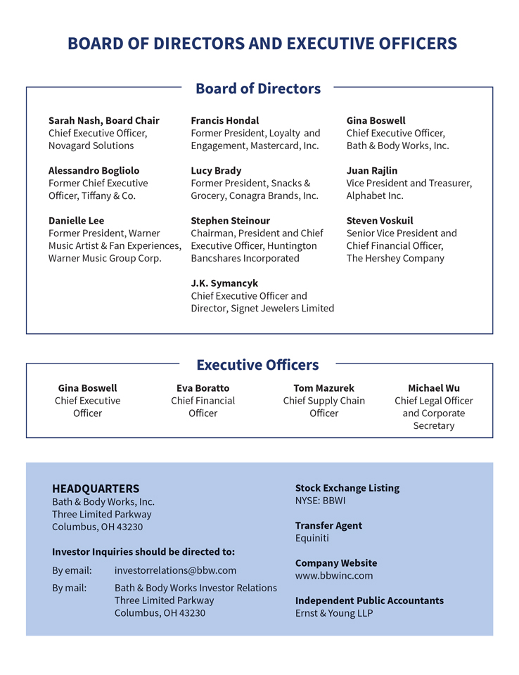
BOARD OF DIRECTORS AND EXECUTIVE OFFICERS Board of Directors Sarah Nash, Board Chair Francis Hondal Gina Boswell Chief Executive Officer, Former President of Loyalty and Chief Executive Officer, Novagard Solutions Engagement, Mastercard, Inc. Bath & Body Works, Inc. Alessandro Bogliolo Lucy Brady Juan Rajlin Former Chief Executive Former President, Snacks & Vice President and Treasurer, Officer, Tiffany & Co. Grocery, Conagra Brands, Inc. Alphabet Inc. Danielle Lee Stephen Steinour Steven Voskuil Former President, Warner Chairman, President and Chief Senior Vice President and Music Artist & Fan Experiences, Executive Officer, Huntington Chief Financial Officer, Warner Music Group Corp. Bancshares Incorporated The Hershey Company J.K. Symancyk Chief Executive Officer, Signet Jewelers Limited Executive Officers Gina Boswell Eva Boratto Tom Mazurek Michael Wu Chief Executive Chief Financial Chief Supply Chain Chief Legal Officer Officer Officer Officer and Corporate Secretary HEADQUARTERS Stock Exchange Listing Bath & Body Works, Inc. NYSE: BBWI Three Limited Parkway Columbus, OH 43230 Transfer Agent Equiniti Investor Inquiries should be directed to: Company Website By email: investorrelations@bbw.com www.bbwinc.com By mail: Bath & Body Works Investor Relations Three Limited Parkway Independent Public Accountants Columbus, OH 43230 Ernst & Young LLP

Table of Contents

Bath & BodyWorks Bath & Body Works, Inc. Three Limited Parkway Columbus, Ohio 43230 www.bbwinc.com

Table of Contents
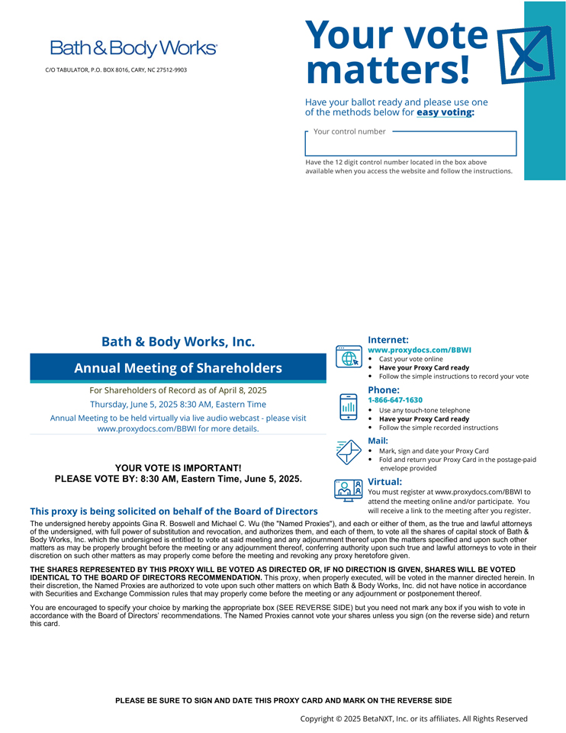
Your vote C/O TABULATOR, P.O. BOX 8016, CARY, NC 27512-9903 matters! Have your ballot ready and please use one of the methods below for easy voting: Your control number Have the 12 digit control number located in the box above available when you access the website and follow the instructions. Bath &amp; Body Works, Inc. Internet: www.proxydocs.com/BBWI Cast your vote online Annual Meeting of Shareholders Have your Proxy Card ready Follow the simple instructions to record your vote For Shareholders of Record as of April 8, 2025 Phone: Thursday, June 5, 2025 8:30 AM, Eastern Time 1-866-647-1630 Use any touch-tone telephone Annual Meeting to be held virtually via live audio webcast—please visit Have your Proxy Card ready www.proxydocs.com/BBWI for more details. Follow the simple recorded instructions Mail: Mark, sign and date your Proxy Card Fold and return your Proxy Card in the postage-paid YOUR VOTE IS IMPORTANT! envelope provided PLEASE VOTE BY: 8:30 AM, Eastern Time, June 5, 2025. Virtual: You must register at www.proxydocs.com/BBWI to attend the meeting online and/or participate. You This proxy is being solicited on behalf of the Board of Directors will receive a link to the meeting after you register. The undersigned hereby appoints Gina R. Boswell and Michael C. Wu (the “Named Proxies”), and each or either of them, as the true and lawful attorneys of the undersigned, with full power of substitution and revocation, and authorizes them, and each of them, to vote all the shares of capital stock of Bath &amp; Body Works, Inc. which the undersigned is entitled to vote at said meeting and any adjournment thereof upon the matters specified and upon such other matters as may be properly brought before the meeting or any adjournment thereof, conferring authority upon such true and lawful attorneys to vote in their discretion on such other matters as may properly come before the meeting and revoking any proxy heretofore given. THE SHARES REPRESENTED BY THIS PROXY WILL BE VOTED AS DIRECTED OR, IF NO DIRECTION IS GIVEN, SHARES WILL BE VOTED IDENTICAL TO THE BOARD OF DIRECTORS RECOMMENDATION. This proxy, when properly executed, will be voted in the manner directed herein. In their discretion, the Named Proxies are authorized to vote upon such other matters on which Bath &amp; Body Works, Inc. did not have notice in accordance with Securities and Exchange Commission rules that may properly come before the meeting or any adjournment or postponement thereof. You are encouraged to specify your choice by marking the appropriate box (SEE REVERSE SIDE) but you need not mark any box if you wish to vote in accordance with the Board of Directors? recommendations. The Named Proxies cannot vote your shares unless you sign (on the reverse side) and return this card. PLEASE BE SURE TO SIGN AND DATE THIS PROXY CARD AND MARK ON THE REVERSE SIDE Copyright 2025 BetaNXT, Inc. or its affiliates. All Rights Reserved

Table of Contents
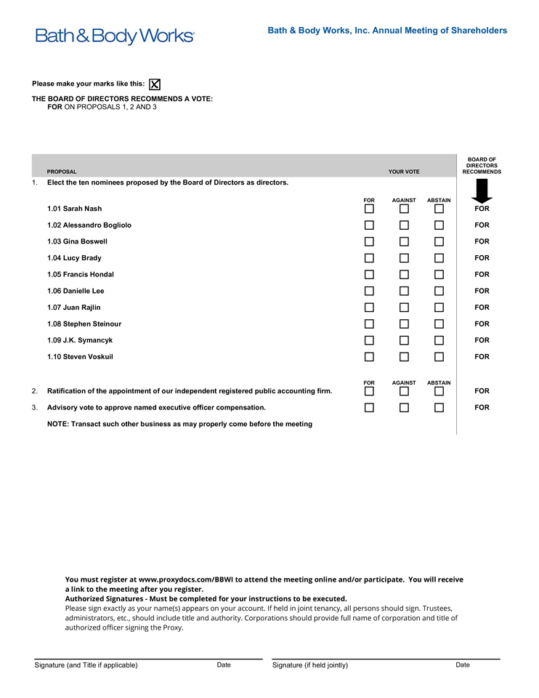
Bath &amp; Body Works, Inc. Annual Meeting of Shareholders Please make your marks like this: THE BOARD OF DIRECTORS RECOMMENDS A VOTE: FOR ON PROPOSALS 1, 2 AND 3 BOARD OF DIRECTORS PROPOSAL YOUR VOTE RECOMMENDS 1. Elect the ten nominees proposed by the Board of Directors as directors. FOR AGAINST ABSTAIN 1.01 Sarah Nash FOR #P2# #P2# #P2# 1.02 Alessandro Bogliolo FOR #P3# #P3# #P3# 1.03 Gina Boswell FOR #P4# #P4# #P4# 1.04 Lucy Brady FOR #P5# #P5# #P5# 1.05 Francis Hondal FOR #P6# #P6# #P6# 1.06 Danielle Lee FOR #P1.07 Juan Rajlin FOR #8# 1.08 Stephen Steinour FOR #P9# #P9# #P9# 1.09 J.K. Symancyk FOR #P10# #P10# #P10# 1.10 Steven Voskuil FOR #P1 #P11# FOR AGAINST ABSTAIN 2. Ratification of the appointment of our independent registered public accounting firm. FOR # #P12# 3. Advisory vote to approve named executive officer compensation. FOR #P13# #P13# #P13# NOTE: Transact such other business as may properly come before the meeting You must register at www.proxydocs.com/BBWI to attend the meeting online and/or participate. You will receive a link to the meeting after you register. Authorized Signatures—Must be completed for your instructions to be executed. Please sign exactly as your name(s) appears on your account. If held in joint tenancy, all persons should sign. Trustees, administrators, etc., should include title and authority. Corporations should provide full name of corporation and title of authorized officer signing the Proxy. Signature (and Title if applicable) Date Signature (if held jointly) Date

