TABLE OF CONTENTS

UNITED STATES

SECURITIES AND EXCHANGE COMMISSION

Washington, D.C. 20549

SCHEDULE 14A

(Rule 14a-101)

INFORMATION REQUIRED IN PROXY STATEMENT

SCHEDULE 14A INFORMATION

Proxy Statement Pursuant to Section 14(a) of the

Securities Exchange Act of 1934

Filed by the Registrant ☒ Filed by a party other than the Registrant ☐

Check the appropriate box:

  - Preliminary Proxy Statement

  - Confidential, for Use of the Commission Only (as permitted by Rule 14a-6(e)(2))

- Definitive Proxy Statement

  - Definitive Additional Materials

  - Soliciting Material Pursuant to §240.14a-12

Bath & Body Works, Inc.

(Name of Registrant as Specified in its Charter)

Not applicable.

(Name of Person(s) Filing Proxy Statement, if other than the Registrant)

Payment of Filing Fee (Check all boxes that apply):

- No fee required.

  - Fee paid previously with preliminary materials.

  - Fee computed on table in exhibit required by Item 25(b) per Exchange Act Rules 14a-6(i)(1) and 0-11.

TABLE OF CONTENTS


TABLE OF CONTENTS


TABLE OF CONTENTS

Dear Fellow Shareholders,

As we reflect on fiscal 2025, it has been a year of transition fueled by change and transformative, innovative energy to help set the groundwork for

success in 2026 and beyond. Bath & Body Works is a business with meaningful and durable advantages: an iconic brand with deep customer affection, category-leading fragrance franchises, a large and highly engaged loyalty base of 40 million members, a fast and flexible domestic
supply chain, and a global fleet of 2,500 stores. These are powerful assets that we believe position us to win.

In 2025, the Board of Directors fulfilled a key governance responsibility by guiding a planned CEO transition. Under this new leadership, we acknowledged that recent performance does not fully realize the Company’s potential. In response, we introduced the Consumer First Formula, a comprehensive, multi-year strategy to drive sustainable, profitable growth by placing the consumer back at the center of every decision.

Our Plan: The Consumer First Formula

First, Create Innovative, Disruptive Product. We are refocusing on our hero categories where we believe that our brand and expertise give us the strongest right to win - body care, home fragrance, and soaps & sanitizers. Our innovation pipeline is grounded in deeper consumer insight,
earlier testing, and a sharper focus on benefits.

Second, Reignite the Brand. Bath & Body Works has high awareness, but awareness alone is not enough. We must earn greater cultural relevance and give new and younger consumers stronger reasons to choose us. We believe that this requires clearer positioning, more distinctive storytelling, and a more elevated, creator-led, and digitally driven marketing model.

Third, Win in the Marketplace. We are putting ourselves in the path of the consumer. Our store fleet remains a significant competitive advantage, and we are improving the in-store experience through simplification and better navigation. At the same time, our Amazon launch and digital investments expand our reach to new and lapsed consumers. Internationally, our partners continue to deliver strong growth, providing an additional avenue for expansion.

Fourth, Operate with Speed & Efficiency. We are simplifying how we operate and reallocating resources to the highest-impact opportunities. Our Fuel for Growth program targets $250 million in cost savings over two years, including $175 million in 2026. These savings will fund investments in product, brand, and distribution while increasing the speed and agility of the organization.

We have also strengthened leadership across key functions, including merchandising, digital, wholesale, stores, and brand. Equally important is the culture we are cultivating - one that is more agile, accountable, and creative, with a strong consumer-centric foundation.

Board Support

As we navigate our transformation, we remain grounded in strong corporate governance and support the creation of long-term value for our shareholders.

We are committed to ensuring balanced and thoughtful allocation of capital, as we invest in the new strategy while returning cash to shareholders.

We were pleased to pay $167 million in dividends and repurchase approximately 15 million shares of common stock for $400 million in 2025.

We are focused on ensuring our executive compensation program is designed to drive shareholder value creation and top-line growth. This past year we started transitioning our short-term incentive program to an annual program to better align with market practice. In 2026, we will evolve our executive compensation program to support the Consumer First Formula.

We believe that our significantly refreshed Board of Directors has the optimal structure and composition with the right mix of expertise, backgrounds, and tenures. If all nominees are elected to serve as directors at the 2026 annual meeting, the average tenure will be 5 years, with 90% of the directors joining in 2019 or later.

Looking Ahead

The work is well underway, and customers and shareholders will see increasing momentum throughout 2026 and into 2027. We remain confident in our ability to deliver to all our stakeholders. We believe that we have the platform, the plan, and the team to win.

The Company and the Board are committed to ongoing engagement with our shareholders. We continue to listen, learn and implement feedback that supports our Company’s long-term growth.

Thank you for your continued support and confidence in Bath & Body Works. We respectfully ask for your voting support on the matters set forth in this proxy statement.

Sincerely,
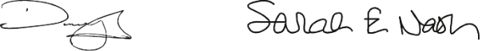

Daniel Heaf

Chief Executive Officer
Bath & Body Works, Inc.


Sarah E. Nash

Board Chair
Bath & Body Works, Inc.


Thank you for your continued support and confidence in Bath

- Body Works. We respectfully ask for your voting support on the matters set forth in this proxy statement.

TABLE OF CONTENTS

Notice of Annual Meeting of Shareholders

June 11, 2026




DATE: | TIME: | PLACE:
Thursday, | 8:30 a.m. | Meeting will be held virtually at
June 11, 2026 | Eastern Time | www.virtualshareholdermeeting.com/BBWI2026

ITEMS OF BUSINESS

- Elect the ten nominees proposed by the Board of Directors as directors.

- Ratify the appointment of our independent registered public accounting firm.

- Hold an advisory vote to approve named executive officer compensation.

- Transact such other business as may properly come before the meeting.

This proxy statement contains important information, including a description of the business that will be acted upon at the meeting. Shareholders will not be able to attend the meeting in person. Please see “Information About the Annual Meeting and Voting” on page 62 of this proxy statement for additional information regarding attendance at the meeting. Your vote is important. Shareholders of record can give proxies by calling a toll-free telephone number, by using the Internet or by mailing their signed proxy cards. Whether or not you plan to virtually attend the meeting, please vote by telephone or via the Internet, or sign, date and return the enclosed proxy card in the envelope provided. Instructions are included on your proxy card. You may change your vote by submitting a later dated proxy (including a proxy via telephone or the Internet) or by attending the meeting and voting virtually.

By Order of the Board of Directors,
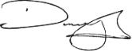

Daniel J. Heaf

Chief Executive Officer
April 28, 2026

Who May Vote

Shareholders of record at the close of business on April 14, 2026, may vote at the meeting.

Date of Mailing

A Notice of Internet Availability of Proxy Materials or this proxy statement and the enclosed proxy card is first being sent to shareholders on or about April 28, 2026.

Internet Availability

In accordance with Securities and Exchange Commission rules, we are using the Internet as our primary means of furnishing our proxy materials to most of our shareholders. Rather than sending those shareholders a paper copy of our proxy materials, we are sending them a Notice of Internet Availability of Proxy Materials with instructions for accessing the materials and voting via the Internet. We believe this method of distribution makes the proxy distribution process more efficient and less costly and limits our impact on the environment. This proxy statement and our Annual Report on Form 10-K for the fiscal year ended January 31, 2026, are available at www.bbwinc.com (see the “Investors” link followed by the “Annual Reports/Proxy” link).

TABLE OF CONTENTS

Table of Contents

1 2026 Proxy Statement Summary

- Safe Harbor Statement Under the Private Securities Litigation Reform Act of 1995

5​ Election of Directors

- The Board’s 2026 Director Nominees

7 Qualifications and Skills

7 A Broadly Representative Board

8 Board Nominees

13 Director Independence

- Board Refreshment and Selection of Director Nominees

15 Corporate Governance

- Corporate Governance Highlights

- Board Leadership Structure

17 Meeting Attendance

17 Committees of the Board

- Board and Committee Evaluations

- Meetings of Independent Directors

- Board Role in Strategic Planning and Capital Structure

- Board Role in Risk Oversight

- Code of Conduct, Insider Trading, Governance Documents and Related Person Transactions

- Human Capital & Compensation Committee Participation and Interlocks

- Director Stock Ownership Guidelines

- Contacting the Board

- Fiscal 2025 Director Compensation

- Ratification of the Appointment of Independent Registered Public Accounting Firm

- Report of the Audit Committee

- Independent Registered Public Accounting Firm’s Fees

25 Audit and Other Fees

25 Pre-approval Policies and Procedures

- Information About Our Executive Officers

- Advisory Vote to Approve Named Executive Officer Compensation

- Compensation-related Matters

- Compensation Discussion and Analysis

- 2025 Summary Compensation Table

- Grants of Plan-based Awards for Fiscal 2025

- Outstanding Equity Awards at Fiscal Year-end 2025

- Option Exercises and Stock Vested Information for Fiscal 2025

- Potential Payments Upon Termination or Change in Control

- 2025 Pay Ratio Disclosure

- 2025 Pay Versus Performance Disclosure

60 Beneficial Ownership of Common Stock

- Information About the Annual Meeting and Voting

65 General Matters

65 Delinquent Section 16(a) Reports

- Shareholder Proposals or Director Nominations for the 2027 Annual Meeting

- Other Proposed Actions

- Solicitation of Proxies

A-1 Appendix A – Non-GAAP Financial Measures

TABLE OF CONTENTS

2026 Proxy Statement Summary

This is a summary of information contained in this Proxy Statement about Bath & Body Works, Inc. (referred to in this proxy statement as “we,” “us,” “our” and the “Company”) and our upcoming 2026 annual meeting of shareholders. This summary does not contain all the information you should consider. Please carefully read the entire proxy statement before voting.

YOUR VOTE IS IMPORTANT

How to Vote Your Shares (See Page 62)

You may vote if you were a Company shareholder of record as of the close of business on April 14, 2026.

Online before the meeting

Go to the website designated on the enclosed proxy card or to the website indicated on the materials provided by your broker

By mail

Complete, sign and date the enclosed proxy card and return it promptly in the envelope provided

Roadmap for Voting Items

By phone

Call the phone number designated on the enclosed proxy card or the materials provided by your broker

Virtually during the annual meeting

Submit your vote online at the annual meeting on June 11, 2026


 |  | BOARD VOTE
ITEMS TO BE VOTED ON | VOTE STANDARD | RECOMMENDATION

Item 1. |  | FOR | See Page 6
Election of directors | Majority of votes cast | EACH NOMINEE
Item 2.
Ratification of the | Majority of votes present | FOR
appointment of independent | at the meeting or by | FOR | See Page 23
registered public accounting | proxy and voting thereon
firm

Item 3.

Advisory vote to approve named executive officer compensation

Majority of votes present
at the meeting or by ^{FOR} ^{See Page} ²⁷ proxy and voting thereon

Bath & Body Works, Inc. | 2026 Proxy Statement 1

TABLE OF CONTENTS

2026 Proxy Statement

Summary

Our Director Nominees (See Page 6)

The following table provides summary information about the ten director nominees the Board of Directors (the “Board”) has nominated for election at our 2026 annual meeting of shareholders. Additional information about each nominee’s background and experience can be found beginning on page 8 of this proxy statement.


 |  |  |  | COMMITTEE MEMBERSHIP
 |  |  |  | HUMAN CAPITAL & | NOMINATING &
NAME AND PRINCIPAL OCCUPATION | AGE | TENURE INDEPENDENT |  | AUDIT COMPENSATION | GOVERNANCE
Alessandro Bogliolo | 61 | 4.1 |  |  | C
Former CEO, Tiffany & Co. | 61 | 4.1 |  |  | C
Lucy Brady | 56 | 3.2
Former President, Snacks & Grocery, | 56 | 3.2
Conagra Brands, Inc.
Daniel Heaf | 48 | 0.9
CEO, Bath & Body Works, Inc.
Francis Hondal | 61 | 5.1 |  | C​
Former President of Loyalty & | 61 | 5.1 |  | C​
Engagement, Mastercard, Inc.
Danielle Lee
Former President, Warner Music Artist & | 50 | 5.1
Fan Experiences, Warner Music Group | 50 | 5.1
Corp.
Sarah Nash | 72 | 6.9
Chair of the Company’s Board; CEO & | 72 | 6.9
Owner of Novagard Solutions
Juan Rajlin | 51 | 4.1
Vice President & Treasurer, Alphabet Inc.
Stephen Steinour | 67 | 12.2
Chairman, President & CEO, | 67 | 12.2
Huntington Bancshares Incorporated
J.K. Symancyk | 54 | 4.9
CEO, Signet Jewelers Limited
Steven Voskuil | 57 | 3.1 |  | C​
Senior Vice President & CFO, | 57 | 3.1 |  | C​
The Hershey Company

C = committee chair

Director Nominee Highlights

90% |  |  | 5.0 Years | 58
of the Nominees
Joined the Board |  |  | Average | Average
in 2019 or Later |  |  | Tenure | Age
2 Bath & Body Works, Inc. |  | | 2026 Proxy Statement

TABLE OF CONTENTS

2026 Proxy Statement

Summary

Relevant Qualifications, Skills and Experience

We believe that our director nominees, as a whole, possess the optimal mix of qualifications, skills and experience that, taken together, provide us with the variety and depth of knowledge, judgment and vision necessary to provide effective oversight of the Company, including:
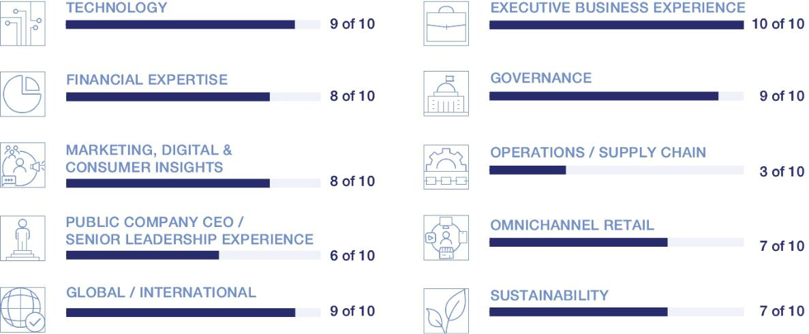

Governance Highlights (See Page 16)

The “Corporate Governance” section beginning on page 15 of this proxy statement describes our strong governance framework, which includes:

Independent Board Chair

Nine of ten director nominees are independent

Board actively involved in overseeing the Company’s long-term business strategy, strategic priorities and material risks

Shareholders have the right to call special meetings (25%)

Regular management succession planning

Proxy access rights

No shareholders rights plan in effect

Separate CEO and Board Chair roles

Independent directors meet without management present

Each of our standing Board committees is composed of 100% independent directors

All directors are elected annually by majority vote No supermajority voting requirements
Robust executive officer and director stock ownership guidelines

Annual Board and committee self-evaluations and bi-annual individual meetings between the Board Chair and each committee chair

Our Executive Compensation Program Aligns Pay-for-Performance (See Page 29)

Our executive compensation program is designed to emphasize pay-for-performance and to provide a meaningful and direct link between the interests of our named executive officers (“NEOs”) and those of our shareholders. We employ a pay mix philosophy that focuses on performance-based compensation, and we utilize rigorous performance metrics that align with our strategic direction, provide balance between top-line growth and profitability and are designed to drive total shareholder return.

Bath & Body Works, Inc. | 2026 Proxy Statement 3

TABLE OF CONTENTS

Safe Harbor Statement Under the Private Securities Litigation Reform Act of 1995

We caution that any forward-looking statements (as such term is defined in the Private Securities Litigation Reform Act of 1995) contained in this proxy statement or made by our Company or our management involve risks and uncertainties and are subject to change based on various factors, many of which are beyond our control. Accordingly, our future performance and financial results may differ materially from those expressed or implied in any such forward-looking statements. Words such as “estimate,” “project,” “plan,” “believe,” “expect,” “anticipate,” “intend,” “potential,” “target,” “goal” and any similar expressions may identify forward-looking statements. The forward-looking statements contained in this proxy statement are subject to certain risks, uncertainties and other factors that could affect our financial performance and actual results and could cause actual results to differ materially from those expressed or implied in any forward-looking statements included in this proxy statement or otherwise made by our Company or our management. We are not under any obligation and do not intend to make publicly available any update or other revisions to any of the forward-looking statements contained in this proxy statement to reflect circumstances existing after the filing date of this proxy statement or to reflect the occurrence of future events even if experience or future events make it clear that any expected results expressed or implied by those forward-looking statements will not be realized. Additional information regarding these and other factors can be found in “Item 1A. Risk Factors” in the Company’s 2025 Annual Report on Form 10-K for the fiscal year ended January 31, 2026 (the “2025 10-K”), as filed with the Securities and Exchange Commission (the “Commission”), and our subsequent filings.

4 Bath & Body Works, Inc. | 2026 Proxy Statement

TABLE OF CONTENTS


Election of Directors

(Item 1 on the Proxy Card)

Our Board is elected annually by our shareholders and currently has ten members. Each director is, and throughout his or her service during fiscal 2025 was, independent in accordance with applicable New York Stock Exchange (“NYSE”) standards other than Daniel Heaf, our Chief Executive Officer.

In this Section

- The Board’s 2026 Director Nominees

7 Qualifications and Skills

7 A Broadly Representative Board

8 Board Nominees

13 Director Independence

- Board Refreshment and Selection of Director Nominees

Bath & Body Works, Inc. | 2026 Proxy Statement 5

TABLE OF CONTENTS

Election of

Directors

The Board’s 2026 Director Nominees

The Nominating & Governance Committee is responsible for considering candidates for the Board and recommending director nominees for the Board. After evaluating the performance, qualifications, skills and experience of each of the current Board members and the composition of our full Board, based upon the recommendations of the Nominating & Governance Committee, the Board has recommended the election of ten directors.


THE BOARD UNANIMOUSLY RECOMMENDS THAT SHAREHOLDERS

- VOTE “FOR” THE ELECTION OF EACH OF THE NOMINEES LISTED BELOW.



Sarah Nash

CEO and Owner,
Novagard Solutions, and

Board Chair,
Bath & Body Works, Inc.



Lucy Brady

Former President,
Snacks & Grocery,
Conagra Brands, Inc.



Francis Hondal

Former President,
Loyalty & Engagement,
Mastercard Inc.



Juan Rajlin

VP & Treasurer,
Alphabet Inc.



J.K. Symancyk

CEO and Director,
Signet Jewelers Limited

Alessandro Bogliolo

Former CEO,
Tiffany & Co.



Daniel Heaf

CEO,
Bath & Body Works, Inc.



Danielle Lee

Former President,
Warner Music Artist &
Fan Experiences,
Warner Music Group Corp.



Stephen Steinour

Chairman, President & CEO, Huntington Bancshares Incorporated



Steven Voskuil

SVP & CFO,
The Hershey Company

6 Bath & Body Works, Inc. | 2026 Proxy Statement

TABLE OF CONTENTS

Election of

Directors

We believe that our director nominees, as a whole, possess the right mix of qualifications, skills and experience that, taken together, provide us with the variety and depth of knowledge, judgment and vision necessary to provide effective oversight of the Company. The tables below summarize the skills, qualifications and attributes of our director nominees.

Qualifications and Skills

QUALIFICATIONS / SKILLS

Technology

Knowledge of or experience with technology, including digital solutions, information technology systems and architecture, artificial intelligence, and/or cybersecurity or data security

Executive Business Experience

Experience serving in an executive capacity in a public company

Financial Expertise

Knowledge of or experience in capital markets, capital allocation, corporate finance and/or accounting

Governance

Experience serving on a public company board or developing corporate governance policies or investor relations programs for public companies

Marketing, Digital & Consumer Insights

Experience in marketing, branding, digital and e-commerce, data analytics, customer loyalty and/or consumer insights

Operations / Supply Chain

Experience with multi-site operational management, including logistics, distribution and/or fulfillment

Public Company CEO / Senior Leadership Experience

Experience serving as a chief executive officer or in a similar leadership position of a public company

Omnichannel Retail

Retail or consumer products experience or experience connecting digital and physical commerce, including services and capabilities, organizational structure and related solutions

Global / International

International experience or experience managing international operations or organizations

Sustainability

Expertise in sustainability

 | BOGLIOLO | BRADY |  | HEAF | HONDAL |  | LEE | NASH |  | RAJLIN | STEINOUR |  | SYMANCYK | VOSKUIL
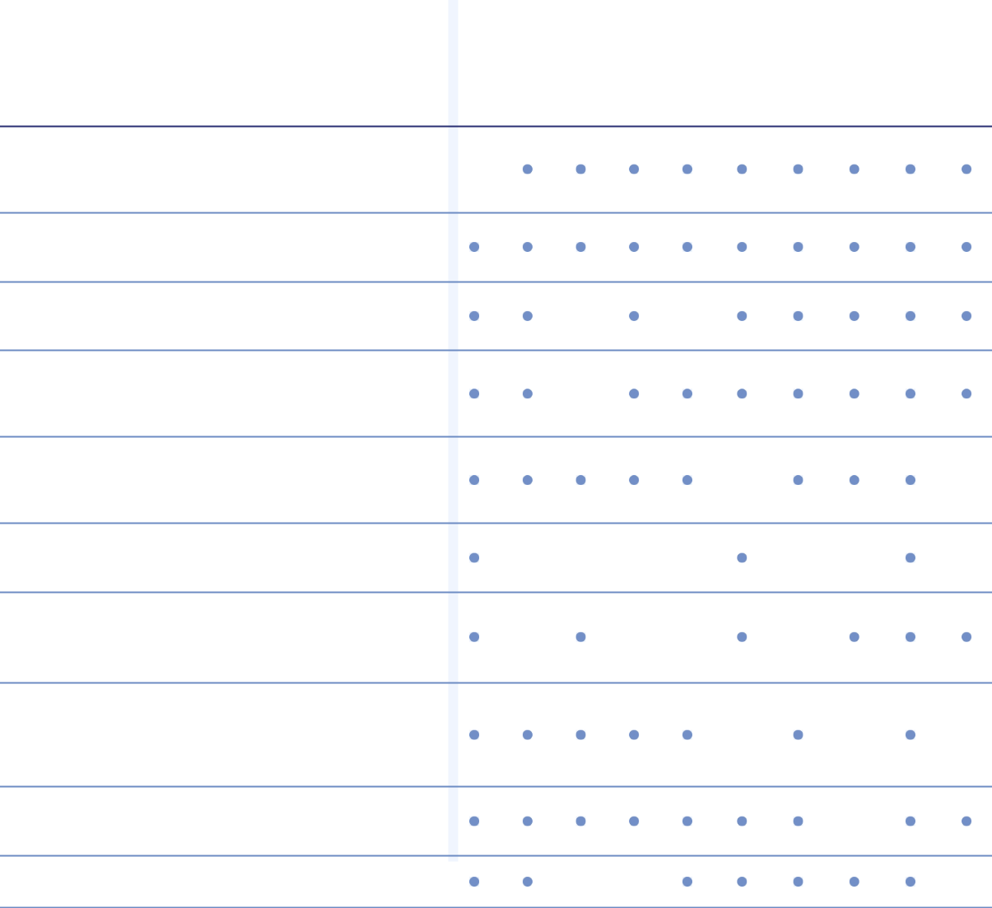

A Broadly Representative Board
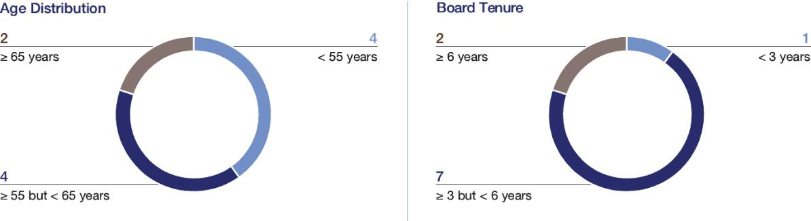

Each of the ten individuals nominated for election to the Board would hold office until our 2027 annual meeting of shareholders or until his or her successor is elected and qualified. If any nominee is unable to serve, your proxy may vote for another nominee proposed by the Board; alternatively, the Board may elect to reduce the size of the Board. We are unaware of any nominee of the Board who would be unable to serve as a director if elected.

Bath & Body Works, Inc. | 2026 Proxy Statement 7

TABLE OF CONTENTS

Election of

Directors

Following is additional information about the experience and qualifications of each of the nominees for director that led the Board to conclude that the director nominee would provide valuable insight and guidance as a member of the Board.

Board Nominees


Alessandro Bogliolo

INDEPENDENT DIRECTOR

Age: 61

Director since: 2022

Committees:

Human Capital & Compensation Nominating & Governance

Career Highlights

• Chief Executive Officer and director of Tiffany & Co. (“Tiffany”), a luxury jewelry and specialty retailer (October 2017 through the acquisition of Tiffany, then a publicly traded company, by LVMH Moët Hennessy Louis Vuitton SE in January 2021)

• Chief Executive Officer and director of Diesel SpA, an international fashion brand that is part of the OTB Group (2013 to 2017)

• Senior roles in Asia, Europe and the US, including as Chief Operating Officer, North America, for Sephora USA and Executive Vice President and Chief Operating Officer of Bulgari (2011 to 2013)

• Born in Italy, Mr. Bogliolo also serves as the chairman of the board of Audemars Piguet, a Swiss manufacturer of luxury mechanical watches

Other Current Public Company Boards

Hyatt Hotels Corporation, an international hotel chain, since December 2023

Education

Mr. Bogliolo graduated from Bocconi University with a degree in Business Administration. He also attended Ecole des Hautes Etudes Commerciales’s International Management Program.


Key Qualifications

Mr. Bogliolo’s nomination is supported by his extensive executive, strategic and operational leadership experience, including as chief executive officer of a publicly traded retail brand, his deep knowledge of the retail industry and consumers, his international experience and perspective and his service on other public company boards of directors.

Lucy O. Brady


INDEPENDENT DIRECTOR

Age: 56

Director since: 2023

Committees:

Human Capital & Compensation Nominating & Governance

Career Highlights

• President, Snacks and Grocery at Conagra Brands, Inc. (“Conagra”), a publicly traded leading branded food company (June 2022 to February 2025)

• Senior Vice President and Chief Digital Customer Engagement Officer (January 2020 to April 2022) and Senior Vice President of Corporate Strategy, Business Development and Innovation (September 2016 to January 2020) at McDonald’s Corporation (“McDonald’s”), the owner and operator of McDonald’s restaurants located in more than 100 countries

• Prior to joining McDonald’s, Ms. Brady served as Managing Director and Senior Partner at The Boston Consulting Group

Education

Ms. Brady received a B.A. in Economics from the Wharton School at the University of Pennsylvania and has an M.B.A. from the Stanford University Graduate School of Business.


Key Qualifications

Ms. Brady’s nomination is supported by her omnichannel retail and consumer products experience, her executive leadership and corporate strategy experience and her expertise in global digital strategy and customer loyalty and engagement. As President, Snacks and Grocery, Ms. Brady led the ongoing modernization and growth of Conagra’s $5 billion grocery and snacks portfolio. In addition, Ms. Brady oversaw some of McDonald’s most significant growth drivers, including delivery, loyalty, digital ordering and pickup and personalized communications.

8 Bath & Body Works, Inc. | 2026 Proxy Statement

TABLE OF CONTENTS

Election of

Directors


Daniel J. Heaf

CHIEF EXECUTIVE OFFICER

Age: 48

Director since: 2025

Career Highlights

• Chief Strategy and Transformation Officer at Nike Inc. (“Nike”), a publicly traded retail company

(August 2023 – March 2025), built Nike’s Transformation Office and developed Nike’s corporate, functional, consumer, and geography strategies

• Vice President and Head of Nike Direct (April 2020 – August 2023), oversaw 45,000 employees in 9,000 stores across 41 companies, managing the global direct-to-consumer (DTC) business

• Prior to joining Nike, Mr. Heaf served as Senior Vice President of Digital, Digital Marketing, and Customer Service & Data at Burberry

Education

Mr. Heaf received a B.A. from the University of Nottingham’s School of Geography.


Key Qualifications

Mr. Heaf’s nomination is supported by his extensive experience executing transformation growth strategies across consumer goods, media, retail and technology sectors. He was Chief Strategy and Transformation Officer at Nike Inc., where he built Nike’s Transformation Office and developed its corporate, functional, consumer and geography strategies. Prior to that, he led Nike’s direct-to-consumer (DTC) business, growing it from

$10.4 billion in 2018 to $22.3 billion in 2023, and expanding Nike’s portfolio of digital applications.

Francis A. Hondal

INDEPENDENT DIRECTOR

Age: 61

Director since: 2021

Committees:

Audit

Human Capital & Compensation

Career Highlights

• President, Loyalty & Engagement (September 2018 to March 2022); Executive Vice President, Global Credit/Loyalty Products and Services (September 2015 to September 2018); and Executive Vice President of Products, Marketing and Advisors at Mastercard within the Latin American region (August 2011 to September 2015) at Mastercard Inc. (“Mastercard”), a global technology company in the payments industry

• Prior to joining Mastercard, Ms. Hondal spent 17 years at American Express Company in global and regional general management, marketing and finance roles within its consumer services division

• Member of the board of directors of the Florida International University Foundation

Other Current Public Company Boards

Equitable Holdings, Inc., a financial services holding company composed of two principal franchises, Equitable and AllianceBernstein since 2020

Education

Ms. Hondal has a B.A. in Finance and International Business and an M.B.A. from Florida International University.


Key Qualifications

Ms. Hondal’s nomination is supported by her extensive international general management experience, finance, data-driven marketing, and deep expertise in customer acquisition and engagement. She previously served as President of Loyalty and Engagement at Mastercard and was a member of the Mastercard management committee. She held senior leadership roles at American Express, overseeing regional and global businesses with P&L responsibility. She is a former member of the Board of Trustees of Florida International University (FIU) and currently serves on the FIU Foundation board of directors.

Bath & Body Works, Inc. | 2026 Proxy Statement 9

TABLE OF CONTENTS

Election of

Directors


Danielle M. Lee

INDEPENDENT DIRECTOR

Age: 50

Director since: 2021

Committees:

Human Capital & Compensation Nominating & Governance

Career Highlights

• President, Warner Music Artist and Fan Experiences (June 2021 to June 2023) at Warner Music Group Corp. (“Warner Music”), a publicly traded music entertainment company

• Chief Fan Officer (March 2020 through May 2021) with the National Basketball Association (the “NBA”), a professional basketball league

• Global Vice President, Partner Solutions (March 2016 to March 2020) at Spotify Technology S.A. (“Spotify”)

• Prior to Spotify, Ms. Lee served as Global Vice President, Commercial Marketing at Vevo LLC and spent seven years at AT&T Inc. and served as Vice President of Product Marketing and Innovation for AT&T AdWorks after beginning her career at Showtime Networks Inc.

• Member of the board of directors of Applause App Quality, Inc., a digital testing company owned by Vista Equity Partners

Education

Ms. Lee holds a B.A. from Columbia University and an M.B.A. from Columbia Business School.


Key Qualifications

Ms. Lee’s nomination is supported by her extensive experience and involvement in brand-building, product innovation and strategic marketing across technology, media and entertainment. At Warner Music, Ms. Lee led an in-house creative agency for the Warner Recorded Music roster as well as for third-party musical artists. At the NBA, she oversaw brand, creative and multiplatform fan marketing globally and was charged with elevating brand perceptions, cultural connection and fan engagement. At Spotify, she was responsible for developing go-to-market strategy and growing global revenue across music, podcasts and high-impact digital experiences.

Sarah E. Nash


INDEPENDENT BOARD CHAIR

Age: 72

Director since: 2019

Board Chair

Career Highlights

• Independent Chair of the Company’s Board (January 2023 to present and May 2020 to February 2022)

• Interim Chief Executive Officer of the Company (May 2022 through November 2022) and Executive Chair of the Board (February 2022 to January 2023), following the resignation of the Company’s Chief Executive Officer in May 2022

• Chief Executive Officer and owner (2018 to present) of Novagard Solutions, an innovator and manufacturer of silicone sealants and coatings and hybrid and foam solutions for the building systems, electronics, EV and battery, and industrial and transportation markets

• Ms. Nash spent nearly 30 years in investment banking at JPMorgan Chase & Co. (and predecessor companies), a financial services firm, retiring as vice chairman of global investment banking in July 2005

• Ms. Nash has also served on the board of directors of Irving Oil Company and as a member of the National Board of the Smithsonian Institution

• She currently serves on the board of directors of HBD Industries, Inc. and as a trustee of the

New York-Presbyterian Hospital, a member of the Smithsonian Tropical Research Institute, Panama, the chair of the International Advisory Board of the Montreal Museum of Fine Arts and a trustee for the Cleveland Museum of Art

Other Former Public Company Boards

Blackbaud, Inc. (2010-2025)

Knoll, Inc. (2006 through its acquisition by Herman Miller, Inc. in 2021)

Education

Ms. Nash holds a B.A. in political science from Vassar College.


Key Qualifications

Ms. Nash’s nomination is supported by her extensive experience in capital markets, strategic transactions, operations and corporate governance as well as her management expertise.

10 Bath & Body Works, Inc. | 2026 Proxy Statement

TABLE OF CONTENTS


Juan Rajlin

INDEPENDENT DIRECTOR

Age: 51

Director since: 2022

Committees:

Audit

Nominating & Governance

Career Highlights

• Vice President and Treasurer (October 2018 to present) of Alphabet Inc. (“Alphabet”), a publicly traded multinational technology company, and its subsidiary Google LLC

• Chief Financial Officer, Products and Services (October 2017 to September 2018) and Corporate Treasurer and Chief Risk Officer (February 2013 to October 2017) of Mastercard

• Before joining Mastercard, Mr. Rajlin held various roles with increasing levels of responsibility at General Motors Company

Education

Born in Argentina, Mr. Rajlin holds a B.S. in economics from Universidad Torcuato Di Tella in Argentina and an M.B.A. from Columbia University.


Key Qualifications

Mr. Rajlin’s nomination is supported by his extensive finance and risk management experience, his experience with financial and capital allocation matters, consumer-driven technologies and sustainability matters and his deep international experience and perspective. In Mr. Rajlin’s role with Alphabet, he oversees over $100 billion of investments, corporate finance policy and financial risk management. He is also a key executive overseeing Google’s sustainability strategy.

Election of

Directors


Stephen D. Steinour

INDEPENDENT DIRECTOR

Age: 67

Director since: 2014

Committees:

Audit

Human Capital & Compensation

Career Highlights

• Chairman, President and Chief Executive Officer since 2009 of Huntington Bancshares Incorporated (“Huntington”), a publicly traded bank holding company

• Interim Lead Independent Director on the Company’s Board (March 2022 to January 2023)

• Managing Partner (2008 to 2009) with CrossHarbor Capital Partners, LLC, a recognized leading manager of alternative investments

• Mr. Steinour was with Citizens Financial Group from 1992 to 2008, where he served in various executive roles, including Vice Chairman from 1997 to 2007 and President and Chief Executive Officer from 2007 to 2008

• Mr. Steinour also serves as a supervisory board member of The Clearing House, a real-time payments platform and he previously served as a trustee of Liberty Property Trust, a real estate investment trust, from 2010 to 2014 and as a director of the Federal Reserve Bank of Cleveland, from 2017 to 2019

Other Current and Former Public Company Boards

Huntington, since 2009

Exelon Corporation, a utility services holding company, from 2007 to 2020

Education

Mr. Steinour holds a bachelors in economics from Gettysburg College and completed the Stanford University Graduate School of Business Executive Program in Leadership.


Key Qualifications

Mr. Steinour’s nomination is supported by his extensive executive experience, financial expertise and service on several public company boards of directors.

Bath & Body Works, Inc. | 2026 Proxy Statement 11

TABLE OF CONTENTS

Election of

Directors


J.K. Symancyk

INDEPENDENT DIRECTOR

Age: 54

Director since: 2021

Committees:

Audit

Nominating & Governance

Career Highlights

• Chief Executive Officer and director of Signet Jewelers Limited, a specialty jewelry retailer, since November 2024

• President and Chief Executive Officer and a director (June 2018 to September 2024) of PetSmart LLC, a large specialty pet retailer

• Chief Executive Officer (September 2015 to June 2018) of Academy Sports and Outdoors, Inc., a sporting goods and outdoor recreation retailer (“Academy Sports”)

• Mr. Symancyk has nearly 30 years of industry experience managing complex retail organizations, including in roles of increasing responsibility with each of Academy Sports, Meijer and Walmart Stores

Former Public Company Boards

Chewy, Inc., an online retailer for pet products, supplies and prescriptions, from June 2018 through July 2021

GameStop Corp., a gaming and entertainment products retailer, from March 2020 to June 2021

Education

Mr. Symancyk holds a B.A. from the University of Arkansas.


Key Qualifications

Mr. Symancyk’s nomination is supported by his executive experience, including as a leading retail chief executive officer, his financial and operational experience, and his deep understanding of the retail industry.

Steven E. Voskuil


INDEPENDENT DIRECTOR

Age: 57

Director since: 2023

Committees:

Audit

Human Capital & Compensation

Career Highlights

• Senior Vice President and Chief Financial Officer (2019 to present) of The Hershey Company (“Hershey”), a global confectionary leader

• Senior Vice President and Chief Financial Officer (2014 to 2019) of Avanos Medical, Inc. (previously Halyard Health, Inc.) (“Avanos”), a publicly traded global medical device company serving healthcare needs in more than 90 countries, after he led Avanos’ successful spin-off from Kimberly-Clark Corporation (“Kimberly-Clark”) in 2014

• Prior to Avanos, he worked for 23 years at Kimberly-Clark, including serving as Chief Financial Officer of Kimberly-Clark International and Vice President and Treasurer of Kimberly-Clark

• Since 2023, Mr. Voskuil has served on the Economic and Community Advisory Council for the Federal Reserve Bank of Philadelphia, and currently as Vice Chairman

Education

Mr. Voskuil received a B.B.A. in Finance from the University of Wisconsin, and has a Master’s degree in Management from the Stanford Graduate School of Business.


Key Qualifications

Mr. Voskuil’s nomination is supported by his extensive financial (including capital allocation) and executive experience, including as chief financial officer of a Fortune 500 company, his international business experience and his consumer products experience. At Hershey, Mr. Voskuil is responsible for leading Hershey’s global finance organization, including financial planning and analysis, accounting and reporting, tax, treasury, internal audit and investor relations.

WE RECOMMEND THAT YOU VOTE “FOR” THE ELECTION OF EACH

- NOMINEE TO OUR BOARD OF DIRECTORS.

12 Bath & Body Works, Inc. | 2026 Proxy Statement

TABLE OF CONTENTS

Director Independence

The Board has determined that each of the individuals nominated to serve on the Board (except for Mr. Heaf, our Chief Executive Officer, and Ms. Boswell, who resigned from the Board effective May 16, 2025) has no material relationship with the Company other than in his or her capacity as a director of the Company and that each is “independent” in accordance with applicable NYSE standards. If all director nominees are elected to serve as our directors at our 2026 annual meeting, independent directors will continue to constitute 90% of our Board.

Election of

Directors


90%
of our Board are Independent

9 of 10 directors

In making these determinations, the Board took into account all factors and circumstances that it considered relevant, including, where applicable, the existence of any employment relationship between the director or a member of the director’s immediate family and the Company; whether within the past three years the director or a member of the director’s immediate family has served as an executive officer of the Company; whether the director or a member of the director’s immediate family has received, during any 12-month period within the last three years, direct compensation from the Company in excess of $120,000 (other than compensation in respect of such person’s service on the Board); whether the director or a member of the director’s immediate family has been, within the last three years, a partner or an employee of the Company’s internal or external auditors; and whether the director or a member of the director’s immediate family is employed by an entity that is engaged in business dealings with the Company that exceed the greater of $1 million or 2% of such entity’s consolidated gross revenues. The Board has not adopted categorical standards with respect to director independence. The Board believes that it is more appropriate to make independence determinations on a case-by-case basis in light of all relevant factors.

Board Refreshment and Selection of Director Nominees

The Company believes that an effective Board consists of individuals who possess a variety of complementary skills, a range of tenures, a diversity of perspectives and expertise in key areas supporting our business and evolving strategy. Accordingly, the Nominating & Governance Committee and the Board consider the performance, contributions, skills and experience of our Board members in the broader context of the Board’s overall composition, with a view toward constituting a Board that has the integrity, judgment, skill set, experience and other characteristics to oversee the broad set of challenges that the Company faces and evaluate management on executing the Company’s strategy. Refreshment of the Board promotes the long-term interests of our shareholders and strengthens Board and management accountability.


The Board has in place a robust refreshment process.

If all nominees are elected to serve as directors at the 2026 annual meeting,

90%

of the Company’s directors will have joined the Board in 2019 or later

5.0 Years

will be the average director tenure on our Board

In assessing new individuals to serve as directors and committee members, the Nominating & Governance Committee takes into account the qualifications of existing directors for continuing service or re-nomination, which may be affected by, among other things, the quality of their contributions, their attendance records, changes in their primary employment or other business affiliations, the number of boards of publicly traded companies on which they serve or other competing demands on their time and attention. While the Board has not established any specific minimum qualifications for director nominees, as indicated in the Company’s corporate governance principles, the directors and any potential nominees should possess the integrity, judgment, skills, experience and other characteristics that are deemed necessary or desirable for the effective performance of the Board’s oversight function. Certain of the skills, qualifications and particular areas of expertise considered with respect to the members of the Board are summarized under the heading “Election of Directors—The Board’s 2026 Director Nominees” and in the director biographies found on pages 8 through 12 of this proxy statement. The Company’s corporate governance principles provide that the Board will be composed of members of diverse backgrounds. The Nominating & Governance Committee considers the diversity of experience, background and expertise of the current directors and areas where new directors might add additional perspectives as factors in the selection of Board nominees.

Bath & Body Works, Inc. | 2026 Proxy Statement 13

TABLE OF CONTENTS

Election of

Directors

The Nominating & Governance Committee does not have a formal policy regarding the consideration of director candidates recommended by shareholders. The Board believes that it is more appropriate to provide the Nominating & Governance Committee flexibility in evaluating shareholder recommendations. If a director nominee is recommended by a shareholder, the Nominating & Governance Committee will give due consideration to the director nominee and will use the same criteria used for evaluating individuals nominated by the Board, in addition to considering the information relating to the director nominee provided by the shareholder. Shareholders may submit recommendations for director candidates for consideration by the Nominating & Governance Committee by contacting the committee as described under the heading “Contacting the Board” found on page 21.

14 Bath & Body Works, Inc. | 2026 Proxy Statement

TABLE OF CONTENTS


Corporate Governance

The Company has a long-standing commitment to strong corporate governance, which promotes the long-term interests of our shareholders, strengthens Board and management accountability and helps build stakeholder trust in the Company. The Board regularly reviews the Company’s major governance documents, policies and processes in the context of current governance trends, recognized best practices and legal and regulatory changes.

The following sections provide an overview of our corporate governance structure, policies and processes, including key aspects of our Board’s and its committees’ operations.

In this Section

- Corporate Governance Highlights

- Board Leadership Structure

17 Meeting Attendance

17 Committees of the Board

- Board and Committee Evaluations

- Meetings of Independent Directors

- Board Role in Strategic Planning and Capital Structure

- Board Role in Risk Oversight

- Code of Conduct, Insider Trading, Governance Documents and Related Person Transactions

- Human Capital & Compensation Committee Participation and Interlocks

- Director Stock Ownership Guidelines

- Contacting the Board

- Fiscal 2025 Director Compensation

Bath & Body Works, Inc. | 2026 Proxy Statement 15

TABLE OF CONTENTS

Corporate

Governance

Corporate Governance Highlights

INDEPENDENT BOARD OVERSIGHT

 | Majority Independent Board | Our Board includes ten members, nine of whom are independent, including our independent Board Chair.
 | Separate Board Chair and | The Chief Executive Officer and Board Chair are two separate people. The Chief Executive Officer and
 | Separate Board Chair and | Board Chair roles are required to be separated pursuant to our Nominating & Governance Committee
 | CEO Roles
 | CEO Roles | charter.
 | Independent Board | Each of our standing Board committees is composed solely of independent directors.
 | Committees
 |  | Our Board oversees the Company’s strategy, capital structure (including capital allocation), risk
 | Oversight of Critical Matters | management, financial and other controls, legal and regulatory, ethics and compliance, technology,
 |  | cybersecurity, artificial intelligence, data security, culture and sustainability matters.
 | Management Succession | Our Board regularly reviews succession plans for our Chief Executive Officer and other senior
 | Management Succession | management positions.
 | Independent Executive | At every regular Board meeting, time is set aside for the independent directors to meet in
 | Sessions | executive session.

SHAREHOLDER RIGHTS AND ACCOUNTABILITY

 | Annual Board Elections | All directors are elected annually. We do not have a classified Board.
 | Majority Voting Requirements | Neither our Certificate of Incorporation nor our Amended and Restated Bylaws (the “Bylaws”) has a
 | Majority Voting Requirements | supermajority voting requirement.
 |  | Our Bylaws include proxy access rights, permitting up to 20 shareholders owning 3% or more of the
 | Proxy Access | outstanding shares of the Company’s common stock continuously for at least three years to nominate the
 |  | greater of two directors or up to 20% of our Board and include those nominees in our proxy materials.
 | Shareholder Ability to Call | Shareholders who own at least 25% of the outstanding shares of the Company’s common stock may call a
 | Special Meetings | special meeting of shareholders.
 | Majority Voting Standard for | In uncontested director elections, directors are elected by a majority of votes cast.
 | Uncontested Director
 | Elections
 | No Shareholder Rights Plan | We do not have a shareholder rights plan / “poison pill” in effect.

BOARD STRUCTURE

 |  | Director Nominee |  | We believe that our director nominees, as a whole, possess the optimal mix of qualifications, skills
 |  | Qualifications and Skills |  | and experience.
 |  |  |  | Under the Company’s corporate governance principles, directors may serve on no more than four public
 |  | Director Overboarding Policy |  | company boards (including the Company’s Board), and any director who is also a named executive officer
 |  | Director Overboarding Policy |  | of another public company may serve on no more than two public company boards (including the
 |  |  |  | Company’s Board).
 |  | Self​-evaluations |  | The Board and its committees engage in self-evaluation at least annually, including bi-annual individual
 |  | Self​-evaluations |  | meetings between the Board Chair and each committee chair.
16 Bath & Body Works, Inc. | |  |  | 2026 Proxy Statement

TABLE OF CONTENTS

Corporate

Governance

Board Leadership Structure

Mr. Heaf serves as Chief Executive Officer and Ms. Nash serves as Board Chair. Ms. Nash, who has chaired our Board since May 2020, served as independent Board Chair throughout fiscal 2025. The charter of the Nominating & Governance Committee provides that the positions of Board Chair and Chief Executive Officer will be held by different persons. If the Board Chair is not an independent director, our corporate governance principles further provide that an independent director will be appointed by the independent directors of the Board as the lead independent director (the “Lead Independent Director”). If a Lead Independent Director is appointed, the Lead Independent Director will have the following responsibilities:

- preside at all meetings of the Board at which the Board Chair is not present, including executive sessions of the independent and non-management directors;

- serve as liaison between the Board Chair and the independent and non-management directors;

- approve information sent to the Board;

- collaborate with the Board Chair to set meeting agendas for the Board;

- approve meeting schedules to assure that there is sufficient time for discussion of all agenda items;

- have the authority to call meetings of the independent and non-management directors;

- if requested by major shareholders, ensure that he or she is available for consultation and direct communication;

- assist the Board Chair and the Board in assuring compliance with and implementation of the Company’s corporate governance principles; and

- perform any other duties that may be deemed appropriate or necessary by the Board.

The Board believes that the separated roles of Board Chair and Chief Executive Officer, and the significant responsibilities of a Lead Independent Director if the Board Chair is not independent, provide an appropriate balance between leadership and independent oversight.


Given​ that we currently have an

Independent

Board Chair,

we do not have a

Lead Independent Director.

Meeting Attendance

During fiscal 2025, our Board held eight meetings and all of the then-current directors attended 75% or more of the total number of meetings of the Board and of the committees of the Board on which they served. Each director is expected to dedicate sufficient time, energy and attention to ensure the diligent performance of the director’s duties, including by attending meetings of the Board and the committees of which the director is a member.

The Company does not have a formal policy regarding attendance by members of the Board at the Company’s annual meeting of shareholders. However, it encourages directors to attend and historically nearly all have done so. All of the then-current Board members attended the 2025 annual meeting of shareholders.

Committees of the Board

During fiscal 2025, the Board had a standing Audit Committee, Human Capital & Compensation (“HCC”) Committee and Nominating & Governance Committee. The charters for the Audit, HCC and Nominating & Governance Committees are available on the Company’s website at www.bbwinc.com (see the “Investors” link followed by the “Committee Charters and Governance Materials” link). The current members of our committees, the principal roles and responsibilities of each committee and the number of meetings each committee held during fiscal 2025 are reflected on the next page. Each member of each committee during fiscal 2025 was, and each current member continues to be, independent in accordance with the Company’s corporate governance principles and applicable NYSE standards and Commission rules.

Bath & Body Works, Inc. | 2026 Proxy Statement 17

TABLE OF CONTENTS

Corporate

Governance

Audit

Committee

MEMBERS: NUMBER OF MEETINGS

Steven Voskuil (Chair) IN FISCAL 2025: 8
Francis Hondal
Juan Rajlin
Stephen Steinour
J.K. Symancyk


PRINCIPAL ROLES AND RESPONSIBILITIES

• Oversees the integrity of the Company’s financial | •​ Reviews and evaluates the qualifications, independence and
statements and internal controls | performance of the Company’s independent auditors
• Assists the Board with overseeing the Company’s risk | • Reviews and evaluates the performance of the Company’s
management framework, including reviewing the Company’s | internal audit function
policies and practices with respect to risk identification, | • Oversees the Company’s compliance with legal and
assessment, mitigation and management, including review | • Oversees the Company’s compliance with legal and
assessment, mitigation and management, including review | regulatory requirements, including oversight of the
of the Company’s policies and practices with respect to | Company’s Code of Conduct and the Company’s ethics and
cybersecurity, data security, technology, privacy and artificial | compliance function, including receiving at least quarterly
intelligence risk exposures | reports from such function

The Board has determined that each of the Audit Committee members qualifies as an “audit committee financial expert” within the meaning of the regulations promulgated by the Commission.

Human Capital

& Compensation Committee

MEMBERS: NUMBER OF MEETINGS

Francis Hondal (Chair) IN FISCAL 2025: 7
Alessandro Bogliolo
Lucy Brady
Danielle Lee
Stephen Steinour
Steven Voskuil


PRINCIPAL ROLES AND RESPONSIBILITIES

• Oversees and assists the Board with the human capital management of the Company, including organizational engagement and effectiveness, culture, leadership development and succession planning, talent attraction and retention strategies, and enterprise-wide employee engagement and development programs

• Reviews and makes recommendations to the Board with respect to succession plans for the Chief Executive Officer, executive officers and other members of senior management as designated by the HCC Committee

• Reviews and approves the Company’s compensation and benefits philosophy and policies

• Approves corporate goals and objectives relevant to the compensation of the Chief Executive Officer, executive officers and other members of senior management as designated by the HCC Committee

• Evaluates the Chief Executive Officer’s performance in light of the corporate goals and objectives, and sets the Chief Executive Officer’s compensation

• Oversees the compensation structure for other executive officers of the Company and other members of senior management as designated by the HCC Committee and, based on the recommendations of the Company’s Chief Executive Officer, approves such officers’ compensation

• Evaluates and recommends for approval by the Board compensation for the Company’s directors

• Reviews, approves and oversees the stock ownership guidelines for the Company’s executive officers and directors and any other associates of the Company as the HCC Committee deems appropriate

• Administers any Company policies related to the clawback, forfeiture, recoupment or recovery of compensation

• Conducts an annual review and risk assessment of the Company’s compensation policies and practices

• Reviews the independence of the committee’s compensation consultant

The HCC Committee may delegate its authority to subcommittees or the HCC Committee chair as it deems appropriate and in the best interests of the Company, provided that periodic reports by the parties receiving any such delegation are made to the full HCC Committee in accordance with the terms of the delegation. In accordance with its charter, the HCC Committee may also delegate to one or more Company officers its authority to make stock awards to any individual who is not an executive officer of the Company. The HCC Committee has delegated to our Chief Human Resources Officer the authority to make stock awards under the provisions of the Company’s 2020 Stock Option and Performance Incentive Plan (the “2020 Plan”) with a value up to $500,000 in any year to any associate who is not a Section 16 officer of the Company.

18 Bath & Body Works, Inc. | 2026 Proxy Statement

TABLE OF CONTENTS

Corporate

Governance

Nominating & Governance Committee

MEMBERS: NUMBER OF MEETINGS

Alessandro Bogliolo (Chair) IN FISCAL 2025: 4
Lucy Brady
Danielle Lee
Juan Rajlin
J.K. Symancyk


PRINCIPAL ROLES AND RESPONSIBILITIES

• Identifies individuals qualified to become Board members

• Proposes a slate of candidates for election as directors at each annual meeting or special meeting of shareholders at which directors are to be elected, to fill any vacancies or newly created directorships that may occur between such meetings, and to consider and review the qualifications of any individual nominated for election by shareholders

• Provides oversight on governance issues relating to the composition and operation of the Board, including recommending criteria for selection of candidates to the Board and its committees and, together with the Board Chair, recommends to the Board changes to the size and structure of the Board or its committees consistent with such criteria

• Develops and recommends to the Board, and reviews from time to time, the Company’s corporate governance principles and monitors compliance with such principles

Board and Committee Evaluations

• Oversees the evaluation of the performance of the Board and its committees and recommends ways to improve Board and committee performance

• Reviews the Company’s actions in furtherance of its corporate social responsibility, including sustainability and philanthropic initiatives, including the impact of Company procedures and processes on associates, citizens and communities

• Reviews the independence of directors

• Oversees orientation programs and continuing education opportunities for directors

• Stays abreast of developments in corporate governance generally

To ensure that the Board and its committees remain effective, the Nominating & Governance Committee oversees a robust annual evaluation of the Board, the Audit Committee, the HCC Committee and the Nominating & Governance Committee and recommends ways to improve performance. At least annually, each of the Audit Committee, the HCC Committee and the Nominating & Governance Committee evaluates its own performance and reports to the Board on such evaluation. The full Board also engages in self-evaluation at least annually, including bi-annual individual meetings between the Board Chair and each committee chair.

Meetings of Independent Directors

The independent directors on the Board meet in regular executive sessions. Ms. Nash serves as the chair of those meetings.

Mr. Heaf does not attend any meetings of the independent directors.

Board Role in Strategic Planning and Capital Structure

Our Board plays an important role in the Company’s strategic planning process through dedicated strategy sessions that occur at least annually as well as active engagement with Company management regarding the Company’s strategy at each regular Board meeting. The Board regularly reviews the Company’s capital structure with a view toward long-term value creation for the Company’s shareholders. As discussed under the heading “Election of Directors—The Board’s 2026 Director Nominees,” beginning on page 6 of this proxy statement, our director nominees possess specific qualifications, skills and experience that support the Company’s strategy.

Bath & Body Works, Inc. | 2026 Proxy Statement 19

TABLE OF CONTENTS

Corporate

Governance

Board Role in Risk Oversight
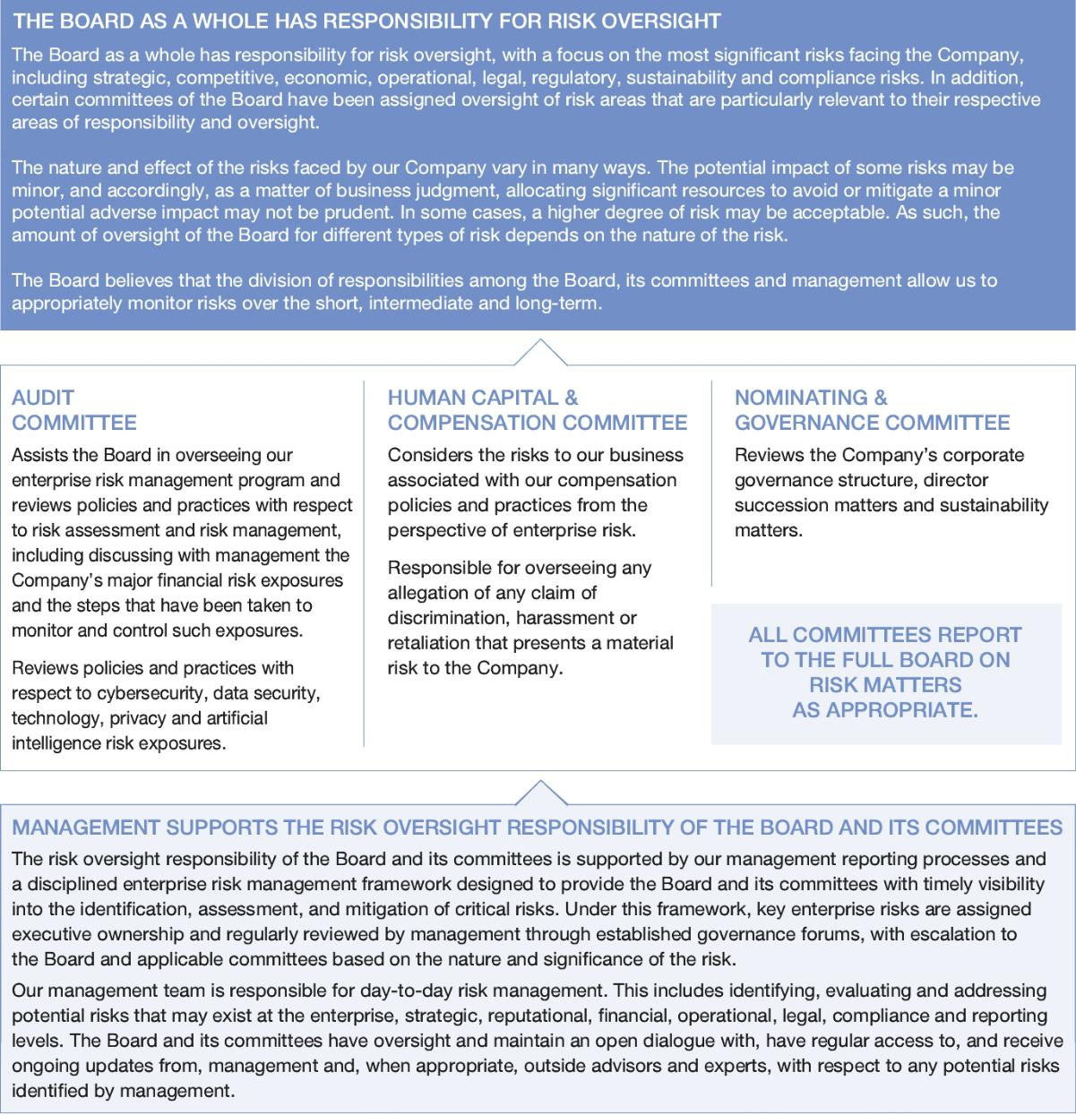

20 Bath & Body Works, Inc. | 2026 Proxy Statement

TABLE OF CONTENTS

Corporate

Governance

Code of Conduct, Insider Trading, Governance Documents and Related Person Transactions

The Company has a code of conduct that is applicable to all of our associates, officers and directors. Any amendments to the code or any waivers from any provisions of the code granted to executive officers or directors will be promptly disclosed to shareholders through posting on the Company’s website at www.bbwinc.com.

The Company maintains an Insider Trading Policy governing all transactions in the Company’s securities by our directors and associates (including officers), as well as any other person designated by the Chief Legal Officer or Chief Financial Officer. The Insider Trading Policy is reasonably designed to promote compliance with insider trading laws, rules and regulations, and applicable listing standards. For further discussion on our Insider Trading Policy and practices related to compensation and equity, see “Compensation-related Matters—Compensation Discussion and Analysis—Executive Compensation Philosophy—Executive Compensation Best Practices” on page 32 of this proxy statement. A copy of our insider trading policy was filed as Exhibit 19 to the 2025 10-K.

Under the Company’s related person transaction policy, subject to certain exceptions, directors and executive officers of the Company are required to notify the Company’s Corporate Secretary of any potential financial or commercial transaction, agreement or relationship involving the Company in which a director or executive officer, a director nominee, a 5% beneficial owner of the Company’s common stock or any of their immediate family members has a direct or indirect material interest. Each such transaction must be approved by the Board or a committee consisting solely of independent directors after consideration of all material facts and circumstances.

Based on the information provided by the Company’s officers and directors and assessments by the Company’s management, there were no such related person transactions during fiscal 2025.

The Company’s code of conduct, corporate governance principles and related person transaction policy, as well as the charters of the Audit Committee, HCC Committee and Nominating & Governance Committee, are available on the Company’s website at www.bbwinc.com (see the “Investors” link followed by the “Committee Charters and Governance Materials” link). Shareholders may also request a copy of any such document from: Bath & Body Works, Inc., Attention: Corporate Secretary, Three Limited Parkway, Columbus, Ohio 43230.

Human Capital & Compensation Committee Participation and Interlocks

No person who has served as a member of the HCC Committee during the last fiscal year is a former or current officer or associate of the Company or any of its subsidiaries. None of our executive officers serve as a member of a board of directors or compensation committee of any other company that has one or more executive officers who serve on our Board or the HCC Committee.

Director Stock Ownership Guidelines

All independent directors are required to own Company common stock with a value equal to six times the amount of their annual cash retainer by October 2028. All members of our Board are either in compliance with the guidelines or are on track to comply with the guidelines within the required time frame. For a discussion of the stock ownership guidelines that apply to our executive officers, see “Compensation-related Matters—Compensation Discussion and Analysis—Compensation Governance—Executive Stock Ownership Guidelines” on page 43 of this proxy statement.

6X ANNUAL CASH RETAINER


We require our directors to own Company common stock with a value equal to 6X their annual cash retainer

Contacting the Board

The Board provides a process for interested parties to send communications to the full Board, the Board Chair, the independent directors and any committee of the Board. The Board, any Board committee or any individual director may be contacted by writing to the Board, committee or director, as applicable, c/o Bath & Body Works, Inc., Three Limited Parkway, Columbus, Ohio 43230, Attention: Corporate Secretary, or by sending an email to boardofdirectors@bbw.com. Communications that are not related to a director’s duties and responsibilities as a Board or committee member may be excluded by the Company, including,

Bath & Body Works, Inc. | 2026 Proxy Statement 21

TABLE OF CONTENTS

Corporate

Governance

without limitation, solicitations and advertisements; junk mail; product-related communications; job referral materials such as resumes; surveys; and any other material that is determined to be illegal or otherwise inappropriate. The directors to whom such information is addressed are informed that the information has been removed and that it will be made available to such directors upon request.

Fiscal 2025 Director Compensation

The HCC Committee’s independent compensation consultant conducts an annual comprehensive review of the Company’s non-employee director compensation program. This review includes benchmarking against the same peer company group used for executive compensation to ensure that director pay remains competitive and aligned with best practices.

The following table sets forth compensation earned by the individuals who served as directors of the Company during fiscal 2025 (other than Mr. Heaf and Ms. Boswell, who, as a current and former Company associate, respectively, received no additional compensation for service on the Board).

 | FEES EARNED
 | OR PAID | STOCK
 | IN CASH⁽¹⁾ | AWARDS⁽²⁾ | TOTAL
 | ($) | ($) | ($)
Bogliolo, Alessandro | 165,000​ | 141,025​ | 306,025​
Brady, Lucy | 145,000​ | 141,025​ | 286,025​
Hondal, Francis | 175,000​ | 141,025​ | 316,025​
Lee, Danielle | 145,000​ | 141,025​ | 286,025​
Nash, Sarah | 250,000​ | 235,050​ | 485,050​
Rajlin, Juan | 145,000​ | 141,025​ | 286,025​
Steinour, Stephen | 150,000​ | 141,025​ | 291,025​
Symancyk, J.K. | 145,000​ | 141,025​ | 286,025​
Voskuil, Steve | 175,000​ | 141,025​ | 316,025​

- Directors (other than the Board Chair) received an annual cash retainer of $100,000. Ms. Nash, as Board Chair, received an annual cash retainer of $250,000. Directors received an additional annual cash retainer of $25,000 for membership on the Audit Committee and HCC Committee and $20,000 for membership on the Nominating & Governance Committee. The Audit Committee and HCC Committee chairs received an additional $25,000. The Nominating & Governance Committee chair received an additional $20,000.

- Directors (other than the Board Chair) received an annual stock retainer of $150,000. Ms. Nash, as Board Chair, received an annual stock retainer of $250,000. Stock retainers were granted under the 2020 Plan and vest one year following the grant date, generally subject to the director’s continued service on the Board through the vesting date. The number of RSUs granted was calculated based on the fair market value of the Company’s common stock on the date the RSUs were granted. The value of stock awards reflects the aggregate grant date fair value, excluding estimated forfeitures, computed in accordance with Accounting Standards Codification (“ASC”) Topic 718 Compensation— Stock Compensation, for each award. See Note 14 to the Company’s consolidated financial statements filed in the Company’s 2025 10-K for a discussion of the Company’s assumptions in determining the aggregate grant date fair value of these awards. As of January 31, 2026, each individual listed in the table held 5,641 outstanding RSUs, other than Ms. Nash, who held 9,402 outstanding RSUs.

22 Bath & Body Works, Inc. | 2026 Proxy Statement

TABLE OF CONTENTS

Ratification of the Appointment of Independent Registered Public Accounting Firm (Item 2 on the Proxy Card)

The Audit Committee has appointed Ernst & Young LLP to serve as the Company’s independent registered public accounting firm for the fiscal year ending January 30, 2027. Ernst & Young LLP has been retained as the Company’s independent registered public accounting firm continuously since 2003.

The Audit Committee is responsible for the appointment, compensation, retention and oversight of the Company’s independent registered public accounting firm. The Audit Committee is also responsible for approving the fees associated with the Company’s retention of Ernst & Young LLP. In accordance with the Commission’s rules, Ernst & Young LLP’s lead engagement partner rotates every five years. The Audit Committee is directly involved in the selection of Ernst & Young LLP’s lead engagement partner. In addition, the Audit Committee evaluates Ernst & Young LLP’s qualifications, performance and independence and presents its conclusions on these matters to the Board on at least an annual basis, and annually considers whether to continue its engagement of Ernst & Young LLP.

The members of the Audit Committee and the Board believe that the continued retention of Ernst & Young LLP to serve as the Company’s independent registered public accounting firm is in the best interests of the Company and its shareholders. We are asking you to ratify Ernst & Young LLP’s appointment, although your ratification is not required. The Audit Committee intends to carefully consider the results of the vote. If the shareholders do not ratify the appointment of Ernst & Young LLP, the Audit Committee will reconsider Ernst & Young LLP’s selection. Even if the selection is ratified, the Audit Committee, in its discretion, may select a different independent registered public accounting firm at any time during the year if the Audit Committee determines that such a change would be in the best interests of the Company and its shareholders. A representative of Ernst & Young LLP will be present at the annual meeting, will have the opportunity to make a statement and will be available to respond to appropriate questions.

Additional information concerning the Company’s engagement of Ernst & Young LLP is included under the heading “Independent Registered Public Accounting Firm’s Fees” on page 25 of this proxy statement.


WE RECOMMEND THAT YOU VOTE “FOR” THE RATIFICATION OF THE

- APPOINTMENT OF ERNST & YOUNG LLP AS THE COMPANY’S INDEPENDENT REGISTERED PUBLIC ACCOUNTING FIRM.

Bath & Body Works, Inc. | 2026 Proxy Statement 23

TABLE OF CONTENTS

Report of the Audit Committee

As provided in our written charter, the Audit Committee is instrumental in the Board’s fulfillment of its oversight responsibilities relating to (i) the integrity of the Company’s financial statements and internal controls, (ii) the Company’s compliance with legal and regulatory requirements, (iii) the qualifications, independence and performance of the Company’s independent auditors and (iv) the performance of the Company’s internal audit function.

It is not the duty of the Audit Committee to plan or conduct audits or to determine that the Company’s financial statements are complete and accurate and are in accordance with generally accepted accounting principles (“GAAP”). This is the responsibility of management and the independent auditors. Furthermore, while we are responsible for reviewing the Company’s policies and practices with respect to risk assessment and risk management, it is the responsibility of the Chief Executive Officer and senior management to determine the appropriate level of the Company’s exposure to risk.

We have reviewed and discussed the Company’s audited financial statements as of and for the year ended January 31, 2026, and met with both management and the Company’s independent auditors to discuss the financial statements. Management has represented to us that the financial statements were prepared in accordance with GAAP. We have reviewed with the internal auditors and independent auditors the overall scope and plans for their respective audits. We also met with the internal auditors and independent auditors, with and without management present, to discuss the results of their examinations and their evaluations of the Company’s internal controls.

We have also discussed with the independent auditors the matters required to be discussed by the applicable requirements of the Public Company Accounting Oversight Board (the “PCAOB”) and the Commission. The Company’s independent auditors also provided to us the written disclosures and the letter required by applicable requirements of the PCAOB regarding the independent auditor’s communications with the Audit Committee concerning independence, and we discussed with the independent auditors their independence from the Company. We considered whether the provision of non-audit services by the independent auditors to the Company is compatible with maintaining their independence.

Based on the reviews and discussions summarized in this Report, and subject to the limitations on our role and responsibilities, certain of which are referred to above and in the Audit Committee charter, we recommended to the Board that the Company’s audited financial statements be included in the Company’s 2025 10-K for filing with the Commission.

We have appointed Ernst & Young LLP as the Company’s independent registered public accounting firm.

Audit Committee

Steven Voskuil, Chair

Francis Hondal
Juan Rajlin
Stephen Steinour
J.K. Symancyk

24 Bath & Body Works, Inc. | 2026 Proxy Statement

TABLE OF CONTENTS

Independent Registered Public Accounting Firm’s Fees

During fiscal 2025, Ernst & Young LLP served as the Company’s independent registered public accounting firm and, in that capacity, rendered an opinion on our consolidated financial statements as of and for the fiscal year ended January 31, 2026. The Audit Committee has selected Ernst & Young LLP as the Company’s independent registered public accounting firm for fiscal 2026.

Audit and Other Fees

The following table presents fees billed or expected to be billed for services rendered by Ernst & Young LLP for fiscal 2025 and 2024 (amounts in thousands):

 | FISCAL 2025 |  | FISCAL 2024
 |  | ($) |  | ($)
Audit Fees⁽¹⁾ | 3,998 |  | 3,869
Audit-related Fees⁽²⁾ | ​ | 15 |  | 133
Tax Fees⁽³⁾ | ​ | — | ​ | —
All Other Fees | ​ | — | ​ | —
Total Fees | 4,013 |  | 4,002

- “Audit Fees” consist of fees for professional services rendered by Ernst & Young LLP in connection with the audit of our consolidated financial statements and reviews of our unaudited consolidated interim financial statements, as well as fees for services that generally only the independent auditor can reasonably be expected to provide, including comfort letters and consultations regarding financial accounting and/or reporting standards. These amounts also include fees for services rendered in connection with the audit of our internal control over financial reporting and fees for services rendered in connection with statutory audits of our international subsidiaries’ financial statements.

- “Audit-related Fees” consist of assurance and related services that are traditionally performed by the independent auditor and include audits of employee benefit plans, agreed upon procedures and other attest engagements not required by statute or regulation.

- “Tax Fees” consist of tax compliance and advisory services.

Pre-approval Policies and Procedures

Our Audit Committee is required to pre-approve the audit and non-audit services performed by Ernst & Young LLP to ensure that these services do not impair Ernst & Young LLP’s independence from us. We maintain an auditor independence policy that, among other things, mandates that our Audit Committee annually pre-approves all audit and permitted non-audit services expected to be performed each year by Ernst & Young LLP and the related fees. This policy also mandates that we may not enter into engagements with Ernst & Young LLP for other permissible non-audit services without the express pre-approval of the Audit Committee. In accordance with this policy, the Audit Committee pre-approved all services performed by Ernst & Young LLP in fiscal 2025 and 2024.

Bath & Body Works, Inc. | 2026 Proxy Statement 25

TABLE OF CONTENTS

Information About Our Executive Officers

Set forth below is the name, age (as of April 28, 2026) and certain information regarding each of our executive officers, other than Mr. Heaf whose biographical information is presented on page 9 of this proxy statement under the heading “Election of Directors —The Board’s 2026 Director Nominees.”



Eva Boratto

CHIEF FINANCIAL

OFFICER

Age: 59

Career Highlights

• Chief Financial Officer (August 2023 to present). Ms. Boratto, a seasoned executive with over three decades of financial and operational experience at both public and private companies, oversees the Company’s global finance organization and real estate group.

• Chief Financial Officer (February 2022 to July 2023) of Opentrons Labworks, Inc., a privately held life sciences company.

• Executive Vice President and Chief Financial Officer (November 2018 to May 2021); Executive Vice President, Controller and Chief Accounting Officer (2017 to 2018); Senior Vice President and Chief Accounting Officer (2013 to 2017); and Senior Vice President for Pharmacy Benefit Management Finance (2010 to 2013) with CVS Health Corporation (“CVS Health”), a leading health solutions company with more than 300,000 employees and over 9,000 retail locations. During her tenure at CVS Health, Ms. Boratto held roles with increasing responsibility and was critical to the development of the company’s growth plan, including investment in digitization efforts and new businesses, and supporting the integration of CVS Health’s transformative acquisition of Aetna.

• Earlier in her career, she spent 20 years at Merck & Co., Inc. in a number of leadership roles, including vice president and U.S. market finance leader.

Public Company Boards

United Parcel Service Inc. (“UPS”), including as chair of UPS’s audit committee, since 2020.

Education

Ms. Boratto earned a B.S. in Accounting and Economics from Rutgers University and an M.B.A. from Drexel University.

Tom Mazurek

CHIEF SUPPLY CHAIN OFFICER

Age: 59

Career Highlights

• Chief Supply Chain Officer (May 2022 to present).

Mr. Mazurek has more than two decades of experience in product development, production and manufacturing and leads teams responsible for collaborating with merchants and the design function to bring products to life. He also manages all commercial product development including R&D and engineering, in addition to all manufacturing and sourcing across a diverse global base of supply, and leads the Company’s enterprise sustainability strategies and initiatives.

• Mr. Mazurek joined the Company in 2000 and throughout his tenure, he has taken on progressively larger roles and initiatives, including being a key contributor to Beauty Park, a business park that includes several of the Company’s key manufacturing partners within close proximity to the Company’s central Ohio distribution centers and headquarters.

• Earlier in his career, Mr. Mazurek worked in operational roles with Hasbro and Mattel.

Education

Mr. Mazurek earned a B.S. degree from Fordham University in New York City and an M.B.A. from The University at Buffalo.

26 Bath & Body Works, Inc. | 2026 Proxy Statement

TABLE OF CONTENTS

Advisory Vote to Approve Named Executive Officer Compensation

(Item 3 on the Proxy Card)

We are providing our shareholders with the opportunity to vote to approve, on an advisory, non-binding basis, the compensation of our NEOs as disclosed in this proxy statement in accordance with the Commission’s rules. This proposal, which is commonly referred to as the “say-on-pay” proposal, is required by the Dodd-Frank Wall Street Reform and Consumer Protection Act of 2010 (the “Dodd-Frank Act”), which added Section 14A to the Securities Exchange Act of 1934, as amended (the “Exchange Act”).

We conduct our “say-on-pay” advisory vote on an annual basis to provide our shareholders with the ability to regularly express a view on our executive compensation program and practices. Accordingly, we are providing our shareholders with the opportunity to cast an advisory vote on the fiscal 2025 compensation of our NEOs as disclosed in this proxy statement, including the Compensation Discussion and Analysis and the compensation tables and other related disclosures. The next advisory vote to approve the compensation of our named executive officers will be at our 2027 annual meeting of shareholders.

The Board is asking our shareholders to approve a non-binding advisory vote on the following resolution. While this vote is advisory and therefore not binding on the Company, the Board and the HCC Committee value the opinions of our shareholders.


THERE IS ALIGNMENT BETWEEN OUR PERFORMANCE, OUR

- SHAREHOLDERS’ INTERESTS AND OUR NEOS’ PAY; THEREFORE, WE RECOMMEND THAT YOU VOTE “FOR” THIS PROPOSAL.

Bath & Body Works, Inc. | 2026 Proxy Statement 27

TABLE OF CONTENTS


Compensation-Related Matters

In this Section

- Compensation Discussion and Analysis

45 2025 Summary Compensation Table

- Grants of Plan-based Awards for Fiscal 2025

- Outstanding Equity Awards at Fiscal Year-end 2025

- Option Exercises and Stock Vested Information for Fiscal 2025

- Potential Payments Upon Termination or Change in Control

- 2025 Pay Ratio Disclosure

- 2025 Pay Versus Performance Disclosure

28 Bath & Body Works, Inc. | 2026 Proxy Statement

TABLE OF CONTENTS

Compensation-Related Matters

Compensation Discussion and Analysis

This Compensation Discussion and Analysis section (referred to as the “CD&A”) summarizes our general philosophy regarding the compensation of our NEOs for fiscal 2025 and describes in detail the compensation paid to our NEOs for fiscal 2025. The CD&A provides context for the executive compensation disclosures presented throughout in both tabular and narrative forms.

Executive Summary

We are a global leader in personal care and home fragrance, driven by the belief that everybody deserves to feel good. For over 35 years, the brand’s beloved and iconic scents have been expertly crafted for exceptional performance and a luxury fragrance experience. Formulated with thoughtfully chosen ingredients, our body care products are available in multiple forms including fine fragrance mist, body cream, lotion, eau de parfum, body wash, hand soap, sanitizer and more, as well as our famous 3-wick candles. Consumers can shop Bath & Body Works anytime and anywhere they choose, from welcoming, in store experiences at 1,927 company-operated stores in the United States and Canada, and 573 international stores, as well as 34 e-commerce sites in more than 45 other countries, and on Amazon.

Our executive compensation program has remained committed to aligning executive compensation with performance and making decisions to help drive our business goals and promote shareholder value. Over the past couple of years, our say-on-pay advisory vote results have reflected the evolution and strength of our compensation program, with 96.05% approval in 2024 and 98.8% approval in 2025.

Fiscal 2025 was a year of significant transition for the Company, as we welcomed Daniel Heaf, our Chief Executive Officer. Under Mr. Heaf’s leadership, the Company launched our new growth strategy in the third quarter of fiscal 2025 – the Consumer First Formula - putting the consumer at the center of everything that we do, with focus on our four largest revenue driving opportunities to: (1) create disruptive and innovative products; (2) reignite the brand; (3) win in the marketplace; and (4) operate with speed and efficiency. This transformative plan is intended to revitalize the Company across brand, product and marketplace to try and attract new, younger consumers, which we expect will help us unlock our next era of sustainable growth. In 2026, we will continue to evolve our executive compensation program to help support the Company’s new strategy and drive durable, top-line growth.


Bath & Body Works, Inc. | 2026 Proxy Statement 29

TABLE OF CONTENTS

Compensation-Related Matters

Fiscal 2025 Financial and Business Overview

In 2025, performance was impacted significantly by consumer sentiment as consumers remained cautious and value seeking throughout the year, and by tariffs (which we did not adjust performance targets for). Our performance reinforces the Company’s need for change, and the necessity and urgency of the Consumer First Formula.

Net | Operating | Net​ | Income | Free
Sales | Income Margin | Per | Diluted Share | Cash Flow⁽¹⁾

$7.3B | 15.4% | $3.11 | $865M
(0.2%) to LY | GAAP | GAAP
 | 15.9% | $3.21
 | ADJUSTED⁽¹⁾ | ADJUSTED⁽¹⁾

- Adjusted Operating Income Margin, Adjusted Net Income Per Diluted Share, and Free Cash Flow, are all non-GAAP financial measures. Attached as Appendix A are reconciliations of these non-GAAP financial measures relative to reported GAAP financial measures.

Named Executive Officers

Our success is built on the leadership of our executive team with significant industry experience. Our fiscal 2025 NEOs are as follows:

NAMED EXECUTIVE OFFICER | TITLE
Daniel Heaf | Chief Executive Officer
Eva Boratto | Chief Financial Officer
Tom Mazurek | Chief Supply Chain Officer
Gina Boswell⁽¹⁾ | Former Chief Executive Officer
Michael Wu⁽²⁾ | Former Chief Legal Officer and Corporate Secretary
- Ms. Boswell ceased serving as Chief Executive Officer effective as of May 16, 2025.

- Mr. Wu ceased serving as Chief Legal Officer and Corporate Secretary effective as of February 24, 2026.

Fiscal 2025 Compensation Highlights

Our executive compensation program continues to place a significant emphasis on pay-for-performance and provides a meaningful and direct link between the interests of our NEOs and those of our shareholders. We align pay with performance by providing our NEOs with predominantly performance-based compensation, delivered in the form of short-term cash incentives based on annual performance metrics and long-term equity incentives subject to rigorous performance metrics that align with our strategic direction, provide balance between top-line growth and profitability, and are designed to drive shareholder value.

Fiscal 2025 was a year of significant transition for the Company, as we welcomed a new Chief Executive Officer, launched the Consumer First Formula, introduced an annual strategic modifier to our short-term cash incentive compensation program and started transitioning from a seasonal short-term cash incentive program to an annual short-term cash incentive program. In 2026, we will continue to find ways to enhance our executive compensation program to further emphasize pay-for-performance and support the Consumer First Formula.

The compensation paid to our NEOs for fiscal 2025 as described in detail in this CD&A is directly reflective of the Company’s business and operational performance achievements in fiscal 2025. This relationship between pay and performance exemplifies the HCC Committee’s commitment to providing compensation for performance that drives our strategic business goals and shareholder value creation.

30 Bath & Body Works, Inc. | 2026 Proxy Statement

TABLE OF CONTENTS

Compensation-Related Matters

The following summarizes certain key highlights from our fiscal 2025 executive compensation program:

- In 2025 we began transitioning from a seasonal short-term cash incentive program to an annual short-term cash incentive program. As part of this evolution, our short-term cash incentive program for 2025 included annual performance metrics with a mid-year payout based on first half results and year-end payout based on full year results. Starting in 2026, short-term incentives will be measured entirely based on achievement of annual performance metrics with one annual payout based on full year results to better align with market practice. Also, in 2026 we will evaluate additional enhancements to our executive compensation program to support the Consumer First Formula.

- Our short-term cash incentive program payout continued to align with our financial and strategic performance with NEOs receiving no year-end annual payment. To emphasize the Company’s drive towards durable, top-line growth, the HCC Committee revised our short-term cash incentive program for fiscal 2025 to increase the weighting of the absolute net sales metric from 25% to 35%, which reduced the weighting of the adjusted operating income from 75% to 65%. Additionally, to help create greater focus on driving durable, top-line growth, the HCC Committee added a one-time annual strategic modifier supporting the strategies in place at that time. The short-term cash incentive program mid-year payout (weighted 40%) based on first half results paid at 80.6%, equating to 32.2% of target after weighting for the annual performance period, with both absolute net sales and adjusted operating income performing below target. No year-end annual payment was made under the short-term cash incentive program because both absolute net sales and adjusted operating income did not meet the minimum thresholds for the annual performance period. The one-time annual strategic modifier had no impact on the short-term cash incentive program payouts, as the annual performance metric thresholds had not been met. Therefore, the overall short-term cash incentive payout for fiscal year 2025 was 32.2%. This payout for 2025 reflects the direct linkage between our NEOs’ incentive pay and company performance. Performance was impacted significantly by consumer sentiment as consumers remained cautious and value seeking throughout the year, and by tariffs (which we did not adjust performance targets for). See “—Compensation for NEOs—Compensation Components—Short-term Performance-based Incentive Compensation” beginning on page 35 of this proxy statement for more details.

- A significant portion of the long-term equity incentives granted to our NEOs in fiscal 2025 were granted subject to challenging performance metrics. We redesigned our performance stock unit (“PSU”) program in 2023 following discussions with our shareholders to more closely align award payouts with shareholder returns. PSUs are subject to two performance metrics: (i) relative total shareholder return (“TSR”) (50%) and (ii) adjusted operating income margin (50%), each of which is measured over a cumulative three-year performance period. In addition, all PSUs are subject to a “negative absolute TSR cap,” whereby the payout is limited to the target performance level when our absolute TSR is negative over the performance period. In 2024, the HCC Committee also increased the proportion of our Chief Executive Officer’s long-term equity incentive compensation that is subject to performance-based conditions to 60%, thereby enhancing the weighting of performance-based compensation for our Chief Executive Officer. We believe these rigorous performance metrics continue to provide a balance of growth and profitability, support the strategic direction of the Company and ensure alignment with the interests of our shareholders.

Shareholder Engagement

The Board values the input of shareholders on all matters, including our executive compensation program. We annually provide shareholders with the opportunity to cast an advisory vote on the compensation of the Company’s NEOs. The HCC Committee considers the feedback we receive during shareholder engagements, as well as the results of the say-on-pay votes, when reviewing and implementing our executive compensation program. At the 2025 annual meeting of shareholders, 98.8% of the votes cast supported the say-on-pay proposal.

Since the beginning of the calendar year, we have reached out to shareholders representing 57% of our shares outstanding as of the last day of our 2025 fiscal year end. Of the shareholders to whom we reached out, we held meetings with shareholders representing 9% of our outstanding shares as of the last day of fiscal 2025. During those meetings we discussed the strategy of the Company, Board structure and experience, our compensation program, corporate governance and sustainability.

As our executive compensation program continues to evolve, we are committed to ongoing shareholder engagement to ensure our practices continue to reflect the valuable input of our shareholders.

Bath & Body Works, Inc. | 2026 Proxy Statement 31

TABLE OF CONTENTS

Compensation-Related Matters

Executive Compensation Philosophy

GUIDING PRINCIPLES

The HCC Committee oversees an executive compensation program based on the following clear and purposeful guiding principles:

 | COMPENSATION
 | COMPONENT | OUR PRINCIPLES
 |  | Attract and retain top leaders in a highly competitive market for talent.
 | Pay Level
 | Pay Level | Pay competitively and equitably.
 |  | Recognize depth and scope of accountability and complexity of responsibility.
 | Pay Mix | Emphasize performance-contingent, long-term equity-based incentive compensation over
 | Pay Mix | fixed compensation.
 |  | Recognize and reward enterprise and individual performance.
 |  | Utilize performance metrics that closely align executives’ interests with shareholders’ interests.
 |  | Require NEOs to own a significant amount of the Company’s common stock.
 | Pay-for-Performance | For fiscal 2025, set annual targets with a mid-year payout based on the first half results and
 | Pay-for-Performance | introduced an annual strategic modifier as we transition to an annual plan in 2026.
 |  | Create long-term shareholder value through regular achievement of short- and long-term
 |  | financial strategic goals.
 |  | Retain and incent high-performers with a pay mix delivered predominantly through long-term
 |  | equity incentive awards.

EXECUTIVE COMPENSATION BEST PRACTICES

Our executive compensation practices incorporate the following corporate governance best practices that promote the interests of our shareholders and are consistent with high standards of risk management.
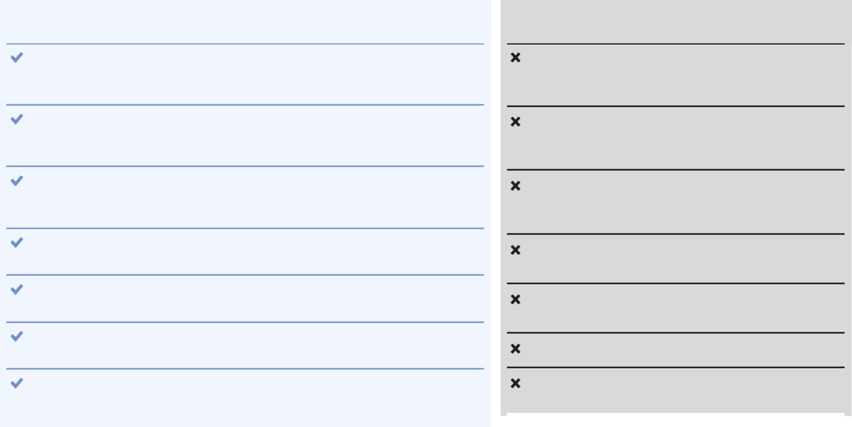

What We Do:

We align our NEOs’ pay with Company and individual performance and grant incentive awards based on actual results and achievements.

We maintain robust clawback policies as described under the heading “—Compensation Governance—Recovery of Compensation” on page 43 of this proxy statement.

The HCC Committee engages a compensation consultant that is independent of the Company and management to advise on compensation-related matters.

We maintain robust stock ownership guidelines for our NEOs and directors.

Our equity incentive plan requires a minimum vesting period of at least one year for all awards, subject to certain exceptions.

We use appropriate peer group comparisons when determining compensation.

We mitigate undue business risk in compensation programs and, in consultation with the HCC Committee’s independent compensation consultant, perform an annual compensation risk assessment.

What We Don’t Do:

No tax gross-ups for NEOs to cover excise taxes under Section 4999 of the Internal Revenue Code (the “Code”).

Hedging and short-selling of Company securities is prohibited under our insider trading policy.

No pledging of Company stock without advance approval. None of the Company’s stock held by our NEOs or Board members is pledged.

No re-pricing of stock options without shareholder approval.

No single-trigger vesting of NEO equity awards upon a change in control.

No payments of dividends on unearned awards.

No excessive perquisites provided to our directors and executive officers.

32 Bath & Body Works, Inc. | 2026 Proxy Statement

TABLE OF CONTENTS

Compensation-Related Matters

CONNECTING PAY AND PERFORMANCE

There are two key elements of our executive compensation program design that connect pay to performance. First, our incentive goals are designed to challenge our NEOs to achieve a high level of performance to earn incentives at target levels. When the Company’s performance meets and exceeds, or falls short of, these goals, our NEOs’ compensation is calibrated accordingly. Second, to further connect executive pay to performance and shareholder interests, we employ a pay mix philosophy that places greater emphasis on performance-based incentive compensation over non-performance-based base salary and RSUs.

The following charts illustrate the pay mix philosophy of our executive compensation program, showing a higher percentage of performance-based incentive compensation.
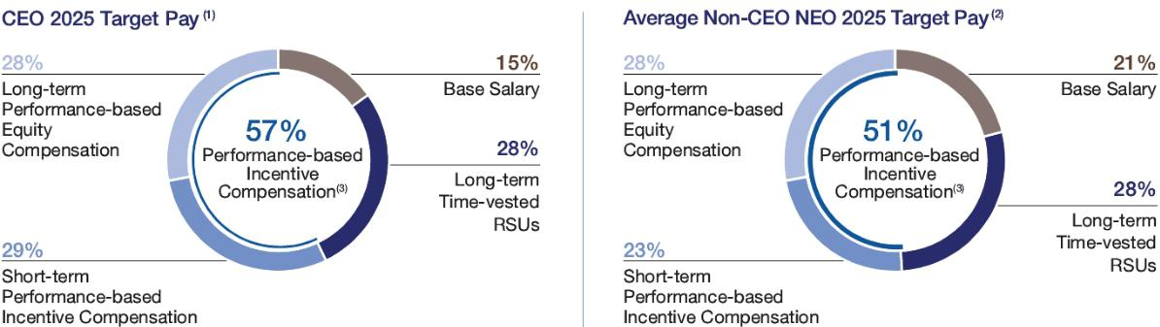

- The CEO Target Pay reflects target direct compensation for Mr. Heaf for 2025 (reflecting annualized base pay, annualized short-term incentive (“STI”) target and approved target long-term incentive grant).

- The Average Non-CEO NEO Target Pay reflects target direct compensation for our NEOs (other than Mr. Heaf, who began service as Chief Executive Officer on May 16, 2025, and for Ms. Boswell, who ceased serving as the Chief Executive Officer, effective May 16, 2025, due to her partial year of employment).

- The amounts included in the table above reflect the aggregate values of the RSUs and PSUs approved by the HCC Committee for the above listed NEOs for 2025. These approved values reflected above may differ from the grant date fair value of these awards as reflected in the Summary Compensation Table that follows this CD&A, because of the accounting methodology used to report the RSUs and PSUs in the Summary Compensation Table, as required by SEC rules.

COMPENSATION COMPARISON

We review our NEO compensation against publicly available data on executive compensation, including compensation paid by a group of peer companies. We use this data to evaluate the competitiveness of our compensation levels, establish an appropriate mix of our NEO compensation elements and ensure our compensation programs properly attract, retain and incentivize highly talented executives who are critical to executing our strategy and business plan.

The HCC Committee annually reviews and approves our peer group used for compensation comparisons (the “Compensation Peer Group”) in consultation with the HCC Committee’s independent compensation consultant, and with consideration for companies considered to be peers by certain proxy advisory firms, to generally include a balanced mix of the following criteria:

- businesses that are similar in size and scope (using criteria such as total revenue, market capitalization, global footprint, business and/or merchandise focus);

- companies that compete with us for executive talent; and

- companies with similar talent and business model characteristics.

We do not specifically set our NEOs’ compensation against our Compensation Peer Group. Instead, we consider peer group comparisons provided by the HCC Committee’s independent compensation consultant as one of several factors the HCC Committee uses, along with its business judgment and experience, in setting the pay of our NEOs.

Bath & Body Works, Inc. | 2026 Proxy Statement 33

TABLE OF CONTENTS

Compensation-Related Matters

The HCC Committee reviewed the Company’s 2025 Compensation Peer Group and determined no changes were appropriate for 2025. The HCC Committee believes the Compensation Peer Group closely aligns with our business model and merchandise focus and reflects companies that are similar in size and scope, and that compete with us for executive talent.

2025 COMPENSATION PEER GROUP

Abercrombie & Fitch Co. [AND]

American Eagle Outfitters, Inc. [AEO]

Coty Inc. [COTY]

DICK’s Sporting Goods, Inc. [DKS]

Gap Inc. [GPS]

lululemon athletica inc. [LULU]

Newell Brands Inc. [NWL]

PVH Corp. [PVH]

Ralph Lauren Corporation [RL]

Sally Beauty Holdings, Inc. [SBH]

Signet Jewelers Limited [SIG]

Tapestry, Inc. [TPR]

The Estée Lauder Companies Inc. [EL]

Tractor Supply Company [TSCO]⁽¹⁾

Ulta Beauty, Inc. [ULTA]

Victoria’s Secret & Co. [VSCO]

Williams-Sonoma, Inc. [WSM]

- In 2025, the HCC Committee reviewed the Company’s 2026 Compensation Peer Group and determined that Tractor Supply Company should be removed from our peer group for 2026 because of that company’s outsized market capitalization and product mix not aligning with the Company and its other compensation peers.

Compensation for NEOs

COMPENSATION SETTING PROCESS

The HCC Committee makes all decisions regarding Chief Executive Officer compensation with advisory input from its independent compensation consultant. Our Chief Executive Officer recommends, and the HCC Committee approves, compensation for the other NEOs, including all grants of stock awards. In making compensation decisions for our NEOs, the HCC Committee takes into consideration input, recommendations and market-based analyses provided by management and the HCC Committee’s independent compensation consultant. Target compensation for the NEOs is reviewed annually after the fiscal year closes and is designed to reward historical performance, incent future performance and be competitive with the external market for talent.

COMPENSATION COMPONENTS

The three principal elements of our executive compensation program are base salary, short-term performance-based cash incentive compensation and long-term equity incentive compensation. Each NEO’s base salary is set considering multiple factors described below. For fiscal 2025, all of our NEOs participated in the same short-term performance-based incentive compensation program and long-term equity incentive compensation program. The Company also provides our NEOs with health and welfare benefits, retirement benefits and a limited set of perquisites, in line with market practice and generally focused on managing risk to the enterprise. Additional information about each of these compensation components is provided herein.

Base Salary

The following factors are considered in determining any base salary adjustments for our NEOs:

- scope and responsibility of the NEO’s position;

- achievement of annual business goals;

- level of overall compensation paid by competitors for comparable positions;

- recruitment, retention and development of leadership talent; and

- appropriate balancing of the NEO’s base salary against their incentive compensation to ensure there is a higher mix of performance-based compensation as a percentage of their total pay mix.

34 Bath & Body Works, Inc. | 2026 Proxy Statement

TABLE OF CONTENTS

Compensation-Related Matters

Our NEOs’ base salaries for fiscal 2025 are set forth in the following table. Our NEOs’ base salaries have not been increased since 2022 and, for fiscal 2025, the HCC Committee determined to again hold base salaries flat except for Mr. Mazurek whose salary was increased by 3.6% to recognize an increase in his responsibilities. This decision, when coupled with the NEO target long-term equity incentive compensation as shown under the heading “—Long-term Equity Incentive Compensation” beginning on page 37 of this proxy statement, further enhances the weighting of our NEOs’ long-term equity incentive compensation as a percentage of their total pay mix.

 | FISCAL 2025 | YEAR OVER
NAMED EXECUTIVE OFFICER⁽¹⁾ | BASE SALARY | YEAR %
NAMED EXECUTIVE OFFICER⁽¹⁾ | ($) | CHANGE | RATIONALE
Mr. Heaf⁽²⁾ | 1,350,000 | n/a
Ms. Boratto | 850,000 | 0%
Mr. Mazurek | 725,000 | 3.6% | Increased responsibilities
Mr. Wu | 725,000 | 0%

- Ms. Boswell served as Chief Executive Officer until May 16, 2025. In fiscal 2025, Ms. Boswell's annual base salary was $1,500,000, which was also unchanged from fiscal 2024.

- Mr. Heaf began his employment as our Chief Executive Officer on May 16, 2025.

Short-term Performance-based Incentive Compensation

Short-term performance-based incentive compensation, if earned, is paid in cash pursuant to the Company’s Cash Incentive Compensation Performance Plan (the “Cash Incentive Plan”). The HCC Committee introduced a Cash Incentive Plan structure for fiscal year 2025 to ensure a smooth transition from a seasonal to an annual short-term performance-based incentive compensation plan. The Cash Incentive Plan for fiscal 2025 focused on achievement of annual performance metrics with a mid-year payout (weighted 40%) based on first half results and a year-end payout based on full year results. The transition away from the Company's historical seasonal bonus approach is a significant step in the evolution of the Company's executive compensation program. Beginning in fiscal year 2026, we will complete the transition and launch an annual short-term cash incentive compensation program designed with annual performance metrics and one annual payout.

To emphasize the Company’s drive towards durable, top-line growth, the HCC Committee increased the weighting of the absolute net sales metric from 25% to 35%, which reduced the weighting of the adjusted operating income from 75% to 65% for fiscal year 2025. Additionally, to create greater focus on driving durable, top-line growth, the HCC Committee added a one-time annual strategic modifier supporting the strategies in place at that time.

The HCC Committee established annual goals for the full 2025 performance year at the beginning of 2025 under the short-term cash incentive program. The HCC Committee carefully considered the annual goals to ensure that our executives were properly incented in fiscal year 2025, while at the same time incorporating a level of rigor that maintained a strong link between pay and performance. The HCC Committee believes the incentive annual goals were set at challenging and meaningful levels.

Bath & Body Works, Inc. | 2026 Proxy Statement 35

TABLE OF CONTENTS

Compensation-Related Matters

The charts below show the first half and annual results based on annual targets for adjusted operating income and net sales goals required to earn short-term performance-based incentive compensation, along with the range of performance goals as a percentage of target for threshold and maximum payouts, and actual performance results achieved in fiscal 2025. Achievement level for the first half of the year was at 80.6%, equating to 32.2% after weighting. While the Company’s first half financial performance exceeded the established thresholds, resulting in a mid-year payout, results for the full fiscal year did not meet the threshold performance level and, as a result, no year-end payment was made under the short-term cash incentive program. The one-time annual strategic modifier had no impact on the short-term cash incentive program payouts, as the annual performance metric thresholds had not been met. Therefore, the overall short-term cash incentive payout for fiscal year 2025 was 32.2%.
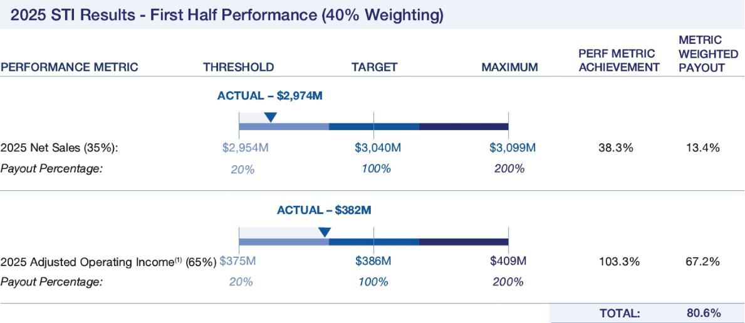

- Adjusted Operating Income is a non-GAAP financial measure. Attached as Appendix A is a reconciliation of this non-GAAP financial measure relative to reported GAAP financial measure.
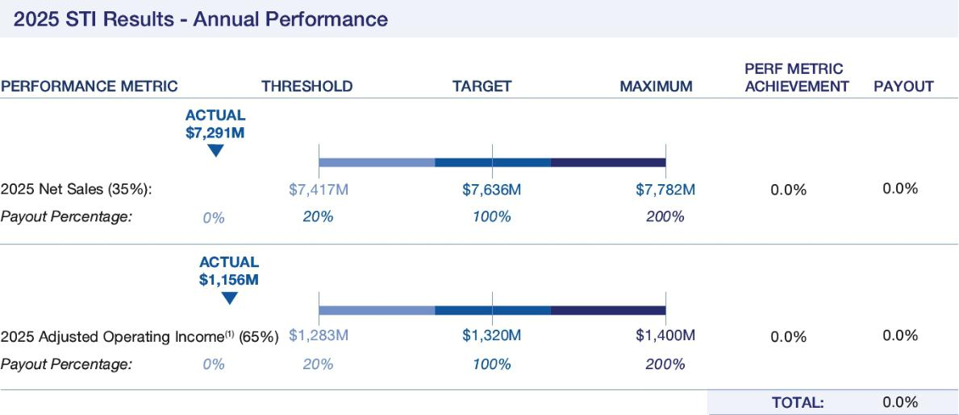

- Adjusted Operating Income is a non-GAAP financial measure. Attached as Appendix A is a reconciliation of this non-GAAP financial measure relative to reported GAAP financial measure.

Performance between threshold and target and target and maximum is interpolated to determine the payout percentage beginning at 20% for threshold performance (if achieved) up to 200% at maximum performance. Short-term performance-based incentive compensation targets are set as a percentage of base salary with the amount earned ranging from 0% to 200% of the target incentive, based on the extent to which financial goals are achieved.

36 Bath & Body Works, Inc. | 2026 Proxy Statement

TABLE OF CONTENTS

Compensation-Related Matters

The table below shows the short-term performance-based incentive compensation targets as a percentage of base salary for each NEO during fiscal 2025. None of our NEOs received an increase in their target annual incentive compensation opportunities for fiscal 2025 from fiscal 2024. See the disclosure under the heading “—Long-term Equity Incentive Compensation” below for additional information.

The NEOs’ payouts for fiscal 2025 performance are also set forth in the table below and in the “Non-Equity Incentive Plan Compensation” column of the 2025 Summary Compensation Table on page 45 of this proxy statement.

 | FISCAL 2025
 | TARGET
 | ANNUAL |  | FISCAL 2025 | FISCAL 2025
 | INCENTIVE | FISCAL 2025 | MID-YEAR | FULL-YEAR | TOTAL FISCAL
 | OPPORTUNITY | TARGET | INCENTIVE | INCENTIVE | 2025 | PERCENT OF
NAMED EXECUTIVE OFFICER⁽¹⁾ | (% OF BASE | INCENTIVE | PAYOUT | PAYOUT | PAYOUT | FISCAL 2025
NAMED EXECUTIVE OFFICER⁽¹⁾ | SALARY) | ($) | ($) | ($) | ($) | TARGET
Mr. Heaf | 190% | 1,839,190⁽²⁾ | 358,953 | - | 358,953 | 19.5%⁽³⁾
Ms. Boratto | 120% | 1,020,000 | 328,848 | - | 328,848 | 32.2%
Mr. Mazurek | 100% | 725,000 | 233,740 | - | 233,740 | 32.2%
Mr. Wu | 100% | 725,000 | 233,740 | - | 233,740 | 32.2%

- Ms. Boswell’s employment with the Company ceased on May 16, 2025. In fiscal 2025, Ms. Boswell’s target incentive compensation opportunity was 190% of her base salary, which was unchanged from fiscal 2024. She received $676,509 for the fiscal 2025 mid-year incentive payout reflecting a pro-rated amount for the performance period she was terminated pursuant to the terms of her existing agreement with the Company. Ms. Boswell received $0 for the fiscal 2025 full-year incentive payout pursuant to the terms of her existing agreement with the Company.

- The amount shown has been prorated based on Mr. Heaf’s start date in May 2025.

- Mr. Heaf commenced employment with the Company on May 16, 2025, and was therefore eligible for a prorated payment for the fiscal 2025 mid-year incentive payout. The “Percent of Fiscal 2025 Target” percentage reflects the percentage earned for all of fiscal 2025 (including a prorated mid-year payment); had Mr. Heaf been employed during the entire fiscal 2025 first half, his “Percent of Fiscal 2025 Target” percentage would align with the percentages of the other NEOs.

Long-term Equity Incentive Compensation

During fiscal 2025, we granted stock awards to our NEOs under the 2020 Plan, which was approved by our shareholders at our 2020 annual meeting.

Our Fiscal 2025 Long-term Equity Incentive Compensation Design
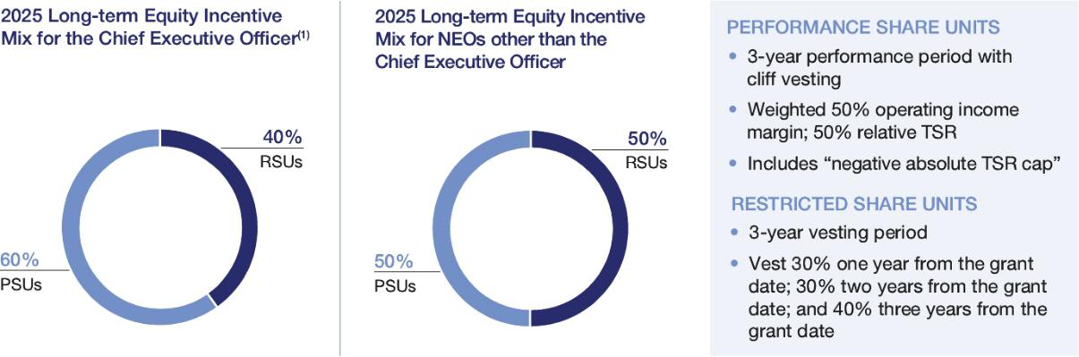

- Annual long-term incentive award for Ms. Boswell was 60% PSU/40% RSU. Mr. Heaf’s new hire long-term incentive grant was 50% PSU/50% RSU. In fiscal 2026, the annual long-term incentive grant for Mr. Heaf will be 60% PSU/40% RSU.

Bath & Body Works, Inc. | 2026 Proxy Statement 37

TABLE OF CONTENTS

Compensation-Related Matters

In connection with his hiring in 2025, Mr. Heaf received a new hire equity award consisting of RSUs with an approved target value of $2,500,000 and PSUs with an approved target value of $2,500,000. The RSUs vest 30% on the first anniversary of May 16, 2025, 30% on the second anniversary and 40% on the third anniversary, subject to Mr. Heaf’s continued employment through each vesting date. This one-time award served as Mr. Heaf’s annual equity grant for fiscal 2025, and no additional equity awards were granted to him during the year.

Performance Share Units

PSUs incent executive performance through the achievement of challenging growth and profitability metrics that closely align the long-term interests of our executives with those of our shareholders. As a result, we place significant emphasis on the PSU component of our long-term equity incentive program for our NEOs. For fiscal 2025, 50% of our NEOs’ long-term equity incentives (60% for our Chief Executive Officer) were granted in the form of “at-risk” PSUs.

Our NEOs’ annual 2025 PSU awards are subject to two equally weighted performance metrics:

- cumulative adjusted operating income as a percentage of cumulative net sales (adjusted operating income margin); and

- relative TSR assessed against the companies listed in the S&P Composite 1500 Consumer Discretionary Distribution & Retail Index as of the date of grant.

The HCC Committee updated this index in 2025 after the Company was removed from the S&P 500 Consumer Discretionary Distribution & Retail Index for purposes of the relative TSR metric because the index is relevant from an industry perspective (i.e., reasonable business, talent and/or investment dollar competitors) and is more easily tracked and communicated to Company associates and investors. The HCC Committee continued the “negative absolute TSR cap”—i.e., if our absolute total shareholder return is negative during the performance period, the payout under the PSU awards is capped at 100% of target performance.

The HCC Committee is committed to establishing robust performance metrics that challenge our executives to deliver superior performance aligned to creating value for our shareholders, while at the same time balancing the rigor of the performance metrics with ensuring that the metrics are reasonably attainable to meaningfully incent executive performance and retention.

Finally, consistent with market practice to ensure our annual PSU program is competitive with our peer companies’ programs and to balance the leverage of the program with the weighting it is expected to command within the NEOs’ pay mix, the maximum payout for the 2025 annual PSU program awards was 200%.

The HCC Committee believes the PSU program aligns our NEOs’ interests with those of our shareholders. Specifically, the HCC Committee believes that adjusted operating income margin continues to provide a direct link between our NEOs’ compensation and the importance of growing and maintaining our adjusted operating income margin as part of the Company’s strategic initiatives. The relative TSR metric for fiscal 2025 is intended to promote alignment between long-term shareholder value creation and our NEOs’ pay outcomes. Its inclusion is also consistent with input we received from our shareholders as well as market practice.

Performance for awards granted in fiscal 2025 will be evaluated based on performance over a three-year performance period, starting with fiscal 2025 through the end of fiscal 2027, paying out in 2028.

38 Bath & Body Works, Inc. | 2026 Proxy Statement

TABLE OF CONTENTS

Compensation-Related Matters

The specific targets are as set forth in the chart below:
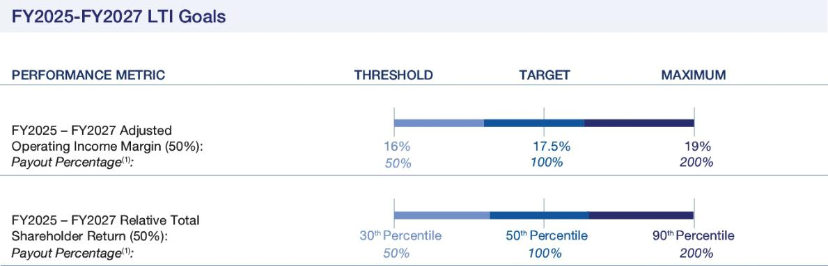

- The Payout Percentage is subject to the “negative absolute TSR cap”—i.e., if our absolute total shareholder return is negative during the performance period, the payout under the PSU awards is capped at 100% of target performance.

Performance will be evaluated based on a scale, and payout, if any, will be interpolated between threshold, target and maximum levels. The earned annual PSU awards (if any) granted in fiscal 2025 will vest in March 2028, subject generally to the executive’s continued employment through such date.

Restricted Share Units

RSUs are granted to ensure market competitiveness of the executive compensation package, align executives’ long-term interests with our shareholders and retain executives over the long-term. The RSU awards vest over three years in three tranches (30% one year from the grant date, 30% two years from the grant date and 40% three years from the grant date), in each case subject generally to continued employment through each such date.

Below is a summary of the grant date fair value of the long-term equity incentive compensation, including PSUs and RSUs, awarded to our NEOs during fiscal 2025 as reported in the summary compensation table found on page 45 of this proxy statement.

 |  |  |  | MAXIMUM
 | VALUE OF | TARGET VALUE | TOTAL FISCAL | VALUE OF
 | TIME-VESTED | OF ANNUAL | 2025 EQUITY | ANNUAL PSU
NAMED EXECUTIVE OFFICER⁽¹⁾ | RSU AWARD | PSU AWARD | AWARD VALUE | AWARD
NAMED EXECUTIVE OFFICER⁽¹⁾ | ($) | ($) | ($) | ($)
Mr. Heaf | 2,368,681 | 2,675,090 | 5,043,771 | 5,350,180
Ms. Boratto | 1,345,364 | 1,535,197 | 2,880,561 | 3,070,394
Mr. Mazurek | 823,743 | 939,974 | 1,763,717 | 1,879,948
Mr. Wu | 760,944 | 868,314 | 1,629,258 | 1,736,629

- In fiscal 2025, Ms. Boswell’s Value of Time-Vested RSU’s Awards was $3,002,277 and Target Value of Annual PSU Award was $5,138,871; with a total annual grant date value of $8,141,148.

Bath & Body Works, Inc. | 2026 Proxy Statement 39

TABLE OF CONTENTS

Compensation-Related Matters

Payout of 2022 Annual Award PSUs

The annual PSUs that were granted in March 2022 to our named executive officers at that time (which included Mr. Mazurek and Mr. Wu) vested in 2025. Performance was evaluated based on a scale, and payout was interpolated between threshold, target and maximum levels as set forth below.
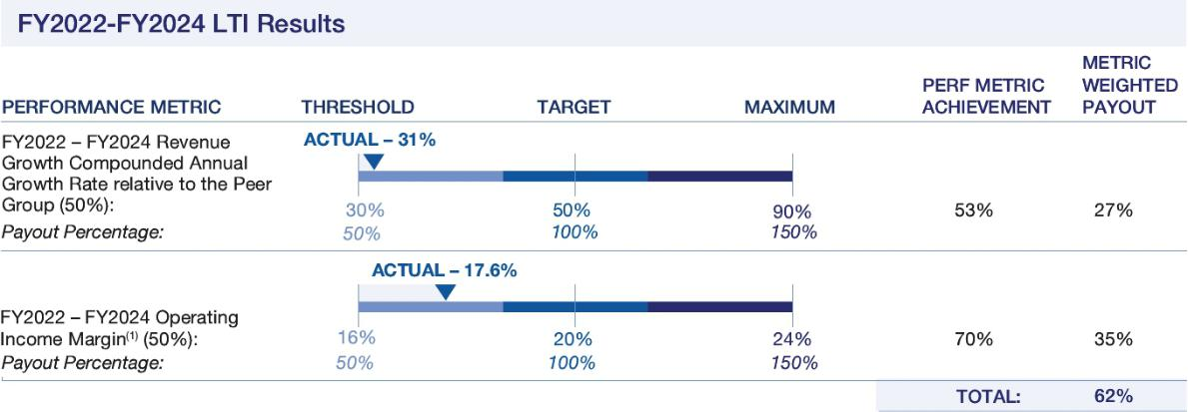

(1) For fiscal 2024, 2023 and 2022, the Company did not make any adjustments to operating income margin.

 | TARGET FY22 | ACTUAL FY22
 | PSU AWARDED | PSU EARNED
 | (#) | (#)
Mr. Mazurek | 6,291 | 3,900
Mr. Wu | 11,533 | 7,150
Other Benefits and Perquisites
Qualified Defined Contribution Retirement Plan

Our qualified defined contribution retirement plan (our “401K plan”) is available to all Company associates, including our NEOs, who meet certain age and service requirements. Associates can contribute up to the amounts allowable under Section 401 of the Code, which is reflected in the “All Other Compensation” column of the Summary Compensation Table on page 45 of this proxy statement.

Perquisites

We provide our NEOs with certain perquisites that the HCC Committee has determined are reasonable and in the best interests of the Company and its shareholders. These perquisites include life insurance coverage, an annual executive physical, cybersecurity coverage, and a financial planning reimbursement.

We also provide relocation benefits, as applicable, pursuant to the Company’s policy applicable to senior executives or as may otherwise be set forth in an applicable employment agreement. As a condition to Mr. Heaf’s employment, he is required to perform a significant portion of his duties from the Company’s Columbus, Ohio headquarters and to relocate to the Columbus, Ohio region no later than June 30, 2027. Based on temporary family obligations he continues to have in his current home region, Mr. Heaf is eligible to receive a travel stipend of up to $200,000 per fiscal year (prorated for a partial year) until the date of his permanent relocation to Columbus, Ohio, but in no event no later than June 30, 2027. In addition, we have provided Mr. Heaf with relocation reimbursements consistent with our policies. As a condition of Ms. Boratto’s employment, she was initially required to perform a significant portion of her duties from the Company’s Columbus, Ohio headquarters and to relocate to the Columbus, Ohio region no later than June 30, 2025. To induce Ms. Boratto to join the Company and based on temporary family obligations she continues to have in her current home region, the HCC Committee approved a temporary travel and lodging stipend to Ms. Boratto in the amount of $130,000 per year (pro-rated for any partial periods and taxable to Ms. Boratto) to offset a portion of her expenses, with eligibility that commenced on July 31, 2023 and ends on the date of her permanent relocation to Columbus, Ohio, but no later than June 30, 2025. However, on July 21, 2025, following the termination of her stipend, the HCC Committee amended her offer letter to provide that she was no longer required to relocate to Columbus, Ohio; rather she was

40 Bath & Body Works, Inc. | 2026 Proxy Statement

TABLE OF CONTENTS

Compensation-Related Matters

required to work in Columbus, Ohio an average of three days a week and it would be her responsibility to cover the commuting costs. In addition, the Company extended the option for a partial relocation package for Ms. Boratto, including six months of temporary housing that ended on December 31, 2025. The cost to the Company of the travel and lodging stipend for both

Mr. Heaf and Ms. Boratto for fiscal 2025 is included in the “All Other Compensation” column of the 2025 Summary Compensation Table on page 45 of this proxy statement.

The Company contracts with a private jet service for senior management business travel. The HCC Committee approved the use of the contracted private jet service for personal purposes by Mr. Heaf and Ms. Boswell to ensure their safety and security and promote the efficient and effective use of their time while traveling. The use of the contracted private jet service also provides the Company’s Chief Executive Officer with an environment that permits the Chief Executive Officer to perform confidential work while traveling for personal purposes, which would otherwise be impossible on commercial aircraft. Mr. Heaf did not use the contracted private jet service for personal purposes in fiscal 2025. Ms. Boswell did use the contracted private jet service for personal purposes in fiscal 2025, and her spouse accompanied her on one flight. None of our NEOs, other than the Chief Executive Officer, were permitted to use the contracted private jet service for personal purposes during fiscal 2025. We do not cover, reimburse or otherwise gross-up the income taxes owed for personal use of the contracted private jet service. The aggregate incremental cost to the Company of personal use of the contracted private jet service is disclosed in the “All Other Compensation” column of the 2025 Summary Compensation Table on page 45 of this proxy statement.

Severance and Change in Control Agreements

Under the severance agreements with our NEOs, upon a termination of the applicable executive’s employment by the Company without “cause” or by the executive for “good reason” (as defined in such executive’s severance agreement and described in more detail under the heading “—Potential Payments Upon Termination or Change in Control” found on page 50 of this proxy statement), in each case other than during the three-month period prior to, and the 24-month period following, a “change in control” of the Company, the applicable executive will be entitled to receive (i) continued payment of annual base salary for two years following the termination date, (ii) an amount equal to two years of COBRA premiums (for Mr. Heaf and Ms. Boswell, including their eligible dependents), (iii) the executive’s incentive compensation award for the performance period (or, for
Mr. Heaf, the fiscal year) in which the termination date occurs, prorated based on the number of days employed during such performance period (or fiscal year) and determined based on actual performance (provided that, for Mr. Heaf, such amount is not subject to proration), (iv) the incentive compensation the executive would have received if the executive had remained employed by the Company for two years following the termination date, determined based on actual performance (provided that for

Mr. Heaf, such amount is capped at his target incentive opportunity as of the termination date and prorated for any fiscal year ending after the second anniversary of the termination date), (v) accelerated vesting of a pro rata portion of the unvested equity awards held by the executive that vest solely upon the time-based vesting conditions and (vi) continued vesting of a pro rata portion of the unvested equity awards held by the executive that vest based on performance-based vesting conditions, which will remain subject to achievement of the existing performance metrics.

In the event such termination of employment occurs during the three-month period prior to, or during the 24-month period following, a “change in control” of the Company, then the executive will be entitled to receive (a) the amounts described in clauses
- and (ii) above (for Mr. Heaf and Ms. Boswell, the amounts pursuant to clause (i) are paid in a lump sum if the termination of employment occurs on or following a change in control), (b) a payment equal to (x) for Mr. Heaf, two times his “Applicable Bonus” (i.e., the greater of (i) his target annual bonus for the year of his termination and (ii) the average of his cash incentive for the two years prior to termination) and (y) for our other NEOs, the sum of the incentive compensation payouts that the executive received for the prior two years completed performance periods prior to the termination date, (c) the executive’s incentive compensation award for the performance period (or, for Mr. Heaf, the fiscal year) in which the termination date occurs, prorated based on the number of days employed during such performance period (or fiscal year) and determined by reference to (x) for Mr. Heaf, the Applicable Bonus and (y) for our other NEOs, the average of the incentive compensation payouts the executive received for the prior two years completed performance periods prior to the termination date, and (d) accelerated vesting of any outstanding unvested equity awards held by the executive (with performance goals deemed to be achieved at target levels if less than one-third of the applicable performance period has lapsed, otherwise performance goals will be deemed to be achieved at maximum levels). The payments and benefits are subject to the executive’s execution and non-revocation of a release of claims in favor of the Company.

None of our NEOs is entitled to a tax gross-up for any excise taxes on compensation paid in connection with a change in control under their agreements with the Company.

For additional details regarding the severance and change in control arrangements with our NEOs (including a description of estimated benefits in connection with a change in control and/or a termination of employment), see “—Potential Payments Upon Termination or Change in Control” beginning on page 50 of this proxy statement.

Bath & Body Works, Inc. | 2026 Proxy Statement 41

TABLE OF CONTENTS

Compensation-Related Matters

Compensation Governance

INDEPENDENT COMPENSATION CONSULTANT

As permitted by its charter, the HCC Committee retained Meridian Compensation Partners, LLC (“Meridian”) as its independent compensation consultant.

The HCC Committee considers recommendations from our management team and determines the work to be performed by the consultant. The consultant works with management to gather data required in preparing analyses for HCC Committee review. Specifically, the services the consultant provides include:

- assisting in the evaluation of, and providing compensation recommendations for, the Chief Executive Officer, other NEOs, designated members of senior management, and non-employee directors;

- informing the HCC Committee of changing market practices;

- consulting on our executive compensation strategy and program design, including assessing compensation risk from design and practice perspectives;

- analyzing the competitiveness of our executive pay, including benchmarking base salaries, short-term incentive design, long-term incentive design and executive perquisites;

- reviewing and benchmarking the structure of our Board compensation;

- assisting in the selection of our peer groups; and

- assisting in the preparation and review of this disclosure.

The HCC Committee evaluates the performance and independence of Meridian, specifically considering independence factors identified by NYSE rules. This evaluation includes a review of written representations from Meridian confirming its independence. Based on the HCC Committee’s evaluation, it believes that there are no conflicts of interest that could impair Meridian’s ability to provide independent, objective advice to the HCC Committee regarding executive compensation matters and their services to the Company do not raise any conflicts of interest.

COMPENSATION RISK ASSESSMENT

On an annual basis, the HCC Committee, in consultation with its independent compensation consultant, considers the risks to our business associated with our compensation policies and practices for the purpose of determining whether any risks arising from those policies and practices are reasonably likely to have a material adverse effect on the Company. As part of its annual review in 2025, the HCC Committee determined that (i) our compensation program does not encourage excessive risk taking (including by incorporating a balanced pay mix, diverse performance metrics and strong governance policies and procedures), (ii) keeps our NEOs focused on the creation of long-term, sustainable value for our shareholders, and (iii) provides competitive and appropriate levels of compensation over time.

42 Bath & Body Works, Inc. | 2026 Proxy Statement

TABLE OF CONTENTS

Compensation-Related Matters

EXECUTIVE STOCK OWNERSHIP GUIDELINES

The HCC Committee encourages and mandates Company common stock ownership by our NEOs through stock ownership guidelines that promote a long-term focus on stock performance, discourage inappropriate risk-taking and further align the interests of our NEOs with those of our shareholders. Stock ownership guidelines can be met through direct ownership of common stock and indirect ownership through both grants of stock-based awards under our stock incentive plans and common stock held through Company benefit plans. PSUs that remain subject to performance-based vesting requirements and unexercised stock options do not count toward ownership under our stock ownership guidelines.


ROBUST EXECUTIVE STOCK OWNERSHIP GUIDELINES

Chief Executive Officer |  | Other NEOs
6X TIMES BASE SALARY |  | 3X TIMES BASE SALARY

Our NEOs are required to achieve and maintain these ownership levels within five years of becoming subject to the ownership guidelines. All of our NEOs are either in compliance with the guidelines or are on track to comply with the guidelines within the required time frame.

TAX DEDUCTIBILITY

Section 162(m) of the Code generally does not allow a tax deduction to certain publicly-held companies for compensation paid in excess of $1 million during the tax year to their chief executive officer, chief financial officer and certain other current and former highly compensated officers and certain other current and former highly compensated officers and employees, that qualify “as covered employees” within the meaning of Section 162(m) of the Code. The HCC Committee takes into consideration the tax implications of our executive compensation program, including with respect to the tax deductibility of compensation paid under Section 162(m) of the Code. In the exercise of its business judgment, and in accordance with its compensation philosophy, the HCC Committee continues to have flexibility to award compensation that is not tax deductible if it determines that such award is in our shareholders’ best interests and is necessary to comply with contractual commitments, or to maintain flexibility needed to attract talent, promote retention or recognize and reward desired performance.

RECOVERY OF COMPENSATION

Under the 2020 Plan (and its predecessor plan), the HCC Committee has the power and authority to recover previously awarded bonuses or equity-based compensation or profits if (i) required by applicable law with respect to a participant, (ii) a participant engaged in fraudulent conduct or activities (or had knowledge of such conduct or activities) relating to the Company, or

- a participant should have had knowledge of such conduct or activities based on the participant’s position, duties or responsibilities.

The HCC Committee adopted a compensation recoupment policy in connection with the NYSE’s adoption of final listing standards implementing the Commission’s clawback rule mandated by Section 954 of the Dodd-Frank Act (which we refer to as the Financial Statement Compensation Recoupment Policy). The Financial Statement Compensation Recoupment Policy requires the HCC Committee to seek a recovery (subject to specified exceptions) of certain “excess” performance-based incentive compensation paid to any current or former executive officer of the Company if the payment of that incentive compensation was calculated based on financial statements that were required to be restated due to material noncompliance with financial reporting requirements.

In addition, we also maintain a supplemental compensation recoupment policy pursuant to which the HCC Committee has the ability to cancel and/or recoup certain cash and equity incentive compensation (including any equity or equity-based awards that are subject to time- and/or performance-based conditions) and severance compensation paid to associates who are at the level of Vice President or above (including our NEOs) in the event of a termination of employment for cause, or the HCC Committee’s discovery that grounds for cause existed at the time of such associate’s termination of employment.

Bath & Body Works, Inc. | 2026 Proxy Statement 43

TABLE OF CONTENTS

Compensation-Related Matters

TALLY SHEETS

To assess the reasonableness of the compensation of our NEOs, the HCC Committee annually reviews all of the components of the NEOs’ compensation, including base salary, short-term cash incentive compensation, realized and unrealized gains on stock options, PSUs and RSUs, the cost to the Company of all perquisites and potential payouts under several severance and change of control scenarios. Based on this review, the HCC Committee concluded that our NEOs’ compensation components individually and in the aggregate are reasonable, encourage retention, incent performance and are in the best interests of the Company and its shareholders.

EQUITY GRANT PRACTICES

We have the following practices regarding equity compensation grants:

- Annual equity incentive awards are granted by the HCC Committee and/or our Board generally in the first half of the fiscal year, at a meeting typically scheduled over a year in advance.

- Occasionally, the HCC Committee and/or our Board may also grant equity awards outside of our annual grant cycle, including for new hires or other special circumstances. The timing of any equity grants to executive officers in connection with any such new hires or other non-routine grants is tied to the event giving rise to the award (such as an executive officer’s date of commencement of employment).

- We do not strategically time long-term incentive awards in coordination with the release of material non-public information (“MNPI”) and have never had a practice of doing so. We do not time the release of MNPI for the purpose of affecting the value of executive compensation.

- We do not currently grant stock options, stock appreciation rights or any similar awards with “option-like” features and therefore we have not adopted a policy regarding the timing of any such awards in connection with the disclosure of MNPI of the Company.

44 Bath & Body Works, Inc. | 2026 Proxy Statement

TABLE OF CONTENTS

Compensation-Related Matters

2025 Summary Compensation Table

The following table sets forth information concerning total compensation earned by or paid to our NEOs during fiscal 2025, 2024 and 2023, as applicable.

 |  |  |  |  |  |  |  | CHANGE IN
 |  |  |  |  |  |  |  | PENSION
 |  |  |  |  |  | NON-EQUITY |  | VALUE AND
 |  |  |  |  |  | NON-EQUITY |  | NON-QUALIFIED
 |  |  |  | STOCK ₍₁₎ |  | INCENTIVE |  | DEFERRED
NAME AND PRINCIPAL |  | SALARY | BONUS | STOCK ₍₁₎ | OPTION | PLAN | (2) | COMPENSATION | ALL OTHER | (3) | TOTAL
NAME AND PRINCIPAL | YEAR | SALARY | BONUS | AWARDS | AWARDS | COMPENSATION |  | EARNINGS | COMPENSATION |  | TOTAL
POSITION | YEAR | ($) | ($) | ($) | ($) | ($) |  | ($) | ($) |  | ($)
Daniel Heaf | 2025 | 913,846 | — | 5,043,771 | — | 358,953 |  | — | 271,332 |  | 6,587,902
Chief Executive Officer
Chief Executive Officer | ​ | ​ | ​ | ​ | ​ | ​ |  | ​ | ​ |  | ​
 | ​ | ​ | ​ | ​ | ​ | ​ |  | ​ | ​ |  | ​
Eva Boratto | 2025 | 850,000 | — | 2,880,561 | — | 328,848 |  | — | 159,046 |  | 4,218,455
Chief Financial Officer
Chief Financial Officer | 2024 | 850,000 | 500,000 | 2,784,937 | — | 1,016,328 |  | — | 150,971 |  | 5,302,236
 | 2023 | 408,654 | 500,000 | 1,913,900 | — | 911,880 |  | — | 81,238 |  | 3,815,672
Thomas Mazurek | 2025 | 720,192 | — | 1,763,717 | — | 233,740 |  | — | 21,080 |  | 2,738,729
Chief Supply Chain
Officer | 2024 | 700,000 | — | 1,502,843 | — | 697,480 |  | — | 25,931 |  | 2,926,254
 | ​ | ​ | ​ | ​ | ​ | ​ |  | ​ | ​ |  | ​
Gina Boswell⁽⁴⁾ | 2025 | 486,264 | — | 8,141,147 | — | 676,509 |  | — | 3,263,216 |  | 12,567,136
Former Chief
Former Chief | 2024 | 1,500,000 | — | 8,126,164 | — | 2,839,740 |  | — | 104,389 |  | 12,570,293
Executive Officer |  |  |  |  |  |  |  | — | 104,389 |  | 12,570,293
 | 2023 | 1,500,000 | — | 7,333,900 | — | 2,547,900 |  | — | 312,713 |  | 11,694,513
Michael Wu⁽⁵⁾ | 2025 | 725,000 | — | 1,629,258 | — | 233,740 |  | — | 30,867 |  | 2,618,865
Former Chief Legal
Former Chief Legal | 2024 | 725,000 | — | 1,556,493 | — | 722,390 |  | — | 33,113 |  | 3,036,996
Officer |  |  |  |  |  |  |  | — | 33,113 |  | 3,036,996
 | 2023 | 725,000 | 326,250 | 1,417,874 | — | 648,150 |  | — | 34,559 |  | 3,151,833

- Stock awards were granted to each NEO under the 2020 Plan. Awards are long-term compensation and generally vest over three years and are not realizable on an annual basis. See discussion under the heading “—Compensation Discussion and Analysis—Compensation for NEOs—Compensation Components—Long-term Equity Incentive Compensation” beginning on page 37 of this proxy statement for additional details.

- The value of stock awards reflects the aggregate grant date fair value computed in accordance with ASC Topic 718 Compensation—Stock Compensation for each award. The grant date fair values of the PSUs granted to the NEOs during fiscal 2025 were calculated based on the probable outcome of the performance conditions as of the grant date, consistent with the estimate of aggregate compensation cost to be recognized over the service period determined as of the grant date under ASC Subtopic 718-10, excluding the effect of estimated forfeitures. The grant date value of the PSUs granted to the NEOs in fiscal 2025 assuming the maximum level of performance conditions will be achieved is $5,350,180 for Mr. Heaf, $3,070,394 for Ms. Boratto, $1,879,948 for Mr. Mazurek, $10,277,741 for Ms. Boswell, and $1,736,629 for Mr. Wu.

- See Note 14 to the Company’s financial statements filed in the 2025 10-K for the related assumptions for stock awards granted during fiscal 2025 and for a discussion of our assumptions in determining the aggregate grant date fair value of these awards.

- Represents the aggregate of the non-equity performance-based incentive compensation for the applicable first half and second half payouts (mid-year and full year payouts for 2025). Incentive compensation targets are set based on a percentage of base salary and are paid semi-annually based on the achievement of adjusted operating income and net sales first half and second half results (annual results for 2025).
See the discussion under the heading “—Compensation Discussion and Analysis—Compensation for NEOs—Short-term Performance-based Incentive Compensation” beginning on page 35 of this proxy statement for additional details. Ms. Boswell received the Spring 2025 incentive compensation payment pursuant to her existing separation agreement in connection with her termination of employment. For additional details regarding Ms. Boswell’s separation agreement, see “—Compensation Discussion and Analysis—Compensation for NEOs—Severance and Change in Control Agreements” beginning on page 41 of this proxy statement and “—Potential Payments Upon Termination or Change in Control— Ms. Boswell’s Separation Agreement” on page 51 of this proxy statement.

Bath & Body Works, Inc. | 2026 Proxy Statement 45

TABLE OF CONTENTS

Compensation-Related Matters

(3) The following table and related footnotes detail all other compensation paid to each NEO during fiscal 2025:

 | INCREMENTAL | COMPANY
 | COMPANY COST CONTRIBUTIONS
 | TO PROVIDE | TO THE
 | SUPPLEMENTAL EXECUTIVES’
 | LIFE | QUALIFIED | FINANCIAL IDENTITY |  |  | PERSONAL USE | COMMUTING
 | INSURANCE | RETIREMENT | PLANNING | PROTECTION/ EXECUTIVE |  | OF COMPANY | EXPENSE | RELOCATION⁽c) | SEVERANCE
 | COVERAGE | PLAN ACCOUNT | BENEFIT | MONITORING | PHYSICAL | AIRCRAFT⁽a) | STIPEND⁽b) | RELOCATION⁽c) | PAY⁽d) | TOTAL
 | ($) | ($) | ($) | ($) | ($) | ($) | ($) | ($) | ($) | ($)
Mr. Heaf | 291 | — | 14,000 | 3,999 | 5,186 | — | 135,385 | 112,471 | — | 271,332
Ms. Boratto | 571 | 17,500 | 14,000 | 2,999 | 5,690 | — | 53,000 | 65,286 | — | 159,046
Mr. Mazurek | 485 | 17,596 | — | 2,999 | — | — | — | — | — | 21,080
Ms. Boswell | 112 | 11,731 | 14,000 | — | 2,966 | 59,321 | — | — | 3,175,086 | 3,263,216
Mr. Wu | 487 | 17,500 | 6,774 | 2,999 | 3,107 | — | — | — | — | 30,867

  - The Company contracts with a private jet service for senior management business travel. During fiscal 2025, the HCC Committee approved the use of the contracted private jet service for personal purposes by Ms. Boswell, and in connection with his appointment as Chief Executive Officer, Mr. Heaf, to ensure safety and security and promote the efficient and effective use of their time while traveling. The use of contracted private jet service also provides the Company’s Chief Executive Officer with an environment that permits the Chief Executive Officer to perform confidential work while traveling for personal purposes, which would otherwise be impossible on commercial aircraft. Mr. Heaf did not use the contracted private jet service for personal purposes in fiscal 2025. Ms. Boswell did use the contracted private jet service for personal purposes in fiscal 2025, and her spouse accompanied her on one flight. We do not cover, reimburse or otherwise gross-up the income taxes owed for personal use of corporate aircraft or the contracted private jet service. The Company calculates the aggregate incremental cost to the Company based on the invoiced fees from NetJets for each personal flight, which includes variable charges such as fuel and flight hours and excludes certain fixed leasing and management fees charged by NetJets on a monthly basis.

  - In connection with trips to and from the Company’s headquarters in Columbus, Ohio during her service as Chief Financial Officer of the Company prior to Ms. Boratto’s relocation to Columbus, Ohio on or prior to June 30, 2025, pursuant to the terms of her offer letter, Ms. Boratto is provided an annual stipend in the amount of $130,000 to offset travel and lodging expenses. The Company entered into an updated offer letter on July 21, 2025 (“Updated Offer Letter”) where she is no longer required to relocate to Columbus, Ohio.

Ms. Boratto’s annual stipend ended on June 30, 2025.

Mr. Heaf received an annualized travel stipend of $200,000 prorated for a partial year of service due to temporary family obligations he continues to have in his current home region. This benefit will cease on the date of his permanent relocation to Columbus, Ohio but no later than June 30, 2027. See “—Compensation Discussion and Analysis—Compensation for NEOs—Compensation Components— Other Benefits and Perquisites—Perquisites” beginning on page 40 of this proxy statement for additional information.

  - Per the terms of the Updated Offer Letter, the Company agreed to extend to Ms. Boratto a partial relocation including 6 months of temporary housing that would end on December 31, 2025. Ms. Boratto is still required to be in the offices an average of three days a week in Columbus, Ohio and will be responsible for any travel expenses. Thus, Ms. Boratto’s stipend and relocation benefits have since expired.

As a condition to Mr. Heaf’s employment, he is required to perform a significant portion of his duties from the Company’s Columbus, Ohio headquarters and to relocate to the Columbus, Ohio region no later than June 30, 2027. Per the terms of his offer letter, Mr. Heaf has relocation benefits per the term’s of the Company’s relocation policy, including 6 months of temporary housing, and the benefits shall apply to Mr. Heaf’s relocation occurring prior to June 30, 2027. See “—Compensation Discussion and Analysis—Compensation for NEOs—Compensation Components—Other Benefits and Perquisites—Perquisites” beginning on page 40 of this proxy statement for additional information.

  - Represents payments to Ms. Boswell pursuant to her severance agreement in connection with her termination of employment. For additional details regarding Ms. Boswell’s separation agreement, see “—Compensation Discussion and Analysis—Compensation for NEOs—Severance and Change in Control Agreements” beginning on page 51 of this proxy statement.

- Ms. Boswell ceased serving as Chief Executive Officer effective as of May 16, 2025. The amount of salary paid to Ms. Boswell reflects the amount actually paid to her from the beginning of the fiscal year through her termination of employment on May 16, 2025.

- Mr. Wu ceased serving as Chief Legal Officer and Corporate Secretary effective as of February 24, 2026 and his employment terminated on March 27, 2026.

46 Bath & Body Works, Inc. | 2026 Proxy Statement

TABLE OF CONTENTS

Compensation-Related Matters

Grants of Plan-based Awards for Fiscal 2025

The following table provides information relating to plan-based awards and opportunities granted to the NEOs during fiscal 2025.

 |  | ESTIMATED FUTURE PAYOUTS UNDER |  |  |  |  | ESTIMATED FUTURE PAYOUTS |  |  | ALL OTHER | ALL OTHER
 |  |  |  |  |  |  |  |  |  | STOCK | OPTION | _{EXERCISE} GRANT DATE
 |  | NON-EQUITY INCENTIVE PLAN |  |  |  |  | UNDER EQUITY INCENTIVE PLAN AWARDS: |  |  |  | AWARDS:
 |  |  | AWARDS⁽¹⁾ |  |  |  |  | AWARDS⁽²⁾ |  | NUMBER | NUMBER OF | OR BASE | FAIR VALUE
 |  |  |  |  |  |  |  |  |  | ^{OF SHARES} SECURITIES |  | PRICE OF | OF STOCK
 |  |  |  |  |  |  |  |  |  | OF STOCK | UNDERLYING OPTION |  | AND OPTION
 | GRANT | THRESHOLD TARGET |  |  | MAXIMUM |  |  |  |  | (3) |  |  | (4)
NAME | GRANT |  |  |  | MAXIMUM | THRESHOLD TARGET MAXIMUM OR UNITS |  |  |  |  | OPTIONS | AWARDS | AWARDS
NAME | DATE | ($) | ($) |  | ($) | (#) |  | (#) | (#) | (#) | (#) | ($/SH) | ($)
Mr. Heaf | 5/23/2025 |  |  |  |  | 41,295 |  | 82,590 | 165,180 |  |  |  | 2,675,090
 | 5/23/2025 |  |  |  |  |  |  |  |  | 82,590 |  |  | 2,368,681
 |  | 367,838​ | ⁽⁵⁾ 1,839,190​ | ⁽⁵⁾ ​3,678,379⁽⁵⁾
Ms. Boratto 3/13/2025 |  |  |  |  |  | 25,044 |  | 50,088 | 100,176 |  |  |  | 1,535,197
 | 3/13/2025 |  |  |  |  |  |  |  |  | 50,088 |  |  | 1,345,364
 |  | 204,000 | 1,020,000 |  | 2,040,000
Mr. Mazurek 3/13/2025 |  |  |  |  |  | 15,334 |  | 30,668 | 61,336 |  |  |  | 939,974
 | 3/13/2025 |  |  |  |  |  |  |  |  | 30,668 |  |  | 823,743
 |  | 145,000 | 725,000 |  | 1,450,000
Ms. Boswell 3/13/2025 |  |  |  |  |  | 83,832 |  | 167,663 | 335,326 |  |  |  | 5,138,871
 | 3/13/2025 |  |  |  |  |  |  |  |  | 111,775 |  |  | 3,002,277
 |  | 570,000 | 2,850,000 |  | 5,700,000
Mr. Wu | 3/13/2025 |  |  |  |  | 14,165 |  | 28,330 | 56,660 |  |  |  | 868,314
 | 3/13/2025 |  |  |  |  |  |  |  |  | 28,330 |  |  | 760,944
 |  | 145,000 | 725,000 |  | 1,450,000

- Non-Equity Incentive Plan Awards represent the aggregate threshold, target and maximum opportunities under the Cash Incentive Plan for fiscal 2025. The actual amounts earned for fiscal 2025 under this plan are disclosed in the 2025 Summary Compensation Table in the “Non-Equity Incentive Plan Compensation” column.

- Equity Incentive Plan Awards are PSUs granted pursuant to the 2020 Plan. Grant dates are the dates the awards were approved (or otherwise deemed effective) by the HCC Committee. The awards vest on the third anniversary of the grant date, subject to continued employment through the vesting date, with the number of shares to be awarded determined based on the Company’s achievement of
(i) Adjusted Operating Income Margin over the three-year performance period and (ii) relative TSR over the three-year performance period as compared to the companies listed in the S&P 1500 Consumer Discretionary Distribution & Retail Index as of the date of grant, in each case as further described under the heading “—Compensation Discussion and Analysis—Compensation for NEOs—Compensation Components— Long-term Equity Incentive Compensation” beginning on page 37 of this proxy statement.

- All Other Stock Awards are RSUs granted pursuant to the 2020 Plan. Grant dates are the dates the awards were approved (or otherwise deemed effective) by the HCC Committee. The awards vest 30% on each of the first and second anniversaries of the grant date, and 40% on the third anniversary of the grant date, subject to continued employment through each such date, except for Mr. Heaf whose awards vest 30% on each of the first and second anniversaries of his start date, and 40% on the third anniversary of his start date.

- The value of stock awards reflects the grant date fair value under ASC Topic 718 Compensation—Stock Compensation for each award. The grant date fair values of the PSUs granted to the NEOs during fiscal 2025 were calculated based on the probable outcome of the performance conditions as of the grant date, consistent with the estimate of aggregate compensation cost to be recognized over the service period determined as of the grant date under ASC Subtopic 718-10, excluding the effect of estimated forfeitures. See Note 14 to the Company’s financial statements included in the 2025 10-K for the related assumptions for stock awards granted during fiscal 2025 and for a discussion of the Company’s assumptions in determining the aggregate grant date fair value of these awards.

- Represents the prorated amount to reflect Mr. Heaf’s partial year of service. Annualized amounts would be as follows: $513,000 (threshold); $2,565,000 (target); and $5,130,000 (maximum).

Bath & Body Works, Inc. | 2026 Proxy Statement 47

TABLE OF CONTENTS

Compensation-Related Matters

Outstanding Equity Awards at Fiscal Year-end 2025

The following table provides information relating to outstanding equity awards granted to the NEOs as of the fiscal year ended January 31, 2026. The market value of the stock awards assumes a stock price of $21.80, the closing price of the Company’s common stock on January 30, 2026 (the last trading day during fiscal 2025).

 |  |  | OPTION AWARDS |  |  |  |  |  | STOCK AWARDS
 |  |  |  |  |  |  |  |  |  | EQUITY
 |  |  |  |  |  |  |  |  |  | INCENTIVE
 |  |  |  |  |  |  |  |  |  | PLAN | EQUITY
 |  |  |  |  |  |  |  |  |  | AWARDS: | EQUITY
 |  |  |  |  |  |  |  |  |  | NUMBER | INCENTIVE
 |  |  |  |  |  |  |  |  |  | OF | PLAN AWARDS:
 |  |  |  |  |  |  |  |  | MARKET | UNEARNED | MARKET OR
 |  |  |  |  |  |  |  | NUMBER OF | MARKET | SHARES, | PAYOUT VALUE
 |  | NUMBER OF |  |  |  |  |  | NUMBER OF | VALUE OF | UNITS OR | OF UNEARNED
 |  |  |  |  |  |  |  | SHARES OR | SHARES OR | OTHER | SHARES, UNITS
 |  | SECURITIES |  | OPTION |  |  |  | UNITS OF | UNITS OF | RIGHTS | OR OTHER
 |  | UNDERLYING |  | OPTION | OPTION |  |  | STOCK THAT | STOCK THAT | THAT | RIGHTS THAT
 | GRANT | UNEXERCISED |  | EXERCISE | OPTION |  |  | HAVE NOT | HAVE NOT | HAVE NOT | HAVE NOT
NAME | GRANT | OPTIONS # |  | PRICE | EXPIRATION | GRANT DATE |  | VESTED | VESTED | VESTED | VESTED
NAME | DATE | EXERCISABLE |  | ($) | DATE |  |  | (#) | ($) | (#) | ($ )
Mr. Heaf |  |  |  |  |  | 05/23/2025 |  | 82,590 ⁽¹⁾ | 1,800,462​ | 82,590 ⁽²⁾ | 1,800,462​
Ms. Boratto |  |  |  |  |  | 08/01/2023 |  | 21,798 ⁽³⁾ | ​ 475,196 |  | ​ | —
 |  |  |  |  |  | 03/13/2024 |  | 21,076⁽⁴⁾ | ​ 459,457 | 30,106⁽⁵⁾ | ​ 656,311
 |  |  |  |  |  | 03/13/2025 |  | 50,088⁽⁶⁾ | 1,091,918​ | 50,088⁽⁷⁾ | ​1,091,918
Mr. Mazurek | 3/31/2016 | 4,232⁽¹⁰⁾ |  | 70.87 | 3/31/2026 | 05/19/2023 |  | 7,562⁽⁸⁾ | ​ 164,852 | 18,902⁽⁹⁾ | ​ 412,064
 | 3/16/2021 | 4,933⁽¹⁰⁾ |  | 48.64 | 3/16/2031 | 03/13/2024 |  | 11,374⁽⁴⁾ | ​ 247,953 | 16,246⁽⁵⁾ | ​ 354,163
 |  |  |  |  |  | 03/13/2025 |  | 30,668⁽⁶⁾ | ​ 668,562 | 30,668⁽⁷⁾ | ​ 668,562
Ms. Boswell |  |  |  |  |  | 05/19/2023 |  |  |  | 78,764 ⁽⁹⁾ | ​1,717,055
 |  |  |  |  |  | 03/13/2024 |  |  |  | 46,420 ⁽⁵⁾ | ​1,011,956
 |  |  |  |  |  | 03/13/2025 |  |  |  | 18,629 ⁽⁷⁾ | ​ 406,112
Mr. Wu |  |  |  |  |  | 05/19/2023 |  | 7,832 ⁽⁸⁾ | ​ 170,738 | 19,578 ⁽⁹⁾ | ​ 426,800
 |  |  |  |  |  | 03/13/2024 |  | 11,780 ⁽⁴⁾ | ​ 256,804 | 16,826 ⁽⁵⁾ | ​ 366,807
 |  |  |  |  |  | 03/13/2025 |  | 28,330 ⁽⁶⁾ | ​ 617,594 | 28,330 ⁽⁷⁾ | ​ 617,594

- Shares will vest 30% on May 16, 2026, and will vest 30% on May 16, 2027 and 40% on May 16, 2028.

- Subject to achievement of performance conditions (assumed at target), 100% of these shares vest on May 16, 2028.

- Remaining shares to vest on August 1, 2026.

- Shares vested 43% on March 13, 2026 and 57% will vest on March 13, 2027.

- Subject to achievement of performance conditions (assumed at target), 100% of these shares vest on March 13, 2027.

- Shares vested 30% on March 13, 2026, and will vest 30% on March 13, 2027 and 40% on March 13, 2028.

- Subject to achievement of performance conditions (assumed at target), 100% of these shares vest on March 13, 2028.

- Remaining shares to vest on May 19, 2026.

- Subject to achievement of performance conditions (assumed at target), 100% of these shares vest on May 19, 2026.

- Pursuant to the terms of the Employee Matters Agreement, dated as of August 2, 2021, by and between the Company and Victoria’s Secret & Co., each applicable stock option, RSU and PSU held by our associates (including the applicable NEOs) as of such date was equitably adjusted upon the occurrence of the separation of the Company and Victoria’s Secret & Co. These amounts reflect these equitable adjustments.

48 Bath & Body Works, Inc. | 2026 Proxy Statement

TABLE OF CONTENTS

Compensation-Related Matters

Option Exercises and Stock Vested Information for Fiscal 2025

The following table provides information relating to option awards exercised and RSU and PSU awards vested during fiscal 2025.

 |  | OPTION AWARDS |  |  | STOCK AWARDS
 | NUMBER OF |  |  | NUMBER OF |  | VALUE
 | SHARES |  | VALUE | SHARES |  | VALUE
 | ACQUIRED ON |  | REALIZED ON | ACQUIRED ON |  | REALIZED ON
 | EXERCISE |  | EXERCISE | VESTING |  | VESTING⁽¹⁾
NAME | (#) |  | ($) | (#) |  | ($)
Mr. Heaf |  | — | — |  | — | —
Ms. Boratto |  | — | — | 25,382 |  | ​ 717,540
Mr. Mazurek |  | — | — | 16,961 |  | ​ 530,041
Ms. Boswell |  | — | — | 97,030 |  | 2,596,039​
Mr. Wu |  | — | — | 22,684 |  | ​ 709,239

(1) Stock Award Value Realized is calculated based on the closing stock price on the date the RSUs and PSUs vested.

Bath & Body Works, Inc. | 2026 Proxy Statement 49

TABLE OF CONTENTS

Compensation-Related Matters

Potential Payments Upon Termination or Change in Control

We have entered into certain agreements with our current NEOs that will require us to provide compensation in the event of certain terminations of employment, including a termination following a change in control of our Company.

The following tables set forth the expected benefits to be received by each of our current NEOs in the event of termination resulting from various scenarios, assuming a termination date of January 31, 2026, and a stock price of $21.80, the closing price of the Company’s common stock on January 30, 2026 (the last trading day during fiscal 2025). Each scenario relates to the single termination event described, and amounts are not cumulative in situations where multiple scenarios may apply. Assumptions and explanations of the numbers set forth in the tables below are set forth in additional text following the tables.

 |  | INVOLUNTARY | INVOLUNTARY
 |  | W/OUT CAUSE | W/OUT CAUSE
 |  | VOLUNTARY | FOLLOWING
 |  | W/GOOD | CHANGE IN | DEATH⁽⁵⁾ |  | VOLUNTARY OR
 |  | REASON | CONTROL | DEATH⁽⁵⁾ | DISABILITY | RETIREMENT
 |  | ($) | ($) | ($) | ($) | ($)
Mr. Heaf
Base Salary⁽¹⁾ |  | 2,700,000 | 2,700,000 | — | — | —
_{IC}(2) |  | 5,130,000 | ​ 5,130,000 | — | — | —
Value of Vested Stock⁽³⁾ |  | ​ 400,103 | 3,600,924 | 1,800,462 | 1,800,462 | —
Benefits and Perquisites⁽⁴⁾ |  | 62,935 | 62,935 | 2,000,000 | 300,000 | —
 | Total | 8,293,038 | 11,493,859​ | 3,800,462 | 2,100,462 | —
 | Ms. Boratto
Base Salary⁽¹⁾ |  | 1,700,000 | 1,700,000 | — | — | —
_{IC}(2) |  | 2,040,000 | 1,345,176 | — | — | —
Sign on⁽⁵⁾ |  | — | — | — | — | —
Value of Vested Stock⁽³⁾ |  | 751,704 | 4,431,112 | 2,026,572 | 2,026,572 | —
Benefits and Perquisites⁽⁴⁾ |  | 63,200 | 63,200 | 1,700,000 | 300,000 | —
 | Total | 4,554,904 | 7,539,488 | 3,726,572 | 2,326,572 | —
 | Mr. Mazurek
Base Salary⁽¹⁾ |  | 1,450,000 | 1,450,000 | — | — | —
_{IC}(2) |  | 1,450,000 | 931,220 | — | — | —
Value of Vested Stock⁽³⁾ |  | 543,175 | 3,282,382 | 1,225,589 | 1,225,589 | —
Benefits and Perquisites⁽⁴⁾ |  | 58,750 | 58,751 | 1,450,000 | 300,000 | —
 | Total | 3,501,925 | 5,722,353 | 2,675,589 | 1,525,589 | —
 | Mr. Wu
Base Salary⁽¹⁾ |  | 1,450,000 | 1,450,000 | — | — | —
_{IC}(2) |  | 1,450,000 | 956,130 | — | — | —
Value of Vested Stock⁽³⁾ |  | 541,789 | 3,249,944 | 1,194,516 | 1,194,516 | —
Benefits and Perquisites⁽⁴⁾ |  | — | — | 1,450,000 | 300,000 | —
 | Total | 3,441,789 | 5,656,074 | 2,644,516 | 1,494,516 | —

- In the event of a termination of the NEO’s employment by the Company other than for “Cause” or by the NEO for “Good Reason,” other than during the three-month period prior to or the 24-month period following a “Change in Control,” the NEO will receive continued payment of base salary for 24 months following the termination date in accordance with the Company’s normal payroll practices. If such termination occurs within the three-month period prior to or the 24-month period following a Change in Control, the NEO will receive a lump sum payment equal to two times his or her annual base salary. The foregoing payments are subject to such NEO’s execution and non-revocation of a release of claims.

- In the event of a termination of the NEO’s employment by the Company other than for “Cause” or by the NEO for “Good Reason,” other than during the three-month period prior to or the 24-month period following a “Change in Control,” the NEO will receive bonus payments based on the bonus amounts the NEO would have received under the Cash Incentive Plan (and its predecessor plan) had the NEO remained employed by the Company for two years of completed performance periods following the NEO’s termination date plus a pro rata amount for the performance period in which the termination occurs. For purposes of these tables, future bonus amounts are assumed at target levels.

If such termination occurs within the three-month period prior to or the 24-month period following a Change in Control, the NEOs will receive a lump sum amount equal to the sum of the last two years of completed performance periods bonus payments received under the Cash Incentive Plan (and its predecessor plan), plus a pro rata amount for the performance period in which the termination occurs (based on an average of the prior four payments received). Ms. Boswell, pursuant to the terms of her severance arrangement with the Company, will

50 Bath & Body Works, Inc. | 2026 Proxy Statement

TABLE OF CONTENTS

Compensation-Related Matters

receive a lump sum amount equal to the sum of the last four seasonal bonus payments received under the Cash Incentive Plan (and its predecessor plan) (with the payout of any partial seasonal performance period to be annualized and the target seasonal incentive opportunity to be used for purposes of calculating such bonus amounts for any season during which she is not eligible for a payout because she has not been employed long enough to be eligible for four seasonal incentive payouts), plus a pro rata amount for the season in which the termination occurs (based on an average of the prior four payments received, with the payout for any partial seasonal performance period to be annualized and the target seasonal incentive opportunity to be included in such average if she has not been employed long enough to be eligible for four seasonal bonus payments). Mr. Heaf, pursuant to the terms of his severance agreement with the Company, will receive (a) a lump sum payment equal to two times his “Applicable Bonus” (i.e., the greater of (i) his target annual bonus for the year of his termination and

(ii) the average of his cash incentive for the two years prior to termination (with any payout prorated due to the date of commencement of Mr. Heaf’s employment to be adjusted so as to reflect the amount earned for the full incentive period as nonprorated)) and (b) a prorated Applicable Bonus for the year of termination based on the number of days employed during the performance period prior to the termination date.

- Reflects the value of the “double-trigger” acceleration of unvested stock options, RSUs and PSUs in the event of a termination of the NEO’s employment by the Company without “Cause” or by the NEO for “Good Reason” within three months prior to or 24 months following a “Change in Control” or due to the NEO’s death or “Disability.” In the event of a termination of the NEO’s employment by the Company without “Cause” or by the NEO for “Good Reason” absent a “Change in Control,” unvested stock options, RSUs and PSUs will accelerate on a pro-rated basis. For purposes of these tables, PSUs are assumed achieved at target levels.

- Reflects estimates for benefits and perquisites payable to the NEOs upon a termination of employment, which includes an amount equal to two years of COBRA premiums (based on the premium rate in effect as of January 31, 2026) under the involuntary termination without “Cause,” voluntary resignation for “Good Reason” and involuntary termination following a “Change in Control” scenarios. Under the death and disability scenarios, the applicable amounts include proceeds from life insurance policies, as applicable, and the value of unvested retirement plan balances that would become vested, as applicable. Under the disability scenario, the applicable amounts include the maximum long-term disability payments for one year.

- Generally, in the event of a NEO’s death, subject to achievement of any underlying performance conditions, any time-vesting conditions are deemed satisfied. PSUs awarded to our NEOs are subject to continued vesting based on performance.

The HCC Committee retains discretion to provide, and in the past has provided, additional benefits to NEOs upon termination or resignation if it determines the circumstances so warrant.

MS. BOSWELL’S SEPARATION AGREEMENT

In connection with Ms. Boswell’s termination of employment without cause in May 2025, we entered into a separation agreement

with Ms. Boswell which provided for certain payments and benefits in accordance with the terms of Ms. Boswell’s existing
entitlements under her executive severance agreement (the terms of which are described in more detail under the heading “—
Compensation Discussion and Analysis—Compensation for NEOs—Severance and Change in Control Agreements” beginning on

page 41 of this proxy statement). The payments and benefits are as follows: (i) continued payment of her annual base salary for
two years following her termination date ($3,000,000) plus payment of her annual base salary for 30 days in lieu of notice
($123,626), (ii) an amount equal to two years of COBRA premiums and one month of life insurance ($51,459), (iii) the incentive
compensation she would have received if she had remained employed by the Company for two years following her termination
date (i.e., through fiscal 2026 and 40% of fiscal 2027), determined based on actual performance, (iv) a pro-rated cash bonus for
the performance period in which the separation date occurs, determined based on actual performance (for first half payout),
- accelerated vesting of a pro rata portion of her unvested equity awards that vest solely upon the time-based vesting conditions and (vi) continued vesting of a pro rata portion of her unvested equity awards that vest based on performance-based vesting conditions, which will remain subject to achievement of the existing performance metrics.

Payments of such benefits were conditioned on Ms. Boswell remaining employed in good standing through her ultimate separation date to ensure a seamless transition and her execution and non-revocation of a release of claims.

MR. WU’S SEPARATION

In connection with Mr. Wu’s termination of employment without cause in March 2026, Mr. Wu is eligible to receive certain payments and benefits in accordance with the terms of Mr. Wu’s existing entitlements under his executive severance agreement (the terms of which are described in more detail under the heading “—Compensation Discussion and Analysis—Compensation for NEOs—Severance and Change in Control Agreements” beginning on page 41 of this proxy statement). Payment of these amounts is subject to Mr. Wu’s execution and non-revocation of a separation agreement and release of claims.

Bath & Body Works, Inc. | 2026 Proxy Statement 51

TABLE OF CONTENTS

Compensation-Related Matters

CONFIDENTIALITY, NON-COMPETITION AND NON-SOLICITATION AGREEMENTS

As a condition to each NEO’s entitlement to receive certain severance payments and equity vesting acceleration upon certain termination scenarios, the NEO is required to execute a release of claims against the Company and shall be bound by the terms of certain restrictive covenants, including non-competition and non-solicitation agreements that prohibit the NEO from soliciting or diverting any current or potential associate, customer or supplier or competing with any of the Company’s businesses in which he or she has been employed for a period of one year from the date of termination.

TERMINATION PROVISIONS—DEFINITIONS OF CAUSE AND GOOD REASON

The agreements for the NEOs contain customary definitions of cause and good reason. “Cause” generally means that (i) the applicable NEO was grossly negligent in the performance of his or her duties with the Company (in each case, other than a failure resulting from his or her incapacity due to physical or mental illness); (ii) the NEO has pled “guilty” or “no contest” to or has been convicted of an act which is defined as a felony under federal or state law; (iii) the NEO engaged in misconduct in bad faith which could reasonably be expected to materially harm the Company’s business or its reputation; or (iv) the NEO committed or engaged in sexual harassment (including creation of a hostile work environment), gender discrimination and retaliation related to the foregoing or a violation of any policy of the Company relating to sexual harassment (including creation of a hostile work environment), gender discrimination and retaliation related to the foregoing.

Each NEO has the right to resign for “Good Reason” in case of certain events. “Good Reason” generally means (i) for Ms. Boswell, the failure to continue as Chief Executive Officer of the Company (or, in the event of a change in control, the resulting ultimate parent company) and, for our NEOs other than Ms. Boswell (including Mr. Heaf), a material diminution in such NEO’s position as of the date set forth in the severance agreement; (ii) the assignment to the NEO of any duties materially inconsistent with, and that constitute a material adverse change to, his or her duties, authority, responsibilities or reporting requirements or structure, including, for our NEOs other than Ms. Boswell, ceasing being a direct report of the Company’s Chief Executive Officer (or, in the case of Mr. Heaf, ceasing to report to the Board); (iii) the NEO’s mandatory relocation to an office location more than 50 miles from the NEO’s principal office location in the Columbus, Ohio area; (iv) the failure by the Company to obtain the assumption in writing of its obligation to perform the agreement by a successor; (v) for Ms. Boswell only, a reduction in her annual base salary, target annual bonus opportunity or target annual equity award opportunity (other than any across the board reduction in annual base salary not to exceed 15% of the annual base salary (and corresponding decrease in target annual bonus opportunity) that applies uniformly to Ms. Boswell and similarly situated executives of the Company); (vi) for Ms. Boswell only, the Company’s failure to renominate Ms. Boswell to the Board upon the expiration of her term of service as a member of the Board occurring during her employment; (vii) for Ms. Boswell only, any other material breach by the Company of any material agreement between her and the Company or (viii) for Mr. Heaf only, a decrease in his base salary (other than in connection with across-the-board decrease applied on the same basis to similarly situated executives).

PAYMENTS UPON A TERMINATION IN CONNECTION WITH A CHANGE IN CONTROL

A “Change in Control” of the Company will generally be deemed to have occurred upon the first to occur of any of the following events:

- any person, together with all affiliates, becomes a beneficial owner of securities representing 33% or more of the combined voting power of the voting stock then outstanding;

- during any period of 24 consecutive months, individuals who at the beginning of such period constitute the Board (and any new director, whose election by the Board or nomination for election by the shareholders of the Company was approved by a vote of at least two-thirds of the directors then in office who either were directors at the beginning of the period or whose election or nomination for election was so approved) cease for any reason to constitute a majority of directors then constituting the Board;

- a reorganization, merger or consolidation of the Company is consummated, unless more than 50% of the outstanding shares of the Company’s common stock resulting from such reorganization, merger or consolidation are beneficially owned by individuals and entities who beneficially owned the Company’s voting stock outstanding just prior to such reorganization, merger or consolidation; or

- the consummation of a complete liquidation or dissolution of the Company or the sale or other disposition of all or substantially all of the assets of the Company.

Participants in the 2020 Plan receive accelerated vesting of equity awards upon a Change in Control in the event of the participant’s termination of employment (other than for Cause or Good Reason (if applicable)) within 24 months of the Change in Control (“double trigger” vesting), with performance (if applicable) fixed as of the date of the Change in Control (and thus such

52 Bath & Body Works, Inc. | 2026 Proxy Statement

TABLE OF CONTENTS

Compensation-Related Matters

awards are solely subject to continued service) as follows: (A) if less than one-third of the Restricted Period (as defined in the award agreement) has elapsed as of the date of the Change in Control, the payout percentage shall be fixed at the time of the Change in Control based on target performance and (B) if more than one-third of the Restricted Period has elapsed as of the date of the Change in Control, the payout percentage shall be fixed at the time of the Change in Control based on maximum performance unless the HCC Committee determines prior to the Change in Control, in its discretion, that actual projected performance can be reasonably predicted, in which case the Committee may provide the payout percentage shall be based on such predicted performance as determined by the Committee prior to the Change in Control.

NO TAX GROSS-UP

In the event of a Change in Control, none of our NEOs are entitled to reimbursement or gross-up for any excise taxes that may be imposed under Section 280G of the Code.

Bath & Body Works, Inc. | 2026 Proxy Statement 53

TABLE OF CONTENTS

Compensation-Related Matters

2025 Pay Ratio Disclosure

PAY RATIO

In accordance with the requirements of Section 953(b) of the Dodd-Frank Act and Item 402(u) of Regulation S-K (which we collectively refer to as the “Pay Ratio Rule”), we are providing the following estimated information for fiscal 2025:

- the median of the annual total compensation of all our associates (except our Chief Executive Officers) was $9,602.99;

- the total compensation of our Chief Executive Officer (Daniel Heaf) in the Summary Compensation Table was $6,587,902;

- the annual total compensation of our Chief Executive Officer (Daniel Heaf) was $7,492,204; and

- the ratio of the annual total compensation of our Chief Executive Officer (Daniel Heaf) to our median associate is 780 to 1.

We believe that this ratio is calculated in a manner consistent with the requirements of the Pay Ratio Rule.

METHODOLOGY FOR IDENTIFYING OUR “MEDIAN ASSOCIATE”

Identifying and Adjusting Our Associate Population

To identify the median of the annual total compensation of all of our associates (other than our Chief Executive Officers), we identified our total associate population as of January 31, 2026, the last day of our fiscal year. Our associate population consisted of full-time, part-time, seasonal and temporary associates globally.

Determining Our Median Associate

To identify our median associate, we calculated the cash compensation paid during the fiscal year for the associate population, annualizing the cash compensation of any permanent associate who joined the Company during the fiscal year, if applicable. We identified the median compensation amount using this compensation measure which was consistently applied to all our associates in the calculation. We then selected a reasonably representative associate with total compensation equal to the median compensation amount as our “median associate.”

Using the methodologies described above, we determined that our median associate was a part-time, hourly associate.

DETERMINATION OF ANNUAL TOTAL COMPENSATION OF OUR MEDIAN ASSOCIATE AND OUR CHIEF EXECUTIVE OFFICER

Once we identified our median associate, we then calculated such associate’s annual total compensation for fiscal 2025 using the same methodology we used for purposes of determining the annual compensation of our NEOs for fiscal 2025. The total compensation of the median associate was $9,602.99.

Our Chief Executive Officer’s employment began on May 16, 2025. For purposes of the Pay Ratio, the “Total” column in the 2025 Summary Compensation Table was annualized to give a more accurate representation on the Chief Executive Officer’s total compensation.

The Commission’s rules for identifying the median associate and calculating the pay ratio allow companies to apply various methodologies and assumptions and, as a result, the pay ratio reported by us may not be comparable to the pay ratio reported by other companies. Our median associate worked approximately 10.73 hours per week during fiscal 2025. If the total compensation per hour earned by the median associate was extrapolated to full-time employment, the median associate’s annual total compensation would be approximately $35,800 and the ratio would be 209 to 1.

54 Bath & Body Works, Inc. | 2026 Proxy Statement

TABLE OF CONTENTS

Compensation-Related Matters

2025 Pay Versus Performance Disclosure

The following table sets forth the compensation for our Principal Executive Officers (“PEO”) and the average compensation for our other non-PEO NEOs, both as reported in the 2024 Summary Compensation Table and with certain adjustments to reflect the “compensation actually paid” (as defined under Commission rules) to such individuals for each of fiscal 2025, 2024, 2023, 2022 and 2021. The table also provides information on our cumulative TSR, the cumulative TSR of our peer group, our net income and our adjusted operating income over such years in accordance with Commission rules.

 |  | HEAF⁽¹⁾ |  |  |  |  |  | BOSWELL⁽¹⁾ |  |  | NASH⁽¹⁾ |  |  |  |  | MESLOW⁽¹⁾
 | SUMMARY |  | COMPENSATION |  | SUMMARY |  |  |  | COMPENSATION | SUMMARY |  | COMPENSATION |  |  | SUMMARY |  | COMPENSATION
 | COMPENSATION |  |  |  | COMPENSATION |  |  |  | COMPENSATION | COMPENSATION |  |  |  |  | COMPENSATION |  | COMPENSATION
 | TABLE "SCT" |  | ACTUALLY PAID |  | TABLE TOTAL |  |  |  | ACTUALLY PAID | TABLE TOTAL |  | ACTUALLY PAID |  |  | TABLE TOTAL |  | ACTUALLY PAID
YEAR | TOTAL FOR PEO |  | TO PEO⁽²⁾ |  | FOR PEO |  |  |  | TO PEO⁽²⁾ | FOR PEO |  | TO PEO⁽²⁾ |  |  | FOR PEO |  | TO PEO⁽²⁾
YEAR | ($) |  |  | ($) | ($) |  |  |  | ($) | ($) |  |  | ($) |  | ($) |  | ($)
2025 | 6,587,902 |  |  | 4,286,615​ | 12,567,136 |  |  |  | (4,768,809) |  | — |  | — |  |  | — | —
2024 |  | — |  | — | 12,570,293 |  |  |  | 8,575,701 |  | — |  | — |  |  | — | —
2023 |  | — |  | — | 11,694,513 |  |  |  | 12,796,859 |  | — |  | — |  |  | — | —
2022 |  | — |  | — | 6,908,991 |  |  |  | 7,029,815 | 22,795,013 |  |  | 21,646,899 |  | 9,467,439 |  | (115,380,126)
2021 |  | — |  | — |  |  |  | — | — |  | — |  | — |  | 17,668,627 |  | 90,562,269
 |  | AVERAGE |  |  |  |  |  |  | VALUE OF INITIAL FIXED $100
 |  | SUMMARY |  | AVERAGE |  |  |  |  | INVESTMENT BASED ON:
 |  | COMPENSATION COMPENSATION
 |  | TABLE TOTAL |  | ACTUALLY PAID |  |  |  |  |  |  |  |  |  |  |  |  | ADJUSTED
 |  | FOR NON-PEO |  | TO NON-PEO |  |  |  | TOTAL SHAREHOLDER PEER GROUP TOTAL |  |  |  |  |  |  |  |  | OPERATING
 |  | _{NEOS}(2)(3) |  | _{NEOS}(2)(3) |  |  |  | RETURN⁽⁴⁾ |  |  | SHAREHOLDER RETURN⁽⁴⁾ |  |  |  |  | NET INCOME | INCOME⁽⁵⁾
YEAR | ($) |  |  | ($) |  |  |  |  | ($) |  |  | ($) |  |  |  | ($M) | ($M)
2025 | 3,192,016 |  |  | ​ 862,665 |  |  |  |  | 73.27 |  | 122​ |  | .45 |  | 649 |  | 1,156
2024 | 4,138,178 |  |  | 2,506,748 |  |  |  |  | 122.41 |  | 134​ |  | .96 |  | 798 |  | 1,266
2023 | 3,749,110 |  |  | 2,984,218 |  |  |  |  | 138.47 |  | 102​ |  | .42 |  | 878 |  | 1,285
2022 | 6,048,032 |  |  | 5,371,173 |  |  |  |  | 139.22 |  | ​ 93.72 |  |  |  | 800 |  | 1,376
2021 | 5,340,605 |  |  | 6,947,481 |  |  |  |  | 167.02 |  | 101​ |  | .29 |  | 1,333 |  | 2,019

- The Company’s PEOs include the following: (i) for fiscal 2025, Daniel Heaf and Gina Boswell; (ii) for fiscal 2023 and 2024, Gina Boswell; (iii) for fiscal 2022, Gina Boswell, Sarah Nash and Andrew Meslow; and (iv) for fiscal 2021, Andrew Meslow.

- The “compensation actually paid” (“CAP”) for the PEOs and average CAP for the Company’s non-PEO NEOs in each of fiscal 2025, 2024, 2023, 2022 and 2021 reflect such individuals’ “Total Compensation” for the applicable year (as reported in the Summary Compensation Table for such year), adjusted as set forth in the following table in accordance with Commission rules. The dollar amounts of CAP reflected in the table on the previous page of this proxy statement do not reflect the actual amount of compensation earned by or paid to the PEOs or our other NEOs during the applicable fiscal year, but rather reflect each NEO’s CAP for such year determined pursuant to Commission rules. For information regarding the compensation decisions made by the HCC Committee in regard to the Company’s PEO and other NEOs for fiscal 2025, see “—Compensation Discussion and Analysis” beginning on page 29 of this proxy statement.

Bath & Body Works, Inc. | 2026 Proxy Statement 55

TABLE OF CONTENTS

Compensation-Related Matters

 |  |  |  |  |  | CHANGE IN FV OF
 |  |  | ADD FV OF |  |  | EQUITY AWARDS
 |  |  | EQUITY AWARDS |  |  | GRANTED DURING
 |  |  | GRANTED DURING | ADD FV OF |  | ANY PRIOR FISCAL |  | GRANTED
 |  |  | THE COVERED | EQUITY AWARDS | CHANGE IN FV OF | YEAR THAT FAIL |  | DURING ANY
 |  |  | FISCAL YEAR | GRANTED | ALL THE EQUITY | TO MEET THE |  | PRIOR FISCAL
 |  |  | REMAINS | DURING THE | AWARDS GRANTED | APPLICABLE |  | YEAR REMAINS
 |  | SUBTRACT FV | OUTSTANDING | COVERED | DURING ANY PRIOR | VESTING |  | OUTSTANDING
 | TOTAL FROM | OF AWARDS | AND UNVESTED | FISCAL YEAR | FISCAL YEAR | CONDITIONS |  | AND UNVESTED
 | SUMMARY | GRANTED IN | AT THE END OF | AND VESTED | AND VESTED | DURING THE |  | AS OF THE END
 | COMPENSATION YEAR FROM |  | THE COVERED | DURING THE | DURING THE | COVERED |  | OF THE COVERED | COMPENSATION
 | TABLE | SCT^{(a)} | FISCAL YEAR^{(a)} | FISCAL YEAR^{(a)} | FISCAL YEAR^{(a)} | FISCAL YEAR^{(a)} |  | FISCAL YEAR^{(a)} | ACTUALLY PAID
 | ($) | ($) | ($) | ($) | ($) | ($) |  | ($) |  | ($)
Fiscal 2025
Mr. Heaf | ​ 6,587,902 | 5,043,771 | ​ 2,742,484 | — | — |  | — | — | ​ | 4,286,615
Ms. Boswell | 12,567,136 | 8,141,147 | ​ 232,397 | 199,806 | (853,283) | (5,919,359) |  | (2,854,359) |  | (4,768,809)
Non-PEO NEO
Average | 3,192,016 | 2,091,179 | 1,207,437 | — | (241,225) | ​ | — | (1,204,384) | ​ | 862,665
Fiscal 2024:
Ms. Boswell | 12,570,293 | 8,126,164 | 6,141,959 | — | 37,659 |  | — | (2,048,047) |  | 8,575,701
Non-PEO NEO
Average | 4,138,178 | 1,941,748 | 1,216,202 | — | 73,956 | (609,467) |  | (370,373) |  | 2,506,748
Fiscal 2023:
Ms. Boswell | 11,694,513 | 7,333,900 | 8,738,905 | — | (276,498) |  | — | (26,161) |  | 12,796,859
Non-PEO NEO
Average | 3,749,110 | 1,370,407 | 1,636,606 | — | (152,427) | (253,153) |  | (625,511) |  | 2,984,218
Fiscal 2022:
Ms. Boswell | 6,908,991 | 3,853,024 | 3,973,847 | — | — |  | — | — |  | 7,029,815
Ms. Nash | 22,795,013 | 17,412,228 | 16,342,298 | — | (43,538) |  | — | (34,646) |  | 21,646,899
Mr. Meslow | 9,467,439 | — | — | — | (451,632) | (124,395,933) |  | — | (115,380,126)
Non-PEO NEO
Average | 6,048,032 | 2,642,339 | 2,409,483 | — | (141,718) |  | — | (302,285) |  | 5,371,173
Fiscal 2021:
Mr. Meslow | 17,668,627 | 7,348,518 | 6,102,879 | — | 1,405,205 |  | — | 72,734,076 |  | 90,562,269
Non-PEO NEO
Average | 5,340,605 | 1,126,764 | 1,023,384 | — | 735,793 | (480,289) |  | 1,454,751 |  | 6,947,481

- Represents the fair value of equity awards calculated in accordance with ASC Topic 718 Compensation—Stock Compensation.

  - Stock options are valued on the applicable measurement date using the Black-Scholes option pricing model. Valuation assumptions are based on an expected term calculated as the product of (i) the original expected term, multiplied by (ii) the ratio of remaining and original terms. Dividend yield is calculated based on the projected dividend at the time of measurement over the expected term.

Volatility is calculated based on historical volatility at the time of measurement for the same time period as the expected term. The risk-free interest rate is based on U.S. Treasury rates on the measurement date for a time period that most closely aligns with the expected term.

  - RSUs and PSUs are valued based on the fair market value of a share of the Company’s common stock on the measurement date, adjusted for anticipated dividend yields. PSU value is determined based on the probable outcome of the performance conditions as of the applicable measurement date.

- The average compensation for the non-PEO NEOs reflects the compensation for the following individuals: (i) for fiscal 2025, Eva Boratto, Michael Wu, and Tom Mazurek; (ii) for fiscal 2024, Eva Boratto, Michael Wu, Tom Mazurek, Julie Rosen and Deon Riley; (iii) for fiscal 2023, Wendy Arlin, Eva Boratto, Julie Rosen, Deon Riley and Michael Wu; (iv) for fiscal 2022, Wendy Arlin, Julie Rosen, Deon Riley and Michael Wu; and (v) for fiscal 2021, Wendy Arlin, James Bersani, Julie Rosen, Deon Riley and Stuart Burgdoerfer.

- TSR is cumulative for the measurement periods beginning on January 31, 2021 and ending on the last day of each of fiscal 2025, 2024, 2023, 2022 and 2021, calculated in accordance with Item 201(e) of Regulation S-K, including reinvestment of dividends. The Company’s stock prices prior to August 3, 2021 have been adjusted to give effect to the spin-off of Victoria’s Secret & Co. For fiscal 2025, the Company updated its peer group for purposes of Item 201(e) of Regulation S-K to the S&P 400 Consumer Discretionary Distribution and Retail Index in connection with the Company’s inclusion in the S&P MidCap 400 Consumer Discretionary Index beginning in 2025. Accordingly, the peer group total shareholder return amounts presented in the table above for all years reflect this updated peer group. In prior fiscal years, the Company utilized the S&P 500 Consumer Discretionary Distribution and Retail Index as its peer group. The prior peer group TSR presented for the years fiscal years 2025, 2024, 2023, 2022, and 2021 were $164.12, $161.20, $123.16, $87.69, and $105.90, respectively.

56 Bath & Body Works, Inc. | 2026 Proxy Statement

TABLE OF CONTENTS

Compensation-Related Matters

- Adjusted operating income is a non-GAAP financial measure that reflects the Company’s operating income excluding certain special items. Attached as Appendix A are reconciliations of the Company’s fiscal 2025, 2024, 2023, 2022 and 2021 adjusted operating income to the Company’s fiscal 2025, 2024, 2023, 2022 and 2021 GAAP operating income, as well as other important disclosures regarding non-GAAP financial measures. For fiscal 2024, 2023 and 2022, we did not make any adjustments to operating income; therefore, for fiscal 2024, 2023 and 2022, adjusted operating income is equal to our GAAP operating income for fiscal 2024, 2023 and 2022, respectively.

MOST IMPORTANT PERFORMANCE MEASURES FOR FISCAL 2025

The following table sets forth a list of the performance measures that we view as the “most important” measures for linking our PEO and other NEO pay to performance for fiscal 2025. While these financial measures are considered the most important measures, additional financial and other measures were also considered to align pay and performance as further described under the heading “—Compensation Discussion and Analysis” beginning on page 29 of this proxy statement.

PERFORMANCE MEASURE

Adjusted operating income

Net Sales

Relative total shareholder return

Cumulative adjusted operating income as a percentage of cumulative sales (“adjusted operating income margin”)

From the above list of performance measures, we view adjusted operating income as our most important financial performance measure used to link compensation actually paid to our PEOs and other NEOs to Company performance for fiscal 2025. Adjusted operating income is a key component of the Company’s short-term performance-based incentive compensation program and is a performance measure over which our NEOs can have significant impact. In addition, adjusted operating income is directly linked to the Company’s long-term strategic growth plan and performance that drive shareholder value and is highly correlated with fluctuations in our stock price. In fiscal 2025, we adjusted the weighting of the Company’s short-term performance-based incentive compensation program, net sales being weighted at 35%, with absolute adjusted operating income weighted at 65% and continuing to serve as the primary performance metric.

As for the other performance measures listed in the table above, adjusted operating income margin and relative TSR are equally weighted metrics in our long-term performance-based incentive compensation program for fiscal 2025, which was a key component of our NEOs’ pay in 2025.

For additional information regarding how the above listed performance measures were utilized as part of our executive compensation program in fiscal 2025, see “—Compensation Discussion and Analysis” beginning on page 29 of this proxy statement.

Bath & Body Works, Inc. | 2026 Proxy Statement 57

TABLE OF CONTENTS

Compensation-Related Matters

RELATIONSHIP BETWEEN CAP AND PERFORMANCE

The following charts illustrate the relationship of CAP of our PEOs and our other non-PEO NEOs to (i) the Company’s total shareholder return, (ii) the Company’s net income, and (iii) the Company’s adjusted operating income.
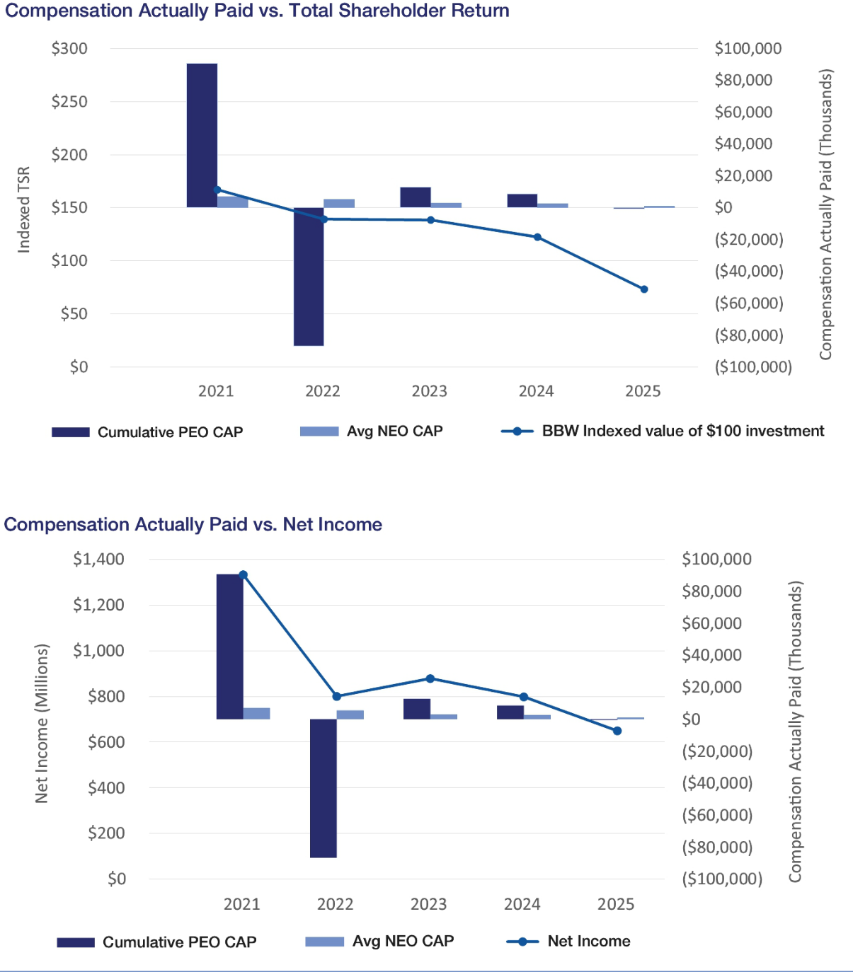

58 Bath & Body Works, Inc. | 2026 Proxy Statement

TABLE OF CONTENTS

Compensation-Related Matters
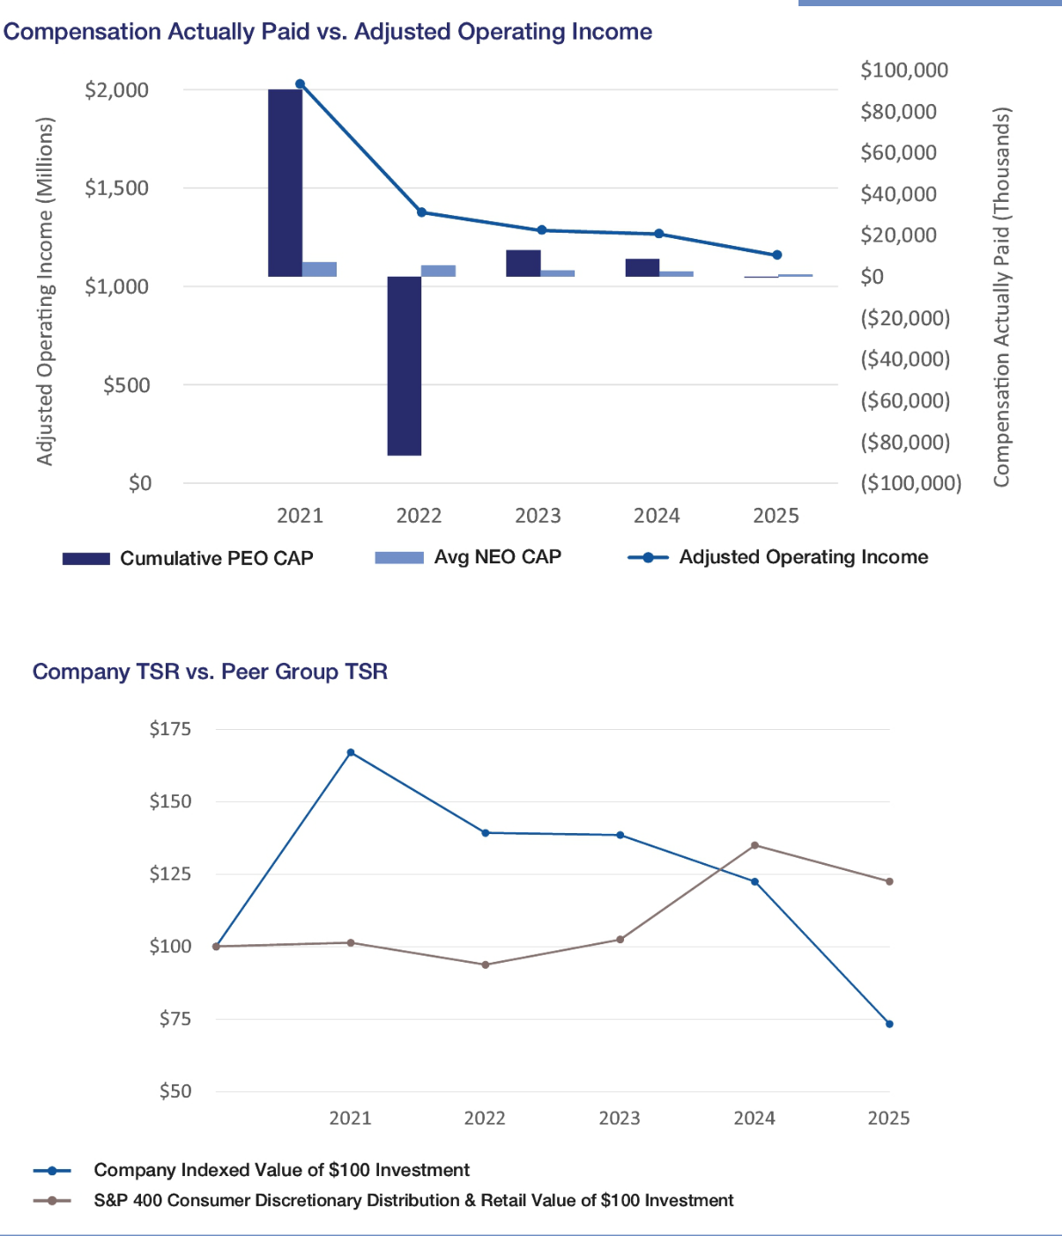

Bath & Body Works, Inc. | 2026 Proxy Statement 59

TABLE OF CONTENTS

Beneficial Ownership of Common Stock

The following table includes certain information about the securities ownership of all directors of the Company, the current and former executive officers of the Company named in the 2025 Summary Compensation Table on page 45 of this proxy statement and all directors and current executive officers of the Company as a group.

 | NUMBER OF SHARES OF
 | COMMON STOCK
 | BENEFICIALLY | PERCENT OF
NAME OF BENEFICIAL OWNER | _{OWNED}(1)(2) | CLASS⁽²⁾

Alessandro Bogliolo | ​ | 16,520⁽³⁾ |  | *
Eva Boratto | ​ | 38,740 |  | *
Gina Boswell |  | 78,764⁽⁴⁾ |  | *
Lucy Brady | ​ | 17,481⁽³⁾ |  | *
Daniel Heaf |  | 24,777⁽³⁾ |  | *
Francis Hondal | ​ | 21,554⁽³⁾⁽⁵⁾ |  | *
Danielle Lee | ​ | 18,211⁽³⁾ |  | *
Tom Mazurek | ​ 62,696.404⁽³⁾ |  |  | *
Sarah Nash | ​ 285,610.77⁽³⁾ |  |  | *
Juan Rajlin | ​ | 16,520⁽³⁾ |  | *
Stephen Steinour | ​ | _{80,900}(3)(6) |  | *
J.K. Symancyk | ​ | 40,379⁽³⁾ |  | *
Steven Voskuil | ​ | 33,925⁽³⁾ |  | *
Michael Wu | ​ 76,227.904⁽⁴⁾ |  |  | *
All directors and current executive officers as a group (12 people) | 657,314​ |  | _{.726}(3)(5)(6) | *

- Less than 1%

- Unless otherwise indicated, each named person has voting and investment power over the listed shares and such voting and investment power is exercised solely by the named person or shared with a spouse. None of the listed shares have been pledged as security or otherwise deposited as collateral.

- Reflects beneficial ownership of shares of the Company’s common stock, and shares outstanding, as of April 14, 2026.

- Includes the following number of shares issuable within 60 days of April 14, 2026, upon the exercise or vesting of outstanding stock awards: Mr. Heaf, 24,777; Mr. Mazurek, 26,464 (which includes PSUs reflected at the target performance level (100%); the actual number of PSUs earned can range 0-200% of target); all non-employee directors (with the exception of Ms. Nash), 5,641; Ms. Nash, 9,402; and all directors and current executive officers as a group, 105,771.

- Includes the following number of shares issuable within 60 days of April 14, upon the vesting of outstanding stock awards (which includes PSUs reflected at the target performance level (100%); the actual number of PSUs earned can range 0-200% of target): Ms. Boswell, 78,764; and Mr. Wu 25,234.

- Includes 13,850 shares held in The Francis A. Hondal Living Trust, for which Ms. Hondal has sole voting and investment power, and 2,063 shares held in the L Brands Inc for Francis Hondal, for which Ms. Hondal has sole voting and investment power.

- Includes 9,900 shares held in the Patricia M. Steinour Legacy Trust, for which Mr. Steinour has shared voting and investment power, and 9,900 shares held in the Stephen D. Steinour Dynasty Trust, for which Mr. Steinour has shared voting and investment power. Includes 12,925 shares owned by Mr. Steinour’s spouse, as to which Mr. Steinour may be deemed to share voting and investment power.

60 Bath & Body Works, Inc. | 2026 Proxy Statement

TABLE OF CONTENTS

Beneficial Ownership of Common Stock

The following table sets forth the names of all persons who, as of the dates indicated below, were known by the Company to be the beneficial owners (as defined in the rules of the Commission) of more than 5% of the outstanding shares of the Company’s common stock.

 | AMOUNT
 | BENEFICIALLY |  | PERCENT OF
NAME AND ADDRESS OF BENEFICIAL OWNER | OWNED |  | CLASS
AQR Capital Management, LLC⁽¹⁾
One Greenwich Plaza Suite 130
Greenwich, CT 05830 | 11,445,928 |  | 5.59%
BlackRock, Inc.⁽²⁾
50 Hudson Yards
New York, NY 10001 | 18,850,697 |  | 8.8%
FMR, LLC⁽³⁾
245 Summer Street
Boston, MA 02210 | 20,867,399​ | .55 | 8.3%

- As of December 31, 2025, based solely on information set forth in the Schedule 13G filed on February 13, 2026, by AQR Capital Management, LLC and AQR Capital Management Holdings, LLC (each, an “AQR Reporting Person”). Each AQR Reporting Person reported having shared voting power over 11,445,928 shares and shared dispositive power over 11,445,928 shares.

- As of March 31, 2025, based solely on information set forth in the Schedule 13G/A filed on April 17, 2025, BlackRock, Inc. reported having sole voting power over 18,339,958 shares and sole dispositive power over 18,850,697 shares.

- As of March 31, 2026, based solely on information set forth in the Schedule 13G/A filed on April 7, 2026, by FMR, LLC and Abigail P. Johnson (each, an “FMR Reporting Person”). Each FMR Reporting Person reported having sole dispositive power over 20,867,399.55 shares, and FMR, LLC reported having sole voting power over 20,743,248.36 shares.

Bath & Body Works, Inc. | 2026 Proxy Statement 61

TABLE OF CONTENTS

Information About the Annual Meeting and Voting

The Board is soliciting your proxy to vote at our 2026 annual meeting of shareholders (or at any adjournment of the meeting). This proxy statement summarizes the information you need to know to vote at the meeting.

We began mailing this proxy statement and the enclosed proxy card, or the Notice of Internet Availability of Proxy Materials (the “Notice”), on or about April 28, 2026 to all shareholders entitled to vote. The 2025 10-K, which includes our financial statements, is being sent with this proxy statement and is available in paper copy by request or in electronic form. You may request copies of such documents from: Bath & Body Works, Inc., Three Limited Parkway, Columbus, Ohio 43230, Attention: Corporate Secretary.

DATE: | TIME: | PLACE:
June 11, 2026 | 8:30 a.m. | Meeting will be held virtually at
 | Eastern Time | www.virtualshareholdermeeting.com/BBWI2026

Attending the Meeting

This year’s annual meeting will be held in a virtual format only. There will be no physical location for the meeting. We adopted a virtual format to make participation more convenient, safe and accessible for our shareholders regardless of their location. You will be able to attend the annual meeting, vote and submit your questions during the meeting by visiting www.virtualshareholdermeeting.com/BBWI2026.

By your attendance, you acknowledge that you have agreed to abide by the rules of conduct for our annual meeting that will be made available at the virtual meeting site. Only questions that comply with the rules of conduct of our annual meeting will be answered.

Shares Entitled to Vote

Shareholders entitled to vote are those who owned Company common stock (“Common Stock”) at the close of business on the record date, April 14, 2026. As of the record date, there were 201,382,518 shares of Common Stock outstanding. Each share of Common Stock that you own entitles you to one vote.

Voting Your Shares

Whether or not you plan to virtually attend the annual meeting, we urge you to vote. Shareholders of record can give proxies by calling a toll-free telephone number, by using the Internet or by mailing their signed proxy cards.

The telephone and Internet voting procedures are designed to authenticate shareholders’ identities, to allow shareholders to give their voting instructions and to confirm that shareholders’ instructions have been recorded properly. If you are voting by mail, please complete, sign and date the enclosed proxy card and return it promptly in the envelope provided. If you are voting by telephone or via the Internet, please use the telephone or Internet voting procedures set forth on the enclosed proxy card. Returning the proxy card or voting via telephone or the Internet will not affect your right to virtually attend the meeting and vote.

The enclosed proxy card indicates the number of shares that you own. Voting instructions are included on your proxy card. If you properly fill in your proxy card and send it to us or vote via telephone or the Internet in time to vote, one of the individuals named on your proxy card (your “proxy”) will vote your shares as you have directed. If you sign the proxy card or vote via telephone or the Internet but do not make specific choices, your proxy will follow the Board’s recommendations and vote your shares in the following manner:

- “FOR” the election of the Board’s ten nominees for director (as described on page 6);

62 Bath & Body Works, Inc. | 2026 Proxy Statement

TABLE OF CONTENTS

Information About the Annual Meeting and Voting

- “FOR” the ratification of the appointment of our independent registered public accounting firm (as described on page 23); and

- “FOR” the advisory vote to approve named executive officer compensation (as described on page 27).

If any other matter is properly presented at the meeting, your proxy will vote in accordance with his or her best judgment. At the time this proxy statement was filed, we knew of no other matters to be acted on at the meeting. See “—Vote Necessary to Approve Proposals” below for a discussion of the votes required to approve these items.

Certain shareholders received a Notice containing instructions on how to access this proxy statement and our 2025 10-K via the Internet. Those shareholders should refer to the Notice for instructions regarding how to vote.

Revoking Your Proxy

You may revoke your proxy by:

- submitting a later dated proxy (including a proxy via telephone or the Internet);

- notifying our Corporate Secretary at our principal executive offices at Three Limited Parkway, Columbus, Ohio 43230, Attention: Corporate Secretary, in writing before the meeting that you have revoked your proxy; or

- voting virtually at the meeting.

Voting at the Annual Meeting

If you own common stock of record, you may virtually attend the annual meeting and vote, regardless of whether you previously voted by proxy card, via the Internet, or by telephone. If your shares are held in the name of your broker, bank or other nominee, you may virtually attend the annual meeting, but in order to vote your shares at the annual meeting you must provide your 16-digit control number provided in your Notice or proxy card (if you received a printed copy of the proxy materials). We encourage you to vote your shares in advance of the annual meeting.

Our virtual meeting platform vendor will have technicians ready to assist you with any technical difficulties you may have accessing the virtual meeting or submitting questions. If you encounter any difficulties accessing the virtual meeting, please call the technical support number that will be posted on the meeting login page.

Appointing Your Own Proxy

If you want to give your proxy to someone other than the individuals named as proxies on the proxy card, you may cross out the names of those individuals and insert the name of the individual you are authorizing to vote. If you appoint your own proxy, the individual you appoint must provide your 16-digit control number provided in your Notice or proxy card (if you received a printed copy of the proxy materials) to virtually attend and vote at the meeting.

Quorum Requirement

A quorum of shareholders is necessary to hold a valid meeting. The presence in person or by proxy at the meeting of holders of shares representing at least one-third of the votes of the Common Stock entitled to vote constitutes a quorum. Abstentions and “broker non-votes” are counted as present for establishing a quorum. A broker non-vote occurs on an item when a broker is not permitted to vote on that item absent instruction from the beneficial owner of the shares and no instruction is given.

Vote Necessary to Approve Proposals

- Pursuant to the Company’s Bylaws, each director will be elected by a majority of the votes cast with respect to such director. A majority of the votes cast means that the number of votes “for” a director’s election must exceed 50% of the votes cast with respect to that director’s election. Any “against” votes will count as a vote cast, but “abstentions” and broker non-votes will not count as a vote cast with respect to that director’s election. Under Delaware law, if the director is not elected at the annual meeting, the director will continue to serve on the Board as a “holdover director.” As required by the Bylaws, each director has submitted an irrevocable letter of resignation as director that becomes effective if the director does not receive a majority of votes cast in an election and the Board accepts the resignation. If a director is not elected, the Nominating & Governance Committee will consider the director’s resignation and recommend to the Board whether to accept or reject the resignation.

Bath & Body Works, Inc. | 2026 Proxy Statement 63

TABLE OF CONTENTS

Information About the Annual Meeting and Voting

- The ratification of Ernst & Young LLP as our independent registered public accounting firm requires the affirmative vote of a majority of the votes present in person or by proxy and voting thereon.

- The advisory vote to approve named executive officer compensation requires the affirmative vote of a majority of the votes present in person or by proxy and voting thereon. While this vote is required by law, it will neither be binding on the Company nor the Board, nor will it create or imply any change in the fiduciary or other duties of, or impose any additional fiduciary or other duties on, the Company or the Board. However, the HCC Committee will carefully consider the shareholder vote, along with all other expressions of shareholders’ views on this matter, when considering future executive compensation decisions.

Impact of Abstentions and Broker Non-votes

You may “abstain” from voting for any nominee in the election of directors and on the other proposals. Abstentions with respect to the election of directors, the ratification of Ernst & Young LLP as our independent registered public accounting firm, and the advisory vote to approve named executive officer compensation will be excluded entirely from the vote and will have no effect.

In addition, under NYSE rules, if your broker holds your shares in its name, your broker is permitted to vote your shares on the proposal to ratify Ernst & Young LLP as our independent registered public accounting firm, even if it did not receive voting instructions from you. Your broker may not vote your shares on any of the other matters without specific instruction. A “broker non-vote” occurs when a broker submits a proxy but refrains from voting. Shares represented by broker non-votes are counted as present or represented for purposes of determining the presence of a quorum but are not counted as otherwise present or represented.

Obtaining Additional Copies of the Proxy Materials

We have adopted a procedure called “householding.” Under this procedure, shareholders who share the same last name and reside at the same mailing address will receive one Notice or one set of proxy materials (if they have elected to receive hard copies of the proxy materials), unless one of the shareholders at that address has notified us that they wish to receive individual copies. Shareholders who participate in householding continue to receive separate control numbers for voting. Householding does not in any way affect dividend check mailings.

If you hold Common Stock and currently are subject to householding, but prefer to receive separate copies of proxy materials and other shareholder communications from the Company, or if you are sharing an address with another shareholder and would like to consent to householding, you may revoke or grant your consent to householding as appropriate at any time by calling (866) 540-7095 or sending the request to Householding Department, 51 Mercedes Way, Edgewood, New York 11717. We will promptly deliver separate copies of the proxy materials upon request.

A number of brokerages and other institutional holders of record have implemented householding. If you hold your shares beneficially in street name, please contact your broker or other intermediary holder of record to request information about householding.

64 Bath & Body Works, Inc. | 2026 Proxy Statement

TABLE OF CONTENTS

General Matters

Delinquent Section 16(a) Reports

Our common stock is registered pursuant to Section 12(b) of the Exchange Act. The officers and directors of the Company and beneficial owners of greater than 10% of our shares of common stock (the “10% Beneficial Owners”) are required to file reports on Forms 3, 4 and 5 with the Securities and Exchange Commission disclosing beneficial ownership and changes in beneficial ownership. Securities and Exchange Commission rules require disclosure in our Proxy Statement and Annual Report on Form 10-K of the failure of an officer, director or 10% Beneficial Owner of the shares of common stock to file a Form 3, 4 or 5 on a timely basis. Based on our review of such ownership reports and written representations from reporting persons, all required filings were made on a timely basis for fiscal 2025, except for Mr. Heaf’s Form 3 in connection with his hiring due to inadvertent administrative delays in obtaining his EDGAR access credentials. The filings were made promptly after his credentials were issued.

Shareholder Proposals or Director Nominations for the 2027 Annual Meeting

SHAREHOLDER PROPOSALS PURSUANT TO RULE 14A-8

Proposals submitted for inclusion in the proxy statement for our 2027 annual meeting of shareholders must be received by the Company’s Corporate Secretary at our principal executive offices on or before December 29, 2026.

SHAREHOLDER DIRECTOR NOMINATIONS FOR INCLUSION IN OUR 2027 PROXY STATEMENT

Written notice of shareholder nominations of persons for election as a director at our 2027 annual meeting of shareholders that are to be included in our proxy statement for the 2027 annual meeting pursuant to the proxy access provisions in Section 2.05 of our Bylaws must be received by the Company’s Corporate Secretary at our principal executive offices no earlier than November 29, 2026, and no later than December 29, 2026. The notice must contain the information required by our Bylaws.

OTHER SHAREHOLDER PROPOSALS

If a shareholder intends to present a proposal or nominate a person for election as a director at the 2027 annual meeting other than as described above, the shareholder must comply with the requirements set forth in Section 2.04 of our Bylaws. The Bylaws require, among other things, that the Company’s Corporate Secretary receive written notice of the intent to present a proposal or nomination no earlier than February 11, 2027, and no later than March 13, 2027. The notice must contain the information required by our Bylaws.

Other Proposed Actions

The Board knows of no other matters to be brought before the annual meeting. However, if other matters should come before the meeting, each of the persons named as a proxy intends to vote in accordance with such person’s judgment on such matters.

Solicitation of Proxies

We are soliciting proxies primarily by the use of the mail. However, we may also solicit proxies by telephone, email and personal solicitation, in addition to the use of the mail. To the extent our directors or associates participate in this solicitation, they will not receive compensation for their participation, other than their normal compensation. We will, upon request, reimburse banks, brokerage houses and other institutions, nominees and fiduciaries for their expenses in forwarding proxy materials to beneficial owners. We bear all costs associated with this proxy solicitation.

Bath & Body Works, Inc. | 2026 Proxy Statement 65

TABLE OF CONTENTS

Appendix A

Non-GAAP Financial Measures

The Company uses certain adjusted financial information in this proxy statement, including adjusted operating income, adjusted operating income margin, adjusted net income per diluted share, and free cash flow. The adjusted financial information should not be construed as an alternative to the results determined in accordance with GAAP. Further, the Company’s definitions of adjusted financial information may differ from similarly titled measures used by other companies. Management believes that the presentation of the adjusted financial information provides additional information to investors to facilitate the comparison of past and present operations. Further, the Human Capital & Compensation Committee uses adjusted operating income and adjusted operating income margin because it is a performance measure over which the Company’s executives can have significant impact and is also directly linked to the Company’s long-term growth plan and performance that drive shareholder value. While it is not possible to predict future results, management believes the adjusted financial information is useful for the assessment of the operations of the Company because the adjusted items are not indicative of the Company’s ongoing operations due to their size and nature. Additionally, management uses adjusted financial information as key performance measures for the purpose of evaluating performance internally. The adjusted financial information should be read in conjunction with the Company’s historical financial statements and notes thereto contained in the Company’s Quarterly Reports on Form 10-Q and Annual Reports on Form 10-K.

The table below reconciles the adjusted operating income and margin of the Company for fiscal 2025 to the Company’s operating income and margin, the most comparable GAAP financial measure. The table also reconciles the adjusted operating income of the Company for fiscal 2021 to the Company’s operating income. For fiscal 2024, 2023, 2022, the Company did not make any adjustments to operating income; therefore, for fiscal 2024, 2023 and 2022, adjusted operating income is equal to the Company’s fiscal 2024, 2023 and 2022 GAAP operating income, respectively.

RECONCILIATIONS OF REPORTED OPERATING INCOME RESULTS TO ADJUSTED OPERATING INCOME RESULTS ($ IN MILLIONS)

 |  |  | FIRST HALF
 | 2025 |  | 2025 | 2024 | 2023 | 2022 | 2021
 | (52 WEEKS) |  | (26 WEEKS) | (52 WEEKS) | (53 WEEKS) | (52 WEEKS) | (52 WEEKS)
 | $ | Margin | $ | $ | $ | $ | $
Reported Operating Income | $1,126 | 15.4% | $367 | $1,266 | $1,285 | $1,376 | $2,009
Business Transformation Activities⁽¹⁾ | 15 | 0.2 | — | — | — | — | —
Leadership Transition Costs⁽²⁾ | 15 | 0.2 | 15 | — | — | — | —
Write-off of Inventory due to Tornado⁽³⁾ | — | — | — | — | — | — | 9
Adjusted Operating Income | $1,156 | 15.9% | $382 | $1,266 | $1,285 | $1,376 | $2,019

- In 2025, we recognized aggregate pre-tax costs of $15 million resulting from business transformation activities in connection with the Consumer First Formula. These costs primarily related to severance benefits.

- In the first half of 2025, we recognized aggregate pre-tax costs of $15 million due to the transition of certain members of the leadership team, primarily related to severance benefits.

- In 2021, we recognized a pre-tax loss of $9 million related to the write-off of inventory that was destroyed by a tornado at a vendor’s facility.

Bath & Body Works, Inc. | 2026 Proxy Statement A-1

TABLE OF CONTENTS

Appendix

A

The table below reconciles the Company’s fiscal 2025 adjusted net income per diluted share to the Company’s fiscal 2025 net income per diluted share, the most comparable GAAP financial measure.

RECONCILIATION OF REPORTED NET INCOME PER DILUTED SHARE TO ADJUSTED NET INCOME PER DILUTED SHARE

 | 2025
Reported Net Income per Diluted Share | $ 3.11
Business Transformation Activities⁽¹⁾ | 0.06
Leadership Transition Costs⁽²⁾ | 0.07
Gain on Sale of Non-Core Asset⁽³⁾ | (0.03)
Adjusted Net Income per Diluted Share | $ 3.21

- In 2025, we recognized aggregate pre-tax costs of $15 million ($12 million after tax) resulting from business transformation activities in connection with the Consumer First Formula. These costs primarily related to severance benefits.

- In 2025, we recognized aggregate pre-tax costs of $15 million ($14 million after tax) due to the transition of certain members of the leadership team, primarily related to severance benefits.

- In 2025, we recognized an $8 million pre-tax gain ($6 million after tax) related to the sale of a non-core asset.

The table below reconciles the Company’s fiscal 2025 free cash flow to the Company’s fiscal 2025 net cash provided by operating activities, the most comparable GAAP financial measure.

RECONCILIATION OF REPORTED NET CASH PROVIDED BY OPERATING ACTIVITIES TO FREE CASH FLOW (IN MILLIONS)

 | 2025
Reported Net Cash Provided by Operating Activities | $ | 1,102
Capital Expenditures |  | (237)
Free Cash Flow | $ | 865

A-2 Bath & Body Works, Inc. | 2026 Proxy Statement

TABLE OF CONTENTS
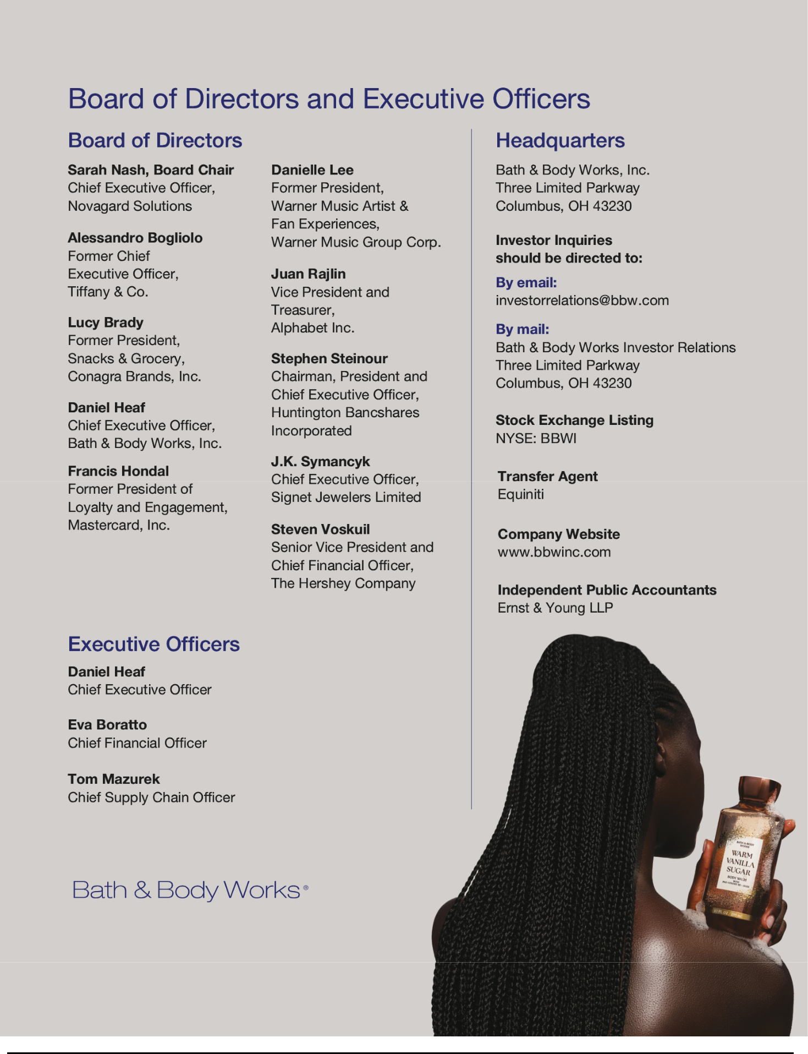

TABLE OF CONTENTS


TABLE OF CONTENTS
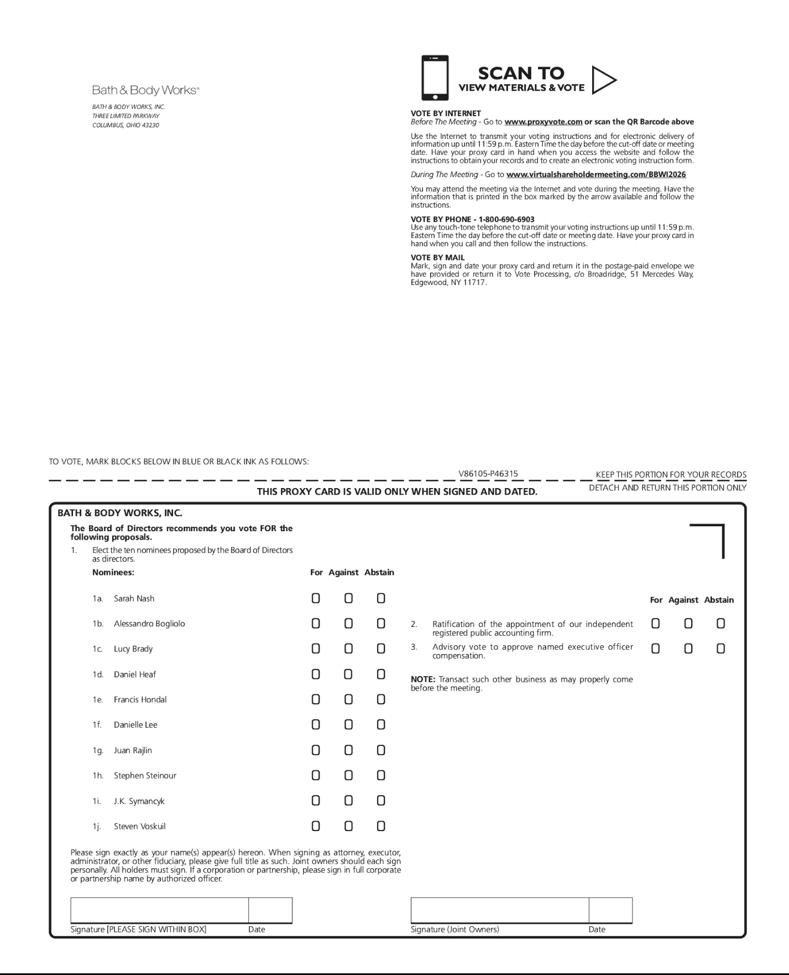

TABLE OF CONTENTS


